Promenaea stapelioides (Link & Otto) Lindl., 1843

[sta-pee-lee-OY-deez]

Common Name Stapelia-Like Promenaea

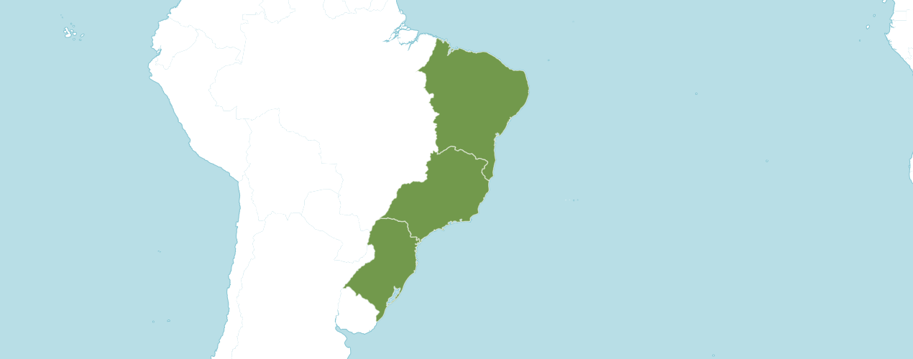

Native

Brazil Northeast, Brazil South, Brazil Southeast

Homotypic Synonyms

Cymbidium stapelioides Link & Otto in Icon. Pl. Select. 4: t. 52 (1821)

Maxillaria stapelioides (Link & Otto) Lindl. in Gen. Sp. Orchid. Pl.: 146 (1832)

Peristeria stapelioides (Link & Otto) Loudon in Suppl. Hort. Brit.: 604 (1850)

Zygopetalum stapelioides (Link & Otto) Rchb.f. in W. G. Walpers, Ann. Bot. Syst. 6: 658 (1863)

Accepted Infraspecifics - Includes 5 Accepted Infraspecifics

Promenaea stapelioides nothosubsp. nigricans (Königer & J.G.Weinm.bis) Meneguzzo

Promenaea stapelioides subsp. rollissonii (Lindl.) Meneguzzo

Promenaea stapelioides subsp. stapelioides

Promenaea stapelioides f. viridiflora (F.Barros & Barberena) Meneguzzo

Promenaea stapelioides subsp. xanthina (Lindl.) Meneguzzo

Orchid Wiz notes Origin/Habitat: Brazil. This species is native to the cool, moist mountains near the coast in the States of Rio de Janeiro, São Paulo, Paraná, and Santa Catarina. Plants usually grow on trees at moderate elevations, but they also grow attached to damp rocks. Miller & Warren (1994) report that this orchid is very rare at 3300 ft. (1000 m) in the Macaé de Cima Forest Reserve in northeastern Rio de Janeiro, but that is the extreme upper limit of its range. They further state that plants are commonplace in nearby valleys at about 1950 ft. (600 m).

Plant Size AND Type: A small, 2.8-3.6 in. (7-9 cm), sympodial epiphyte on trees or rocks.

Pseudobulb: 0.8–1.2 in. (2–3 cm) long by 0.3–0.6 in. (0.8–1.4 cm) wide. The clustered pseudobulbs are compressed, more or less 4–angled, and enclosed at the base by 2–4 leaf-bearing bracts. The low, spreading growths are about 4 in. (10 cm) wide.

Leaves: 2.0–2.4 in. (5–6 cm) long by 0.3–1.0 in. (0.7–2.5 cm) wide. A pair of spreading, soft, gray-green leaves are carried at the apex of the pseudobulb. They are sharply pointed at the apex, curve downward toward the tip, are somewhat folded longitudinally along the midvein with a prominent midrib on the underside and a channel on the upper surface.

Inflorescence: 1.2–3.1 in. (3–8 cm) long. Recently matured pseudobulbs each produce 1–2 short, horizontally spreading to somewhat pendulous flower spikes that emerge from the base. Flowers are carried on a pedicellate ovary that is 0.4–0.6 in. (1.0–1.5 cm) long.

Flowers: 1 per inflorescence. Flowers are about 2 in. (5 cm) across, which is large for the size of the plant. Sepals and petals are greenish yellow and densely blotched and barred with dark purple-maroon. The velvety lip is mostly a dark purplish black, but the lateral lobes show touches of greenish white at the base. The column is greenish white. The broadly triangular but rather bluntly pointed sepals and petals are somewhat concave, keeled, slightly overlapping, and 0.8–1.0 in. (2.0–2.5 cm) long by 0.4–0.5 in. (1.0–1.3 cm) wide near the base, with the petals often being slightly wider than the sepals. The dorsal sepal projects forward hoodlike over the column. The oblique lateral sepals and petals project forward somewhat at the base but flare outward toward their tips. The 3–lobed, concave lip is 0.6–0.7 in. (1.6–1.9 cm) long overall with lateral margins that curve upward forming a trough. Lateral lobes are bluntly pointed and point forward. The round to oval midlobe is 0.4–0.5 in. (1.0–1.2 cm) long by 0.4–0.6 in. (1.1–1.4 cm) wide. The column is 0.5–0.6 in. (1.2–1.4 cm) long with a 0.2–0.3 in. (0.5–0.7 cm) long foot at the base.

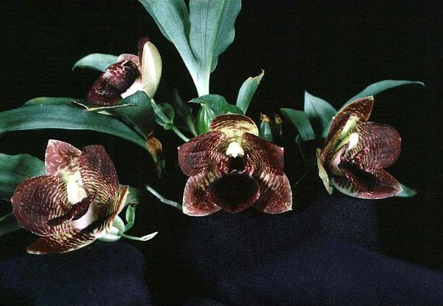
Promenaea stapelioides ‘Noscentuous’ HCC/AOS, 78 points, 1998
Photography by William Merritt

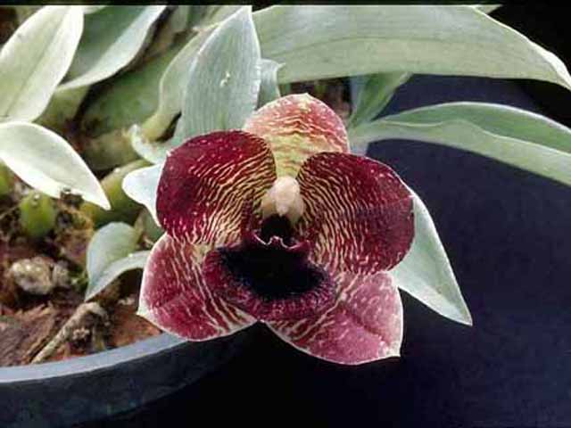
Promenaea stapelioides ‘Killer Bees’ AM/AOS, 80 points, 2003
Photography by unknown

AOS Awards

Promenaea stapelioides Awards
 | FCC | AM | HCC | AQ | JC | CCM | CCE | CHM | CBM | TOTAL
AOS | - | 6 | 2 | - | 2 | 6 | - | - | 1 | 17
Years Awarded |  | 1976  to  2018 | 1995  1998 |  | 1992  1997 | 1991 to  2018 |  |  | 1975

Promenaea stapelioides Hybrids

Promenaea stapelioides has twenty-two F1 generation offspring and ninety-two progeny. The first registered hybrid of Promenaea stapelioides was in 1905. The hybrid was Promenaea Crawshayana (stapelioides x xanthina), made and registered by Chrawshay. Promenaea Crawshayana has eighteen AOS awards (AM -8; CCE – 1; CCM – 5; and HCC - 4). Promenaea Crawshayana has sixteen F1 generation offspring and sixty-six total progeny.

Promenaea Crawshayana Grexes and Awards
Four Generations of Progeny
Generation | Grexes | Awarded | % Awarded | Awards
1 | 16 | 8 | 50.0% | 36
2 | 23 | 4 | 17.4% | 6
3 | 20 | 6 | 30.0% | 18
4 | 7 | 1 | 14.3% | 1

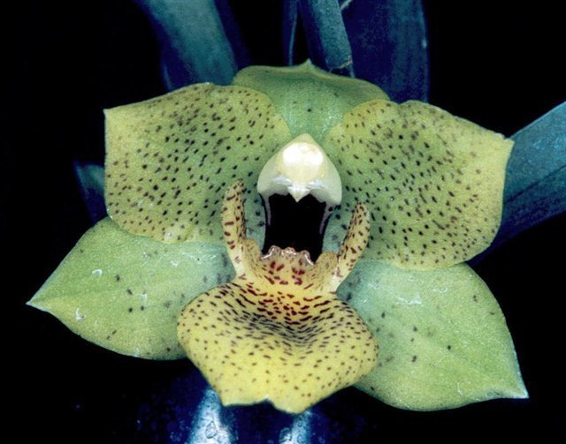
Promenaea Crawshayana from World Orchid Conference
Photography by unknown
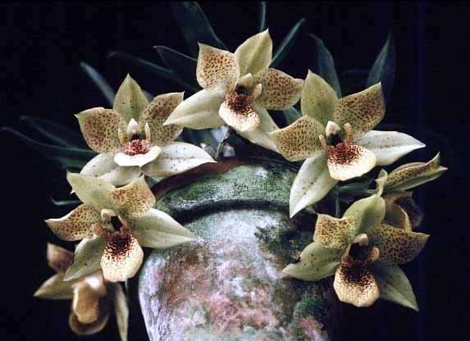
Promenaea Crawshayana ‘Great Hawaiian’ HCC/AOS, 79 points, 1995
Photography by OWZ Lib

The second registered hybrid of Promenaea stapelioides was in 1998. The hybrid was Promenaea Winelight (Limelight x stapelioides), made and registered by Dr. B. C. Berliner. Promenaea Winelight has fifteen AOS awards (AM -6; AQ – 1; CCM – 2; and HCC - 6). Promenaea Winelight has two F1 generation offspring that are both Intergeneric.
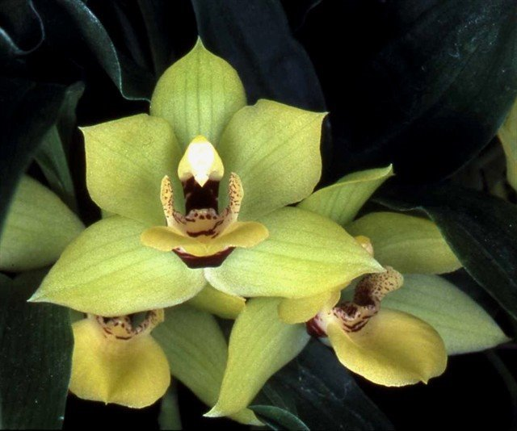
Promenaea Winelight ‘Stacey’ HCC/AOS, 78 points, 2006
Photography by James McCulloch
American Orchid Society. (n.d.). Promenaea stapelioides. Retrieved May 24, 2023, https://www.aos.org/orchids/orchids-a-to-z/letter-p/promenaea.aspx.

Brazil Flora Group. (2015). Growing knowledge: an overview of Seed Plant diversity in Brazil. Rodriguésia 66(4): 1085–1113.

Govaerts, R. (2003). World Checklist of Monocotyledons Database in ACCESS: 1-71827. The Board of Trustees of the Royal Botanic Gardens, Kew.

Neto, V. (2012). Icones Orchidacearum Brasilienses 3: t. 201-t. 300.

da Rocha Fiuza de Melo, M., and et. al. (2007). Flora Fanerogâmica da Ilha do Cardoso 12: 1-289. Instituto de Botânica, São Paulo, Brazil.

Kew (n.d.). Promenaea stapelioides. Royal Botanical Gardens Kew: Plants of the World Online. Retrieved May 24, 2023, from https://powo.science.kew.org/results?q=Promenaea+stapelioides.

Internet Orchid Species Encyclopedia http://www.orchidspecies.com/bolcoelestis.htm.

Cogniaux, A. (1906). Flora Brasiliensis-Orchidaceae I, vol. III, part 4.

Hamilton, R. (1988). When does it flower? 2nd ed. Hamilton. Richmond, B. C., Canada.

Hawkes, A. (1987). Encyclopedia of cultivated orchids. Faber and Faber, London.

McQueen, J., and McQueen, B. (1992). Miniature orchids. Timber Press, Portland, OR.

McQueen, J., and McQueen, B. (1993). Orchids of Brazil. Timber Press, Portland, OR.

Miller, D., and Warren, R. (1994). Orchids of the high mountain Atlantic rainforest in Southeastern Brazil. Salamandra Consultoria Editorial SA, Rio de Janeiro, Brazil.

OrchidWiz X9.0.

Pabst, G., and Dungs, F. (1975). Orchidaceae Brazilienses, book 1 and 2. Brücke-Verkag Kurt Schmersow, Hildesheim, Germany.

Pridgeon, A. (1992). The illustrated encyclopedia of orchids. Timber Press, Portland, OR.

