Promenaea xanthina (Lindl.) Lindl., 1843
[zan-THYE-na]

Per Kew, this name is synonymous with Promenaea stapelioides subsp. xanthina

Common Name The yellow Promenaea

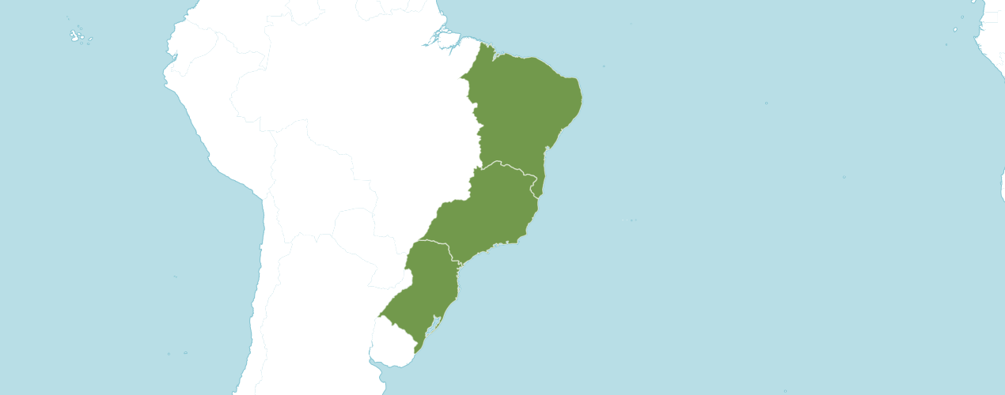

Native

Brazil

Orchid Wiz notes Origin/Habitat: Brazil. This orchid grows near 5600 ft. (1700 m) in the cooler mountains near the southeast coast in the States of Espirito Santo, Rio de Janeiro, São Paulo, Paraná, and Minas Gerais. Miller & Warren (1994) reported that Promenaea xanthina is common in the Macaé de Cima Forest Reserve above 3300 ft. (1000 m), but that it is never found in another nearby, lower-elevation valley. These plants usually grow on trees, but occasionally they grow on rocks.

Plant Size and Type: A small, 2.6-4.0 in. (11.5-13.0 cm), sympodial epiphyte or lithophyte.

Pseudobulb: 0.6–1.2 in. (1.5–3.0 cm) long by 0.4–0.6 in. (1.0–1.5 cm) wide. The somewhat compressed pseudobulbs are obscurely 4–angled and partially enclosed at the base by 1–2 leaf-bearing bracts. The low, spreading growths are about 4 in. (10 cm) wide. Growths are clustered along a branching rhizome. When not in flower, Promenaea xanthina and Promenaea stapelioides are almost impossible to tell apart.

Leaves: 2.0–2.8 in. (5–7 cm) long by 0.4–0.6 in. (1.0–1.5 cm) wide. A pair of suberect to spreading leaves are carried at the apex of each pseudobulb.

Inflorescence: 1.6–3.5 in. (cm) long. The pale green, arching flower spike emerges from the base of a recently matured pseudobulb.

Flowers: 1–2. The very fragrant, heavily textured, long-lasting, slightly cupped blossoms are clear yellow with reddish spots at the base of the lateral lobes of the lip and on the column. Flowers are 1.2–1.6 in. (3–4 cm) across with slightly concave sepals, rather broadly pointed at the tip, and about 0.8 in. (2 cm) long by 0.3 in. (0.7–0.8 cm) wide near the base. The petals are slightly concave and about 0.6 in. (1.4–1.5 cm) long, which is slightly shorter than the sepals, but they are 0.3–0.4 in. (0.7–0.9 cm) wide. The 3–lobed lip is about 0.6 in. (1.5 cm) long with erect lateral lobes and a midlobe that curves downward somewhat and is more or less rounded at the apex. There is a 3–lobed callus at the base of the lip with a raised protuberance inside the 3–toothed apex of its midlobe. The column is 0.4–0.5 in. (1.0–1.2 cm) long and has a foot at its base that is about 0.2 in. (0.5–0.6 cm) long.

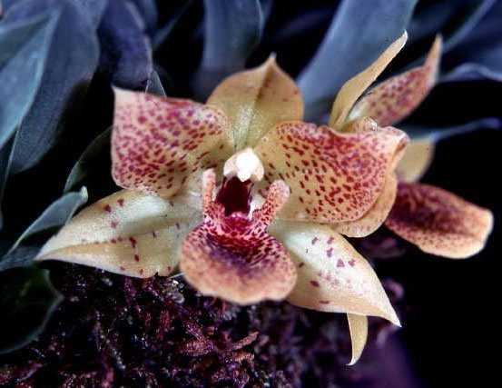
Promenaea xanthina ‘Ara Marie’ AM/AOS, 81 points, 1976
Photography by OWZ Lib

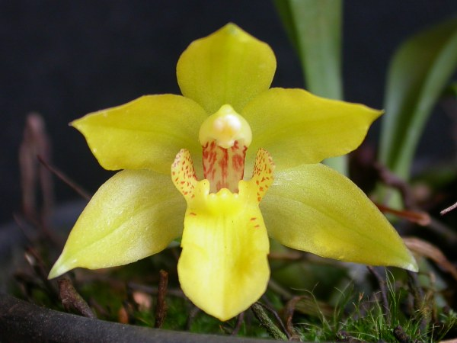
Promenaea xanthina
Photography by Dalton Baptista

AOS Awards

Promenaea xanthina Awards
 | FCC | AM | HCC | AQ | JC | CCM | CCE | CHM | CBM | TOTAL
AOS | - | 1 | 4 | - | - | 6 | 1 | 2 | 3 | 17
Years Awarded |  | 1976 | 1991  1996  1997  2004 |  |  | 1975 to  2004 | 2000 | 1983  &  1996 | 1974  1974  1975

Promenaea xanthina Hybrids

Promenaea xanthina has twenty-one F1 generation offspring and one hundred twenty-one progeny. The first registered hybrid of Promenaea xanthina was in 1905. The next Promenaea xanthina registered hybrid was in 1935. Another Promenaea xanthina hybrid was not registered until 1985, then a few in the 1990’s and 2000’s.

The first Promenaea xanthina hybrid was Promenaea Crawshayana (stapelioides x xanthina), made and registered by Chrawshay. Promenaea Crawshayana has eighteen AOS awards (AM - 8; CCE – 1; CCM – 5; and HCC - 4). Promenaea Crawshayana has sixteen F1 generation offspring and sixty-six total progeny.

Promenaea Crawshayana Grexes and Awards
Four Generations of Progeny
Generation | Grexes | Awarded | % Awarded | Awards
1 | 16 | 8 | 50.0% | 36
2 | 23 | 4 | 17.4% | 6
3 | 20 | 6 | 30.0% | 18
4 | 7 | 1 | 14.3% | 1

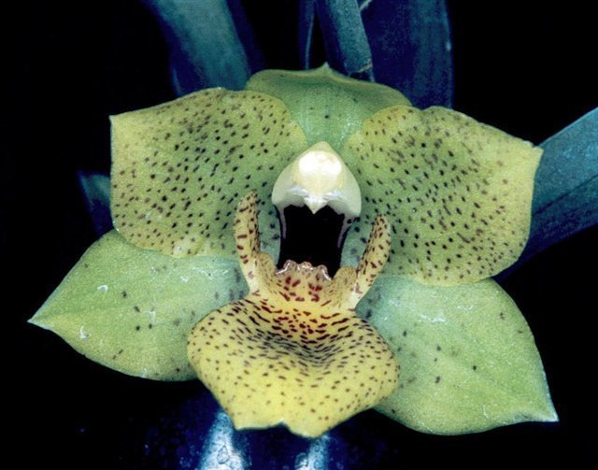
Promenaea Crawshayana from World Orchid Conference
Photography by unknown
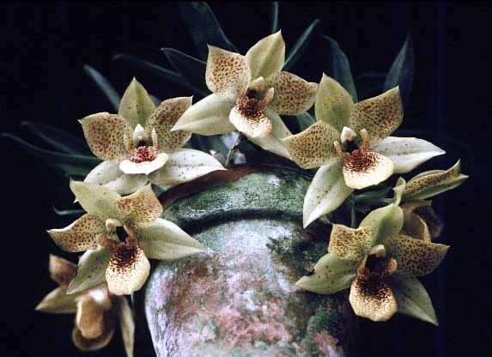
Promenaea Crawshayana ‘Great Hawaiian’ HCC/AOS, 79 points, 1995
Photography by OWZ Lib

The second registered hybrid of Promenaea stapelioides was in 1998. The hybrid was Promenaea Winelight (Limelight x stapelioides), made and registered by Dr. B. C. Berliner. Promenaea Winelight has fifteen AOS awards (AM -6; AQ – 1; CCM – 2; and HCC - 6). Promenaea Winelight has two F1 generation offspring that are both Intergeneric.

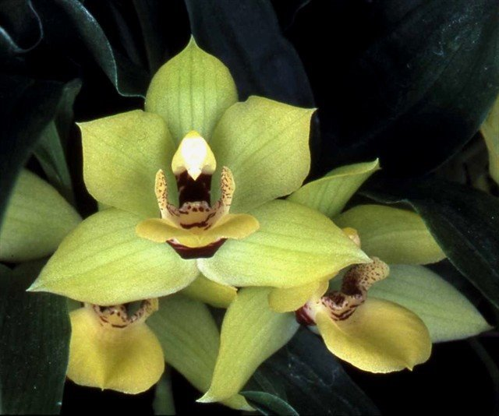
Promenaea Winelight ‘Stacey’ HCC/AOS, 78 points, 2006
Photography by James McCulloch
References

American Orchid Society. (n.d.). Promenaea. Retrieved May 24, 2023, https://www.aos.org/orchids/orchids-a-to-z/letter-p/promenaea.aspx.

Bechtel, H., Cribb, P., and Launert, E. (1980). Manual of cultivated orchid species. MIT Press, Cambridge, Mass.
Cogniaux, A. (1906). Martii, Flora Brasiliensis-Orchidaceae I, vol. III, part 4.

Hamilton, R. 1988. When does it flower? 2nd ed. Hamilton. Richmond, B. C., Canada.

Hawkes, A. (1987). Encyclopedia of cultivated orchids. Faber and Faber, London.

Kew (n.d.). Promenaea xanthina. Royal Botanical Gardens Kew: Plants of the World Online. Retrieved May 24, 2023, from https://powo.science.kew.org/taxon/urn:lsid:ipni.org:names:655073-1

McQueen, J., and McQueen, B. (1992). Miniature orchids. Timber Press, Portland, OR.

McQueen, J., and McQueen, B. (1993). Orchids of Brazil. Timber Press, Portland, OR.

Miller, D., and Warren, R. (1994). Orchids of the high mountain Atlantic rainforest in Southeastern Brazil. Salamandra Consultoria Editorial SA, Rio de Janeiro, Brazil.

OrchidWiz X9.0.

Pabst, G., and Dungs, F. (1975). Orchidaceae Brazilienses, book 1 and 2. Brücke-Verkag Kurt Schmersow, Hildesheim, Germany.

Pridgeon, A. (1992). The illustrated encyclopedia of orchids. Timber Press, Portland, OR.

