Malaxis Five Sample Descriptions

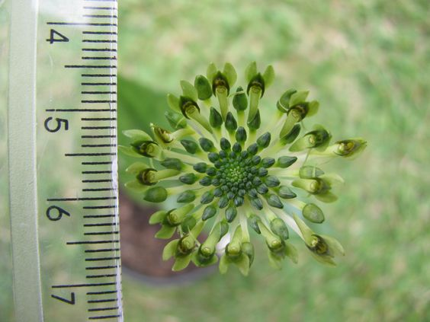

Malaxis excavata
Photography by unknown

Thirteen flowers, 20 distinct buds, additional buds developing, presented on an umbel X cm inflorescence; sepals, petals chartreuse; lip, held perpendicular to the umbel, emerald green; substance firm, texture waxy.

Award: HCC/AOS, 75 points

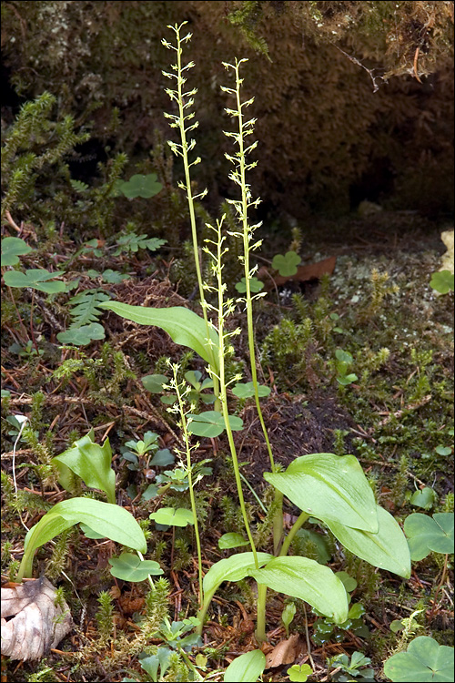

Malaxis monophyllos
Photography by Dr. Amadej Trnkoczy

Two baseline items associated with the description I am writing. 1. The photograph used for this description depicts one plant of Malaxis monophyllos, not four separate plants. 2. Because of the limited visibility of the flowers, a review of a closeup of Malaxis monophyllos was used for flower description.

Fifty-four flowers and seventeen buds on four erect inflorescences up to x cm tall; well grown plant displaying green leaves; sepals and petals white; lip white, column white overlaid chartreuse; substance firm, texture waxy.

Award: CHM/AOS, 81 points

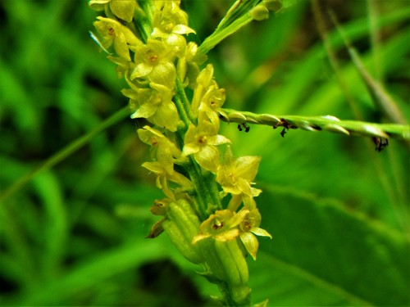

Malaxis rosei
Photography by Pablo Franco

Seventeen flowers presented on an erect x cm inflorescence; sepals and petals yellow; lip yellow, overlaid chestnut proximally; column yellow overlaid chartreuse; staminode yellow; substance firm; texture flat.

Award: HCC/AOS, 75 points.
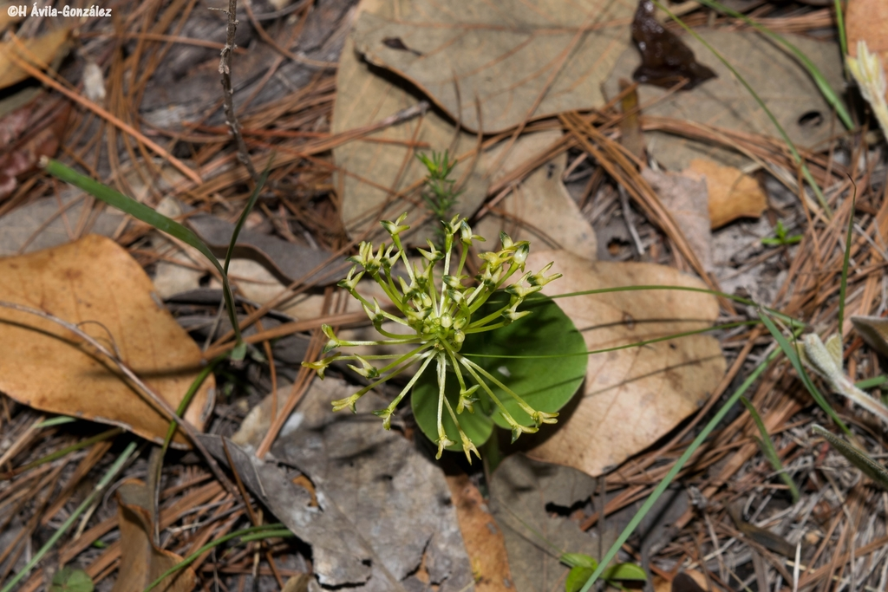

Malaxis novogaliciana
Photography by Avila-Gomzalez

Twenty-three flowers and six buds on an umbel x cm inflorescence; sepals, petals cream overlaid chartreuse; lip emerald green; substance firm, texture waxy.

Award: CBR/AOS
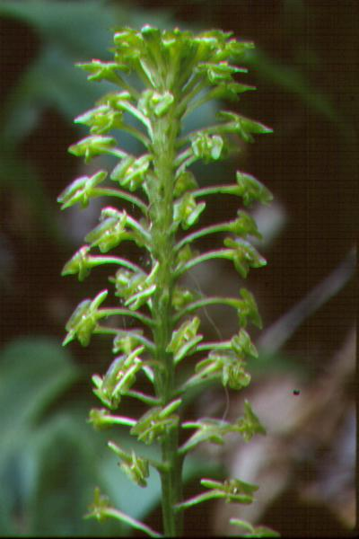

Malaxis bayardii
Photography by unknown

Thirty-nine flowers, eleven buds on one erect x cm inflorescence; sepals, petals chartreuse; lip chartreuse, pollinia yellow; substance firm; texture waxy.

Award: AM/AOS, 84 points.

