Malaxis Swartz 1778
mal-AX-iss
As noted from the American Orchid Society, Malaxis is a large genus of terrestrial orchids with variation in vegetative growth. All have minuscule nonresupinate flowers. The genus was first described in 1788 by Olof Peter Swartz, who selected the Greek word malaxis (softening) as the generic name. He was probably referring to the soft succulent leaves found on some species, or possibly to the fact that some leaves instead of drying out at the end of their lives turn light tan, become soft and collapse as noted in Malaxis latifolia. In the journal article, Malaxidinae index nominum – Seidenfia Szlach. (Orchidacease) authored by H. B. Margoriska, there is reference that Malaxis was revised in 1889.
Some Malaxis species have wide distribution ranges. For example, Malaxis unifolia is found from eastern Canada southward through the central and eastern United States and into the Caribbean. Another example of a Malaxis species with a wide distribution range is Malaxis monophyllos, which ranges throughout the temperate Northern Hemisphere to the Philippines. While some Malaxis species have a wide distribution range, other Malaxis species are endemic to a small area, such as a single island. Two examples of a Malaxis with a small distribution area is Malaxis rhabdophylla, which is found on the island of New Guinea and Malaxis aurata found only on the island of Borneo.
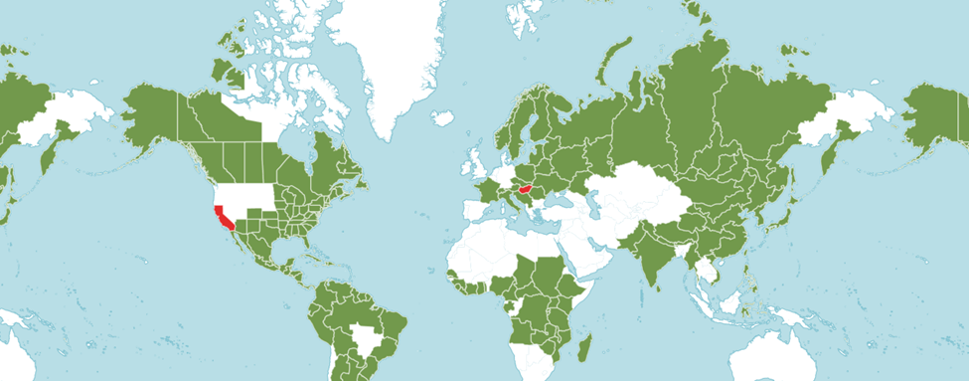
Range of Malaxis. Green colored areas native found. Red colored areas are now extinct.
Native to:
Alabama, Alaska, Alberta, Aleutian Island, Altay, Amur, Angola, Argentina Northeast, Argentina Northwest, Arizona, Arkansas, Austria, Bahamas, Baltic States, Belarus, Belize, Bolivia, Brazil, British Columbia, Burundi, Buryatia, Cameroon, Central African Republic, Chad, China, Chita, Colombia, Colorado, Comoros, Connecticut, Costa Rica, Cuba, Czechoslovakia, Delaware, District of Colombia, Dominican Republic, Himalaya, Ecuador, El Salvador, Ethiopia, Finland, Florida, France, French Guiana, Gabon, Georgia, Ghana, Guatemala, Guinea, Gulf of Guinea Island, Guyana, Haiti, Honduras, Illinois, India, Indiana, Mongolia, Iowa, Irkutsk, Italy, Ivory Coast, Jamaica, Japan, Kamchatka, Kansas, Kentucky, Kenya, Khabarovsk, Korea, Krasnoyarsk, Kuril Island, Labrador, Leeward Islands, Liberia, Louisiana, Madagascar, Maine, Malawi, Maluku, Manchuria, Manitoba, Maryland, Massachusetts, Mexico, Michigan, Minnesota, Mississippi, Missouri, Mongolia, Mozambique, Myanmar, Nepal, New Brunswick, New Hampshire, New Jersey, New Mexico, New York, Newfoundland, Nicaragua, Nigeria, North Carolina, Russia, Northwest Territories, Norway, Nova Scotia, Ohio, Oklahoma, Ontario, Pakistan, Panamá, Paraguay, Pennsylvania, Peru, Philippines, Poland, Primorsky Krai, Prince Edward Island, Puerto Rico, Qinghai, Québec, Rhode Island, Romania, Rwanda, Sakhalin, Saskatchewan, Senegal, Seychelles, Sierra Leone, South Carolina, Sri Lanka, Sudan, Sulawesi, Suriname, Sweden, Switzerland, Taiwan, Tanzania, Tennessee, Texas, Tibet, Togo, Trinidad-Tobago, Tuva, Uganda, Ukraine, Uruguay, Vanuatu, Venezuela, Vermont, Vietnam, Virginia, Siberia, West Virginia, Windward Islands, Wisconsin, Yakutskaya, Yugoslavia, Yukon, Zambia, Zaïre, and Zimbabwe.

Extinct in: California, and Hungary.

Malaxis, a sympodial plant, varies greatly vegetatively. Some species of Malaxis are miniatures less than 15 centimeters (6 inches) tall. Other Malaxis species have pseudobulbs up to 15 centimeters (6 inches) tall. Inflorescences are variable from Malaxis species to species. Some Malaxis species inflorescences are densely covered with small flowers. Rarely are the flowers over a few millimeters in diameter. Most Malaxis flowers base colors are in hues of greens and creams; however, a few have base colors hues in the pink or purplish pink color range.
Flowers of Malaxis species are most often only 5 millimeters (0.25 inches) across. Malaxis species flowers vary from species to species with the greatest variation seen in the lip. Malaxis sepals and petals are comparable in color and length but differ in width. The floral segments may be flat, reflexed or somewhat twisted. The lips may have midlobes either larger or smaller than the side lobes with or without auricles. The margin of the lip may be entire or toothed. Some lips are broadly trilobed, bilobed, or bifid, divided into two equal lobes or parts.
As of August 2007, the World Monocot Checklist recognized 410 species and numerous named varietal forms.
In the book, Flora of China, the following information was shared. Malaxis are considered herbs, terrestrial, rarely epiphytic, and occasionally holomycotrophic. Holomycotrophic is a plant that is a mycotroph as its sole method of nutrition, without chlorophyll and hence not green; an obligate mycotroph. A mycotroph is a plant that gets all or part of its carbon, water, or nutrient supply through symbiotic association with fungi. The term can refer to plants that engage in either of two distinct symbioses with fungi: Many mycotrophs have a mutualistic association with fungi in any of several forms of mycorrhiza.

Malaxis have hairy roots. Stems are cylindric to pseudobulbous, fleshy, often creeping and rooting in basal part. When leaves are present, they are thinly textured to fleshy, usually plicate, petiole sheathing at base. Inflorescences are known to be erect, racemose, unbranched, floral bracts persistent, lanceolate, or setose. Flowers may be resupinate and in hues of green, brown, yellow, pink, or purple. Dorsal sepal spreading, free; lateral sepals free or fused, spreading. Petals often narrower than sepals, free, spreading; lip erect, flat but sometimes concave at base, entire to lobed, auriculate at base or lacking auricles, apical margin entire or toothed, lacking a spur, callus absent or present and cushion like or obscurely transversely ridged. Column lacking a foot; anther cap dorsal, attached by a slender filament, locules opening ventrally; pollinia 4, waxy, lacking appendages or rarely with 1 or 2 tiny viscidia; stigma semicircular or ovate; rostellum often obtuse or emarginate at apex.

Kew reports Heterotypic Synonyms:
Achroanthes Raf. in Amer. Monthly Mag. & Crit. Rev. 4: 195 (1819), nom. rej.
Acroanthes Raf. in J. Phys. Chim. Hist. Nat. Arts 89: 261 (1819), orth. var.
Cheiropterocephalus Barb.Rodr. in Gen. Spec. Orchid. 1: 28 (1877)
Kornasia Szlach. in Fragm. Florist. Geobot., Suppl. 3: 120 (1995)
Lisowskia Szlach. in Fragm. Florist. Geobot., Suppl. 3: 121 (1995)
Microstylis (Nutt.) Eaton in Man. Bot., ed. 3: 115 (1822), nom. cons
Pycnantha Ravenna in Onira 12: 30 (2011)

Kew reports Accepted Species:
Malaxis abieticola Salazar & Soto Arenas
Malaxis acianthoides (Schltr.) Ames
Malaxis adenotropa R. González, Lizb.Hern. & E. Ramírez
Malaxis adolphii (Schltr.) Ames
Malaxis alvaroi García-Cruz, R. Jiménez & L. Sánchez
Malaxis andersoniana R. González
Malaxis andicola (Ridl.) Kuntze
Malaxis apiculata Dod
Malaxis atrorubra (H. Perrier) Summerh.
Malaxis aurea Ames
Malaxis auriculata P. O’Byrne & J.J. Verm.
Malaxis bayardii Fernald
Malaxis boliviana (Schltr.) Ames
Malaxis brachyrrhynchos (Rchb.f.) Ames
Malaxis brachystachys (Rchb.f.) Kuntze
Malaxis brevis Dressler
Malaxis buchtienii (Schltr.) Christenson
Malaxis bulusanensis Ames
Malaxis cardiophylla (Rchb.f.) Kuntze
Malaxis carlos-parrae Szlach. & Kolan.
Malaxis carnosa (Kunth) C. Schweinf.
Malaxis casillasii R. González
Malaxis chevalieri Summerh.
Malaxis chiarae R. González, Lizb.Hern. & E. Ramírez
Malaxis chica Todzia
Malaxis cipoensis F. Barros
Malaxis cobanensis Archila, Szlach. & Chiron
Malaxis cogniauxiana (Schltr.) Pabst
Malaxis contrerasii R. González
Malaxis cordilabia Portalet
Malaxis crispata (Lindl.) Ames
Malaxis crispifolia (Rchb.f.) Kuntze
Malaxis cumbensis Dodson
Malaxis densiflora (A. Rich.) Kuntze
Malaxis discolor (Lindl.) Kuntze
Malaxis dodii Acev. -Rodr. & Ackerman
Malaxis dolpensis M.R. Shrestha, L.R. Shakya & Ghimire
Malaxis domingensis Ames
Malaxis elliptica A. Rich. & Galeotti
Malaxis elviae R. González
Malaxis espejoi R. González, Lizb.Hern. & E. Ramírez
Malaxis excavata (Lindl.) Kuntze
Malaxis excentrica Chinchilla, Karremans & M.A. Blanco
Malaxis fastigiata (Rchb.f.) Kuntze
Malaxis greenwoodiana Salazar & Soto Arenas
Malaxis hagsateri Salazar
Malaxis hieronymi (Cogn.) L.O. Williams
Malaxis hispaniolae (Schltr.) L.O. Williams
Malaxis histionantha (Link) Garay & Dunst.
Malaxis hoppii (Schltr.) Løjtnant
Malaxis insperata Dressler
Malaxis intermedia (A. Rich.) Seidenf.
Malaxis irmae Radins & Salazar
Malaxis iwashinae T. Yukawa & T. Hashim.
Malaxis jaraguae (Hoehne & Schltr.) Pabst
Malaxis javesiae (Rchb.f.) Ames
Malaxis johniana (Schltr.) Foldats
Malaxis juventudensis Marg.
Malaxis katangensis Summerh.
Malaxis labrosa (Rchb.f.) Acuña
Malaxis lagotis (Rchb.f.) Kuntze
Malaxis leonardii Ames
Malaxis lepanthiflora (Schltr.) Ames
Malaxis lepidota (Finet) Ames
Malaxis licatae Carnevali & I. Ramírez
Malaxis lizbethiae R. González, Lizb.Hern. & E. Ramírez
Malaxis lobulata L.O. Williams
Malaxis longipedunculata Ames
Malaxis luceroana R. González
Malaxis lyonnetii Salazar
Malaxis maclaudii (Finet) Summerh.
Malaxis macrostachya (Lex.) Kuntze
Malaxis macvaughiana R. González, Lizb.Hern. & E. Ramírez
Malaxis maguirei C. Schweinf.
Malaxis maianthemifolia Schltdl. & Cham.
Malaxis major (Rchb.f.) León ex A.D. Hawkes
Malaxis malipoensis Y.F. Meng, A.Q. Hu & F.W. Xing
Malaxis mandonii (Rchb.f.) Marg.
Malaxis marthaleidae R. González, Lizb.Hern. & E. Ramírez
Malaxis martinezii R. González
Malaxis massonii (Ridl.) Kuntze
Malaxis maxonii Ames
Malaxis medinae Carnevali & Nog. -Sav.
Malaxis melanotoessa Summerh.
Malaxis micheliana R. González, Lizb.Hern. & E. Ramírez
Malaxis mixta (Schltr.) R. Vásquez
Malaxis molotensis Salazar & de Santiago
Malaxis monophyllos (L.) Sw.
Malaxis monsviridis Dressler
Malaxis moritzii (Ridl.) Kuntze
Malaxis mucronulata (Schltr.) P. Ortiz
Malaxis muscifera (Lindl.) Kuntze
Malaxis myurus (Lindl.) Kuntze
Malaxis nana C. Schweinf.
Malaxis nelsonii Ames
Malaxis nidiae Carnevali & I. Ramírez
Malaxis novogaliciana R. González ex McVaugh
Malaxis ochreata (S. Watson) Ames
Malaxis oroensis Tobar & Salazar
Malaxis pabstii (Schltr.) Pabst
Malaxis padilliana L.O. Williams
Malaxis panamensis Kolan.
Malaxis pandurata (Schltr.) Ames
Malaxis parthoni C. Morren
Malaxis perezii R. González
Malaxis physuroides (Schltr.) Summerh.
Malaxis pittieri (Schltr.) Ames
Malaxis pringlei (S. Watson) Ames
Malaxis prorepens (Kraenzl.) Summerh.
Malaxis pubescens (Lindl.) Kuntze
Malaxis pusilla Ames & C. Schweinf.
Malaxis quadrata L.O. Williams
Malaxis reichenbachiana (Schltr.) L.O. Williams
Malaxis rheedeana J.M.H. Shaw
Malaxis ribana Espejo & López-Ferr.
Malaxis risaraldana Szlach. & Kolan.
Malaxis roblesgiliana R. González
Malaxis rodrigueziana R. González
Malaxis rosei Ames
Malaxis rosilloi R. González & E.W. Greenw.
Malaxis rositae R. González, Lizb.Hern. & E. Ramírez
Malaxis rostratula Dressler
Malaxis ruizii R. González
Malaxis rupestris (Poepp. & Endl.) Kuntze
Malaxis rzedowskiana R. González
Malaxis schliebenii (Mansf.) Summerh.
Malaxis schneideri (Szlach. & Kolan.) J.M.H. Shaw
Malaxis seramica (J.J.Sm.) S. Thomas, Schuit. & de Vogel
Malaxis seychellarum (Kraenzl.) Summerh.
Malaxis sibundoyensis Kolan., Medina Tr. & Szlach.
Malaxis simillima (Rchb.f.) Kuntze
Malaxis sneidernii (Garay) P. Ortiz
Malaxis sodiroi (Schltr.) Dodson
Malaxis spicata Sw.
Malaxis steyermarkii Correll
Malaxis streptopetala (B.L. Rob. & Greenm.) Ames
Malaxis subtilis Aver.
Malaxis sulamadahensis (J.J.Sm.) S. Thomas, Schuit. & de Vogel
Malaxis talamancana Dressler
Malaxis talaudensis (J.J.Sm.) S. Thomas, Schuit. & de Vogel
Malaxis tamayoana Garay & W. Kittr.
Malaxis tamurensis Tuyama
Malaxis tepicana Ames
Malaxis tequilensis R. González, Lizb.Hern. & E. Ramírez
Malaxis termensis (Kraenzl.) C.Schweinf.
Malaxis thienii Dodson
Malaxis thwaitesii Bennet
Malaxis tonduzii (Schltr.) Ames
Malaxis triangularis Dressler
Malaxis tridentula (Schltr.) Christenson
Malaxis trigonopetala (J.J.Sm.) S. Thomas, Schuit. & de Vogel
Malaxis umbelliflora Sw.
Malaxis unifolia Michx.
Malaxis urbana E.W. Greenw.
Malaxis ventilabrum (Rchb.f.) Kuntze
Malaxis ventricosa (Poepp. & Endl.) Kuntze
Malaxis warmingii (Rchb.f.) Kuntze
Malaxis weberbaueriana (Kraenzl.) Summerh.
Malaxis weddellii (Finet) R. Vásquez
Malaxis welwitschii (Rchb.f.) Hermans
Malaxis wercklei (Schltr.) Ames
Malaxis woodsonii L.O. Williams
Malaxis xerophila Salazar & L.I. Cabrera
Malaxis yanganensis Dodson
Malaxis zempoalensis López-Ferr. & Espejo

Szlachetko and Margońska recognized a number of new genera in subtribe Malaxideae, i.e., Crepidium, Dienia, and Oberonioides. Most of these were included in Malaxis by previous taxonomists. Data from DNA sequence analysis shows that Malaxis is polyphyletic (derived from more than one common evolutionary ancestor or ancestral group and therefore not suitable for placing in the same taxon), but not along the lines defined by Szlachetko and his co-workers. Some of the segregated genera have been accepted by Pridgeon et al. in Genera Orchidacearum (2005) 4(1): 453-486., based on morphological and preliminary molecular data.

All American Orchid Society awards for Malaxis have been CBR, a Certificate of Botanical Recognition, awarded to a cultivar of a species or natural hybrid deemed worthy of recognition for rarity, novelty, and educational value. Only four Malaxis have received an American Orchid Society award: Malaxis unifolia, Malaxis excavata, Malaxis quadrata, and Malaxis umbelliflora. OrchidWiz presents Malaxis as having twelve American Orchid Society awards; however, eight of the Malaxis species noted to have received an award are synonyms. Malaxis unifolia is synonymous with Mal. amplexicolumna, Mal. grisebachiana, Mal. ophioglossoides, and Mal. Thlaspiformis; noted within chart below in light blue. Malaxis excavata is synonymous with Mal. caracasana, Mal. hastilabia, Mal. sertulifera, and Mal. Uncinate; noted within chart below in light green. Malaxis umbelliflora is synonymous with Mal. umbellulate; noted within chart below in light yellow.

Malaxis Species Awards
 | FCC | AM | HCC | AQ | JC | CCM | CCE | CHM | CBM | CBR | TOTAL
amplexicolumna, unifolia | - | - | - | - | - | - | - | - | - | 1 | 1
caracasana, excavata | - | - | - | - | - | - | - | - | - | 2 | 2
grisebachiana, unifolia | - | - | - | - | - | - | - | - | - | 1 | 1
hastilabia, excavata | - | - | - | - | - | - | - | - | - | 2 | 2
ophioglossoides, unifolia | - | - | - | - | - | - | - | - | - | 1 | 1
quadrata | - | - | - | - | - | - | - | - | - | 1 | 1
sertulifera, excavata | - | - | - | - | - | - | - | - | - | 2 | 2
thlaspiformis, unifolia | - | - | - | - | - | - | - | - | - | 1 | 1
umbelliflora | - | - | - | - | - | - | - | - | - | 1 | 1
umbellulate, umbelliflora | - | - | - | - | - | - | - | - | - | 1 | 1
uncinata, excavata | - | - | - | - | - | - | - | - | - | 1 | 1
unifolia | - | - | - | - | - | - | - | - | - | 1 | 1

Dates and Locations of Malaxis Species Awarded
Clone | Date | Location
Malaxis unifolia ‘Riverside’ | 1982 | Coastal Carolina Orchid Society Show
Malaxis excavata ‘Leon’ | 1988 | Northeast Regional Monthly Judging Center
Malaxis excavata ‘Leon’ | 1996 | Northeast Regional Supplemental Judging
Malaxis quadrata “Queen Ann’s Cup’ | 1994 | Northeast Regional Monthly Judging Center
Malaxis umbelliflora ‘MAJ’ | 1988 | Sarasota Orchid Society Show

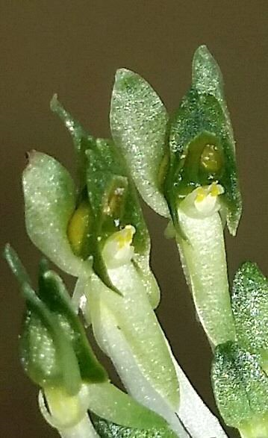
Malaxis excavata
Photography by Marcos Aurelio da Silva

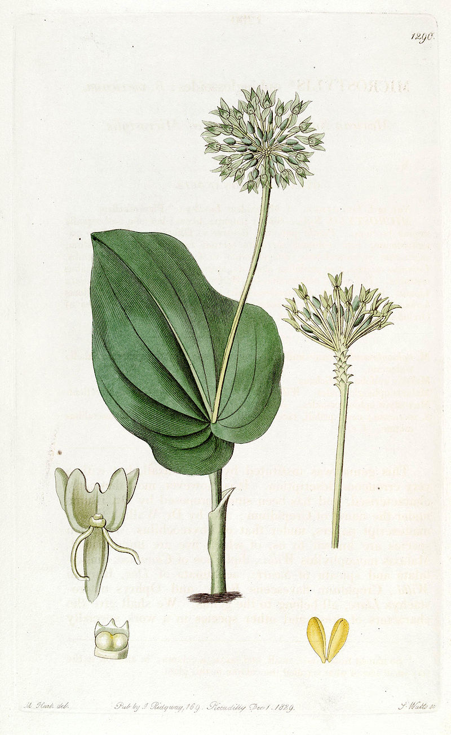
Malaxis umbelliflora
Photography of lithograph by unknown, Source Wikipedia
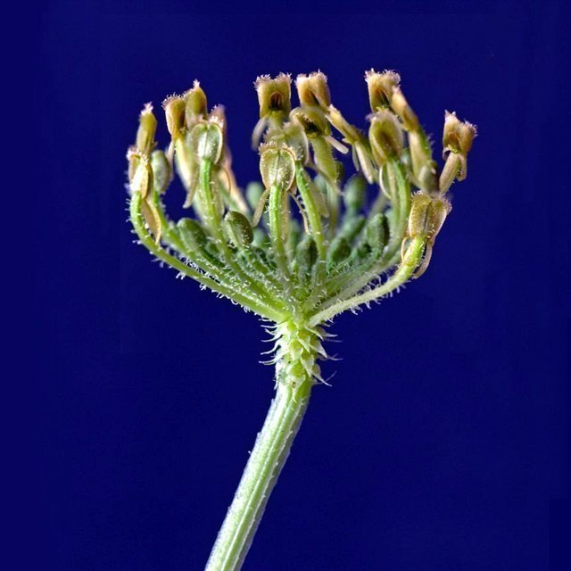
Malaxis quadrata
Photography by Jose Portilla

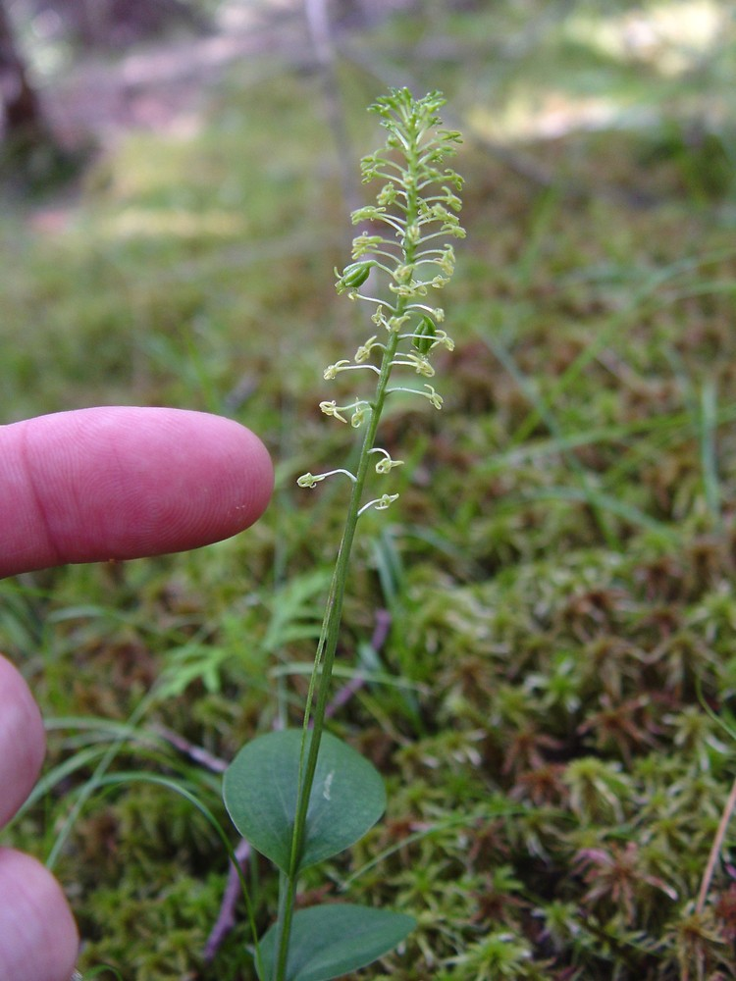
Malaxis unifolia
Photography by unknown, Source Go Botany

From data review in OrchidWiz, there are no registered hybrids of the genus Malaxis.

When reviewing data in OrchidWiz, there are a number of Malaxis species which have been recognized as a different genus. These genera include Crepidium, Liparis, Oberonia, Tamayorkis, Earina, Dienia, and Crossoglossa. It appears there is a need for a revision of the genus Malaxis.

Malaxis Cultural Information
Temperature: | Some withstand freezing but provide 60-65 degrees F (15-18 C) minimum night temperature for tropical species.
Light: | 2400-3600 footcandles
Water-Humidity: | 40-60% humidity. If the species has a dormant period, the plant should be kept moist while in growth and much drier after the plant loses its leaves. If the species does not lose its leaves, it should not become very dry.
Fertilizer: | Monthly, use 1-1-1 ratio or any balanced fertilizer.
Potting: | Any good terrestrial mix.
References: | Sheehan, Tom, and Marion; Orchid Genera Illustrated, a series started in 1967 and concluded in January 1999, published in the AOS Bulletin and Orchids; used with permission of the author.
Author: | Tom Sheehan – 8/2007

Depending on the species of Malaxis and the habitat location, species of Malaxis can be found in bloom year-round.
From data showing the type of American Orchid Society awards Malaxis species have received, American Orchid Society Judges have only awarded members of the Malaxis genus horticultural awards, not quality awards. Considering a Malaxis species for a quality award, I would use the general scale.

References
American Orchid Society. (n. d.). Malaxis. https://www.aos.org/orchids/orchids-a-to-z/letter-m/malaxis.aspx.
Ames, O., and C. Schweinfurth. (1935). Nomenclatural studies in Malaxis and Spiranthes. Botanical Museum Leaflets 3: 113–133Press, St. Louis.
Chen, X. and Wood, J. (2009). Malaxis Solander ex Swartz. Flora of China. 25: 8, 19, and 229. http://www.efloras.org/florataxon.aspx?flora_id=2&taxon_id=119529.
Govaerts, R. (2003). World Checklist of Monocotyledons Database in ACCESS: 1-71827. The Board of Trustees of the Royal Botanic Gardens, Kew.
Kew (n. d.). Malaxis https://powo.science.kew.org/taxon/urn:lsid:ipni.org:names:30005360-2
Pridgeon, A.M., Cribb, P.J., Chase, M.C. & Rasmussen, F.N. (2006). Epidendroideae (Part One). Genera Orchidacearum 4: 1-672. Oxford University Press, New York, Oxford.
OrchidWiz X9.0.
Wu, Z. & Hong, D. (eds.) (2009). Flora of China 25: 1-570. Missouri Botanical Garden.

