Class 706 Stanhopea Alliance Five Sample Descriptions

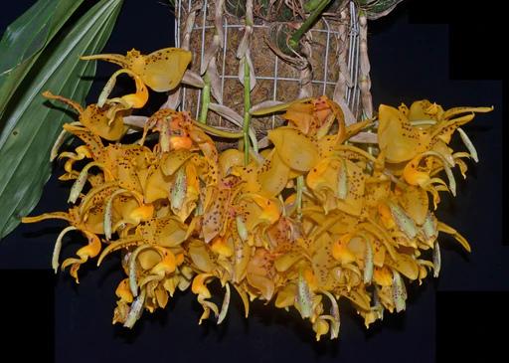

Stanhopea wardii, unnamed
Photography by Equagenera USA Corporation

Twenty-three flowers on six pendulous inflorescences; on x growth plant in a 25-cm wire basket of moss; sepals and petals golden yellow, spotted maroon; lip hypochile golden yellow overlaid orange, maroon spots, mesochile yellow, epichile yellow, fine maroon spots; column wings yellow, column cream, overlaid chartreuse distally, fine maroon spots, anther cap white; substance firm; texture waxy.

Awards: CCM/AOS, 83 points and AM/AOS, 82 points

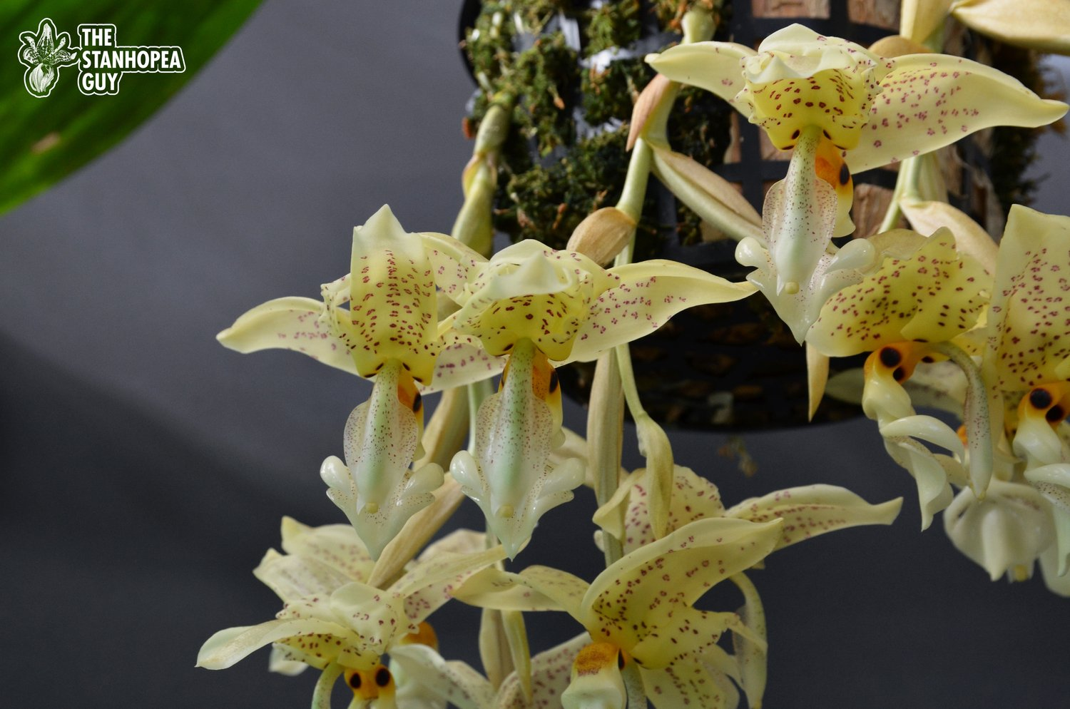

Stanhopea (Bellaerensis x ruckeri)
Photography by The Stanhopea Guy

Ten flowers and two buds on three pendulous inflorescences; sepals and petals cream overlaid yellow, spotted maroon; lip hypochile yellow overlaid orange, maroon eyes, mesochile cream lightly overlaid green, epichile white lightly overlaid green; column cream, overlaid green, finely spotted maroon, column wings cream, finely spotted maroon, anther cap white overlaid yellow; substance firm; texture waxy.

Award: AM/AOS, 84 points

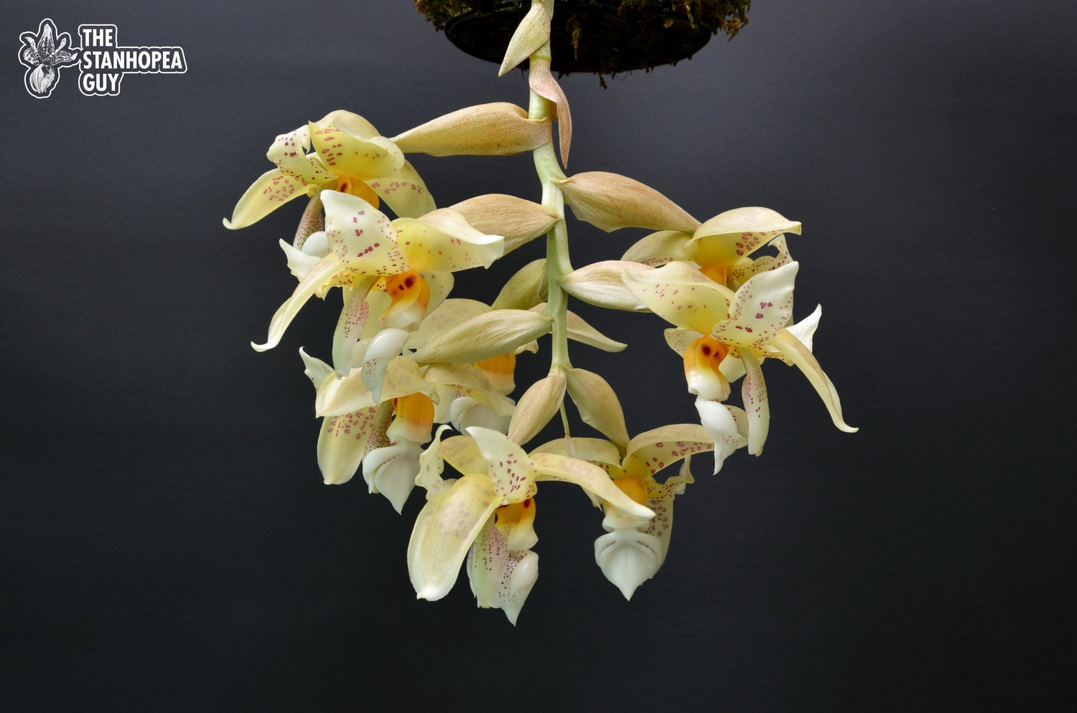

Stanhopea Herios du Mar
Photography by The Stanhopea Guy

Eight flowers on one pendulous inflorescence; sepals and petals cream overlaid yellow, spotted maroon; lip hypochile yellow overlaid orange, maroon eyes, mesochile white, epichile white; column white overlaid distally green, finely spotted maroon, anther cap white; substance firm; texture waxy.

Award: HCC/AOS, 76 points
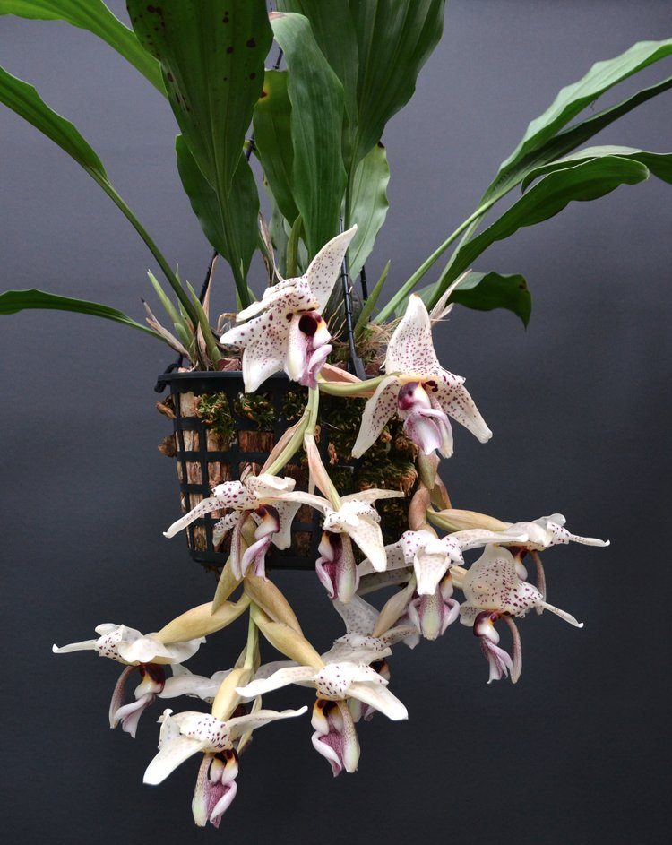
Stanhopea (ruckeri x martiana)
Photography by The Stanhopea Guy

Twelve flowers on two pendulous inflorescences; sepals and petals white, spotted plum; lip hypochile white, overlaid maroon distally, overlaid golden proximally, eyes maroon, mesochile white, epichile white finely spotted plum; column white, finely spotted plum, anther cap cream; substance firm; texture waxy.

Award: AM/AOS, 85 points

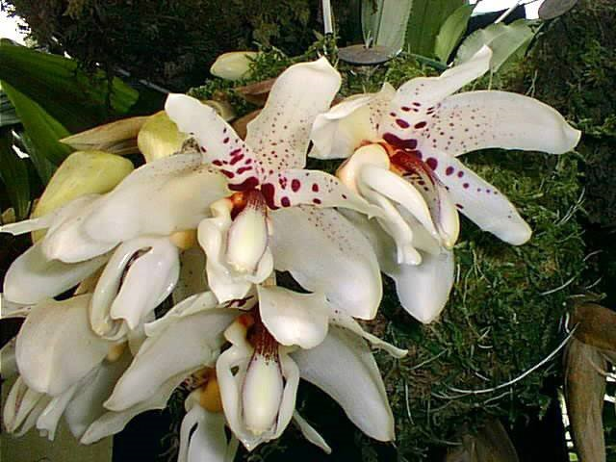

Stanhopea martiana
Photography by Nick Hartley

Six flowers and two buds on one inflorescence; Sepals white, finely spotted burgundy; petals white blotched burgundy basal two-thirds; lip hypochile yellow, overlaid burgundy, mesochile white, epichile white; column white, overlaid burgundy basally, burgundy striped lateral margins; substance firm; texture waxy.

Award: AM/AOS, 85 points

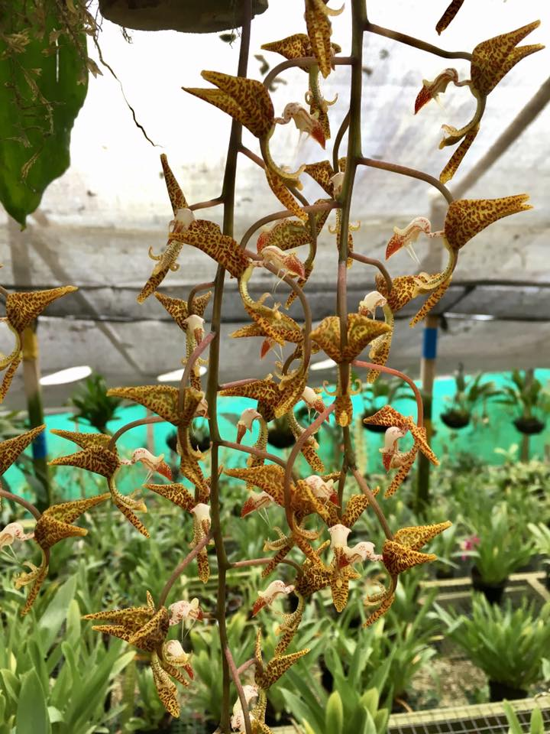
Gongora gratulabunda

Twenty-four flowers on three pendulous inflorescences to x cm; sepals and petals orange, spotted chestnut; lip white, spotted chestnut, epichile white, blush yellow, spotted chestnut; column chartreuse, spotted chestnut, anther cap ivory; substance firm, texture waxy.

Award: AM/AOS, 83 points

Common Award Descriptive Terms

- Hypochile – distal part of lip

- Mesochile – middle part of lip

- epichile – proximal part of lip

