GENUS SUMMARY
Coryanthes, Hook. (1831)
[ko-ree-AN-theez]

General Description
The AOS notes in nature, these orchids are encountered in so-called ant gardens. The symbiotic occurrences provides benefits for both; ants get nectar from extrafloral nectaries and can use the root ball for construction of their nests, the Coryanthes plant is protected and fertilized by the ants. The pollination biology is also very fascinating: trying to collect fragrance compounds below the upper part (hypochile) of the lip, the male euglossine bee falls in the liquid filled bucket of the apical part (epichile). It cannot escape flying because its wings are wet. The only way is to climb up an island (callus of lip) and to pass a tunnel formed by the tip of the lip and the column. Doing this the flower gets pollinated or glues the pollinarium on the bee. The whole passage is very hard for the bee and lasts about half an hour. The genus could be divided into two sections: Coryanthes with a smooth mesochile (middle part of the lip) and lamellunguis with warts or lamellae on it. Most species have pendulous inflorescences, some of them have upright ones. Coryanthes has the heaviest flowers in Orchidaceae, the biggest one Coryanthes bruchmuelleri have a weight of more than 100 grams.

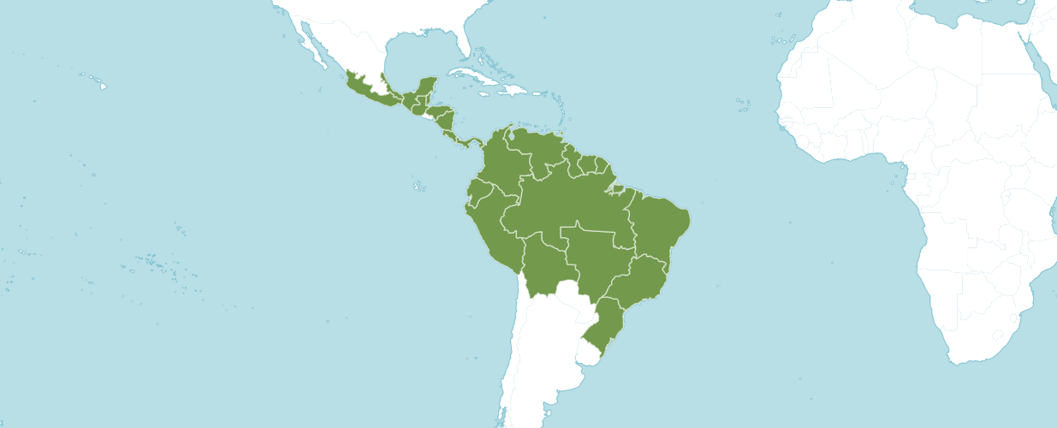

Distribution of Coryanthes, image from Royal Botanical Gardens Kew

Type Species: Coryanthes maculata

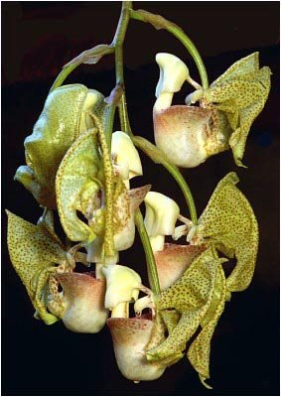

Coryanthes maculata, unawarded

Photography by Dr. F. Thomas Ott

Native to:

Coryanthes natural habitat is Belize, Bolivia, Brazil North, Brazil Northeast, Brazil South, Brazil Southeast, Brazil West-Central, Colombia, Costa Rica, Ecuador, French Guiana, Guatemala, Guyana, Honduras, Mexico Gulf, Mexico Southeast, Mexico Southwest, Nicaragua, Panamá, Peru, Suriname, Trinidad-Tobago, Venezuela Heterotypic

Synonyms

Heterotypic Synonyms

Meliclis Raf. in Fl. Tellur. 2: 99 (1837)

Panstrepis Raf. in Fl. Tellur. 4: 41 (1838)

Coryanthes Species

Coryanthes albertinae H. Karst.

Coryanthes alborosea C. Schweinf.
Coryanthes angelantha Archila

Coryanthes bahiensis Marçal & Chiron

Coryanthes bergoldii J. D. Kenn. ex Dodson

Coryanthes bicalcarata Schltr.

Coryanthes boyi Mansf.

Coryanthes bruchmuelleri Rchb.f.

Coryanthes bueraremensis Campacci & Bohnke

Coryanthes cataniapoensis G. A. Romero & Carnevali

Coryanthes cavalcantei M. F. Silva & A. T. Oliveira

Coryanthes charlesiana Marçal & Chiron

Coryanthes dasilvae F. Barros

Coryanthes elegantium Linden & Rchb.f.

Coryanthes elianae M. F. Silva & A. T. Oliveira

Coryanthes erectiscapa Marçal & Chiron

Coryanthes feildingii Lindl.

Coryanthes flava G. Gerlach

Coryanthes gerlachiana Senghas

Coryanthes gernotii G. Gerlach & G. A. Romero

Coryanthes gomezii G. A. Romero & G. Gerlach

Coryanthes gustavo-romeroi Archila

Coryanthes horichiana Jenny

Coryanthes hunteriana Schltr.

Coryanthes javieri Archila

Coryanthes jorgemarioi Archila

Coryanthes kaiseriana G. Gerlach

Coryanthes lacerdae Marçal & Chiron

Coryanthes lachuensis Archila

Coryanthes lafontainei G. Gerlach

Coryanthes lagunae Manara & Bergold

Coryanthes lanata Marçal & Chiron

Coryanthes leferenziorum G .Gerlach, Senghas & Seeger

Coryanthes leucocorys Rolfe

Coryanthes macrantha (Hook.) Hook.

Coryanthes macrocorys Rolfe

Coryanthes maculata Hook.

Coryanthes maduroana G. Gerlach

Coryanthes marcaliana Chiron

Coryanthes mastersiana F. Lehm.

Coryanthes melissae Archila

Coryanthes minima A. T. Oliveira & J. B. F. Silva

Coryanthes misasii G. A. Romero & G. Gerlach

Coryanthes miuaensis M. F. Silva & A. T. Oliveira

Coryanthes mystax G. Gerlach & J. B. F. Silva

Coryanthes oscarii Archila

Coryanthes oscarrodrigoi Archila

Coryanthes pacaraimensis Campacci & J. B. F. Silva

Coryanthes panamensis G. Gerlach

Coryanthes pegiae G. A. Romero

Coryanthes picturata Rchb.f.

Coryanthes pilosa Marçal & Chiron

Coryanthes recurvata Archila

Coryanthes schmidtii G. Gerlach

Coryanthes seegeri G. Gerlach

Coryanthes selbyana Archila

Coryanthes senghasiana G. Gerlach

Coryanthes speciosa Hook.

Coryanthes tefeensis Marçal, Chiron & G. Q. Freire

Coryanthes thivii Kropf & Seeger

Coryanthes toulemondiana G. Gerlach & T. Franke

Coryanthes tricuspidata G. Gerlach

Coryanthes trifoliata C. Schweinf.

Coryanthes vasquezii Dodson

Coryanthes velizii Archila

Coryanthes verrucolineata G. Gerlach

Coryanthes vieirae G. Gerlach

Coryanthes villegasiana Peláez

Coryanthes vinosa Sambin & Aucourd

Coryanthes wenzeliana G. Gerlach & J. B. F. Silva
Coryanthes Species Awards
 | FCC | AM | HCC | AQ | JC | CCM | CCE | CHM | CBM | CBR | TOTAL
albertinae | - | - | - | - | - | - | - | - | - | 1 | 1
alborosea | - | 1 | - | - | - | - | - | 1 | - | - | 2
angelantha | - | - | - | - | - | - | - | - | - | - | 0
bahiensis | - | - | - | - | - | - | - | - | - | - | 0
balfouriana,  ~bruchmuelleri | 1 | 2 | - | - | - | - | - | 1 | - | - | 4
barkeri ~maculata | - | - | - | - | - | - | - | - | - | - | 0
 | FCC | AM | HCC | AQ | JC | CCM | CCE | CHM | CBM | CBR | TOTAL
bergoldii | - | - | - | - | - | - | - | - | - | - | 0
bicalcarata | - | - | - | - | - | - | - | - | - | - | 0
biflora,  ~bruchmuelleri | 1 | 2 | - | - | - | - | - | 1 | - | - | 4
boyi | - | - | - | - | - | - | - | - | - | 1 | 1
bruchmuelleri | 1 | 2 | - | - | - | - | - | 1 | - | - | 4
bueraremensis | - | - | - | - | - | - | - | - | - | - | 0
bruchmuelleri | 1 | 2 | - | - | - | - | - | 1 | - | - | 4
cataniapoensis | - | - | - | - | - | - | - | - | - | - | 0
cavalcantei | - | - | - | - | - | - | - | - | - | - | 0
dasilvae | - | - | - | - | - | - | - | - | - | - | 0
elegantissima, ~elegantium | - | - | - | - | - | - | - | - | - | 1 | 1
elianae | - | - | - | - | - | - | - | - | - | - | 0
feildingii | - | - | - | - | - | - | - | - | - | - | 0
flava | - | - | - | - | - | - | - | - | - | - | 0
gerlachiana | - | - | - | - | - | - | - | - | - | - | 0
gernotii | - | - | - | - | - | - | - | - | - | 1 | 1
gomezii | - | - | - | - | - | - | - | - | - | - | 0
gustavo-romeroi | - | - | - | - | - | - | - | - | - | - | 0
horichiana | - | - | - | - | - | - | - | - | - | - | 0
hunteriana | - | - | - | - | - | - | - | - | - | - | 0
javieri | - | - | - | - | - | - | - | - | - | - | 0
jorgemarioi | - | - | - | - | - | - | - | - | - | - | 0
kaiseriana | - | - | - | - | - | - | - | - | - | - | 0
lachuensis | - | - | - | - | - | - | - | - | - | - | 0
lafontainei | - | - | - | - | - | - | - | - | - | - | 0
lagunae | - | - | - | - | - | - | - | - | - | - | 0
lanata | - | - | - | - | - | - | - | - | - | - | 0
leferenziorum | - | - | - | - | - | - | - | - | - | - | 0
leucocorys | - | 1 | - | - | - | - | - | - | - | 1 | 2
*macrantha | - | 8 | 4 | - | - | - | - | - | 1 |  | 13
macrocorys | - | 2 | - | - | - | - | - | 1 | - | - | 3
maculata | - | - | - | - | - | - | - | - | - | - | 0
maduroana | - | - | - | - | - | - | - | - | - | - | 0
marcaliana | - | - | - | - | - | - | - | - | - | - | 0
mastersiana | - | - | - | - | - | 2 | - | - | - | 1 | 3
melissae | - | - | - | - | - | - | - | - | - | - | 0
minima | - | - | - | - | - | - | - | - | - | - | 0
misasii | - | - | - | - | - | - | - | 1 | - | - | 1
miuaensis | - | - | - | - | - | - | - | - | - | - | 0
mystax | - | - | - | - | - | - | - | - | - | - | 0
orbiculate, ~rivularis | - | - | - | - | - | - | - | - | - | - | 0
oscarii | - | - | - | - | - | - | - | - | - | - | 0
oscarrodrigoi | - | - | - | - | - | - | - | - | - | - | 0
pacaraimensis | - | - | - | - | - | - | - | - | - | - | 0
panamensis | - | - | - | - | - | - | - | 1 | - | - | 1
parkeri, ~maculata | - | - | - | - | - | - | - | - | - | - | 0
pegiae | - | - | - | - | - | - | - | - | - | - | 0
picturata | - | - | 1 | - | - | - | - | - | - | - | 1
pilosa | - | - | - | - | - | - | - | - | - | - | 0
powellii, ~hunteriana | - | - | - | - | - | - | - | - | - | - | 0
 | FCC | AM | HCC | AQ | JC | CCM | CCE | CHM | CBM | CBR | TOTAL
punctata, ~speciosa | - | - | 2 | - | 1 | - | - | - | - | - | 3
recurvata | - | - | - | - | - | - | - | - | - | - | 0
rodriguesii,  ~bruchmuelleri | 1 | 2 | - | - | - | - | - | 1 | - | - | 4
rutkisii, ~boyi | - | - | - | - | - | - | - | - | - | 1 | 1
schmidtii | - | - | - | - | - | - | - | - | - | - | 0
seegeri | - | - | - | - | - | - | - | 1 | - | - | 1
selbyana | - | - | - | - | - | - | - | - | - | - | 0
senghasiana | - | 1 | - | - | - | - | - | 1 | - | - | 2
speciosa | - | - | 2 | - | 1 | - | - | - | - | - | 3
splendens, ~speciosa | - | - | 2 | - | 1 | - | - | - | - | - | 3
summeriana, ~speciosa | - | - | 2 | - | 1 | - | - | - | - | - | 3
thivii | - | - | - | - | - | - | - | - | - | - | 0
toulemondiana | - | - | - | - | - | - | - | - | - | - | 0
tricuspidate | - | - | - | - | - | - | - | - | - | - | 0
trifoliata | - | - | - | - | - | - | - | - | - | - | 0
vasquezii | - | - | - | - | - | - | - | 1 | - | - | 1
velizii | - | - | - | - | - | - | - | - | - | - | 0
verrucolineata | 1 | - | - | - | - | - | - | 1 | - | - | 2
vieirae | - | - | - | - | - | - | - | 1 | - | - | 1
villegasiana | - | - | - | - | - | - | - | - | - | - | 0
wenzeliana | - | - | - | - | - | - | - | - | - | - | 0
wolfii, ~ elegantium | - | - | - | - | - | - | - | - | - | 1 | 1

Coryanthes Species Offspring and Progeny
 | F1 Offspring | Progeny
albertinae | 2 | 2
alborosea | 1 | 1
angelantha | 0 | 0
bahiensis | 0 | 0
balfouriana,  ~bruchmuelleri | 3 | 4
barkeri ~maculata | 0 | 0
bergoldii | 0 | 0
bicalcarata | 0 | 0
biflora,  ~bruchmuelleri | 3 | 4
boyi | 0 | 0
bruchmuelleri | 3 | 4
bueraremensis | 0 | 0
bungerothii, ~bruchmeulleri | 3 | 4
cataniapoensis | 1 | 1
cavalcantei | 0 | 0
dasilvae | 0 | 0
elegantissima, ~elegantium | 2 | 2
elianae | 0 | 0
feildingii | 0 | 0
flava | 0 | 0
Coryanthes Species Offspring and Progeny
 | F1 Offspring | Progeny
gerlachiana | 0 | 0
gernotii | 0 | 0
gomezii | 0 | 0
gustavo-romeroi | 0 | 0
horichiana | 0 | 0
hunteriana | 1 | 1
javieri | 0 | 0
jorgemarioi | 0 | 0
kaiseriana | 0 | 0
lachuensis | 0 | 0
lafontainei | 0 | 0
lagunae | 0 | 0
lanata | 0 | 0
leferenziorum | 0 | 0
leucocorys | 2 | 2
*macrantha | 12 | 13
macrocorys | 1 | 2
maculata | 0 | 0
maduroana | 0 | 0
marcaliana | 0 | 0
mastersiana | 3 | 5
melissae | 0 | 0
minima | 0 | 0
misasii | 1 | 1
miuaensis | 0 | 0
mystax | 0 | 0
orbiculate, ~rivularis | 0 | 0
oscarii | 0 | 0
oscarrodrigoi | 0 | 0
pacaraimensis | 0 | 0
panamensis | 0 | 0
parkeri, ~maculata | 0 | 0
pegiae | 0 | 0
picturata | 2 | 2
pilosa | 0 | 0
powellii, ~hunteriana | 1 | 1
punctata, ~speciosa | 3 | 3
recurvata | 0 | 0
rodriguesii,  ~bruchmuelleri | 3 | 4
rutkisii, ~boyi | 0 | 0
schmidtii | 0 | 0
seegeri | 0 | 0
selbyana | 0 | 0
senghasiana | 0 | 0
speciosa | 3 | 3
splendens, ~speciosa | 3 | 3
summeriana, ~speciosa | 3 | 3
thivii | 0 | 0
toulemondiana | 0 | 0

 | F1 Offspring | Progeny
Tricuspidate | 0 | 0
trifoliata | 0 | 0
vasquezii | 0 | 0
velizii | 0 | 0
verrucolineata | 2 | 2
vieirae | 0 | 0
villegasiana | 0 | 0
wenzeliana | 0 | 0
wolfii, ~ elegantium | 2 | 2

Type Species: Coryanthes maculata
[mak-yoo-lah-ta]

Meaning: spotted
Common Name: the spotted Coryanthes

ORIGIN/HABITAT: Panama, Venezuela, the Guianas (Guayanas), and Brazil. In Panama, plants are found near Gatun and in the hills east of Panama City at near sea level. Plants in this region frequently are found in the tops of slender trees in ant's nests, often in association with Epidendrum imatophyllum. Williams and Allen ([1946-1949 1980) reported that these plants "seldom thrive in cultivation, possibly from lack of some essential element contributed by the ants in their natural association." -- Source: Charles Baker.

Coryanthes maculata has received zero AOS awards.

Coryanthes maculata has no registered offspring.
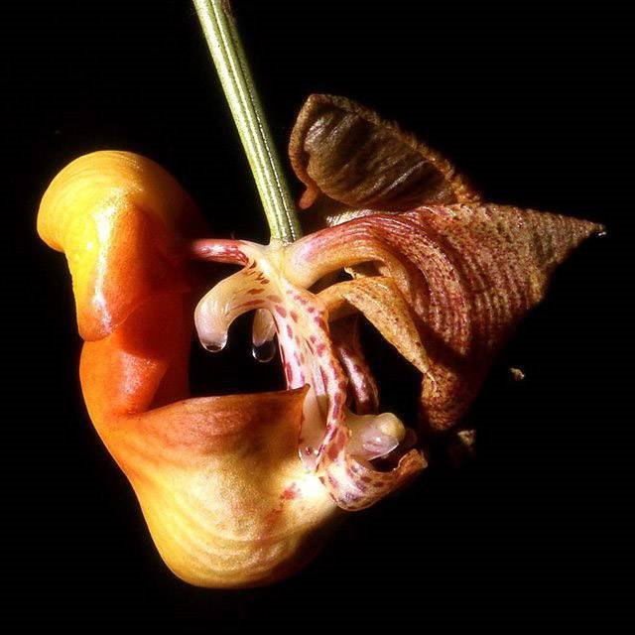
Coryanthes maculata, unawarded
Photography by OWZ Lib.

Coryanthes Species with the Most Offspring and AOS Awards: Coryanthes macrantha
[mak-ran-tha]

Meaning: large flowered
Common Name: The bucket orchid or monkey throat orchid in Trinidad
Synonyms:

Homotypic Synonyms
Gongora macrantha Hook. in Bot. Misc. 2: 151 (1831)

Heterotypic Synonyms
Panstrepis paradoxa Raf. in Fl. Tellur. 4: 41 (1838)

ORIGIN/HABITAT: Venezuela, Trinidad, British Guiana, Colombia, and Peru. In Peru, the plants have been found along the Rio Nanay near Iquitos in the Amazon Basin. In Venezuela, plants were found at about 1500 ft. (560 m) between the Icabaru and Uaiparu Rivers in the southeastern part of Bolivar Province. Plants were growing on trees in a fairly dense but not very tall forest. Some writers feel that the plants found in Peru may represent a separate species, but they have not been split out at this time. Specific habitat information was not given, but Coryanthes species are normally found growing in very acid conditions on the nests of ants. -- Source: Charles Baker r

Coryanthes macrantha has received thirteen AOS awards (CBM – 1; AM – 8; and HCC - 4).

Coryanthes macrantha has twelve first generation registered offspring. Of the twelve offspring four have received an AOS award. The first offspring was registered in 1995 and the last was registered in 2021.

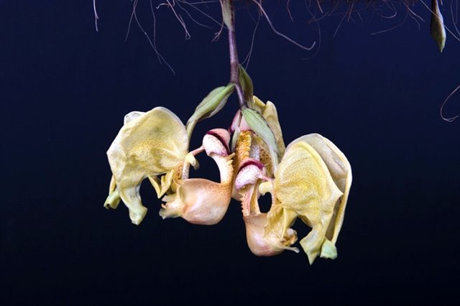
Coryanthes macrantha ‘Romelia’ AM/AOS, 85 points
Photography by Nicolas Gomez Rios

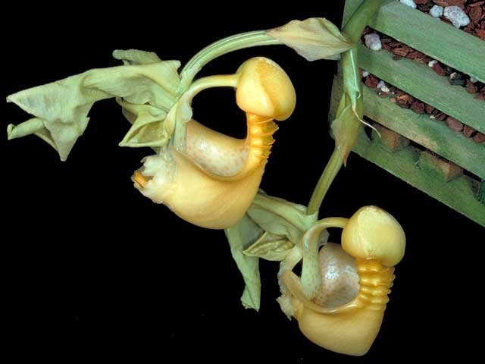
Coryanthes macrantha ‘Meri of Millwood’ HCC/AOS, 76 points
Photography by OWZ Lib

References

American Orchid Society. (n.d.). Coryanthes. Retrieved October 29, 2023, from https://www.aos.org/orchids/orchids-a-to-z/letter-c/coryanthes.aspx .

Bechtel, H., Cribb, P., and Launert, E. (1981). The manual of cultivated orchid species. Blandord Press. Dorset, England.

Govaerts, R. (1999). World Checklist of Seed Plants 3(1, 2a & 2b): 1-1532. MIM, Deurne.

Govaerts, R. (2003). World Checklist of Monocotyledons Database in ACCESS: 1-71827. The Board of Trustees of the Royal Botanic Gardens, Kew.

Hokche, O., Berry, P. and Huber, O. (eds.) (2008). Nuevo Catálogo de la Flora Vascular de Venezuela: 1-859. Fundación Instituto Botánico de Venezuela.
Jørgensen, P., Nee, M., and Beck., S. (eds.) (2013). Catálogo de las plantas vasculares de Bolivia. Monographs in Systematic Botany from the Missouri Botanical Garden 127: 1-1741. Missouri Botanical Garden.

Kew World Checklist of Selected Plant Families. (n.d.). Coryanthes. Retrieved October 29, 2023, from https://powo.science.kew.org/taxon/urn:lsid:ipni.org:names:624306-1.
OrchidPro.

OrchidWiz X9.0.

Pridgeon, A., Cribb, P., Chase, M., and Rasmussen, F. (2009). Epidendroideae (Part two). Genera Orchidacearum 5: 1-585. Oxford University Press, New York, Oxford.

