GENUS SUMMARY
Gongora, Ruiz & Pav. (1794)
[gon-GOR-a]

General Description
The AOS notes Gongora is an epiphytic genus of sympodial orchids that are usually found between 0 and 1000 meter in wet tropical forests. Pseudobulbs are ovoid, strongly ridged, with two-three plicate leaves. The pendulous inflorescences arise from the base of the pseudobulbs, are more than a meter long in some species, and bear many intricately shaped flowers. that are often scented. In general, Gongora’s are easy to grow into large and showy plants. This genus was named for Sr. Don Antonio Caballero y Gongora, Viceroy of New Granada (Colombia and Ecuador) and later Bishop of Cordoba; Governor of Peru during the Dombey, Ruiz & Pavon expeditions. The type species is Gongora quinquenervis, described by H. Ruiz & J. Pavon in 1794 in their Prodromus Florae Peruvianae et Chilensis

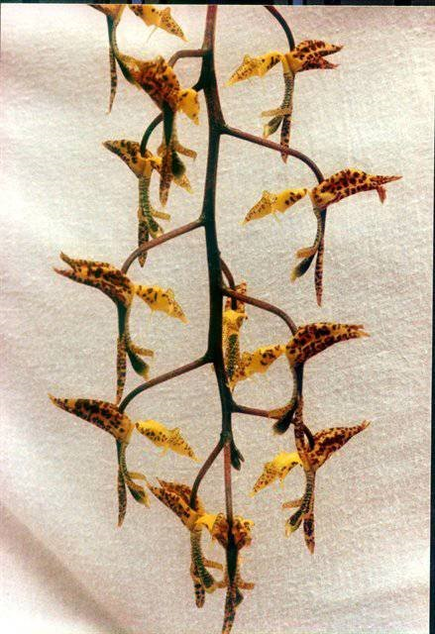
Gongora quinquenervis, unawarded
photography by Arne and Bent Larsen
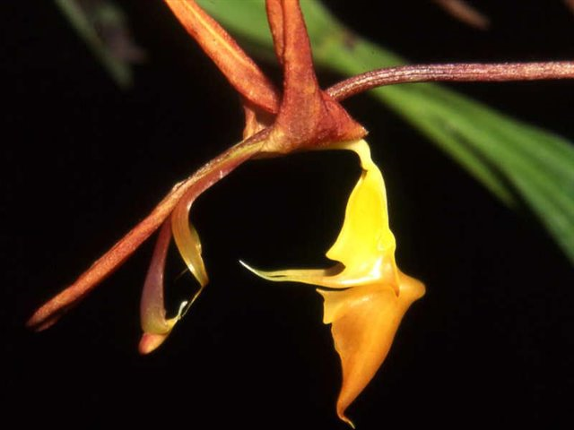
Gongora quinquenervis, unawarded
Photography by Pedro Ortiz Valdivieso

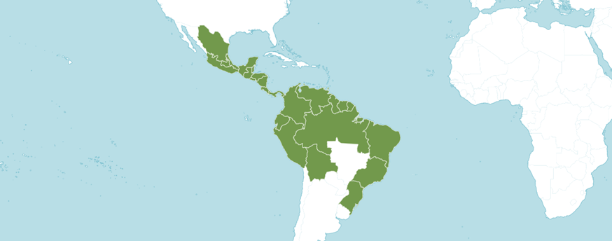

Distribution of Gongora image from Royal Botanical Gardens Kew

Type Species: Gongora quinquenervis

Native to:

Belize, Bolivia, Brazil North, Brazil Northeast, Brazil South, Brazil Southeast, Colombia, Costa Rica, Ecuador, El Salvador, French Guiana, Guatemala, Guyana, Honduras, Mexico Central, Mexico Gulf, Mexico Northeast, Mexico Southeast, Mexico Southwest, Nicaragua, Panamá, Peru, Suriname, Trinidad-Tobago, Venezuela

Heterotypic Synonyms

Acropera Lindl. in Gen. Sp. Orchid. Pl.: 172 (1833)

Gongora Species

Gongora aceras Dressler

Gongora alfieana R. Rice

Gongora amparoana Schltr.

Gongora arcuata G. Gerlach & Toulem.

Gongora armeniaca (Lindl.) Rchb.f.

Gongora aromatica Rchb.f.

Gongora atropurpurea Hook.

Gongora batemanni (Lindl.) Henshall ex Mabb. & Jenny

Gongora bayeri Jenny

Gongora boracayanensis Jenny, Dalström & W. E. Higgins

Gongora bufonia Lindl.

Gongora catalanoi Sambin & Aucourd

Gongora catilligera R. Rice

Gongora charontis Rchb.f.

Gongora chocoensis Jenny

Gongora claviodora Dressler

Gongora cruciformis Whitten & D. E. Benn.

Gongora cymbiformis Lindl.

Gongora erecta Whitten & D. E. Benn.

Gongora escobariana Whitten

Gongora fulva Lindl.

Gongora galeata (Lindl. ex Bosse) Rchb.f.

Gongora galeottiana A. Rich.

Gongora gibba Dressler

Gongora glicensteiniana Jenny

Gongora gratulabunda Rchb.f.

Gongora grossa Rchb.f.

Gongora hirtzii Dodson & N. H. Williams

Gongora histrionica Rchb.f.

Gongora hookeri (Klotzsch & H.Karst.) R. Rice

Gongora horichiana Fowlie

Gongora ileneana G. Gerlach & Heider

Gongora ilensis Whitten & Jenny

Gongora ionodesme G. Gerlach

Gongora irmgardiae Jenny

Gongora jauariensis Campacci & J.B . F. Silva

Gongora javieri Archila

Gongora jennyi Sambin & Aucourd

Gongora juruaensis Campacci & J. B. F. Silva

Gongora lagunae G. Gerlach

Gongora latibasis (C. Schweinf. & P. H. Allen) Jenny

Gongora latisepala Rolfe

Gongora leucochila Lem.

Gongora lilianeae Sambin & Doekoe

Gongora longiracemosa G. Gerlach & J. B. F. Silva

Gongora maculata Lindl.

Gongora meneziana V. P. Castro & G. Gerlach

Gongora minax Rchb.f.

Gongora nigrita Lindl.

Gongora odoratissima Lem.

Gongora oscarrodrigoi Archila, Szlach. & Chiron

Gongora pardina Jenny

Gongora passiflorolens R. Rice

Gongora pleiochroma Rchb.f.

Gongora portentosa Linden & Rchb.f.

Gongora powellii Schltr.

Gongora quinquenervis Ruiz & Pav.

Gongora retrorsa Rchb.f.

Gongora rubescens R .Rice

Gongora rufescens Jenny

Gongora rutkowskiana (Archila, Szlach. & Chiron) J. M. H. Shaw

Gongora saccata Rchb.f.

Gongora sanderiana Kraenzl.

Gongora scaphephorus Rchb.f. & Warsz.

Gongora seideliana Rchb.f.

Gongora sphaerica Jenny

Gongora superflua Rchb.f.

Gongora tracyana Rolfe

Gongora tridentata Whitten

Gongora truncata Lindl.

Gongora unicolor Schltr.

Gongora vitorinoana Chiron & L. C. Menezes

Taxonomy:

This genus was recently surveyed by Rudolf Jenny in Caesiana 20 (2003). See the reviews of his 1993 monograph. Rod Rice (2002) organizes the genus Gongora as follows:

Subgenus Gongora

Section Aceras with four species

Section Gongora with about 30-33 species [atropurpurea, catilligera, latisepala, odoratissima, rufescens]

Section Gratulabunda with four species

Section Grossa with five species

Section Truncata with nine species [charontis, dressleri, longipes, tracyana]

Subgenus Portentosa
one section with at least five species [escobariana, garayana, portentosa, sanderiana]

Subgenus Acropera

Section Acropera with one species

Section Armeniaca with two species and one to two subspecies

Section Cassidea with four species [amparoana, cassidea, galeata, tridentata]

Gongora Species Awards
 | FCC | AM | HCC | AQ | JC | CCM | CCE | CHM | CBM | CBR | TOTAL
acrea | - | - | - | - | - | - | - | - | - | - | 0
alfieana | - | - | - | - | - | - | - | - | - | - | 0
amparoana | - | - | - | - | - | - | - | - | - | - | 0
 | FCC | AM | HCC | AQ | JC | CCM | CCE | CHM | CBM | CBR | TOTAL
arcuata | - | - | - | - | - | - | - | 1 | - | - | 1
armeniaca | - | - | - | - | - | - | - | 1 | - | - | 1
aromatica | - | - | 1 | - | 1 | 1 | - | - | - | - | 3
atropurpurea | - | - | - | - | - | 1 | - | - | - | 1 | 2
aurantiaca | - | - | - | - | - | - | - | - | - | - | 0
batemanii | - | - | - | - | - | - | - | - | - | - | 0
batemanni | - | - | - | - | - | 1 | - | 1 | - | 2 | 4
bayeri | - | - | - | - | - | - | - | - | - | - | 0
bayrodtiana,  ~ scaphephorus | - | 2 | 2 | - | - | 3 | 1 | - | - | - | 8
boothiana, ~maculata | - | 1 | - | - | 1 | 2 | - | 1 | 1 | - | 6
boracayanensis | - | - | - | - | - | - | - | - | - | - | 0
bufonia | - | - | - | - | - | - | - | - | - | 1 | 1
cassidea, ~batemanni | - | - | - | - | - | 1 | - | 1 | - | 2 | 4
catilligera | - | - | - | - | - | - | - | - | - | - | 0
charlesworthii,  ~scaphephorus | - | 2 | 2 | - | - | 3 | 1 | - | - | - | 8
charontis | - | - | - | - | - | - | - | - | - | 1 | 1
chocoensis | - | - | 1 | - | - | - | - | 1 | - | - | 2
clavidora | - | - | - | - | - | - | - | - | - | 1 | 1
claviodora | - | - | - | - | - | - | - | - | - | 1 | 1
colombiana, ~aceras | - | - | - | - | - | - | - | - | - | - | 0
cornuta, ~ armeniaca | - | - | - | - | - | - | - | 1 | - | - | 1
cruciformis | - | - | - | - | - | - | - | - | - | - | 0
donckelaariana,  ~truncata | - | - | - | - | - | 1 | - | - | 1 | - | 2
dressleri, ~tracyana | - | - | - | - | - | - | - | - | 1 | 1 | 2
dylaniana, ~ charontis | - | - | - | - | - | - | - | - | - | 1 | 1
ecornuta, ~portentosa | - | - | 1 | - | - | - | - | 2 | - | - | 3
erecta | - | - | - | - | - | - | - | 1 | - | 1 | 2
escobariana | - | 5 | 1 | - | - | - | - | 1 | - | - | 7
flaveola, ~gratulabunda | - | 1 | 2 | - | - | - | - | 2 | - | 2 | 7
*fulva | - | 5 | 2 | - | - | 2 | 1 | 4 | - | - | 14
fuscata, ~galeata | - | - | - | - | - | 3 | 1 | 1 | 1 | 1 | 7
galeata | - | - | - | - | - | 3 | 1 | 1 | 1 | 1 | 7
galeottiana | - | - | - | - | - | - | - | 2 | - | - | 2
garayana,  ~escobariana | - | 5 | 1 | - | - | - | - | 1 | - | - | 7
gibba | - | - | - | - | - | - | - | 1 | - | 1 | 2
glicensteiniana | - | - | - | - | - | - | - | - | - | - | 0
gracilis, ~pleiochroma | - | - | 1 | - | - | - | - | 3 | - | 1 | 5
gratulabunda | - | 1 | 2 | - | - | - | - | 2 | - | 2 | 7
grossa | - | - | 1 | - | - | - | - | 1 | - | - | 2
heisteri,~atropurpurea | - | - | - | - | - | - | - | 1 | - | 1 | 2
hennisiana,  ~gratulabunda | - | 1 | 2 | - | - | - | - | 2 | - | 2 | 7
*herrenhusana, ~ fulva | - | 5 | 2 | - | - | 2 | 1 | 4 | - | - | 14
hirtzii | - | - | - | - | - | - | - | 1 | - | - | 1
histrionica | - | - | - | - | - | 1 | - | - | - | 1 | 2
hookeri | - | - | - | - | - | - | - | - | - | - | 0
horichiana | - | - | - | - | - | - | - | 3 | - | 1 | 4
Gongora Species Awards continued
 | FCC | AM | HCC | AQ | JC | CCM | CCE | CHM | CBM | CBR | TOTAL
ileneana | - | - | - | - | - | - | - | - | - | - | 0
ilense | - | - | - | - | - | - | - | - | - | 1 | 1
incarum,  ~scaphephorus | - | 2 | 2 | - | - | 3 | 1 | - | - | - | 8
ionodesme | - | - | - | - | - | - | - | - | - | - | 0
irmgardiae | - | - | - | - | - | - | - | 1 | - | - | 1
irrorate, ~bufonia | - | - | - | -- | - | - | - | - | - | 1 | 1
jauariensis | - | - | - | - | - | - | - | - | - | - | 0
javieri | - | - | - | - | - | - | - | - | - | - | 0
jenischii, ~maculata | - | 1 | - | - | 1 | 2 | - | 1 | 1 | - | 6
juruaensis | - | - | - | - | - | - | - | - | - | - | 0
lagunae | - | - | - | - | - | - | - | - | - | - | 0
latibasis | - | - | - | - | - | 1 | - | 2 | - | - | 3
latisepala | - | - | - | - | - | - | - | - | - | - | 0
leucochila | - | 1 | 1 | - | - | - | 1 | 2 | 1 | - | 6
lilianae | - | - | - | - | - | - | - | - | - | - | 0
lilianeae | - | - | - | - | - | - | - | - | - | - | 0
longipes,  ~scaphephorus | - | 2 | 1 | - | - | 3 | 1 | - | - | - | 7
luteola, ~ galeottiana | - | - | - | - | - | - | - | 2 | - | - | 2
*macrantha | - | 8 | 4 | - | - | - | - | - | 1 | - | 15
maculata | - | 1 | - | - | 1 | 2 | - | 1 | 1 | - | 6
meneziana | - | - | - | - | - | - | - | - | - | - | 0
minax | - | - | - | - | - | - | - | - | - | - | 0
napoensis, ~aceras | - | - | - | - | - | - | - | - | - | - | 0
nigrita | - | - | - | - | - | - | - | - | - | - | 0
nigropunctata,  ~grossa | - | - | 1 | - | - | - | - | 1 | - | - | 2
odoratissima | - | - | - | - | - | 1 | - | 1 | - | - | 2
oscarrodrigoi | - | - | - | - | - | - | - | - | - | - | 0
pardina | - | - | - | - | - | - | - | - | - | 1 | 1
passiflorolens | - | - | - | - | - | - | - | - | - | - | 0
pleiochroma | - | - | 1 | - | - | - | - | 3 | - | 1 | 5
portentosa | - | - | 1 | - | - | - | - | 2 | - | - | 3
powellii | - | - | - | - | - | - | - | - | - | 1 | 1
pseudoatropurpurea,  ~ atropurpurea | - | - | - | - | - | 1 | - | - | - | 1 | 2
quadricornis,  ~maculata | - | 1 | - | - | 1 | 2 | - | 1 | 1 | - | 6
quinquenervis | - | 1 | - | - | - | 2 | - | - | 1 | - | 4
retrorsa | - | - | - | - | - | - | - | - | - | - | 0
rosea, ~portentosa | - | - | 1 | - | - | - | - | 2 | - | - | 3
rubescens | - | - | - | - | - | - | - | - | - | - | 0
rufescens | - | 1 | 1 | - | - | - | - | 2 | - | - | 4
rutkowskiana | - | - | - | - | - | - | - | - | - | - | 0
saccata | - | - | - | - | - | - | - | - | - | - | 0
sanderiana | - | - | - | - | - | - | - | - | 1 | - | 1
scaphephorus | - | 2 | 2 | - | - | 3 | 1 | - | - | - | 8

Gongora Species Awards continued
 | FCC | AM | HCC | AQ | JC | CCM | CCE | CHM | CBM | CBR | TOTAL
scaphephorus,  ~scaphephorus | - | 2 | 2 | - | - | 3 | 1 | - | - | - | 8
seideliana | - | - | - | - | - | - | - | - | - | - | 0
shepherdii,  ~maculata | - | 1 | - | - | 1 | 2 | - | 1 | 1 | - | 6
similis, ~gratulabunda | - | 1 | 2 | - | - | - | - | 2 | - | 2 | 7
speciosa | - | - | 2 | - | 1 | - | - | - | - | - | 3
sphaerica | - | - | - | - | - | - | - | 1 | - | - | 1
stenoglassa,  ~galeottiana | - | - | - | - | - | - | - | 2 | - | - | 2
superflua | - | - | - | - | - | - | - | - | - | 1 | 1
tracyana | - | - | - | - | - | - | - | - | 1 | 1 | 2
*tricolor, ~ fulva | - | 5 | 2 | - | - | 2 | 1 | 4 | - | - | 14
tridentata | - | - | - | - | - | - | - | - | - | - | 0
truncata | - | - | - | - | - | 1 | - | - | 1 | - | 2
unicolor | - | 1 | - | - | 1 | 1 | - | 1 | - | 1 | 5
viridipurpurea,  ~dependens | - | - | - | - | - | - | - | - | 2 | - | 2
vitellina, ~galeottiana | - | - | - | - | - | - | - | 2 | - | - | 2
vitorinoana | - | - | - | - | - | - | - | - | - | - | 0

Gongora Species Offspring and Progeny
 | F1 Offspring | Progeny
acrea | 1 | 1
alfieana | 0 | 0
amparoana | 0 | 0
arcuata | 0 | 0
armeniaca | 2 | 2
aromatica | 0 | 0
atropurpurea | 4 | 5
aurantiaca | 0 | 0
batemanii | 0 | 0
batemanni | 3 | 4
bayeri | 0 | 0
bayrodtiana,  ~scaphephorus | 1 | 1
boothiana, ~maculata | 2 | 2
boracayanensis | 2 | 2
bufonia | 1 | 1
cassidea, ~batemanni | 3 | 4
catilligera | 0 | 0
charlesworthii,  ~scaphephorus | 1 | 1
charontis | 0 | 0
chocoensis | 7 | 8
clavidora | 2 | 2
claviodora | 2 | 2
Gongora Species Offspring and Progeny
 | F1 Offspring | Progeny
colombiana, ~aceras | 1 | 1
cornuta, ~armeniaca | 2 | 2
cruciformis | 0 | 0
donckelaariana,  ~truncata | 10 | 11
dressleri, ~tracyana | 1 | 1
dylaniana, ~charontis | 0 | 0
ecornuta, ~portentosa | 4 | 3
erecta | 0 | 0
escobariana | 0 | 0
flaveola, ~gratulabunda | 8 | 9
fulva | 6 | 7
fuscata, ~galeata | 11 | 14
galeata | 11 | 14
galeottiana | 0 | 0
garayana,  ~escobariana | 0 | 0
gibba | 0 | 0
glicensteiniana | 0 | 0
gracilis, ~pleiochroma | 2 | 3
gratulabunda | 8 | 9
grossa | 6 | 6
heisteri,~atropurpurea | 4 | 5
hennisiana,  ~gratulabunda | 8 | 9
herrenhusana, ~fulva | 6 | 7
hirtzii | 0 | 0
histrionica | 2 | 2
hookeri | 0 | 0
horichiana | 5 | 5
ileneana | 0 | 0
ilense | 2 | 2
incarum,  ~scaphephorus | 1 | 1
ionodesme | 0 | 0
irmgardiae | 0 | 0
irrorate, ~bufonia | 1 | 1
jauariensis | 0 | 0
javieri | 0 | 0
jenischii, ~maculata | 2 | 2
juruaensis | 0 | 0
lagunae | 0 | 0
latibasis | 2 | 2
latisepala | 0 | 0
leucochila | 5 | 5
lilianae | 0 | 0
lilianeae | 1 | 1
longipes,  ~scaphephorus | 1 | 1
luteola, ~galeottiana | 0 | 0
Gongora Species Offspring and Progeny
macrantha | 12 | 13
maculata | 2 | 2
meneziana | 0 | 0
minax | 0 | 0
napoensis, ~aceras | 1 | 1
nigrita | 0 | 0
nigropunctata,  ~grossa | 6 | 6
odoratissima | 1 | 1
oscarrodrigoi | 0 | 0
pardina | 0 | 0
passiflorolens | 0 | 0
pleiochroma | 2 | 2
portentosa | 4 | 3
powellii | 0 | 0
pseudoatropurpurea,  ~atropurpurea | 4 | 5
quadricornis,  ~maculata | 2 | 2
quinquenervis, ~quinquenervis | 5 | 8
retrorsa | 0 | 0
rosea, ~portentosa | 4 | 3
rubescens | 0 | 0
rufescens | 3 | 3
rutkowskiana | 0 | 0
saccata | 1 | 1
sanderiana | 0 | 0
scaphephorus, ~scaphophorus | 1 | 1
seideliana | 0 | 0
shepherdii,  ~maculata | 2 | 2
similis, ~gratulabunda | 8 | 9
speciosa | 3 | 3
sphaerica | 1 | 1
stenoglassa,  ~galeottiana | 0 | 0
superflua | 0 | 0
tracyana | 1 | 1
tricolor, ~fulva | 6 | 7
tridentata | 0 | 0
truncata | 10 | 11
unicolor | 1 | 1
viridipurpurea,  ~dependens | 2 | 2
vitellina, ~galeottiana | 0 | 0
vitorinoana | 0 | 0

Type Species: Gongora quinquenervis
[Kin-kew-NER-viss]

Meaning: having five nerves or veins
Common Name: having five-line Gongora

ORIGIN/HABITAT: Peru. The type specimen was collected on the eastern slopes of the Andes near Pozuzo, Peru, which is about 35 mi. (56 km) east of Huanuco and 70 mi. (113 km) south of Tingo Maria. Plants were growing at 3950-5900 ft. (1200-1800 m). Note: The preceding is the habitat of the type specimen. -- Source: Charles Baker

Gongora quinquenervis has received four AOS awards (CBM - 1; CCM – 2; and AM – 1).

Gongora quinquenervis has five first generation registered offspring. Of the five offspring only one has received an AOS award. The first offspring was registered in 1993 and the last was registered in 2004.

Gongora Species with the Most Awards: Gongora fulva
[Full-va]

Meaning: twanny, brown-yellow, reddish-yellow
Common Name: The brown-yellow Gongora
Synonyms: Gga. tricolor, Gga. Herrenhusana, and Gga. maculata var. tricolor

ORIGIN/HABITAT: Panama and Colombia. In Panama, plants are found from near sea level to 2150 ft. (650 m), while plants in Colombia have been collected at elevations up to 3950 ft. (1200 m). In Panama, plants have been found in the Mojinga Swamp near the mouth of the Rio Chagres and in the foothills east of Panama City at near sea level, near Colon in forests along the Rio Boqueron at about 300 ft. (90 m), and in El Valle de Anton at 1800 ft. (550 m). Plants always grow in places with no direct sun. -- Source: Charles Baker

Gongora fulva has received fourteen AOS awards (CCE - 1; CCM – 2; CHM – 4; AM – 5; HCC - 2).

Gongora fulva has six first generation registered offspring. Of the six offspring five have received an AOS award. The first offspring was registered in 2003 and the last was registered in 2019.

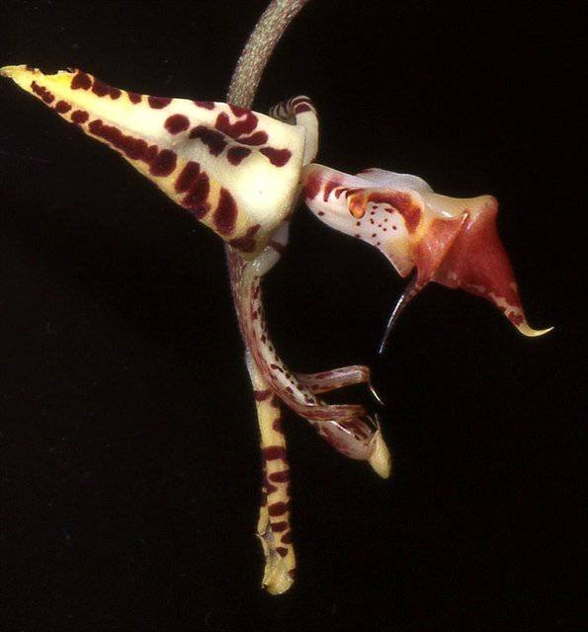
Gongora fulva, unawarded
Photography by OWZ Lib

Gongora Species with the Most Offspring and Progeny #2: Gongora galeata
[gal-EE-AH-ta]

Meaning: helmut shaped
Common Name: The helmut Gongora
Synonyms: Gga. fuscata

ORIGIN/HABITAT: Endemic to southern Mexico. Plants are found mainly on the slopes facing the Gulf of Mexico in the States of Hidalgo, Veracruz, Puebla, Oaxaca, and Chiapas. They are also found on the Pacific slopes in Chiapas. Plants usually grow as epiphytes in mountain rainforests and cloud forests at 1950-5900 ft. (600-1800 m), but they are occasionally found as lithophytes and terrestrials. -- Source: Charles Baker

Gongora galeata has received seven AOS awards (CCE - 1; CCM – 3; CHM – 1; CBM – 1; CBR - 1).

Gongora galeata has eleven first generation registered offspring. Of the eleven offspring two have received an AOS award. The first offspring was registered in 1997 and the last was registered in 2022.

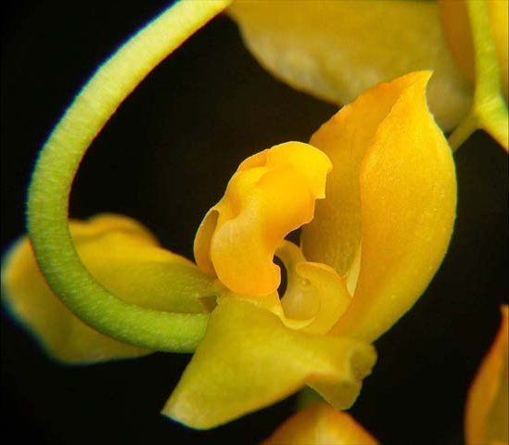
Gongora galeate f. flava, unawarded
Photography by Roman Maruska
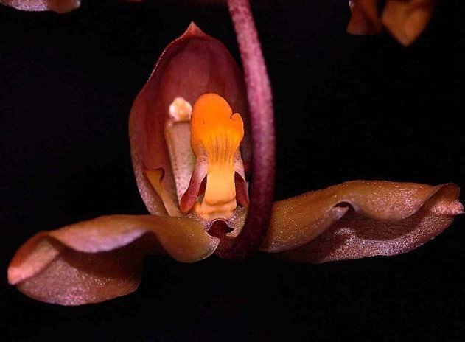
Gongora galeate, unawarded
Photography by Roman Maruska

Gongora Species with the Most Offspring and Progeny #1: Gongora macrantha
[mac-ran-tha]

Meaning: large flowered
Common Name: The bucket orchid or the monkey throat orchid in Trinidad.
Synonyms: not applicable

ORIGIN/HABITAT: Venezuela, Trinidad, British Guiana, Colombia, and Peru. In Peru, the plants have been found along the Rio Nanay near Iquitos in the Amazon Basin. In Venezuela, plants were found at about 1500 ft. (560 m) between the Icabaru and Uaiparu Rivers in the southeastern part of Bolivar Province. Plants were growing on trees in a fairly dense but not very tall forest. Some writers feel that the plants found in Peru may represent a separate species, but they have not been split out at this time. Specific habitat information was not given, but Coryanthes species are normally found growing in very acid conditions on the nests of ants. -- Source: Charles Baker

Gongora macrantha has received seven AOS awards (CHM – 1; AM – 8; HCC - 4).

Gongora macrantha has twelve first generation registered offspring. Of the twelve offspring four have received an AOS award. The first offspring was registered in 1995 and the last was registered in 2021.

References

American Orchid Society. (n.d.). Gongora. Retrieved October 25, 2023, from https://www.aos.org/orchids/collectors-items/gongora.aspx

Govaerts, R. (2003). World Checklist of Monocotyledons Database in ACCESS: 1-71827. The Board of Trustees of the Royal Botanic Gardens, Kew.

Pridgeon, A.M., Cribb, P.J., Chase, M.C. & Rasmussen, F.N. (2009). Epidendroideae (Part two). Genera Orchidacearum 5: 1-585. Oxford University Press, New York, Oxford.

Pridgeon, A.M., Cribb, P.J., Chase, M.C. & Rasmussen, F.N. (2014). Genera Orchidacearum 6: 1-544. Oxford University Press, New York, Oxford.Kew (n.d.).

Gongora. Royal Botanical Gardens Kew: Plants of the World Online.
Retrieved October 25, 2023, from https://powo.science.kew.org/taxon/urn:lsid:ipni.org:names:30005838-2

OrchidPro.

OrchidWiz X9.0.

From the American Orchid Society

The Genus Gongora

Rudolf Jenny, PhD, offers an introduction to this interesting genus Of Neotropical Orchids.

The history of the first-known Gongora species — Gongora quinquenervis Ruiz and Pavon — coincides with its first truly scientific treatment in Flora of Peru by Hipolito Ruiz Lopez, Antonio Pavon y Chimenez and Joseph Dombey during the last quarter of the 18th century. The incentive to start the scientific exploration of the territories that belonged to the Spanish properties in South America in those days (Peru and large parts of what are now Bolivia, Chile, Argentina, and Ecuador) did not come from the Spaniards themselves, but from the French. Indeed, it was A.R.J. Turgot, prime minister of Louis XVI, who, in 1775, decided to launch a scientific expedition to Peru to replace the lost collections of Joseph de Jussieu. De Jussieu himself recommended Joseph Dombey, a botanist and medical doctor who had been one of Joseph de Jussieu's brother Bernard's students, as tentative expedition leader. However, Spain, at the time ruled by Charles III, uncle of Louis XVI, would only agree to the expedition on a number of special conditions. Dombey was to be accompanied by two Spanish scientists, and the overall command had to remain in Spanish hands. Dombey had to agree to turn all herbarium materials that were to be collected during the expedition to the botanical gardens in Madrid. Of each collected object, three herbarium specimens had to be made. Dombey was to receive one of them, but only after examination in Madrid. Furthermore, he had to agree to supplement those materials of which only one herbarium specimen could be made by botanical drawings and descriptions, which, of course, had to be deposited in Madrid.

The Spanish government chose two pharmacists, Ruiz and Pavon, neither of whom had any training in botany, and two artists to accompany Dombey. Ruiz, junior to Dombey by 12 years was appointed commander. Upon arrival in Peru, Dombey had to obtain and pay for his equipment himself, whereas Ruiz and Pavon got the full support of the Spanish administration. Furthermore, as the Spanish artists refused to make any drawing for Dombey, he had no choice but to illustrate all his materials himself.

The Journey Begins
The expedition left Europe in October 1777 and reached Lima in April 1778. In the same year, Dombey sent a first, small collection to Europe, and in March 1779, a large collection followed. The ship transporting this large collection, however, was captured by the English (at the time at war with France and Spain) and the materials were auctioned off in Lisbon. Spanish representatives purchased the entire collection as well as a number of Dombey's personal belongings. Originally, the expedition was to last four years, but the continuing war made a scheduled return impossible. Finally, on April 4, 1784, Dombey left Peru by himself and, after a delay of several months in Rio de Janeiro, reached Cadiz on February 22, 1785, with his part of the collections.

The materials that were to be turned over to the Spaniards remained in Lima and were shipped together with the collections of Ruiz and Pavon to Spain in 1785. The ship carrying these materials was lost off Portugal with all collections on board. The only materials from the expedition that were left, therefore, were what was brought home by Dombey himself. That material was retained by the Spaniards. At the end, Dombey obtained only one third of "his" materials and had to agree to publish nothing, nor to de-scribe any plants before the return of Ruiz and Pavon. Of course, the Spaniards carefully copied all Dombey's notes and descriptions. At last, Dombey reached Paris with the poor remnants of his collection on October 13, 1785.
Gongora Enters the Picture
Ruiz and Pavon stayed in Peru, and in 1785 they were collecting around Huanuco. Again, catastrophe struck and the collections of several months as well as extensive diaries and the great majority of the plant descriptions were lost to a fire at the base camp. The materials of Gongora quinqueneirvis collected in 1779 were part of the shipment that accompanied Dombey on his voyage home. After about nine years in Peru and Chile, Ruiz and Pavon left Peru on April 1, 1787, and reached Spain in the spring of 1788.

Five more years would pass before Ruiz and Pavon had a chance to do any extensive work on the plants they and Dombey had collected. For that reason, they first published a single volume entitled Flora Peruvianae, et Chilensis Prodromus in October 1794. The distribution of that volume, however, was limited. The "complete" Flora Peruviana, et Chilensis followed in 1798 (volume 1), 1799 (volume 2) and 1802 (volume 3). Although the flora was intended to comprise eight volumes, only three were published by Ruiz and Pavon. Two more volumes were published by other authors at a much later date (volume 4 in 1957 and volume 5 in 1959).

All orchids collected by the expedition were first published as genera in the 1794 Prodromus and later (1798) in Ruiz and Pavon's Systema Vegetabilium Florae Peruvianae et Chilensis. In the flora, no orchids were included.

The fact that the majority of this publication is based on the collections, de-scriptions and notes of Dombey and not on any material definitely originating from Ruiz and Pavon is often overlooked and neglected. Dombey did not get credit on the title page and his name is merely mentioned in the preface. Ruiz died in 1815 and Pavon in 1844. Parts of the herbarium containing the collections of the expedition to Peru and Chile were ob-tained by Lambert. They are now in the collections of the British Museum of Natural History in London. Another part, containing the type of material of G. quinquenervis, remained in Madrid. The three herbarium specimens related to that species that are now in Madrid contain only vegetative parts of the plants, and inflorescences with seed capsules, but no flowers. The drawing of G. quinquenervis, published by Ruiz and Pavon in their Systema Vegetabilium, however, is detailed enough to allow for a clear classification of the taxon.

Ruiz and Pavon indicated the type of location as being Pozuzo (Peru) and the flowering time as September and October. Whether the plants were found by Ruiz and Pavon, Dombey or all three collectors together, will most probably remain uncertain. However, as the herbarium specimens of G. quinquenervis were part of the collections brought home by Dombey, it is logical to assume that he was at least present at the time of discovery. The original publication of the genus Gongora appeared in the Prodromus of 1794 with a drawing of the flowers of G. quinquenervis (t. 25) but without any description of these parts. The valid description of the type species of the genus Gongora, Gongora quinquenervis - followed in the Systema, which was an addendum to the first volume of the flora. It is, indeed, somewhat confusing that the authors apparently published what they considered to be the important parts of the flora in their 1794 Prodromus, which, as stated above, had but a limited distribution, and that the publication of the actual flora did not begin before 1798. The generic names published in the Prodromus are, however, considered to be valid and effective and, therefore, have to be cited accordingly. The genus Gongora was named in honor of Don Antonio Caballero y Gongora.

The Story Continues
In 1830, a plant originating from Mexico came into flower in the collection of Conrad Loddiges (England). The plant was described as Maxillaria galeata by John Lindley in 1831. In 1833, Lindley created the genus Acropera and redescribed his Maxillaria galeata in honor of Loddiges as Acropera loddigesii. In 1858, the genus Acropera was included in Ruiz and Pavon's genus Gongora by the younger Reichenbach, who renamed the species as Gongora galeata (Lindl.) Reichb.f. The name "Acropera" has been retained as a subgenus of Gongora, comprising six species, all originating from Central America. Of this subgenus, G. galeata is the type species, and at the same time the species most common in cultivation. It is considered to be a true "beginner's plant."

The Genus Gongora
The Gongora, as far as systematics is concerned, belongs in the subtribe Stanhopeinae Bentham (according to Dressler's classification) or Gongorinae (according to Schlechter's system) together with about 20 other closely related genera such as Coryanthes Hooker, Stanhopea Frost ex Hooker, Sievekingia Reichb.f. and Cirrhaea Lindley. It now comprises about 55 species, subspecies, and varieties.

The distribution of the genus Gongora is limited to the Neotropics (Central and South America). Two species (Gongora atropurpurea and Gongora maculata ) are found on Trinidad (which is floristically similar to South America). No species are found on any of the other Caribbean Islands. The distribution in South America is on both sides of the Andes from Colombia to Ecuador and on the eastern slopes as far south as Peru and Bolivia. The floras of Venezuela, the Guyanas and Brazil are poor in respect to gongoras.

The habit of the Gongora species, and especially the fact that the pendent inflorescences originate from the base of the pseudobulbs, indicates that they all are true epiphytes.

The genus is furthermore characterized by a complex pollination system. They are pollinated by male solitary bees of the Euglossinae family only (a feature they share with the stanhopeas.) The bees are attracted by a strong floral fragrance, and pollination occurs when the insect attempts to reach the source of the fragrance inside the flower structure. As the composition of the fragrance differs from one species to another, it may be assumed that each fragrance is intended to attract few or even one single kind of bee, indicating a more or less clear-cut reproductive isolation. Specific studies, however, have revealed quite distinct qualitative as well as quantitative variation in the composition of the fragrance of plants within one single population. The fragrance also varies in respect to the time of the day and the relative age of the flowers. These results show that fragrance analysis, although possibly a useful taxonomic tool, cannot replace "classic" taxonomy and should not be used isolated from other criteria. Indeed, a difference in fragrance does not necessarily indicate a difference in species.

Growing the Plants
The species of the genus Gongora are not exceptionally rare in cultivation, notwithstanding the fact that their flowers last just a few days and that the plants do require some extra space. Many species of this genus show extensive morphological affinities and are, therefore, often difficult to tell apart, thus just as often causing mislabeling in the collections. Most Gongora species are easy to cultivate and quickly grow into large and showy plants. They do best when mounted on blocks of cork or tree fern or grown in hanging baskets. The important criteria for the successful growing of Gongoras are a warm environment and constant high humidity with, however, continuous ventilation. All species of this genus (and here they do not differ from most other orchids) are "allergic" to stagnating moisture, and are, under adverse conditions, readily targeted by fungi. Although Gongora species can also be found in areas with temporary dry seasons, none of the species really needs a distinct resting period in cultivation, thus, the watering schedule can be continued throughout the year. The gongoras, however, require regular applications of fertilizer. Large specimens should be divided, preferably when the young growths are a few inches in size, but still without roots. Each division should have at least three backbulbs.

Gongoras offer something for every orchid grower, although those with greenhouses are more likely to have the space to develop impressive specimens of this New World genus of orchids.

