GENUS SUMMARY
Stanhopea, J. Frost ex Hook. (1829)
[stan-HOHP-ee-ah]

General Description
Bill Maher notes there are approximately sixty species in the genus Stanhopea, all native to central America from Mexico south to Ecuador, Colombia, and Venezuela. They are mainly found growing on steep mountain sides, trees, and rocks but there are also a few terrestrial species. Although some of these species grow near sea level, others are found at altitudes up to 5000 m, so by no means are they all warm growers and some thrive in Melbourne in conditions suited ideally for cymbidiums. My Stanhopeas grow in baskets lined with paperbark and are suspended about 500 mm below the shade cloth roof (50% shade factor) of my cymbidium house during both summer and winter.
Stanhopeas grown in shade houses generally flower in summer or autumn. Usually the first flower ‘spears’ (flower spikes) emerge from beneath the basket in late spring and take about two months to develop fully. Flowering is spectacular – the flower ‘spears’ emerge from the base of the mature pseudobulbs, pierce the liner of the basket and eventually the buds burst open (sometimes with an audible pop) in early morning. A heavy, sweet fragrance is immediately released. The flowers last for only three days, which in nature gives the pollinator (a bee) little time to have his wicked way. The grower faces the same time constraint to show his plant at an orchid meeting! Transporting your plant to a meeting is not difficult, although it requires some ingenuity. Select a deep box or bucket which is a little wider than your basket and thrust two stakes horizontally through it just below the rim. These stakes will support the basket so that the inflorescence will dangle safely within the box or bucket. Some forethought is also necessary as to how your exhibit will be displayed – either on your own stand or by propping the basket on its side on the bench.
The genus Stanhopea was founded on Stan. insignis when that flamboyant orchid flowered at Kew Gardens in 1828-1829, and there are about sixty other species. Natural hybrids are rare because, although different Stanhopea species may flower side by side, each has its own perfume which attracts a different species of bee. Also, the precise dimensions of the fertilization path that the bee follows down the lip limits the size of the bee and the pollen mass that the bee can carry away.
Some Stanhopea species are quite variable in color and markings. The species most commonly benched in Melbourne are Stan. nigroviolacea, Stan. tigrina and Stan. wardii. The flowers of Stan. tigrina are larger and the tiger stripes are made up of an aggregation of red spots. The red spots on the flowers of Stan. nigroviolacea are randomly distributed on the tepals and the base of these cream-colored segments is covered by an intense “bull’s-blood” red. Stan. wardii has 5-10 medium-sized, golden flowers covered with fine red spots with a conspicuous eye spot at the base of the lip.
More important than flower count, size or color, the shape of the lip is the main basis on which taxonomists separate the Stanhopea species. The lip is considered in three obvious sections – the hypochile (the bulky perfumed part at the top where the lip meets the base of the column), the mesochile (the short middle section which carries the horns) and the epichile (the piece at the end, which is more or less heart-shaped). The hypochile is the source of the perfume which attracts the pollinator, a particular species of bee. Having invaded the hypochile, drunk the nectar and over-indulged, the bee slides down the chute formed by the horns of the mesochile to the epichile, in the process having the pollinia attached to its metathorax by a sticky glue.
This article draws on an excellent book, Those Astonishing Stanhopeas, published in 1998 by Barney Greer, who resides in Sydney and who is internationally recognized as an authority on the genus Stanhopea

Wikipedia notes Stanhopea is a genus of the orchid family (Orchidaceae) from Central and South America. The abbreviation used in horticultural trade is Stan. The genus is named for the 4th Earl of Stanhope (Philip Henry Stanhope) (1781-1855), president of the Medico-Botanical Society of London (1829-1837). It comprises 55 species and 5 natural hybrids. These epiphytic, but occasionally terrestrial orchids can be found in damp forests from Mexico to Trinidad to NW Argentina. Their ovate pseudobulbs carry from the top one long, plicate, elliptic leaf.

Stanhopea is noted for its complex and usually fragrant flowers that are generally spectacular and short-lived. Their pendant inflorescences are noted for flowering out of the bottom of the containers in which they grow, lending themselves to culture in baskets that have enough open space for the inflorescence to push through. They are sometimes called upside-down orchids.

The majority of species are robust plants that grow readily in cultivation. For relatives of Stanhopea see Stanhopeinae and the closely related sister subtribe Coeliopsidinae.

Most Stanhopea flowers flash prominent, elegant horns on the epichile. The exception are the species; Stan. annulata, Stan. avicula, Stan. cirrhata, Stan. ecornuta and Stan. pulla. A second group has short or truncated horns, they include the species; Stan. candida, Stan. grandiflora, Stan. reichenbachiana, Stan. tricornis and the natural hybrid Stan. x herrenhusana. The structure of the labellum of this group is in general, not as complex as other members of the genus.

With most Stanhopea flowers lasting three days or less, the flowers must attract pollinators very quickly. These chemical attractants are generated in the hypochile, attracting the male euglossine bees to the flower. These male euglossine bees are known to be important pollinators of Stanhopea flowers, collecting fragrances at these flowers over their lifetime and storing them in their hind tibia. Bees in the Euglossini tribe, including Eulaema meriana, are known to pollinate these flowers supposedly because the orchids can deceptively mimic the form of a female and her sex pheromone. When the bee touches down on the flower, a great effort is made to collect chemical scent - he eventually slides on the waxy surface of the hypochile, gliding down on the slippery lip to exit the flower. The long column is touched in the process, resulting in the bee taking up pollinia at the very tip of the column. When the bee slides down another flower, the pollinia are deposited on the sticky surface of the stigma.

The AOS notes Stanhopea is a genus of epiphytic, sympodial orchids with pendant inflorescences. It was first described by Sir William Hooker in 1829, through the publication of Stanhopea insignis in the Botanical Magazine. The genus is named for the Rt. Hon. Philip Henry Stanhope, Earl of Stanhope, President of the Medico-Botanical Society of London 1829-1837.

Stanhopeas are found growing from sea level to about 4000 m elevation. They have plicate, dark-medium green leaves with distinct, grooved petioles. The pseudobulbs range in size from small walnuts to large pears. The plants are medium-sized and can grow into very large clumps. The necessity of growing in baskets makes them best suited for outdoor cultivation or the greenhouse collection, rather than windowsill or under artificial lights.

Most species produce a pendant raceme of medium to large spiral flowers, often pleasantly to voluptuously fragrant, and pollinated exclusively in nature by male euglossine bees. The lip structure is very complicated, divided into three parts called the hypochile, mesochile, and epichile. Commonly grown species are Stanhopea candida, Stan. grandiflora, Stan. oculata, Stan. tigrina, and Stan. wardii. As of 2000, there were 46 RHS-registered hybrids, including the magnificent Stan. Assidensis (tigrina x wardii). Intergeneric hybrids include Cirrhopea, Coryhopea, Stangora, and Stanhocycnis.

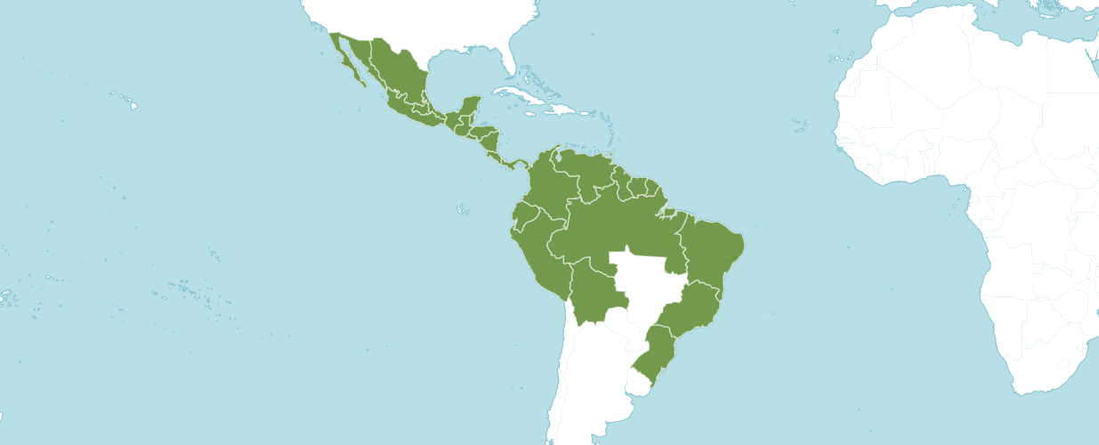

Distribution of Stanhopea image from Royal Botanical Gardens Kew

Type Species: Stanhopea insignis

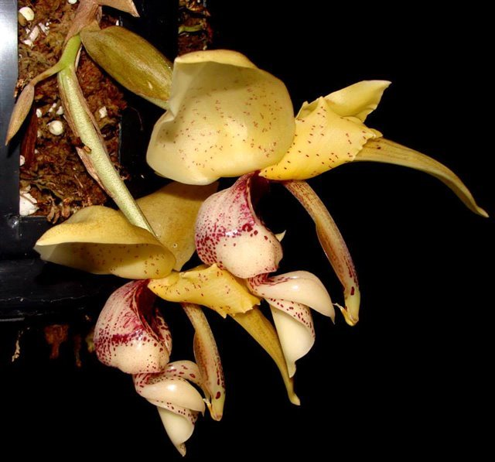

Stanhopea insignis f. aurea ‘C,’ unawarded

Photography by Richardo Gioria

Native to:

Belize, Bolivia, Brazil North, Brazil Northeast, Brazil South, Brazil Southeast, Colombia, Costa Rica, Ecuador, El Salvador, French Guiana, Guatemala, Guyana, Honduras, Mexico Central, Mexico Gulf, Mexico Northeast, Mexico Northwest, Mexico Southeast, Mexico Southwest, Nicaragua, Panamá, Peru, Suriname, Trinidad-Tobago, Venezuela

Heterotypic Synonyms

Ceratochilus Lindl. ex G. Lodd. in Bot. Cab. 15: t. 1414 (1829), nom. illeg.

Gerlachia Szlach. in Richardiana 7: 48 (2007), non W. Gams & E. Müll. (1980), fossil name.

Stanhopeastrum Rchb.f. in Bot. Zeitung (Berlin) 10: 927 (1852)

Tadeastrum Szlach. in Richardiana 7: 47 (2007)

Stanhopea Species

Stanhopea aliceae Archila, Pérez-García, Chiron & Szlach.

Stanhopea anfracta Rolfe

Stanhopea annulata Mansf.

Stanhopea avicula Dressler

Stanhopea bueraremensis Campacci & Marçal

Stanhopea candida Barb. Rodr.

Stanhopea cephalopoda Archila, Pérez-García, Chiron & Szlach.

Stanhopea chironii Archila, Pérez-García & Szlach.

Stanhopea cirrhata Lindl.

Stanhopea confusa G. Gerlach & Beeche

Stanhopea connata Klotzsch

Stanhopea costaricensis Rchb.f.

Stanhopea deltoidea Lem.

Stanhopea dodsoniana Salazar & Soto Arenas

Stanhopea ecornuta Lem.

Stanhopea embreei Dodson

Stanhopea esteponae Archila & Chiron

Stanhopea florida Rchb.f.

Stanhopea fonsecae Archila, Pérez-García, Chiron & Szlach.

Stanhopea × fowlieana Jenny

Stanhopea frymirei Dodson

Stanhopea gibbosa Rchb.f.

Stanhopea grandiflora (Lodd.) Lindl.

Stanhopea graveolens Lindl.

Stanhopea greeri Jenny

Stanhopea grossii Archila & Chiron

Stanhopea guttulata Lindl.

Stanhopea haseloffiana Rchb.f.

Stanhopea hernandezii (Kunth) Schltr.

Stanhopea × herrenhusana Jenny

Stanhopea × horichiana Jenny

Stanhopea insignis J. Frost ex Hook.

Stanhopea intermedia Klinge

Stanhopea javieri Archila, Pérez-García, Chiron & Szlach.

Stanhopea jenischiana F. Kramer ex Rchb.f.

Stanhopea kroliana Gioria & Campacci

Stanhopea × lewisae Ames & Correll

Stanhopea lietzei (Regel) Schltr.

Stanhopea macrocornata Archila, Pérez-García, Chiron & Szlach.

Stanhopea maculosa Knowles & Westc.

Stanhopea madouxiana Cogn.

Stanhopea maduroi Dodson & Dressler

Stanhopea manriquei Jenny & Nauray

Stanhopea marizana Jenny

Stanhopea martiana Bateman ex Lindl.

Stanhopea marylenae Archila, Chiron & Pérez-García

Stanhopea moliana Rolfe

Stanhopea napoensis Dodson

Stanhopea naurayi Jenny

Stanhopea nicaraguensis G. Gerlach

Stanhopea nigripes Rolfe

Stanhopea novogaliciana S. Rosillo

Stanhopea oculata (Lodd.) Lindl.

Stanhopea oscarrodrigoi Archila, Pérez-García, Chiron & Szlach.

Stanhopea ospinae Dodson

Stanhopea panamensis N .H. Williams & W. M. Whitten

Stanhopea peruviana Rolfe

Stanhopea platyceras Rchb.f.

Stanhopea posadae Jenny & Braem

Stanhopea pozoi Dodson & D. E. Benn.

Stanhopea pseudoradiosa Jenny & R. Gonzalez

Stanhopea pulla Rchb.f.

Stanhopea × quadricornis Lindl.

Stanhopea radiosa Lem.

Stanhopea reichenbachiana Roezl ex Rchb.f.

Stanhopea rubroatrata Archila, Pérez-García, Chiron & Szlach.

Stanhopea rubromaculata Archila, Pérez-García, Chiron & Szlach.

Stanhopea ruckeri Lindl.

Stanhopea saccata Bateman

Stanhopea saintexuperyi Archila, Pérez-García, Chiron & Szlach.

Stanhopea schilleriana Rchb.f.

Stanhopea shuttleworthii Rchb.f.

Stanhopea stevensonii A. Mejia & R. Escobar ex Jenny

Stanhopea szlachetkoana Archila, Pérez-García & Chiron

Stanhopea × thienii Dodson

Stanhopea tigrina Bateman ex Lindl.

Stanhopea tolimensis G. Gerlach

Stanhopea tricornis Lindl.

Stanhopea victoriana Archila, Pérez-García, Chiron & Szlach.

Stanhopea wardii Lodd. ex Lindl.

Stanhopea warszewicziana Klotzsch

Stanhopea whittenii Soto Arenas, Salazar & G.Gerlach

Stanhopea xanthoviridea Archila, Pérez-García, Chiron & Szlach.

Stanhopea xytriophora Rchb.f.
Stanhopea Species Awards
 | FCC | AM | HCC | AQ | JC | CCM | CCE | CHM | CBM | CBR | TOTAL
aliceae | - | - | - | - | - | - | - | - | - | - | 0
amesiana, ~reichenbachiana | 1 | 5 | - | - | - | - | - | - | - | - | 6
amoena, ~wardii | - | 10 | 4 | - | 1 | 9 | - | - | - | - | 24
anfracta | - | 2 | 1 | - | - | - | - | 1 | - | - | 4
annulata | - | - | - | - | - | - | - | - | - | 1 | 1
atropurpurea,  ~insignis | - | 1 | 2 | - | - | - | - | - | - | - | 3
aurantia, ~ oculata | - | 9 | 5 | - | 2 | 2 | - | - | - | - | 18
aurata, ~ graveolens | - | 9 | 4 | - | - | 1 | - | 1 | 1 | - | 16
aurea, ~wardii | - | 10 | 4 | - | 1 | 9 | - | - | - | - | 24
avicula | - | - | - | - | - | - | - | - | - | - | 0
bucephalus, ~ oculata | - | 9 | 5 | - | 2 | 2 | - | 1 | 1 | - | 16
bueraremensis | - | - | - | - | - | - | - | - | - | - | 0
calceolata, ~grandiflora | - | - | 1 | - | - | - | - | 1 | - | 1 | 3
calceolus | - | - | - | - | - | - | - | - | - | - | 0
bufonia | - | - | - | - | - | - | - | - | - | 1 | 1
cassidea, ~batemanni | - | - | - | - | - | 1 | - | 1 | - | 2 | 4
catilligera, ~ ecornuta | - | - | - | - | - | - | - | - | - | 1 | 1
candida | - | - | - | - | - | - | - | 1 | - | - | 1
candida, ~ gibbosa |  | 4 | 1 | - | 1 | 1 | - | 2 | - | - | 9
cavendishii,  ~hernandezii | - | 1 | - | - | - | - | - | 1 | - | - | 2
cephalopoda | - | - | - | - | - | - | - | - | - | - | 0
chironii | - | - | - | - | - | - | - | - | - | - | 0
confusa | - | - | - | - | - | - | - | 1 | - | - | 1
connata | - | 6 | 1 | - | - | - | - | - | - | - | 7
convoluta, ~tricornis | - | - | 3 | - | - | - | - | 1 | - | - | 4
costaricensis | - | 4 | 1 | - | - | - | - | - | 1 | - | 6
cymbiformis,  ~oculata | - | 9 | 5 | - | 2 | 2 | - | - | - | - | 18
deltoidea | - | - | - | - | - | - | - | - | - | - | 0
devoniensis,  ~hernandezii | - | 1 | - | - | - | - | - | 1 | - | - | 2
dodsoniana | - | 1 | - | - | - | 1 | - | 1 | - | 1 | 4
eburnean, ~grandiflora | - | - | 1 | - | - | - | - | 1 | - | 1 | 3
ecornuta | - | - | - | - | - | - | - | 1 | - | - | 1
elegantula, ~ saccata | - | 4 | 1 | - | - | - | - | - | 1 | - | 6
embreei | - | 4 | - | - | - | - | - | - | - | 1 | 5
expansa, ~tigrina | 6 | 24 | - | - | - | 3 | 1 | 3 | - | - | 37
flava, ~insignis | - | 1 | 2 | - | - | - | - | - | - | - | 3
florida | - | 2 | 2 | - | - | - | - | - | - | 1 | 5
fonsecae | - | - | - | - | - | - | - | - | - | - | 0
x fowlieana | - | 1 | 1 | - | - | - | - | - | - | - | 2
Stanhopea Species Awards continued
 | FCC | AM | HCC | AQ | JC | CCM | CCE | CHM | CBM | CBR | TOTAL
fregeana,  ~maculosa | - | - | - | - | - | - | - | - | - | 1 | 1
frymirei | - | 1 | 1 | - | - | 1 | - | - | 1 | - | 4
fuerstenbergiae | - | - | - | - | - | - | - | - | - | - | 0
gibbosa | - | 4 | 1 | - | 1 | 1 | - | 2 | - | - | 9
grandiflora | - | - | 1 | - | - | - | - | 1 | - | 1 | 3
graveolens | - | 9 | 4 | -- | - | 1 | - | 1 | 1 | - | 16
greeri | - | - | - | - | - | - | - | - | - | - | 0
greerii | - | - | - | - | - | - | - | - | - | - | 0
grossii | - | - | - | - | - | - | - | - | - | - | 0
guttata, ~oculata | - | 9 | 5 | - | 2 | 2 | - | - | - | - | 18
guttulata | - | - | - | - | - | - | - | - | - | - | 0
haseloffiana,  ~haseloviana | - | - | 2 | - | - | - | - | - | - | - | 2
hernandezii | - | 1 | - | - | - | - | - | 1 | - | - | 2
x herrenhusana | - | 1 | - | - | - | - | - | - | - | - | 1
hoppii, ~jenischiana | - | 7 | 2 | - | - | 1 | - | - | - | - | 4
x horichiana | - | - | - | - | - | - | - | - | - | - | 0
implicata, ~ martiana | - | - | - | - | - | - | - | 1 | - | 1 | 2
impressa, ~ gibbosa | - | 4 | 1 | - | 1 | 1 | - | - | 1 | - | 8
inodora | - | 2 | 4 | - | 1 | - | - | - | 1 | - | 15
insignis | - | 1 | 2 | - | - | - | - | - | - | - | 3
intermedia | - | - | 1 | - | - | - | - | - | - | 1 | 2
javieri | - | - | - | - | - | - | - | - | - | - | 0
jenischiana,  ~jenishiana | - | 7 | 2 | - | - | 1 | - | - | - | - | 10
jimenezii, ~oculata | - | 9 | 5 | - | 2 | 2 | - | - | - | - | 18
langlasseana,  ~tricornis | - | - | 3 | - | - | - | - | 1 | - | - | 4
leucochila, ~insignis | - | 1 | 2 | - | - | - | - | - | - | - | 3
x lewisae | - | 1 | - | - | - | - | - | - | - | - | 1
lietzei, ~ lietzii | - | - | - | - | - | - | - | - | - | 1 | 1
lindleyi, ~ oculata | - | 9 | 5 | - | 2 | 2 | - | - | - | - | 18
longipes | - | - | - | - | - | - | - | - | - | - | 0
lowii,  ~reichenbachiana | 1 | 5 | - | - | - | - | - | - | - | - | 6
lyncea, ~ hernandezii | - | 1 | - | - | - | - | - | 1 | - | - | 2
macrochila, ~insignis | - | 1 | 2 | - | - | - | - | - | - | - | 3
macrocornata | - | - | - | - | - | - | - | - | - | - | 0
maculosa | - | - | - | - | - | - | - | - | - | 1 | 1
madouxiana | - | - | - | - | - | - | - | - | 1 | - | 1
maduroi | - | - | - | - | - | - | - | - | - | 1 | 1
manriquei | - | - | - | - | - | - | - | - | - | - | 0
marizaiana | - | - | - | - | - | - | - | - | - | - | 0
marizana | - | - | - | - | - | - | - | - | - | - | 0
marshii, ~maculosa | - | - | - | - | - | - | - | - | - | 1 | 1
martiana | - | - | - | - | - | - | - | 1 | - | 1 | 2
marylenae | - | - | - | - | - | - | - | - | - | - | 0

Stanhopea Species Awards continued
 | FCC | AM | HCC | AQ | JC | CCM | CCE | CHM | CBM | CBR | TOTAL
minor, ~oculata | - | 9 | 5 | - | 2 | 2 | - | - | - | - | 18
napoensis | - | - | - | - | - | - | - | 1 | - | - | 1
naurayi | - | - | - | - | - | - | - | - | - | - | 0
nicaraguensis | - | - | - | - | - | - | - | - | - | - | 0
nigripes | - | - | 1 | - | - | 1 | - | 1 | - | - | 3
nigroviolacea, ~tigrina | 6 | 24 | 7 | - | - | 3 | 1 | 1 | - | - | 42
novogaliciana | - | - | - | - | - | - | - | - | - | - | 0
oculata | - | 9 | 5 | - | 2 | 2 | - | - | - | - | 18
odoratissima, ~insignis | - | 1 | 2 | - | - | - | - | - | - | - | 3
ornatissima, ~oculata | - | 9 | 5 | - | 2 | 2 | - | - | - | - | 18
oscarrodrigoi | - | - | - | - | - | - | - | - | - | - | 0
ospinae | - | 2 | - | - | - | - | - | - | - | - | 2
panamensis | - | 1 | - | - | - | - | - | 1 | - | - | 2
peruviana | - | - | - | - | - | - | - | - | - | 1 | 1
platyceras | 1 | 7 | - | - | - | - | - | - | 1 | - | 9
posadae | - | 1 | - | - | - | - | - | - | - | - | 1
pozoi | - | - | - | - | - | - | - | 2 | - | - | 2
pseudoradiosa | - | - | - | - | - | - | - | - | - | - | 0
pulla | - | - | - | - | - | - | - | 1 | - | 1 | 2
purpusii, ~graveolens | - | 9 | 4 | - | - | 1 | - | 1 | 1 | - | 16
x quadricornis | - | - | - | - | - | - | - | - | - | - | 0
radiosa | - | - | - | - | - | - | - | - | - | - | 0
randii, ~ candida | - | - | - | - | - | - | - | 1 | - | - | 1
reichenbachiana | 1 | 5 | - | - | - | - | - | - | - | - | 6
rubroatrata | - | - | - | - | - | - | - | - | - | - | 0
rubromaculata | - | - | - | - | - | - | - | - | - | - | 0
ruckeri | - | 7 | 2 | - | - | 1 | - | 2 | - | - | 12
saccata | - | 4 | 1 | - | - | - | - | - | 1 | - | 6
saintexuperyi | - | - | - | - | - | - | - | - | - | - | 0
schilleriana | - | - | - | - | - | - | - | 1 | - | - | 1
shuttleworthii | - | 1 | 1 | - | - | - | - | 1 | - | - | 3
x spindleriana | - | - | - | - | - | - | - | - | - | - | 0
stenochila, ~tricornis | - | - | 3 | - | - | - | - | 1 | - | - | 4
stevensonii | - | 2 | - | - | - | - | - | - | - | 1 | 3
szlachetkoana | - | - | - | - | - | - | - | - | - | - | 0
tadeasi, ~connata | - | 6 | 1 | - | - | - | - | - | - | - | 7
x thienii | - | - | - | - | - | - | - | - | - | - | 0
*tigrina | 6 | 24 | 7 | - | - | 3 | 1 | 1 | - | - | 42
tolimensis | - | - | - | - | - | - | - | - | - | - | 0
tricornis | - | - | 3 | - | - | - | - | 1 | - | - | 4
uncinate, ~martiana | - | - | - | - | - | - | - | 1 | - | 1 | 2
vasquezii,  ~xytriophora | - | - | - | - | - | - | - | - | - | - | 0
velata, ~martinana | - | - | - | - | - | - | - | 1 | - | 1 | 2
venusta, ~wardii | - | 10 | 4 | - | 1 | 9 | - | - | - | - | 24
versicolor | - | - | - | - | - | - | - | - | - | - | 0
victoriana | - | - | - | - | - | - | - | - | - | - | 0
wallisii, ~tricornis | - | - | 3 | - | - | - | - | 1 | - | - | 4
wardii | - | 10 | 4 | - | 1 | 9 | - | - | - | - | 24
warszewicziana | - | - | 1 | - | - | - | - | 1 | - | - | 2
whittenii | - | - | - | - | - | - | - | - | - | - | 0
Stanhopea Species Awards continued
 | FCC | AM | HCC | AQ | JC | CCM | CCE | CHM | CBM | CBR | TOTAL
xanthoviridea | - | - | - | - | - | - | - | - | - | - | 0
xytriophora | - | - | - | - | - | - | - | - | - | - | 0
x wolteriana | - | - | - | - | - | - | - | - | - | - | 0
x bellaerensis | - | - | - | - | - | - | - | - | - | - | 0
x fowlieana | - | 1 | 1 | - | - | - | - | - | - | - | 2
x herrenhusana | - | 1 | - | - | - | - | - | - | - | - | 1
x horichiana | - | - | - | - | - | - | - | - | - | - | 0
x lewisae | - | 1 | - | - | - | - | - | - | - | - | 0
x quadricornis | - | - | - | - | - | - | - | - | - | - | 0
x spindleriana | - | - | - | - | - | - | - | - | - | - | 0
x thienii | - | - | - | - | - | - | - | - | - | - | 0
x wolteriana | - | - | - | - | - | - | - | - | - | - | 0

Stanhopea Species Offspring and Progeny
 | F1 Offspring | Progeny
aliceae | 0 | 0
amesiana, ~reichenbachiana | 4 | 6
amoena, ~wardii | 20 | 27
anfracta | 1 | 1
annulata | 1 | 1
atropurpurea,  ~insignis | 16 | 19
aurantia, ~ oculata | 16 | 18
aurata, ~ graveolens | 10 | 11
aurea, ~wardii | 20 | 27
avicula | 0 | 0
bucephalus, ~ oculata | 16 | 18
bueraremensis | 1 | 1
calceolata, ~grandiflora | 13 | 17
calceolus | 11 | 13
candida | 0 | 0
carchiensis, ~gibbosa | 6 | 9
cavendishii, ~hernandezii | 9 | 12
cephalopoda | 0 | 0
chironii | 0 | 0
cirrhata | 1 | 1
confusa | 0 | 0
connata | 10 | 36
convoluta, ~tricornis | 7 | 8
costaricensis | 6 | 6
cymbiformis,  ~oculata | 16 | 18
deltoidea | 0 | 0
Stanhopea Species Offspring and Progeny
 | F1 Offspring | Progeny
devoniensis,  ~hernandezii | 9 | 12
dodsoniana | 1 | 1
eburnean, ~grandiflora | 13 | 17
ecornuta | 11 | 13
elegantula, ~ saccata | 12 | 13
embreei | 8 | 12
expansa, ~tigrina | 46 | 74
flava, ~insignis | 16 | 19
florida | 7 | 7
fonsecae | 0 | 0
x fowlieana | 0 | 0
fregeana,  ~maculosa | 0 | 0
frymirei | 1 | 1
fuerstenbergiae | 0 | 0
gibbosa | 6 | 9
grandiflora | 13 | 17
graveolens | 10 | 11
greeri | 3 | 3
greerii | 3 | 3
grossii | 0 | 0
guttata, ~oculata | 16 | 18
guttulata | 1 | 1
haseloffiana,  ~haseloviana | 5 | 5
hernandezii | 9 | 12
x herrenhusana | 0 | 0
hoppii, ~jenischiana | 13 | 14
x horichiana | 0 | 0
implicata, ~ martiana | 13 | 14
impressa, ~ gibbosa | 6 | 9
inodora | 12 | 16
insignis | 16 | 19
intermedia | 2 | 2
javieri | 0 | 0
jenischiana,  ~jenishiana | 13 | 14
jimenezii, ~oculata | 16 | 18
langlasseana,  ~tricornis | 7 | 8
leucochila, ~insignis | 16 | 19
x lewisae | 0 | 0
lietzei, ~ lietzii | 1 | 1
lindleyi, ~ oculata | 16 | 18
longipes | 2 | 2
lowii,  ~reichenbachiana | 4 | 6
lyncea, ~ hernandezii | 9 | 12
macrochila, ~insignis | 16 | 19
Stanhopea Species Offspring and Progeny
 | F1 Offspring | Progeny
macrocornata | 0 | 0
maculosa | 0 | 0
madouxiana | 0 | 0
maduroi | 8 | 20
manriquei | 0 | 0
marizaiana | 0 | 0
marizana | 0 | 0
marshii, ~maculosa | 0 | 0
martiana | 13 | 14
marylenae | 0 | 0
minor, ~oculata | 16 | 18
molinana | 0 | 0
napoensis | 2 | 2
naurayi | 0 | 0
nicaraguensis | 2 | 2
nigripes | 1 | 1
nigroviolacea, ~tigrina | 46 | 74
novogaliciana | 0 | 0
oculata | 16 | 18
odoratissima, ~insignis | 16 | 19
ornatissima, ~oculata | 16 | 18
oscarrodrigoi | 0 | 0
ospinae | 0 | 0
panamensis | 6 | 11
peruviana | 1 | 1
platyceras | 10 | 14
posadae | 3 | 3
pozoi | 0 | 0
pseudoradiosa | 1 | 1
pulla | 3 | 3
purpusii, ~graveolens | 10 | 11
x quadricornis | 0 | 0
radiosa | 3 | 3
randii, ~ candida | 0 | 0
reichenbachiana | 4 | 6
rubroatrata | 0 | 0
rubromaculata | 0 | 0
ruckeri | 5 | 5
saccata | 12 | 13
saintexuperyi | 0 | 0
schilleriana | 0 | 0
shuttleworthii | 2 | 2
x spindleriana | 0 | 0
stenochila, ~tricornis | 7 | 8
stevensonii | 1 | 1
szlachetkoana | 0 | 0
tadeasi, ~connata | 10 | 36
x thienii | 0 | 0
*tigrina | 46 | 74
tolimensis | 0 | 0
tricornis | 7 | 8
Stanhopea Species Offspring and Progeny
 | F1 Offspring | Progeny
uncinate, ~martiana | 13 | 14
vasquezii,  ~xytriophora | 0 | 0
velata, ~martinana | 13 | 14
venusta, ~wardii | 20 | 27
versicolor | 1 | 1
victoriana | 0 | 0
wallisii, ~tricornis | 7 | 8
wardii | 20 | 27
warszewicziana | 5 | 5
whittenii | 1 | 1
xanthoviridea | 0 | 0
xytriophora | 0 | 0
Natural Hybrids
x wolteriana | 0 | 0
x bellaerensis | 0 | 0
x fowlieana | 0 | 0
x herrenhusana | 0 | 0
x horichiana | 0 | 0
x lewisae | 0 | 0
x quadricornis | 0 | 0
x spindleriana | 0 | 0
x thienii | 0 | 0
x wolteriana | 0 | 0

Type Species: Stanhopea insignis
[in-SIG-nis]

Meaning: noble, splendid, grand
Common Name: the grand Stanhopea

ORIGIN/HABITAT: Brazil and Ecuador. In Brazil, plants are found in a relatively narrow strip of coastal mountains from the state of Rio de Janeiro southward through São Paulo, Paraná, Santa Catarina, and Rio Grande do Sul. In this coastal strip plants grow in semi-shaded locations in relatively dry forests from sea level to 1650 ft. (0-500 m). Plants are usually found in trees, but they are occasionally found growing terrestrially on steep slopes. In additon to this normal habitat, plants are also reported in the state of Esprito Santo, where they grow on the east side of the mountain range on moss-covered trees in swamps at 3600 ft. (1100 m). S. insignis was originally discovered in Ecuador in the early nineteenth century, but location and details about that habitat were not reported. No additional collections have been reported in any modern literature. Plants described as Stanhopea macrochila Lemaire, now recognized as a synonym of S. insignis, supposedly originated in Mexico, but Williams.(1951) indicated that he had seen no specimens from that region and doubted the veracity of that report. -- Source: Charles Baker

Stanhopea insignis has received three AOS awards (AM – 1; and HCC - 2).

Stanhopea insignis has sixteen first generation registered offspring. Of the sixteen offspring only one has received an AOS award. The first offspring was registered in 1892 and the last was registered in 2021.

Stanhopea Species with the Most Offspring and AOS Awards: Stanhopea tigrina
[ti-GREEN-a]

Meaning: striped/spotted like a tiger
Common Name: The tiger-like Stanhopea
Synonyms: Stan. convoluta, Stan. expansa, and Stan. nigroviolacea

ORIGIN/HABITAT: Mexico. This orchid grows on oak trees in the well-watered, thick forests of the eastern slope of the Mexican Plateau at elevations up to 6550 ft. (2000 m). It was originally collected near Xalapa, Veracruz at 3300-4250 ft. (1000-1300 m), and later collections of both the normal S tigrina and S tigrina var. nigroviolacea have been made in the mountains near the city of Veracruz and near Orizaba. Early writers reported the occurrence of this species in Colombia, Ecuador, Venezuela, and possibly Brazil. Cogniaux (1893-1906) reported that plants were found near Caracas, Venezuela, and in Colombia near Bogota. Modern writers, however, have failed to note the occurrence of S. tigrina outside of Mexico. -- Source: Charles Baker

Stanhopea tigrina has received forty-two AOS awards (CCE - 1; CCM – 3; CHM – 1; AM – 24; FCC – 6; and HCC - 7).

Stanhopea tigrina has forty-six first generation registered offspring. Of the forty-six offspring ten have received an AOS award. The first offspring was registered in 1890 and the last was registered in 2021.

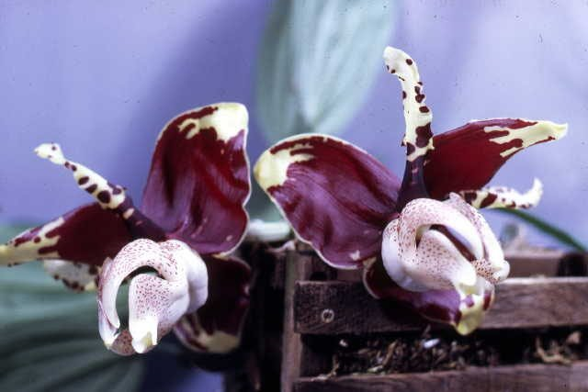
Stanhopea tigrina ‘Katie C. Barcus’ AM/AOS, 85 points
Photography by OWZ Lib

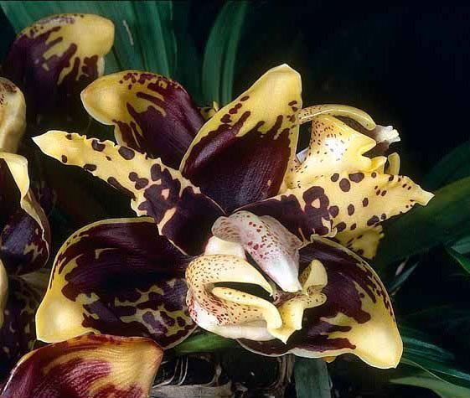
Stanhopea tigrina ‘Sanbar Gold’ AM/AOS, 80 points
Photography by William Merritt

References

American Orchid Society. (n.d.). Stanhopea. Retrieved October 26, 2023, from https://www.aos.org/orchids/orchids-a-to-z/letter-s/stanhopea.aspx .

Kew World Checklist of Selected Plant Families. (n.d.). Stanhopea. Retrieved October 28, 2023, from https://powo.science.kew.org/taxon/urn:lsid:ipni.org:names:30715-1.
Forzza, R. (2010). Lista de espécies Flora do Brasil, Jardim Botânico do Rio de Janeiro, Rio de Janeiro. Found on-line: http://floradobrasil.jbrj.gov.br/2010.
Gerlach, G. & Beeche, J. (2004). Stanhopeinae Mesoamericanae III (Orchidaceae). Reestablecimiento de Stanhopea ruckeri y una especie nueva: Stanhopea confusa. Lankesteriana 4(3): 213–222.
Gerlach, G. (2010). Stanhopeinae Mesoamericanae V: El aroma floral de las Stanhopeas de Mexico. Lankesteriana 9(3): 431–442.
Idárraga-Piedrahita, A., Ortiz, R., Callejas Posada, R., and Merello, M. (2011). Flora de antioquia: Catálogo de las plantas vasculares 2: 9–939. Universidad de Antioquia, Medellín.
Mather, B. (n.d.). Stanhopeas. Orchid Society Council of Victoria. Found on-line: https://oscov.asn.au/articles/stanhopeas-by-bill-mather/ .
McLeish, I., Pearce, N. and Adams, B. (1995). Native Orchids of Belize. 1–278.

OrchidPro.

OrchidWiz X9.0.

Pridgeon, A., Cribb, P., Chase, M., and Rasmussen, F. (2009). Epidendroideae (Part two). Genera Orchidacearum 5: 1-585. Oxford University Press, New York, Oxford.
Rudolf, J. (1993). The Genus Stanhopea, Orchids 62(12):1270-1277.
Rudolf, J. (2003). The Genus Stanhopea. Part 1: Stan. anfracta to Stan. napoensis," in: Caesiana no. 21, Supplement. 200 color photos, 160 p.

