Gongora galeata (Lindl. ex Bosse) Rchb.f. (1854)
[gal-ee-AH-ta]

Nickname: The Helmut Gongora

OrchidWiz notes origin/habitat: Endemic to southern Mexico. Plants are found mainly on the slopes facing the Gulf of Mexico in the States of Hidalgo, Veracruz, Puebla, Oaxaca, and Chiapas. They are also found on the Pacific slopes in Chiapas. Plants usually grow as epiphytes in mountain rainforests and cloud forests at 1950-5900 ft. (600-1800 m), but they are occasionally found as lithophytes and terrestrials. -- Source: Charles Baker

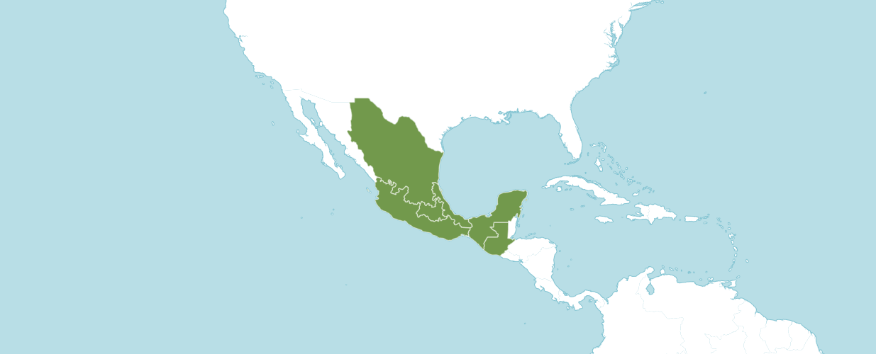
Natural Habitat by Kew

Native to: Guatemala, Mexico Central, Mexico Gulf, Mexico Northeast, Mexico Southeast, Mexico Southwest.

Homotypic Synonyms

Acropera galeata (Lindl. ex Bosse) Archila, Szlach. & Chiron in Orchidophile (Deuil-la-Barre) 211: 345 (2016)

Maxillaria galeata Lindl. ex Bosse in Blumen-Zeitung 9: 196 (1836), nom. cons.

Heterotypic Synonyms

Acropera atropurpurea Heynh. in Alph. Aufz. Gew.: 8 (1846)

Acropera citrina Rchb.f. in Xenia Orchid. 1: 51 (1854)

Acropera flavida Klotzsch in Allg. Gartenzeitung 19: 217 (1851)

Acropera flavirostris Hoffmanns. in Verz. Orchid., ed. 3: 51 (1844)

Acropera fuscata Heynh. in Alph. Aufz. Gew.: 8 (1846)

Acropera loddigesii Lindl. in Gen. Sp. Orchid. Pl.: 172 (1833)

Acropera luteola Heynh. in Alph. Aufz. Gew.: 8 (1846)

Acropera luteola Drapiez in Hort. Universel 2: 128, 331 (1840)

Acropera pallida Heynh. in Alph. Aufz. Gew.: 8 (1846)

Acropera purpurea Heynh. in Alph. Aufz. Gew.: 8 (1846)

Acropera sulphurea Heynh. in Alph. Aufz. Gew.: 8 (1846)

Gongora fuscata (Heynh.) Gentil in Pl. Cult. Serres Jard. Bot. Brux.: 92 (1907)

Gongora galeata var. loddigesii (Lindl.) Autran & T. Durand in Hortus Boiss.: 319 (1896), nom. superfl.

Gongora galeata f. luteola (Drapiez) O. Gruss & M. Wolff in Orchid. Atlas: 161 (2007)

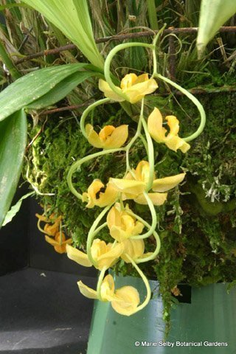

Gongora galeata, unawarded
Photography by Phil Nelson, MD.

AOS Awards:

Gongora galeata
 | FCC | AM | HCC | AQ | JC | CCM | CCE | CHM | CBM | CBR | TOTAL
AOS | - | - | - | - | - | 3 | 1 | 1 | 1 | 1 | 7
Years Awarded |  |  |  |  |  | 1996  1997  2013 | 2001 | 1996 | 1977 | 2020

Hybrids
Gongora galeata has eleven first generations offspring and fourteen total progeny.
The first Gongora galeata registered hybrid is Gongora Galequindon (Gongora galeata x Gongora quinquenervis), originated and registered in 1997 by M. and M. F. Bourdon.

Gongora Galequindon has received no AOS awards. Gongora Galequindon has registered one first generation offspring and two progeny. No Gongora Galequindon offspring and progeny have received an AOS award.

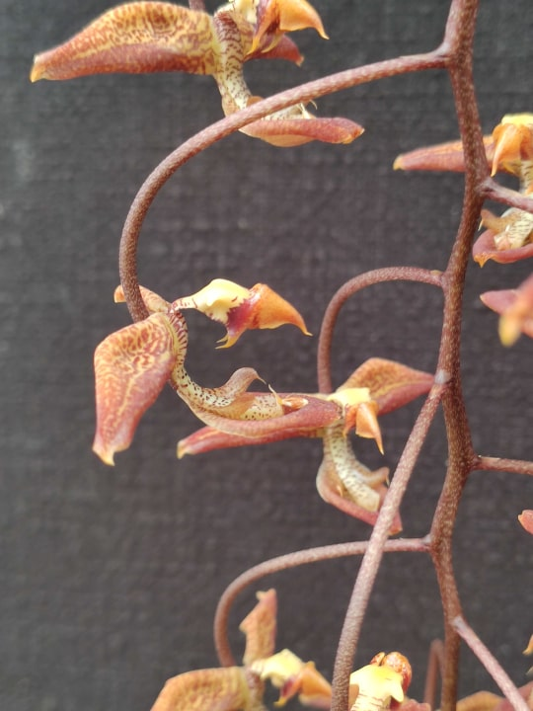
Gongora Galequindon, unawarded
Photography by L’Orchidium
References

Govaerts, R. (2003). World checklist of monocotyledons database in ACCESS: 1-71827. The Board of Trustees of the Royal Botanic Gardens, Kew.

Kew (n.d.). Gongora galeata. Royal Botanical Gardens Kew: Plants of the World Online. Retrieved October 29, 2023, from https://powo.science.kew.org/taxon/urn:lsid:ipni.org:names:636009-1.

OrchidPro.

OrchidWiz 9X.0.

