Stanhopea tigrina, Bateman ex Lindl. (1838)
[ti-GREEN-a]

Meaning: striped/spotted like a tiger
Common Name: The tiger-like Stanhopea
Synonyms: Stan. convoluta, Stan. expansa, and Stan. nigroviolacea

ORIGIN/HABITAT: Mexico. This orchid grows on oak trees in the well-watered, thick forests of the eastern slope of the Mexican Plateau at elevations up to 6550 ft. (2000 m). It was originally collected near Xalapa, Veracruz at 3300-4250 ft. (1000-1300 m), and later collections of both the normal S tigrina and S tigrina var. nigroviolacea have been made in the mountains near the city of Veracruz and near Orizaba. Early writers reported the occurrence of this species in Colombia, Ecuador, Venezuela, and possibly Brazil. Cogniaux (1893-1906) reported that plants were found near Caracas, Venezuela, and in Colombia near Bogota. Modern writers, however, have failed to note the occurrence of S. tigrina outside of Mexico. -- Source: Charles Baker

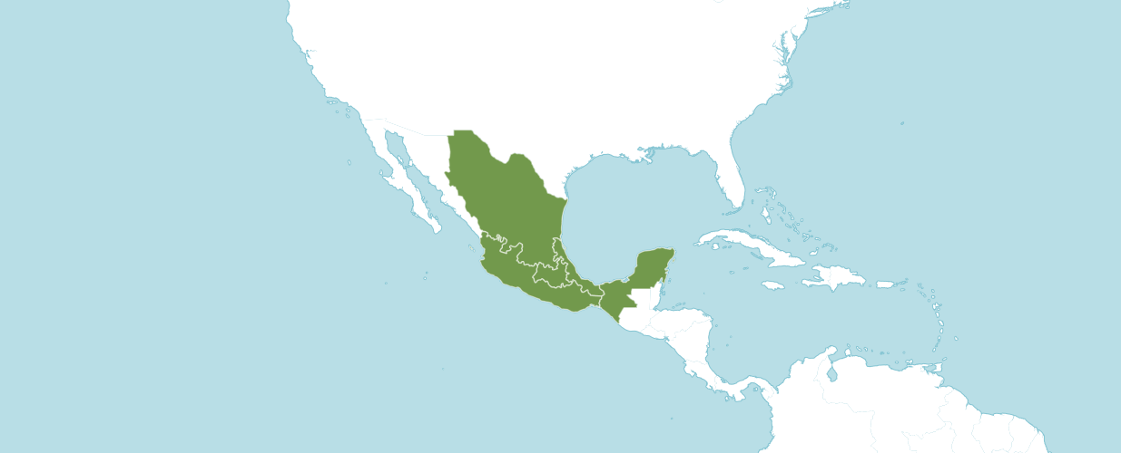

Natural Habitat by Kew

Native to: Mexico Central, Mexico Gulf, Mexico Northeast, Mexico Southeast, Mexico Southwest.

Synonyms

Stanhopea tigrina var. nigroviolacea C. Morren

Stanhopea tigrina var. tigrina

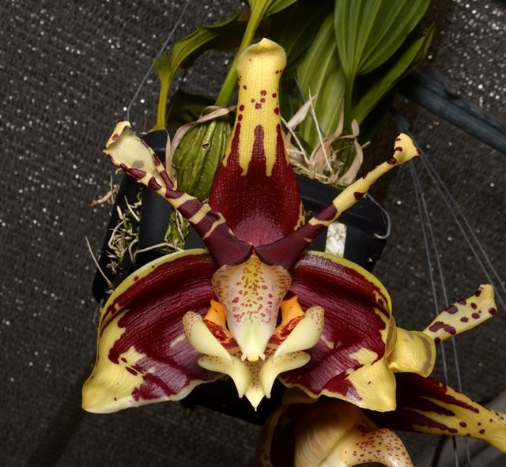
Stanhopea tigrina ‘Gloria of Mexico,’ AM/AOS, 84 points
Photography by Fred Clarke

AOS Awards:

Stanhopea tigrina
 | FCC | AM | HCC | AQ | JC | CCM | CCE | CHM | CBM | CBR | TOTAL
AOS | 6 | 24 | 7 | - | - | 3 | 1 | 1 | - | - | 42
Years Awarded | 1996  -  2019 | 1982  -  2021 | 1971  -  2007 |  |  | 1980  -  2015 | 2009 | 1994

Stanhopea tigrina has forty-six first generation registered offspring. Of the forty-six offspring ten have received an AOS award. The first offspring was registered in 1890 and the last was registered in 2021. Stanhopea Spindleriana was the first registered offspring of Stanhopea tigrina, (Stanhopea oculata x Stanhopea tigrina). The cross originated and was registered by Spindler. Stanhopea Spindleriana has received one AOS award, an AM/AOS of 81 points in 2020.

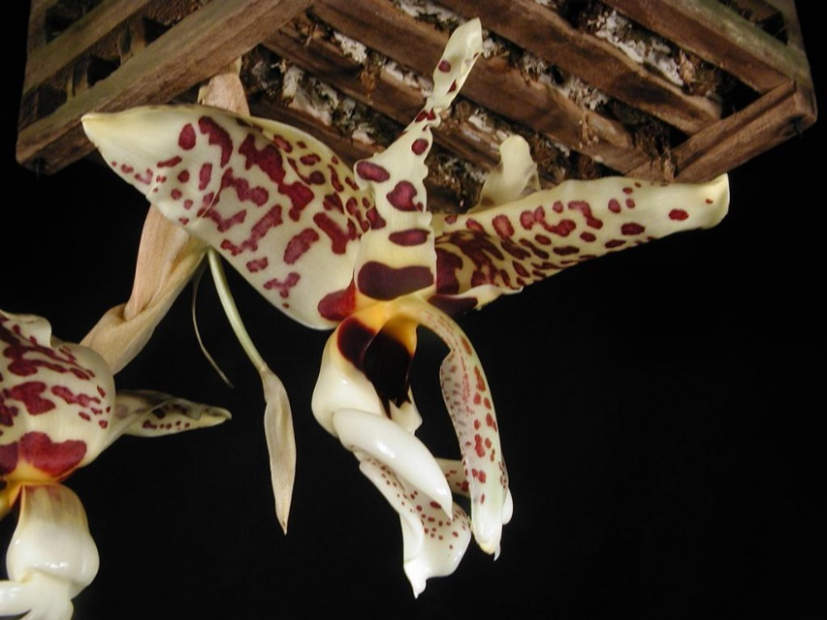
Stanhopea Spindleriana ‘Dark Chocolate’ AM/AOS, 81 points
Photography by Phil Nelson, MD.

Stanhopea tigrina offspring with the most AOS awards is Stanhopea Assidensis (Stanhopea tigrina x Stanhopea wardii), which has received nineteen AOS awards (AM – 13; HCC – 4; and CCM – 2).

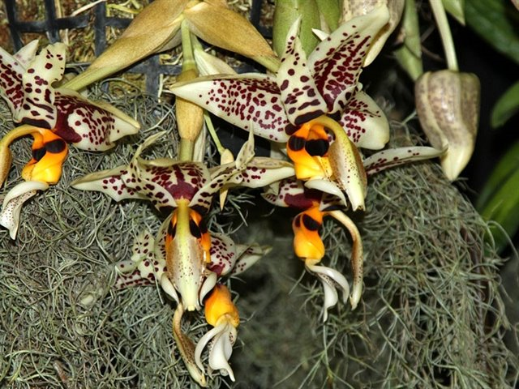
Stanhopea Assidensis ‘Red Sonja’ AM/AOS, 85 points
Photography by Julius Klehm

Both Stanhopea Assidensis and Stanhopea Hautlieu have the largest number of offspring of a Stanhopea tigrina offspring. Stanhopea Assidensis information was shared above. Stanhopea Hauflieu (Stanhopea Augres x Stanhopea tigrina) was originated and registered in 1998 by E. Young O.F. Stanhopea Hauflieu has three
F1 offspring and fifteen progeny. Stanhopea Hauflieu has not received an AOS award.

References

Govaerts, R. (2003). World checklist of monocotyledons database in ACCESS: 1-71827. The Board of Trustees of the Royal Botanic Gardens, Kew.

Kew (n.d.). Stanhopea tigrina. Royal Botanical Gardens Kew: Plants of the World Online. Retrieved October 29, 2023, from https://powo.science.kew.org/taxon/urn:lsid:ipni.org:names:658613-1.

OrchidPro.

OrchidWiz 9X.0.

