Stanhopea wardii Lodd. ex Lindl 1838
[stan-HOHP-ee-ah] [WOR-dee-eye]

Nickname: Ward’s Stanhopea
Named for Dr. E. Ward, 19th Century British collector

OrchidWiz notes origin/habitat: Southern Central America and northern South America. Present thinking is that this orchid is only found south of Honduras, with the range of distribution including Nicaragua, Costa Rica, Panama, Venezuela, and Colombia. It was first collected near Caracas, Venezuela and has since been found as various locations in the region. Dunsterville and Garay (1959) reported that plants have been found near Caracas at Mariposa dam. Foldats (1970) reported that plants were found at 2600-5900 ft. (800-1800 m) in the National Park in the District of Aragua. In Colombia, plants grow in the northern part of the country, north of the Departments of Antioquia and Chocó, at 5900-8200 ft. (1800-2500 m). In Costa Rica, S. wardii is native to the Costa Rican Meseta Central, east, and southeast of Cartago and the adjacent Reventazon area at nearly 4450 ft. (1350 m). It grows on old trees covered with Spanish moss and masses of bromeliads, particularly Tillandsias. In Panama, the orchid is common throughout the intermediate highlands on the Pacific slope of Coclé and Chiriquí Provinces at 1800-4000 ft. (550-1220 m). Plants collected in El Salvador near Boquerón and in the Cerro Grande de Apaneca at 4900 ft. (1500 m) were originally discussed as S. wardii by Hamer (1964), but Hamer (1970) later indicated that they were actually S. graveolens. In Guatemala, Ames and Correll reported that plants were collected in Zacapa, on Sierra de las Minas, between Río Hondo and the summit of the mountain at Finca Alejandría, where the orchids grew on trees and rocks in humid forests at elevations up to 8850 ft. (2700 m). Originally reported to be widespread in Mexico, Guatemala, Costa Rica, and Panama, but later work indicates that the habitat for S. wardii does extend that far north and plants from these areas are probably S. graveolens. -- Source: Charles Baker.

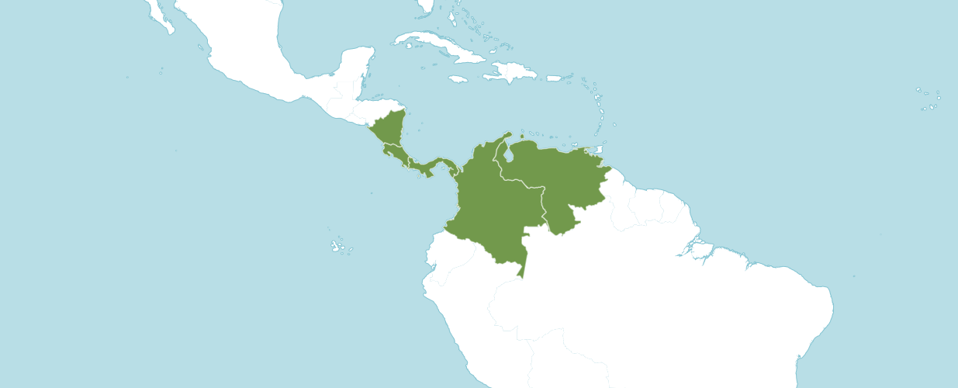
Natural Habitat by Kew

Native to: Colombia, Costa Rica, Nicaragua, Panamá, Venezuela.

Heterotypic Synonyms

Stanhopea amoena Klotzsch in Allg. Gartenzeitung 20: 273 (1852)

Stanhopea aur ea Lodd. ex Lindl. in Edwards's Bot. Reg. 27(Misc.): 11 (1841)

Stanhopea aurea major Lodd. in Orchideae, ed. 2: 28 (1844), nom. nud.

Stanhopea inodora var. amoena (Klotzsch) Lindl. in Fol. Orchid. 1: 2 (1852)

Stanhopea venusta Lindl. in Edwards's Bot. Reg. 27(Misc.): 11 (1841)

Stanhopea wardii var. aurea Henshall in Pract. Treat. Cult. Orch. Pl.: 123 (1845)

The American Orchid Society shares the following information:

Description: A medium sized, hot to warm growing epiphyte occurring on trees and on rocks in humid cloud forests, it can fill an entire house with its pleasing scent. This species has pyriform to ovoid, sulcate pseudobulbs with a single, apical, coriaceous, plicate, ribbed, elliptic-obovate, gradually narrows below into the elongate, petiolate base leaf. They bloom in the summer and fall on a pendant, 3 to 10 flowered, 6 to 7 1/4 [15 to 18 cm] long, crowded inflorescence arising on a mature pseudobulb and last from 2-4 days and as in all Stanhopea they must be kept in a wire basket or mounted on a plaque as the inflorescence hangs pendant from below the plant.

Stanhopeas and related genera have large, pleated leaves and bear incredible flowers with intricate, complex structures and mechanisms for pollination, ranging from channeled walkways for insects to buckets of a watery solution. Most have inflorescences that grow downward, so the plants must be potted in hanging baskets or similar containers. Flowers are often spicily fragrant, and although the flowers are short-lived, each plant may produce many inflorescences throughout the year. Related genera Paphinia and Peristeria grow warmer than others in this group and may produce upright inflorescences.

Light should be bright, with direct sunlight diffused so as not to burn the leaves. Most growers suspend these orchids due to their pendulous inflorescences. This also brings the plants closer to the light. Light levels approximating those for cattleyas, around 3,000 foot-candles, are best.

Temperatures should be moderate: 52° to 60° F at night, with day temperatures 68° to 75° F in the winter. Plants can stand short spells of higher temperatures, but air movement, humidity and shading must all be increased. Many species flower in the summer and putting them outside in the summer may be beneficial. Move into higher light slowly to avoid burn.

Water in ample quantities is important to produce strong pseudobulbs and prevent foliar spotting. Stanhopeas and their relatives can be sensitive to salt accumulation in the medium, so should never be allowed to dry out entirely, even during the winter months when growth may slow or stop. Poor watering habits are also conducive to root loss in these types, and some may be very slow to re-establish once they have lost their roots.

Fertilize at regular intervals. Most growers fertilize with a diluted concentration every week to two weeks. For plants in bark, use a 30-10-10 high-nitrogen formulation, alternating with a 20-20-20 balanced formulation; in the blooming season, which is mainly summer, use a 10-30-20 blossom-booster formulation. Plants grown in osmunda need fertilization only infrequently.

Potting is done best right after summer flowering, as most plants seem to grow year-round. Plants that rest in the winter can be repotted in the spring. The best flowerings come from large clumps of plants, so large baskets are usually used. An airy, yet moist medium seems to work best, such as medium-grade fir bark (often mixed with sphagnum peat) or osmunda fiber. Vigorous plants may need repotting every three years or so.

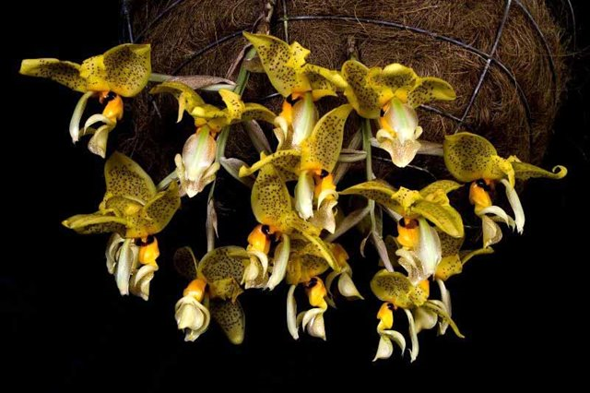
Stanhopea wardii ‘Reina Isabel’, AM/AOS, points
Photography by Jorge Enrique Cespedes

AOS Awards:

Stanhopea wardii
 | FCC | AM | HCC | AQ | JC | CCM | CCE | CHM | CBM | CBR | TOTAL
AOS | - | 10 | 4 | - | 1 | 9 | - | - | - | - | 24
Years Awarded |  | 1984  -  2016 | 2013 –  2016 |  | 1997 | 1958  &  2013

Hybrids
Stanhopea wardii has twenty first generations offspring and twenty-seven total progenies.
The first Stanhopea wardii registered hybrid is Stanhopea Assidensis (Stanhopea tigrina x Stanhopea wardii), originated and registered in 1922 by H. Goldschmidt.

Stanhopea Assidensis has received nineteen awards (AM – 13; CCM – 2; and HCC – 4). Stanhopea Assidensis has registered five first generation offspring and five progeny. Of the Stanhopea Assidensis offspring and progeny only three have received an AOS award. Stanhopea Gary Baker (Stanhopea Assidensis x Stanhopea jenischiana), which received a CCM/AOS in 1999. The second Stanhopea Assidensis offspring and progeny to receive an AOS award is Stanhopea Grad Nite (Stanhopea oculata x Stanhopea Assidensis), which received an AM/AOS in 2013. The third Stanhopea Assidensis offspring and progeny to receive an AOS award is Stanhopea June Bride (Stanhopea panamensis x Stanhopea Assidensis), which received an HCC/AOS in 2003.

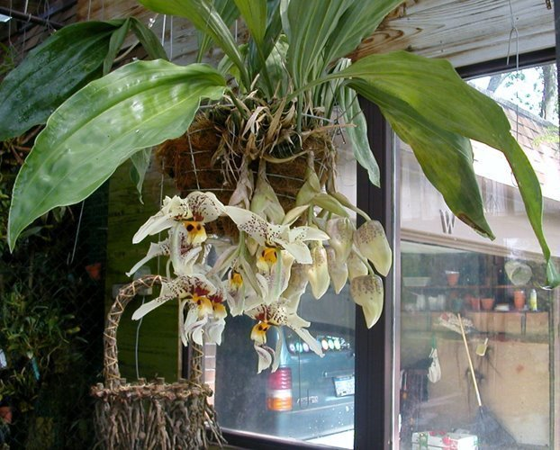
Stanhopea Gary Baker, unawarded
Photography by Dr. Richard Wagner

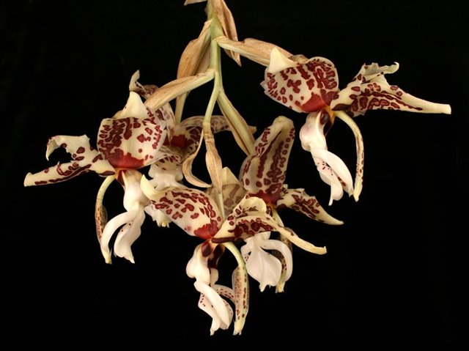
Stanhopea Gran Nite, ‘Let’s Party’ AM/AOS, 83 points
Photography by Fred Rindlisbacher

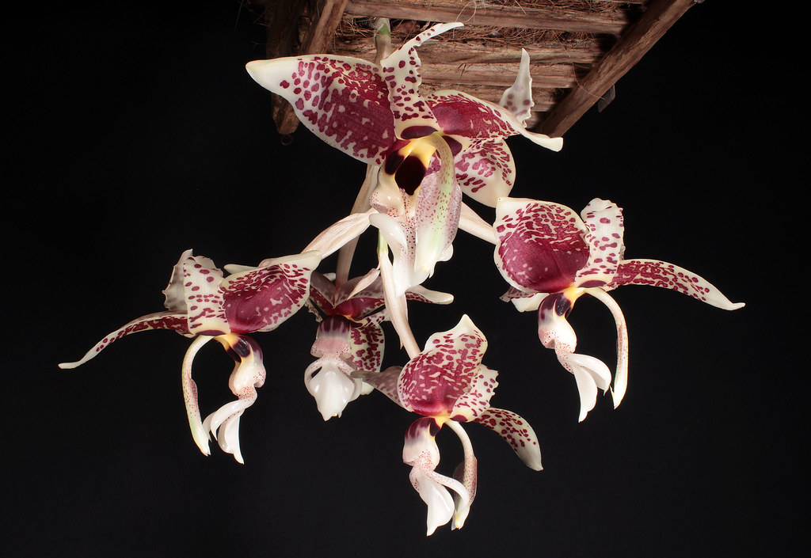
Stanhopea June Bride, unawarded
Photography by unknown

References

Govaerts, R. (2003). World checklist of monocotyledons database in ACCESS: 1-71827. The Board of Trustees of the Royal Botanic Gardens, Kew.

Hammel, B. & al. (2003). Manual de plantas de Costa Rica 3: 1-884. Missouri Botanical Garden Press, St. Louis.

Hokche, O., Berry, P., and Huber, O. (eds.) (2008). Nuevo Catálogo de la Flora Vascular de Venezuela: 1-859. Fundación Instituto Botánico de Venezuela.

Jenny, R. (2003). The genus Stanhopea 1st part S. anfracta to S. napoensis. Caesiana, Rivista Italiana di Orchidologia 21: 1-145.

Jenny, R. (2004). The genus Stanhopea 2nd part S. nigripes to S. xytriophora. Caesiana, Rivista Italiana di Orchidologia 22: 146-260.

Nelson Sutherland, C. (2008). Catálogo de las plantes vasculares de Honduras. Espermatofitas: 1-1576. SERNA/Guaymuras, Tegucigalpa, Honduras.

Kew (n.d.). Stanhopea wardii. Royal Botanical Gardens Kew: Plants of the World Online. Retrieved October 29, 2023, from https://powo.science.kew.org/taxon/urn:lsid:ipni.org:names:658619-1.

OrchidPro.

OrchidWiz 9X.0.

