Bulbophyllum beccarii Rchb.f., 1879

[be-KAH-ree-eye]

Nickname: Beccari’s Bulbophyllum

Origin/Habitat: Borneo. This epiphyte has been found in Kuching District of Sarawak as well as in Brunei, Kalimantan, and Sabah. It usually grows in peat swamp forest in the lowlands from near sea level to 3600 ft. (1100 m) but may sometimes be found on limestone or in kerangas forest. -- Source: Charles Baker.

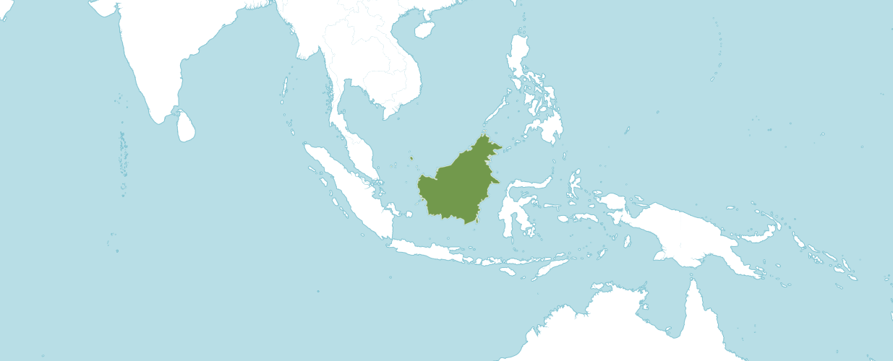
Natural Habitat by Kew

Native to: Borneo

Homotypic Synonyms

Phyllorkis beccarii (Rchb.f.) Kuntze in Revis. Gen. Pl. 2: 677 (1891)

Plant Size and Type: A very large epiphyte, and the largest species in the genus. Growths are about 24 in. (60 cm) long and are spaced well apart along a rhizome that may be up to 8 in. (20 cm) in diameter, encircling the tree on which it grows like a large snake. Numerous roots are produced all along the rhizome.

Pseudobulb/Stem: To about 2 in. (5 cm) long and wide. Pseudobulbs are egg-shaped.

Leaves: To about 24 in. (60 cm) long by 8 in. (20 cm) wide. A solitary elliptic leaf is carried at the apex of each pseudobulb. It is very thick, rigidly leathery, sharply pointed at the apex, somewhat folded together at the base, strongly keeled along the midvein on the lower side, usually colored a yellowish green, and held in a stiffly erect position.

Inflorescence: To 9 in. (23 cm) long. The short-stalked, pendulous inflorescence is produced from the rhizome near the pseudobulb. Flowers are carried in a cylindrical cluster that is up to 4 in. (10 cm) in diameter.

Flowers: Several hundred small blossoms are carried in each inflorescence. The flowers, which do not open widely, are about 0.5 in. (1.2 cm) long. The oblong, sharply pointed sepals are white to yellowish but are intricately marked on the inside surface with red to pink netlike lines. The lanceolate, sharply pointed petals are smaller than the sepals and are yellow with a red median line. The small, tongue-shaped lip is golden yellow with red stripes.

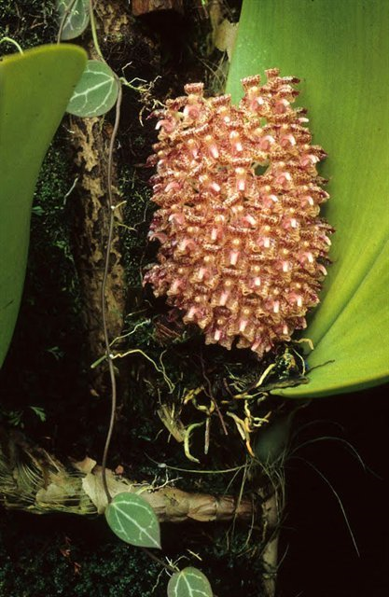

Bulbophyllum beccarii
Photography by Art Vogel
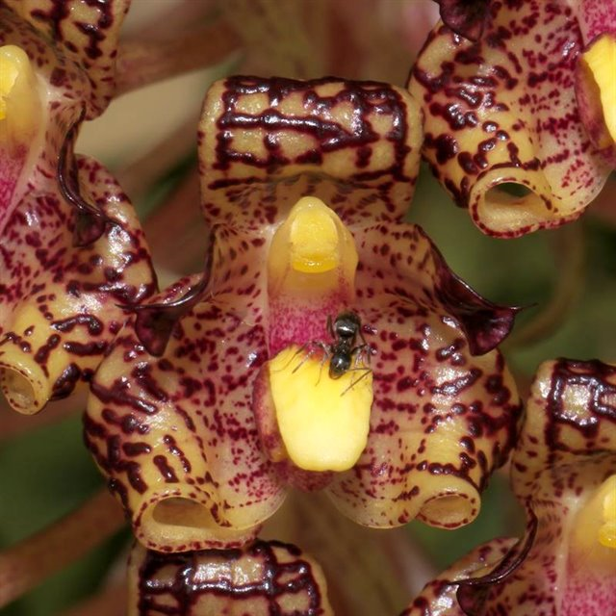

Bulbophyllum beccarii
Photography by Ricci Zepmeusel
AOS Awards:

Bulbophyllum beccarii
 | FCC | AM | HCC | AQ | JC | CCM | CCE | CHM | CBM | CBR | TOTAL
AOS | - | 1 | - | - | - | - | - | 1 | - | 1 | 3
Years Awarded |  | 2021 |  |  |  |  |  | 2021 |  | 2003

Hybrids

Of the seven Bulbophyllum beccarii hybrids registered in the F1 generation, all have been registered since 2009.

Only one AOS award has been given to a Bulbophyllum beccarii hybrid, Bulbophyllum Tien Noi Evening Star, which is (lasiochilum x beccarii). Bulbophyllum Tien Noi Evening Star was originated by registered in 2009 by Y. Punpreuk. Bulbophyllum Tien Noi Evening Star received an AM/AOS of 82 points in 2019.

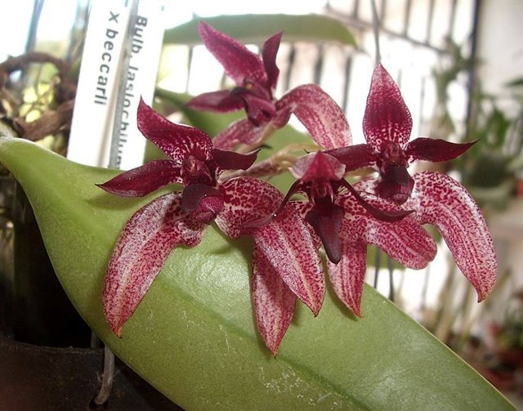
Bulbophyllum Tien Noi Evening Star
Photography by Jose Izquierdo-Rivera

References

Beaman, T., Wood, J. Beaman, R., and Beaman, J. (2001). Orchids of Sarawak. Natural History Publications. Surrey, England.

Govaerts, R. (2003). World Checklist of Monocotyledons Database in ACCESS: 1-71827. The Board of Trustees of the Royal Botanic Gardens, Kew.

Govaerts, R. (1996). World Checklist of Seed Plants 2(1, 2): 1-492. MIM, Deurne.

Hawkes, A. (1965). Encyclopedia of cultivated orchids.

Kew (n.d.). Bulbophyllum beccarii. Royal Botanical Gardens Kew: Plants of the World Online. Retrieved October 2, 2023, from https://powo.science.kew.org/taxon/urn:lsid:ipni.org:names:618409-1.

OrchidWiz 9X.0.

Siegerist, E. 2001. Bulbophyllums and Their Allies. Timber Press, Portland, Or.

Vermeulen, J., O'Byrne, P., and Lamb, A. (2015). Bulbophyllum of Borneo: 1-728. Natural History Publications (Borneo), Kota Kinabalu.

