Bulbophyllum bicolor Lindl. 1830

[BY-kol-or]

Nickname: The two colored Bulbophyllum

ORIGIN/HABITAT: China. Found near Hong Kong in the New Territories. Habitat elevation was not reported, so the following climate table and cultural suggestions are based on an estimated elevation and should be used rather cautiously. -- Source: Charles Baker
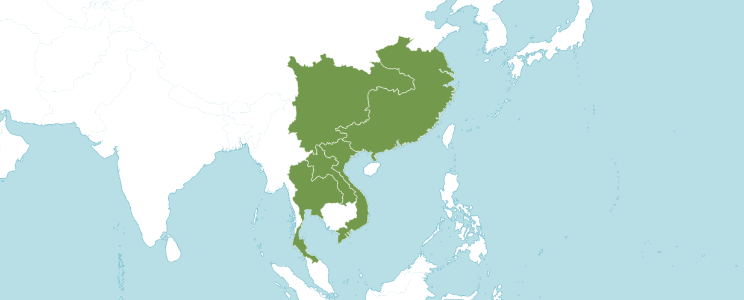
Natural Habitat by Kew

Native to: China South-Central, China Southeast, Laos, Thailand, Vietnam

Homotypic Synonyms

Cirrhopetalum bicolor (Lindl.) Rolfe in J. Linn. Soc., Bot. 36: 14 (1903)

Phyllorkis bicolor (Lindl.) Kuntze in Revis. Gen. Pl. 2: 677 (1891)

PSEUDOBULB/STEM: 0.8 in. (2 cm) long by 0.5 in (1.2 cm) in diameter. The small pseudobulbs are mostly oval in shape.

LEAVES: About 4.3 in. (11 cm) long by 0.8 in. (2 cm) wide. A single, narrowly oval leaf is held in an erect position at the apex of each pseudobulb. It is rather flat, has a rounded tip, and narrows at the base into a slender petiole that is about 0.7 in. (1.7 cm) long.

INFLORESCENCE: 1.8 in. (4.5 cm) long. The slender, erect to ascending flower spike emerges from the base of the pseudobulb. Flowers are carried in an umbel at the apex of the spike, each with a pedicellate ovary that is about 0.4 in. (1 cm) long.

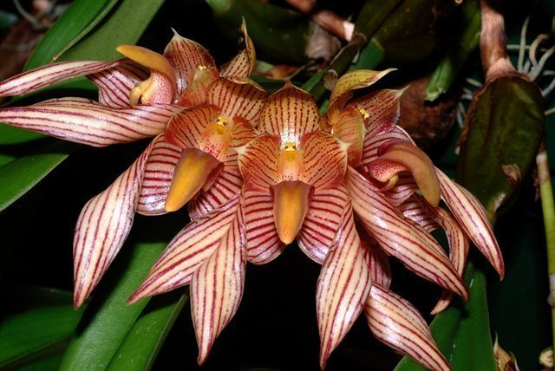

Bulbophyllum bicolor ‘Windy Hill” AM/AOS, 87 points, 2009
Photography Craig Plahn

AOS Awards:

Bulbophyllum bicolor
 | FCC | AM | HCC | AQ | JC | CCM | CCE | CHM | CBM | CBR | TOTAL
AOS | - | 6 | 2 | - | - | 2 | 1 | 1 | - | - | 12
Years Awarded |  | 1999  -  2017 | 2007  -  2016 |  |  | 2012  2012 | 2009 | 1995

Hybrids
Of the twenty-one Bulbophyllum bicolor hybrids registered in the F1 generation one was registered in 1998 and the rest after 2000.

The Bulbophyllum bicolor hybrids two appear to have the highest number of awards. The first is Bulbophyllum Stars and Stripes (bicolor x lobbii), which was originated by registered in 1998 by B. Thomas. Bulbophyllum Stars and Stripes has seven AOS awards (CCM - 1; HCC – 4, and AM - 2 ).

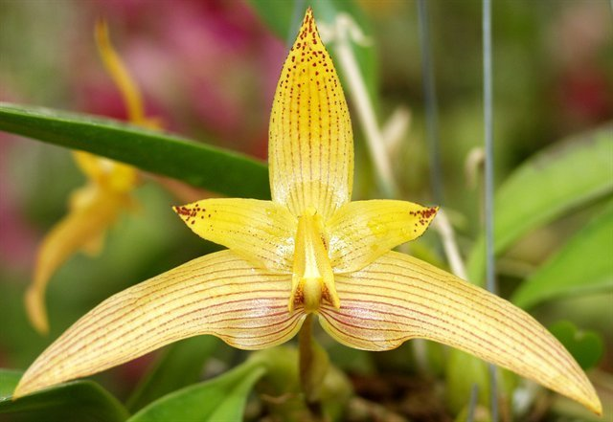

Bulbophyllum Stars and Stripes ‘Sunset Valley Orchids’ HCC/AOS, 79 points, 2004
Photography by Fred Clark

The second Bulbophyllum bicolor hybrid that has six awards is Bulbophyllum Tree Frog, which is (bicolor x macrobulbum). Bulbophyllum Tree Frog was originated by unknown and registered in Krull Smith Orchids in 2020. Bulbophyllum Tree Frog has six AOS awards (FCC - 2; HCC – 1, and AM - 4 ).

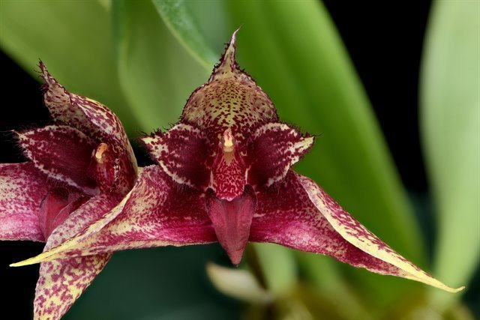

Bulbophyllum Tree Frog
Photography by Mark Duttweiler

References

Averyanov, L. (2012). New orchid taxa and records in the flora of Vietnam. Taiwania 57: 127-152.

Averyanov, L., et al.(2016). New and rare orchids (Orchidaceae) in the flora of Cambodia and Laos. Turczaninowia 19: 5-58.

Averyanov, L., et al. (2016). New species of Orchids (Orchidaceae) in the Flora of Vietnam. Taiwania 61: 319-354.

Govaerts, R. (2003). World Checklist of Monocotyledons Database in ACCESS: 1-71827. The Board of Trustees of the Royal Botanic Gardens, Kew.

Govaerts, R. (1996). World Checklist of Seed Plants 2(1, 2): 1-492. MIM, Deurne.

Kew (n.d.). Bulbophyllum bicolor. Royal Botanical Gardens Kew: Plants of the World Online. Retrieved October 1, 2023, from https://powo.science.kew.org/taxon/urn:lsid:ipni.org:names:618417-1.

OrchidWiz 9X.0.

Sittisujjatham, S. (2006). Wild orchids of Thailand 1: 1-495. Amarin.

Wu, Z. and Hong, D. (2009). Flora of China 25: 1-570. Missouri Botanical Garden Press, St. Louis.

