Bulbophyllum longissimum (Ridl.) J. J. Smith 1912

[lon-GISS-ee-mum]

Nickname: The long petal Bulbophyllum

Origin/Habitat: Thailand. This rare orchid apparently is indigenous to the Thai Peninsula, with collections reported near Phang-nga. Habitat elevation was not reported, so the following climate table and cultural suggestions are based on an estimated elevation and should be used somewhat cautiously. The region is relatively low-lying, however, so the estimated elevation probably is not off by a large amount. -- Source: Charles Baker.

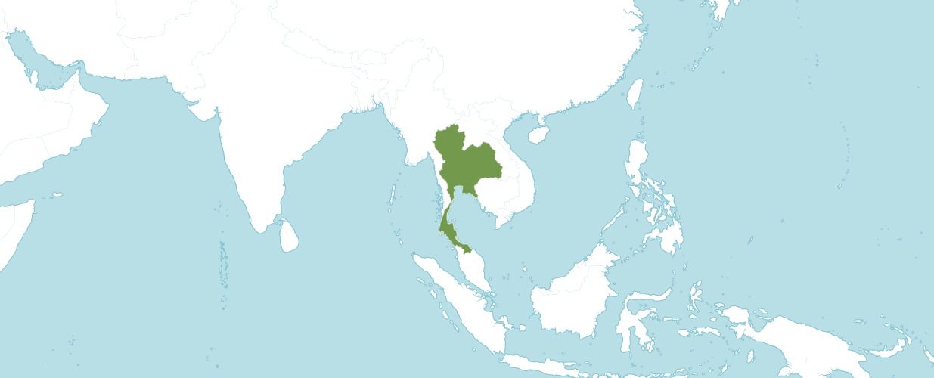
Natural Habitat by Kew

Native to: Thailand

Homotypic Synonyms
Cirrhopetalum longissimum Ridl. in J. Linn. Soc., Bot. 32: 280 (1896)

Plant Size and Type: A rather small epiphyte with growths to about 8 in. (20 cm) tall that are spaced approximately 2 in. (5 cm) apart on a creeping rhizome.

Pseudobulb/Stem: Up to 2 in. (5 cm) long. The glossy, egg-shaped pseudobulb often is vaguely angular.

Leaves: Up to 6 in. (15 cm) long by 2 in. (5 cm) wide. A single, rather rigid, leathery leaf with a blunt tip is carried at the apex of the pseudobulb.

Inflorescence: Up to 8 in. (20 cm) long. The mostly erect flower spike emerges from the base of the pseudobulb. Flowers are carried in an umbel at the apex of the inflorescence.

Flowers: 5-10 per inflorescence. The fragrant, short-lived blossoms are up to 11 in. (27 cm) long. They have a dorsal sepal that more or less arches forward over the column and extremely long, pendulous, thin lateral sepals that taper gradually for more than half their length and then split into two long, thin, threadlike tails toward their tips. The dorsal sepal is about 0.8 in. (2 cm) long, is minutely hairy, and is whitish green with red streaks. The lateral sepals are pale rose-red marked with darker colored veins. The very small petals are somewhat smaller than the dorsal sepal, have ciliate margins and are reddish in color. The small lip is green.

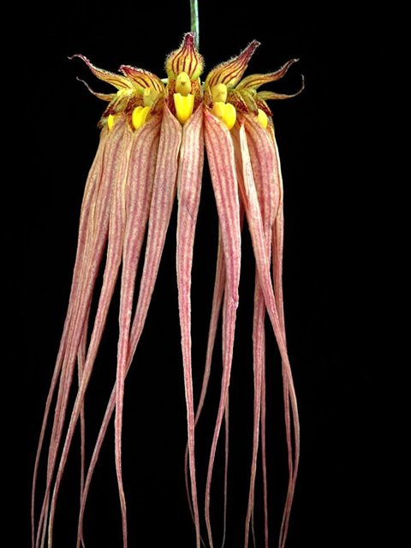

Bulbophyllum longissimum
Photography Manot Quahphanit

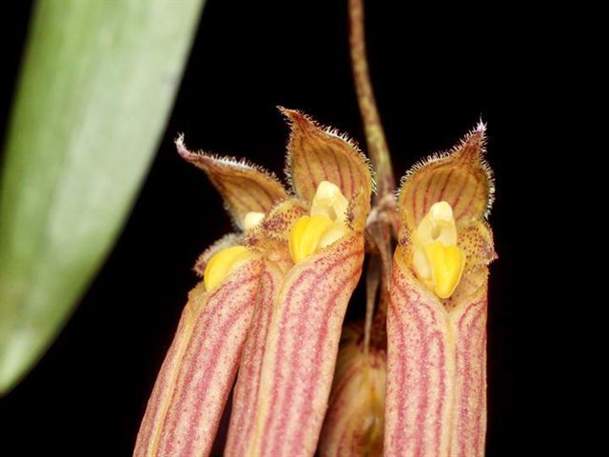

Bulbophyllum longissimum
Photography by Kurt Keller

AOS Awards:

Bulbophyllum longissimum
 | FCC | AM | HCC | AQ | JC | CCM | CCE | CHM | CBM | CBR | TOTAL
AOS | 4 | 5 | 4 | - | - | 3 | 3 | - | 1 | - | 20
Years Awarded | 2007  -  2016 | 1999  -  2017 | 2010  -  2016 |  |  | 1970  -  2011 | 2010  -  2012 |  | 1972

Hybrids
Of the twenty-eight Bulbophyllum longissimum hybrids registered in the F1 generation two were registered in 1936, one was registered in 1969 and the other twenty-five were registered in 2000.

The Bulbophyllum longissimum hybrid with the highest number of offspring and awards is Bulbophyllum Elizabeth Ann, which is (longissimum x rothschildianum). Bulbophyllum Elisabeth Ann has eighteen AOS awards (CCE – 3; CCM - 10; FCC – 2; HCC – 1, and AM - 2).

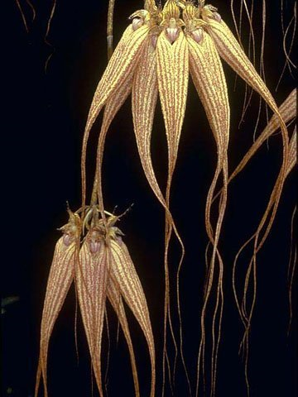

Bulbophyllum Elizabeth Ann ‘Buckleberry’ FCC/AOS, 94 points, 2006
Photography by Judy Cook

Bulbophyllum Elizabeth Ann was originated by S. Low and registered by J. Chambers in 1969. Bulbophyllum Elizabeth Ann has seventeen F1 generation offspring and thirty-two progeny. Of the seventeen F1 generation offspring six or 35.3% received AOS awards.

The Bulbophyllum Elizabeth Ann offspring with the highest number of awards is Bulbophyllum Lovely Elizabeth, which is (Elizabeth Ann x rothschildianum). Bulbophyllum Lovely Elizabeth holds fourteen AOS awards (AM – 6; CCM – 4; HCC – 2; and JC – 2).

Bulbophyllum Lovely Elizabeth has three F1 generation offspring and four progeny.

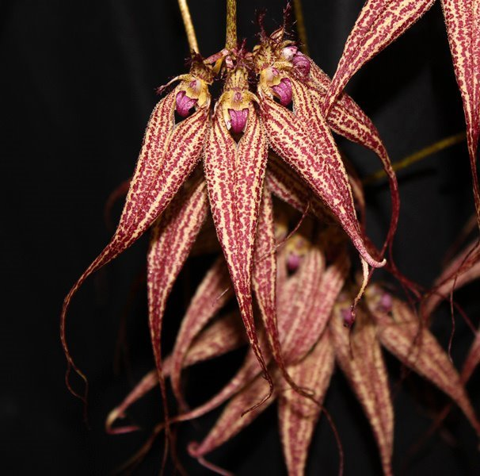

Bulbophyllum Lovely Elizabeth
Photography by Chris Trudgian

The second Bulbophyllum longissimum hybrid with the most awards is Bulbophyllum Emly Siegerist, which is (longissimum x lasiochilum). Bulbophyllum Emly Siegerist was originated by and registered in 1989 by Suphachadiwong. Bulbophyllum Emly Siegerist has seven AOS awards (CCE - 2; CCM – 3; HCC – 1; and AM - 1).

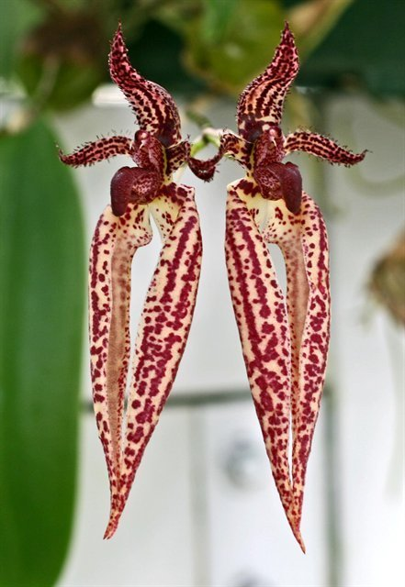

Bulbophyllum Emly Siegerist ‘A-doribil Too’ HCC/AOS 79 points, 2008
Photography by Bill Thomas

Bulbophyllum Emly Siegerist has five F1 generation offspring and six total progeny. No progeny of Bulbophyllum Emly Siegerist have received an AOS award.

References

American Orchid Society. (n.d.). Bulbophyllum. Retrieved October 1, 2023, from https://www.aos.org/orchids/orchids-a-to-z/letter-b/bulbophyllum.aspx.

Govaerts, R. (2003). World Checklist of Monocotyledons Database in ACCESS: 1-71827. The Board of Trustees of the Royal Botanic Gardens, Kew.

Govaerts, R. (1996). World Checklist of Seed Plants 2(1, 2): 1-492. MIM, Deurne.

Hamilton, R. (1988). When does it flower? 2nd ed. Richmond, B. C., Canada.

Hawkes, A. (1965) Encyclopedia of cultivated orchids. Faber and Faber, London.

Kew (n.d.). Bulbophyllum longissimum. Royal Botanical Gardens Kew: Plants of the World Online. Retrieved October 1, 2023, from https://powo.science.kew.org/taxon/urn:lsid:ipni.org:names:619380-1.

OrchidWiz 9X.0.

