Bulbophyllum minutissimum F. Muell., 1878

[mye-new-TISS-i-mum]

Nickname: The Smallest Bulbophyllum. The Red Bead Orchid.

Origin/Habitat: Australia. This extremely diminutive species was originally found in 1849 at a site which is now near the center of the city of Sydney. The species is now known to occur in the coastal lowlands and low mountains from about 60 mi. (100 km) south of Sydney northward to extreme southeastern Queensland. Plants are found mostly on Ficus trees left standing in open fields and on sandstone rocks. The tiny plants normally grow among mosses and lichens, making them very difficult to find in the wild. -- Source: Charles Baker.

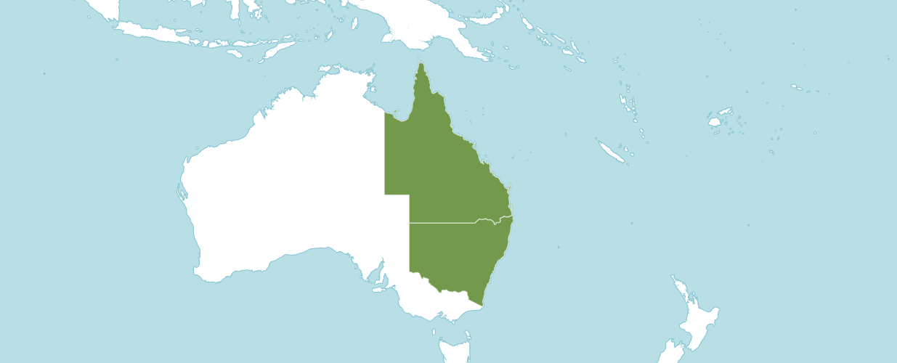
Natural Habitat by Kew

Native to: New South Wales, Queensland

Homotypic Synonyms

Dendrobium minutissimum F. Muell. in Fragm. 5: 95 (1865).

Oncophyllum minutissimum (F. Muell.) D. L. Jones & M. A. Clem. in Orchadian 13: 421 (2001).

Phyllorkis minutissima (F. Muell.) Kuntze in Revis. Gen. Pl. 2: 677 (1891)

Heterotypic Synonyms

Bulbophyllum moniliforme F. Muell. in Gard. Chron., n.s., 9: 818 (1878), nom. illeg.

Bulbophyllum moniliforme R. King in Gard. Chron., n.s., 11: 149 (1879), nom. illeg.

Dendrobium nummulifolium R. King in Gard. Chron., n.s., 11: 789 (1879).

Plant Size and Type: An extremely tiny epiphyte or lithophyte with growths that are closely spaced on a creeping, branching rhizome. Although individual growths are small, this plant is usually formed into a densely packed mass that will eventually form a large mat.

Pseudobulb: 0.1 in. (0.2-0.3 cm) long. The orbicular pseudobulbs are very short, being flattened so that they resemble the head of a pin. They are dark green but are often heavily suffused with red.

Leaves: Less than 1/25 of an inch (less than 0.1 cm) long and very slender. A single extremely tiny green leaf is carried at the apex of each pseudobulb. It is narrowly lanceolate with a sharply pointed tip.

Inflorescence: About 0.1 in. (0.3 cm) long, including both the peduncle and pedicel.

Flowers: A single, rather short-lived blossom (lasting about one week) is carried on each inflorescence. The flowers, which have sepals that open moderately well, are 0.2 in. (0.4-0.5 cm) across. The flowers have cream-colored sepals and petals with three very broad, deep red longitudinal stripes on the sepals and a single deep red stripe on the petals. The lip is red, usually with a pale apex. The red stripes on the sepals and petals along with the red lip give the flower an overall appearance to a casual observer of being completely red. The dorsal sepal is oblong or egg-shaped and 0.1 in. (0.2-0.3 cm) long by 0.1 in. (0.2 cm) wide. The lateral sepals are joined at the base to form a mentum, but the free portion beyond the mentum is about 0.1 in. (0.2 cm) long by 0.1 in. (0.2 cm) wide, more or less triangular in shape, and very bluntly tipped. Petals are about half as long as the sepals and much narrower. The lip is slightly shorter than the sepals and about 0.1 in. (0.1 cm) wide. It is egg-shaped when viewed from above but slightly contracted toward the tip. The column is about 0.1 in. (0.1 cm) long with a forward-curving foot about 0.1 in. (0.15 cm) long. It has a pair of poorly developed rather crescent-shaped wings and apical teeth that do not extend higher than the anther.

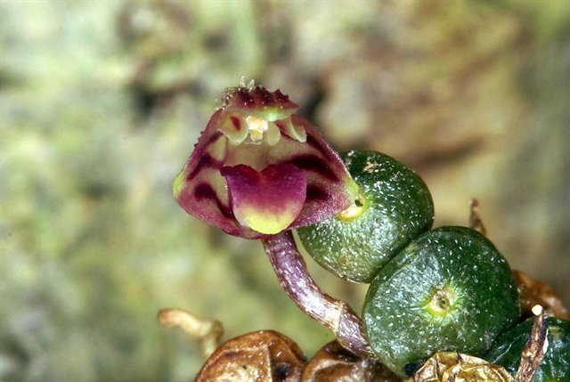
Bulbophyllum minutissimum
Photography by Jonathan Cara

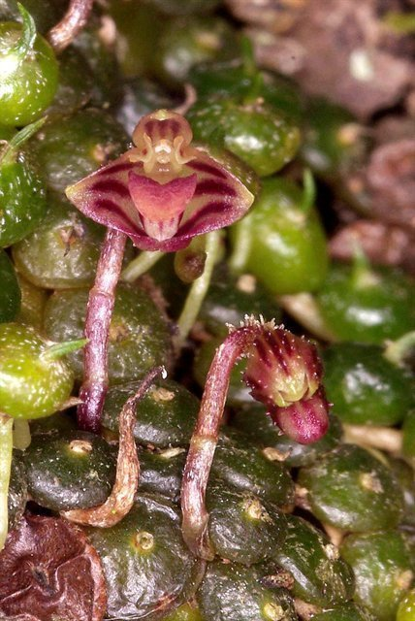
Bulbophyllum minutissimum
Photography by Jonathan Cara

AOS Awards:

No AOS awards found.

Hybrids

No hybrids found.

References

Dockrill, A. (1969). Australian indigenous orchids. Society for Growing Australian Plants, Halstead Press, Sydney, Australia.

Govaerts, R. (2003). World Checklist of Monocotyledons Database in ACCESS: 1-71827. The Board of Trustees of the Royal Botanic Gardens, Kew.

Govaerts, R. (1996). World Checklist of Seed Plants 2(1, 2): 1-492. MIM, Deurne.

Kew (n.d.). Bulbophyllum minutissimum. Royal Botanical Gardens Kew: Plants of the World Online. Retrieved October 2, 2023, from https://powo.science.kew.org/taxon/urn:lsid:ipni.org:names:619548-1.

McQueen, J., and McQueen, B. (1992). Miniature orchids. Timber Press, Portland, OR.

Nicholls, W. (1969). Orchids of Australia. Edited by D. L. Jones and T. B. Muir. Nelson Publishing, Melbourne, Australia.

Northen, R. (1980). Miniature orchids. Van Nostrand Reinhold, New York.

OrchidWiz 9X.0.

Roberts, J. (1992). Bulbophyllum minutissimum F. Muell. The Orchadian 10(8):285.

Walsh, G. (1990). The epiphytic orchids of the Illawarra. The Orchadian 10(1):16-23.

