Broughtonia [Bro.] sanguinea (Sw.) R.Br. (1813)
[san-GWIN-ee-ah]

Common Name: The blood red Broughtonia

ORIGIN/HABITAT: Jamaica. Broughtonia sanguinea is found over most of the island, and it has been reported from sea level and about 2500 ft. (0-760 m). Plants are usually found within about 6 mi. (10 km) of the coast at less than 1600 ft. (490 m), however, and the heaviest concentrations are reported along the coast on the south side of the island near sea level.

PLANT SIZE AND TYPE: A medium-sized 8-10 in. (20-25 cm) sympodial epiphyte.

PSEUDOBULBS: To 2 in. (5 cm) long. Pseudobulbs, which may be globular or somewhat cylindrical, become furrowed with age. They are grayish green, tightly clustered, and often prostrate one against another.

LEAVES: 2 per pseudobulb. Leaves are rigid, oblong, pointed at the tips, and approximately 8 in. (20 cm) long.

INFLORESCENCE: 2 ft. (61 cm) long. The inflorescence, which arises from the apex of the pseudobulb, is slender and wiry with a loosely flowered raceme at the top.

FLOWERS: 8-15 per inflorescence. Blossoms open several at a time. They are very flat when opened fully, and measure 1-2 in. (2-5 cm) across. Flowers are variable in color, but they are usually a shade of red or crimson, but occasional white or yellow clones occur. Sepals are slender, petals broad and oval, and the lip is round and ruffled. All parts are beautifully veined.

The native range of this species is Jamaica. It is a pseudobulbous epiphyte and grows primarily in the wet tropical biome.

Habitat Broughtonia

Native to: Jamaca

Homotypic Synonyms
Broughtonia coccinea Hook. in Bot. Mag. 63: t. 3536 (1836), nom. illeg.

Dendrobium sanguineum (Sw.) Sw. in Nova Acta Regiae Soc. Sci. Upsal., ser. 2, 6: 82 (1799)

Epidendrum sanguineum Sw. in Prodr. Veg. Ind. Occ.: 124 (1788)

From the American Orchid Society - Described by R. Brown in 1813 and named to honor Arthur Broughton, an English botanist who collected in Jamaica in the early nineteenth century, Broughtonia is closely allied to Laeliopsis and Cattleyopsis and the World Monocot Checklist currently considers both genera to be synonymous with Broughtonia. The genus is characterized by conspicuous, usually flattened and tightly clustered, typically bifoliate, pseudobulbs and moderately long cylindrical inflorescences that carry the brightly colored flowers clustered near the apex. The many color forms of B. sanguinea are found in collections. Colors range from deep pink to white or yellow.

Carl Withner reports in his book, The Cattleyas and Their Relatives, volume IV: The Bahamian and Caribbean Species, Robert Brown described the genus in 1813, naming Broughtonia sanguinea as the first species. He pointed out the presence of a nectary tube attached to the ovary. In addition, Robert pointed out the footless column clasped by the lateral edges of the lip base as a distinguished characteristic of the genus, (The Cattleyas and Their Relatives, Volume IV, page 15).

Broughtonia sanguinea has had a considerable influence on orchid hybridization. Broughtonia sanguinea has multiple color forms which allow for producing offspring of assorted colors. Broughtonia sanguinea installs several positive characteristics in its offspring and several post generation progeny, such as round, flat form to the flowers, wide and overlapping petals and sepals, an intensity of rose color, flowers in a cluster at the end of a comparatively long inflorescence, a show display of flowers for the size of the plant, early seedling maturity, a tolerance of heat and sun, and ability to grown well in baskets or on slabs. Hybrids of Broughtonia sanguinea adapt well to outdoor culture, where warmth and humidity are present.

The negative influences Broughtonia sanguinea imparts to its offspring are plants are unusually susceptible to certain pesticide sprays, such as malathion. In addition, offspring, and progeny of Broughtonia sanguinea are vulnerable to rot from over watering, especially during their period of dormancy. Broughtonia sanguinea offspring and some progeny prefer to be mounted with their roots exposed.

Wiki noted Broughtonia sanguinea, also known as blood red broughtonia, is a plant in the genus Broughtonia, a member of the family Orchidaceae. It was named in 1813 by its first describer, Robert Brown, for 18th century English botanist Arthur Broughton.

Broughtonia sanguinea is a species native to Jamaica. Its small, egg-shaped, and compact pseudobulbs measure from 2.5 to 5 centimeters in size. On the top of each pseudobulb, there are two 15–20 cm (6–8 in) long leaves. The leaves have a hard texture and do not break easily, and measures to be about 15–25 mm (1⁄2–1 in) wide. The flower spikes grow to 60 cm (2 ft) and produces long, clustered red flowers 25–50 mm (1–2 in)[3] in size. The spikes are able to bloom for several months and the plant is able to bloom twice per year or more.

Flowers
The flowers are typically red and flower in the late winter to spring and a hint of yellow at the base. The flowers are produced on long arching spikes (inflorescences) that emerge from the top of the pseudobulbs. Each spike bears up to sixteen or more flowers. Plants prefer comparatively warm to hot growing conditions (25 - 35 Celsius) and about 70% humidity and brightly lit conditions of approximately 25,000 - 30,000 lux.

AOS Awards:

Broughtonia sanguinea
 | FCC | AM | HCC | AQ | JC | CCM | CCE | CHM | CBM | CBR | TOTAL
AOS | 2 | 75 | 24 | 5 | 5 | 7 | - | - | 2 | - | 120
Years Awarded | 1994  -  2019 | 1963 - 2022 | 1980  -  2013 | 1987  -  2008 | 1960  -  2019 | 1974 –  2017 | - | - | 1957 &  1962 | -

One hundred twenty American Orchid Society awards averaging 12.0 flowers and buds per inflorescences; 4.1 cm. median natural spread.

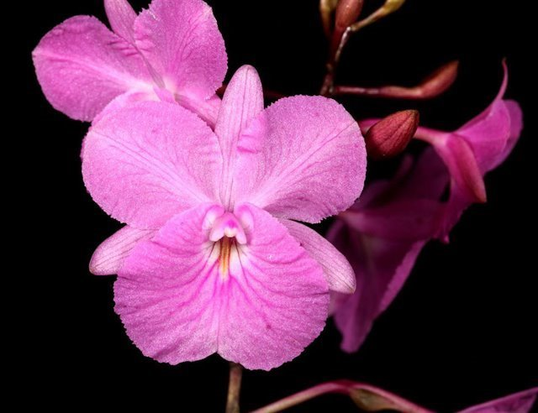
Broughtonia sanguinea ‘Hamlyn’s Treasure’ AM/AOS, 87 points, 2019
Photograph by Claude Hamilton
Natural spread 4.8 cm, 5 Flowers, 9 Buds, 1 Inflorescence

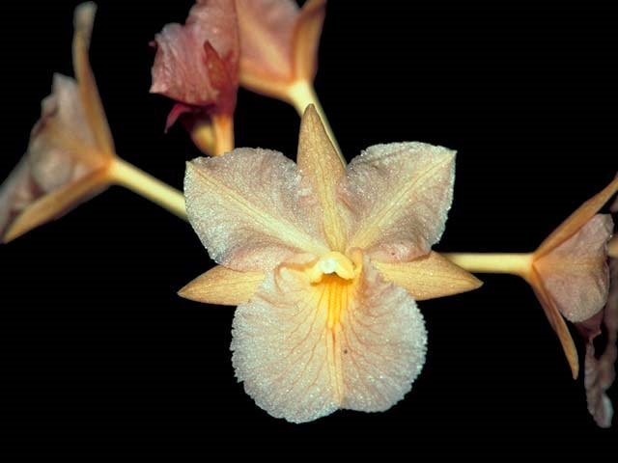
Broughtonia sanguinea ‘Hamlyn’s Peachy’ JC/AOS, 1993
Photograph by OWZ Lib
7 Flowers, 2 Buds, 2 Inflorescence

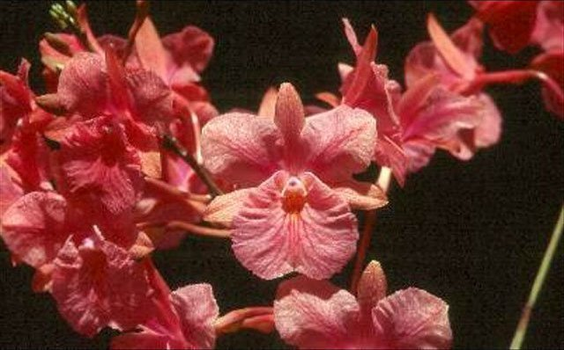
Broughtonia sanguinea ‘Hamlyn’s Pink Salmon’ AM/AOS, 83 points, 2005
Photograph by Claude Hamilton
Natural spread 3.8 cm, 41 Flowers, 26 Buds, 2 Inflorescences
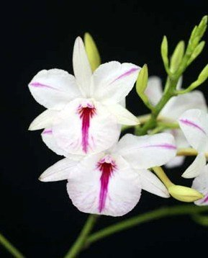
Broughtonia sanguinea h.f. aquinii ‘Hamlyn’s Splash’ AM/AOS, 82 points, 2008
Photograph by Claude Hamilton
Natural spread 3.8 cm, 17 Flowers, 40 Buds, 2 Inflorescences

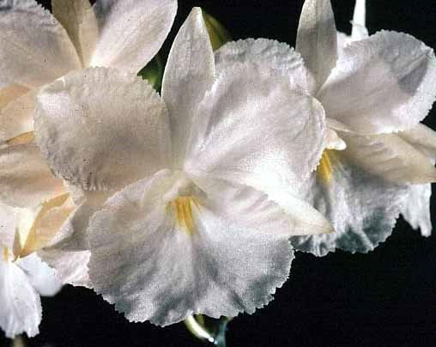
Broughtonia sanguinea h.f. alba ‘Snowflake’ HCC/AOS, 78 points, 2001
Photograph by Dennis Fujimoto
Natural spread 4.0 cm, 11 Flowers, 3 Buds, 1 Inflorescence

Broughtonia sanguinea Progeny

Five Generation of Progeny
G | Grexes | Awdd. | % Awdd. | Awds
1 | 137 | 34 | 24.8% | 258
2 | 540 | 134 | 24.8% | 383
3 | 285 | 46 | 16.1% | 118
4 | 110 | 11 | 10.0% | 42
5 | 8 | 1 | 12.5% | 1

Broughtonia sanguinea has one hundred thirty-seven F1 offspring. Broughtonia sanguinea has 1,080 progeny.

Hybrids
One hundred thirty-seven F1 generation offspring found, thirty-four or 24.8% have been awarded. Broughtonia sanguinea has one thousand eighty progeny. Of the one hundred thirty-seven F1 generation hybrids registered, Broughtonia sanguinea was used thirty-two times as the seed parent and one hundred five times as the pollen parent. The first Broughtonia sanguinea hybrid was registered in 1956, Grt Rosy Jewel, (Broughtonia sanguinea x Gur bowingiana). Grt Rosy Jewel originated and registered in 1956 by W. W. G. Moir. There were one hundred thirty-seven registrations of Broughtonia sanguinea hybrids from 1956 to 1911. No Prosthechea vitellina hybrids were registered from 1911 to 2020. Registrations of Prosthechea vitellina has been steady from 1956 to 2020.

The Broughtonia sanguinea hybrid having the largest number registered offspring is Ctna Keith Roth, (Broughtonia sanguinea x Cattleya bicolor). Ctna Keith Roth has had one hundred ninety-two F1 offspring and five hundred ninety-seven progeny registered. Ctna Keith Roth has received five American Orchid Society awards (AM – 3 (1968, 1972, and 1981); and HCC – 2 (1968 and 1981)), averaging 4.6 flowers and buds per inflorescence; 5.4 natural spread. Ctna Keith Roth was originated by and registered in 1966 by Fields Orchids.

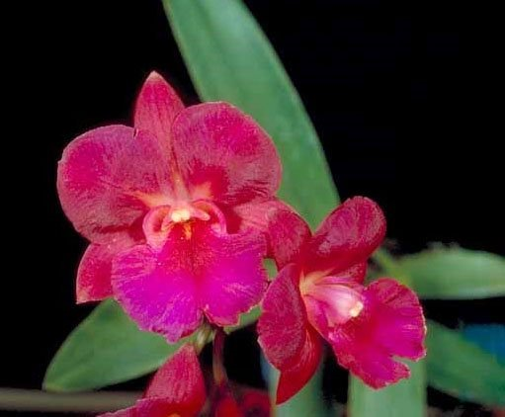
Ctna Keith Roth ‘Chips’ HCC/AOS, 77 points, 1981
Photograph by OWZ Lib
Natural Spread – 4.9 cm, 3 Flowers, 1 Bud, 1 Inflorescence

References

American Orchid Society. (n.d.). Broughtonia. https://www.aos.org/orchids/orchids-a-to-z/letter-b/broughtonia.aspx#:~:text=sanguinea%2C%20ranging%20from%20dark%20pink,flowers%20and%20compact%20growth%20habirit.

Acevedo-Rodríguez, P. and Strong, M. (2012). Catalogue of seed plants of the West Indies. Smithsonian Contributions to Botany 98: 1-1192.

Adams, M. (1989). A revision of the West Indian orchid genera Broughtonia Robert Brown, Cattleyopsis Lemaire, and Laeliopsis Lindley. Orchid Digest 53(1):39-42.

Bassin, H. (1981). Broughtonia plus—a tale of two islands. American Orchid Society Bulletin, Vol. 50, No. 12.

Bechtel, H., Cribb, P., and Launert, E. (1980). Manual of cultivated orchid species. MIT Press, Cambridge.

Bui, H. (1983). Broughtonia sanguinea hybrids—the orchids of the 80's. American Orchid Society Bulletin, Vol. 52, No. 2.

Fowlie, J. (1967). The enigmatic Broughtonias of Jamaica. Orchid Digest 31(3):69-72.

Gipson, G. (1983). Orchid hunting in Jamaica. American Orchid Society Bulletin, Vol. 52, No. 8.

Gloudon, A. and Tobisch, C. (1995). Orchids of Jamaica. The Press, University of the West Indies, 1A Aqueduct Flats, Mona Campus, Kingston, Jamaica, W1.

Govaerts, R. (2003). World checklist of monocotyledons database in ACCESS: 1-71827. The Board of Trustees of the Royal Botanic Gardens, Kew.

Govaerts, R. (1996). World checklist of seed plants 2(1, 2): 1-492. MIM, Deurne.

Hamilton, R. (1988). When does it flower? 2nd ed. Richmond, B.C., Canada.

Hawkes, A. (1987). Encyclopaedia of cultivated orchids. Faber and Faber, London.

McQueen, J., and McQueen, B. (1992). Miniature orchids. Timber Press, Portland, OR.

Northen, R. (1970). Home orchid growing. Van Nostrand Reinhold, New York.

Northen, R. (1980). Miniature orchids. Van Nostrand Reinhold, New York.

OrchidPro. (n.d.).

OrchidWiz X9.0. (n.d.).

Royal Botanical Gardens Kew, Plants of the World On-line. (n.d.). https://powo.science.kew.org/taxon/urn:lsid:ipni.org:names:1008135-2.

Sauleda, R. and Skelsey, A. (1979). Orchids. In: Time-Life encyclopedia of gardening. Time-Life Books, Alexandria, Va.

Werther, M. (1987). Broughtonia sanguinea and its hybrids. American Orchid Society Bulletin, Vol. 56, No. 12.

Withner, C. (1996). The cattleyas and their relatives, vol. 4: the Bahamian and Caribbean species. Timber Press, Portland, OR.

