Encyclia alata (Bateman) Schltr., 1914
[al-AH-ta]

Common Name: Winged Encyclia.

Meaning: Winged

From Charles Baker Culture Sheet: ORIGIN/HABITAT: Distributed from southern Mexico through Belize, Guatemala, Honduras, Nicaragua, and Costa Rica. In Mexico, these plants are found in the States of Campeche, Chiapas, Quintana Roo, Veracruz, and Yucatan. They grow in tropical semideciduous forest and oak forest at 300-4250 ft. (100-1300 m) on slopes facing the Gulf of Mexico and the Caribbean.

PLANT SIZE AND TYPE: A robust, clump-forming sympodial epiphyte that may grow to as much as 23 in. (58 cm) tall.

PSEUDOBULB: To 5 in. (13 cm) tall. The clustered, pear-shaped pseudobulbs are sheathed when young.

LEAVES: 4-20 in. (10-50 cm) long. Usually 2 rather rigidly leathery, narrowly linear-lanceolate leaves are carried at the top of the pseudobulb, but there may sometimes be 3 or more. They are 0.4-2.0 in. (1-5 cm) wide, taper to a sharp point at the tip, and have short, tubular stalks at the base.

INFLORESCENCE: Usually 16-35 in. (40-90 cm) long, but often more than 39 in. (100 cm) long. The stiff, erect inflorescence, which may be simple or branched, emerges from between the leaves at the top of the most recently matured pseudobulb.

FLOWERS: A few to many blossoms are carried in a loose raceme or compound panicle near the top of the long flower spike. The spicily fragrant flowers are variable in size and color but are usually 2.0-2.5 in. (5.0-6.3 cm) across. Sepals and petals are usually yellowish green marked, mostly near their tips, with purple or purplish brown. The wide-spreading sepals and petals are rather narrow and may be bluntly or rather sharply pointed. The 3-lobed lip is usually a dirty white with some brownish or purple suffusions or marks. The wide-spreading side lobes are widest near their rounded tips. The central part of the widely spread midlobe has several raised purple or red-brown lines which change into broken wart-like projections near the very wavy apical margin. The relatively short, somewhat arched, club shaped column is widest at the tip. It is yellow green, speckled with red, and has a pinkish anther cap.

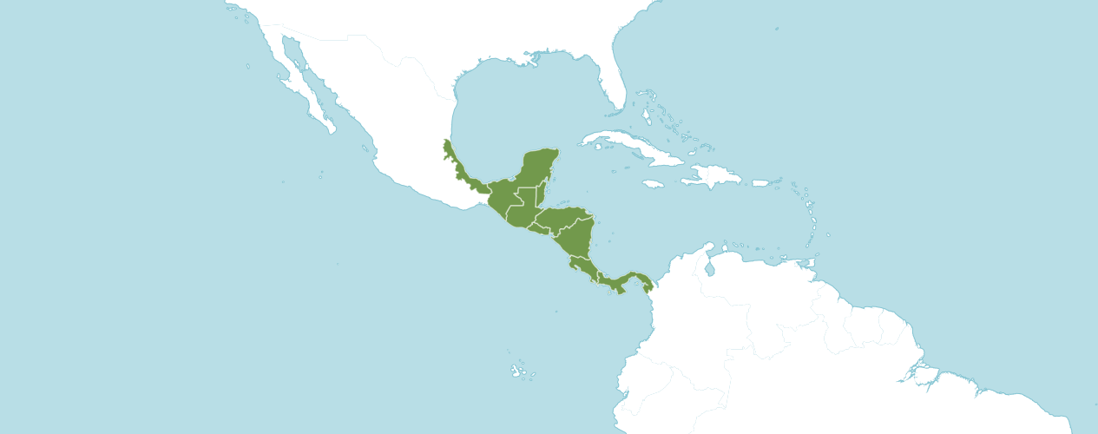
Natural Habitat by Kew

Native to: Belize, Costa Rica, El Salvador, Guatemala, Honduras, Mexico Gulf, Mexico Southeast, Nicaragua, Panamá.

Homotypic Synonyms

Epidendrum alatum Bateman in Proc. Hort. Soc. London 1838(2): 25 (1838)

Heterotypic Synonyms

Epidendrum alatum var. grandiflorum Regel in Ann. Sci. Nat., Bot., sér. 4, 6: 374 (1856)

Epidendrum alatum var. longipetalum Regel in Ann. Sci. Nat., Bot., sér. 4, 6: 374 (1856)

Epidendrum calocheilum Hook. in Bot. Mag. 68: t. 3898 (1841)

Epidendrum formosum Klotzsch in Allg. Gartenzeitung 21: 201 (1853)

Epidendrum longipetalum Lindl. & Paxton in Paxton's Fl. Gard. 1: 149 (1850), nom. illeg.

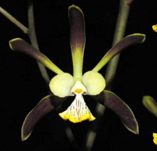

Encyclia alata ‘Beautiful Pamela’
Photograph by Garrie Brumley

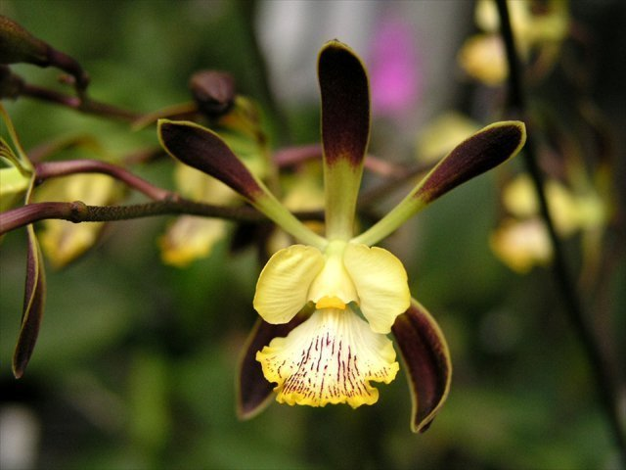

Encyclia alata ‘Early Bird’ AM/AOS, 82 points, 2006
Photograph by Jean Wilson
Alanta Judging Center Monthly Judging

AOS Awards:

Encyclia alata
 | FCC | AM | HCC | AQ | JC | CCM | CCE | CHM | CBM | CBR | TOTAL
AOS | 0 | 16 | 20 | 0 | 6 | 10 | 2 | 2 | 1 | 0 | 57
Years Awarded | - | 1981  -  2022 | 1971 - 2010 | - | 1985 - 2006 | 1981  -  2005 | 2001  &  2004 | 1985  &  2004 | 1957 | -

Fifty-seven awards averaging 42.9 flowers and buds per inflorescences; 4.5 cm. natural spread.

Hybrids
Of the ninety-seven F1 generation offspring found, twenty-five or 25.8% have been awarded. Encyclia alata has two hundred forty-four progeny. Of the ninety-seven F1 generation hybrids registered, Encyclia alata was used thirty-two times as the seed parent and sixty-five times as the pollen parent. The first Encyclia alata hybrid registered in 1955, Encyclia Gail Nakagki (Encyclia alata x Encyclia cordigera). Encyclia Gail Nakagki was originated by Tatsumura and registered in 1955 by Mr. and Mrs. S. Noda. The first registration of Encyclia alata hybrids was registered in 1955 with noted steady registration of crosses to 2022.

The Encyclia alata hybrid that appears to have the most significance is Encyclia Orchid Jungle (phoenciea x alata). Encyclia Orchid Jungle originated and registered in 1984 by Fennell Orchids. Encyclia Orchid Jungle has received thirty-four AOS awards: (FCC – 1; AM – 18; HCC – 8; AQ – 2; and CCM – 5).

Encyclia Orchid Jungle has forty-three F1 generation offspring and eighty-nine progeny.

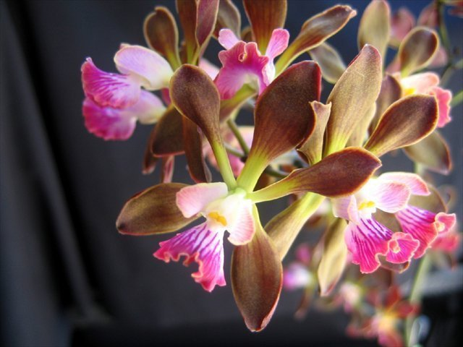
Encyclia Orchid Jungle ‘Epijim’ AM/AOS, 81 points, 2005
Photograph by James Jeansonne
New Orleans Orchid Society Show
From reviewing data and photographs from OrchidWiz, flowers of Encyclia alata tend to be stellated with fenestration. Encyclia alata has a proclivity to pass on dark coloring in sepals and petals of its offspring, depending on the coloring of the secondary parent. More frequently than not Encyclia alata offspring inherit its lip shape. Encyclia alata offspring inherit floriferousness.

References

American Orchid Society. (n.d.). Encyclia. https://www.aos.org/orchids/orchids-a-to-z/letter-e/encyclia.aspx.
Bastos, C., Meneguzzo, T., and van den Berg, C. (2018). A taxonomic revision of the Brazilian species of Encyclia (Orchidaceae: Epidendroideae: Epidendreae). Phytotaxa 342: 1-84.
Bechtel, H., Cribb, P., and Launert, E. (1992). The Manual of cultivated orchids. The MIT Press, Cambridge, Massachusetts.
Curtin, M. (2020). Encyclia species and hybrids with Mike Curtin. American Orchid Society. https://www.aos.org/all-about-orchids/webinars/member-only/encyclia,-a-look-at-the-species-and-hybrids.aspx.
Dressler, R. (1993). Field guide to the orchids of Costa Rica and Panama. Comstock Publishing Associates, Ithaca, New York
Dressler, R., and Pollard, G. (1976). The genus Encyclia in Mexico. Asociation Mexicana de Orquideologia, A. C., Mexico City, Mexico.
Govaerts, R. (2003). World checklist of monocotyledons Database in ACCESS: 1-71827. The Board of Trustees of the Royal Botanic Gardens, Kew.
Hammel, B. et al. (2003). Manual de plantas de Costa Rica 3: 1-884. Missouri Botanical Garden Press, St. Louis.
OrchidPro. (n.d.).
OrchidWiz X9.0. (n.d.).
Pridgeon, A., Cribb, P., Chase, M., and Rasmussen, F. (2006). Epidendroideae (Part One). Genera Orchidacearum 4: 1-672. Oxford University Press, New York, Oxford.
Pupulin, F. and Bogarín, D. (2012). A taxonomic revision of Encyclia (Orchidaceae: Laeliinae) in Costa Rica. Botanical Journal of the Linnean Society 168: 395-448.
Royal Botanical Gardens Kew, Plants of the World On-line. (n.d.). Encyclia alata. https://powo.science.kew.org/taxon/urn:lsid:ipni.org:names:90737-2.
Withner, C. (2000). The Cattleyas and their relatives. Volume VI. The South American Encyclia Species. Timber press, Portland, Oregon.

