Encyclia cordigera (Kunth) Dressler, 1964
[kor-dih-GEER-uh]

Common Name: Large-lipped Encyclia.

Meaning: Wearing a heart.

From Charles Baker Culture Sheet: Origin/habitat: Distributed from southern Mexico, through Central America, the West Indies, and into Colombia and Venezuela. E. cordigera is common in the rather dry, scrubby forests of coastal regions from sea level to 2950 ft. (900 m) on both the Pacific and Atlantic sides of the dividing mountain range. In Central America, it is more common on the Pacific side.

PLANT SIZE AND TYPE: A moderate to large sympodial epiphyte 12-24 in. (30-60 cm) tall.

PSEUDOBULBS: 1-4 in. (3-11 cm) tall. Pseudobulbs are erect, clustered on a short connecting rhizome, and conical to pear-shaped.

LEAVES: Usually, 2 per growth. The leaves, which arise from the top of the pseudobulb, are strap shaped, leathery, and 6-18 in. (15-47 cm) tall.

INFLORESCENCE: 1 per growth. The spike arises from between the leaves at the top of the pseudobulb. It is 6-30 in. (15-76 cm) long, erect to arching, and usually simple, but may occasionally branch.

FLOWERS: 3-15 per inflorescence. Blossoms are 2-3 in. (5-8 cm) across, long lasting, and all open at about the same time. They are very fragrant when in direct sunlight. However, the fragrance rapidly disappears if the flowers are shaded, even by a passing cloud. The sepals and petals are green, heavily overlaid with brown or purplish brown. The lip may be white or magenta. Plants from northern South America and Costa Rica usually produce flowers with white lips which are marked with a small magenta spot or streak in the center of the mid-lobe, while flowers on plants from Panama and Mexico normally have lips that are entirely flushed with magenta.

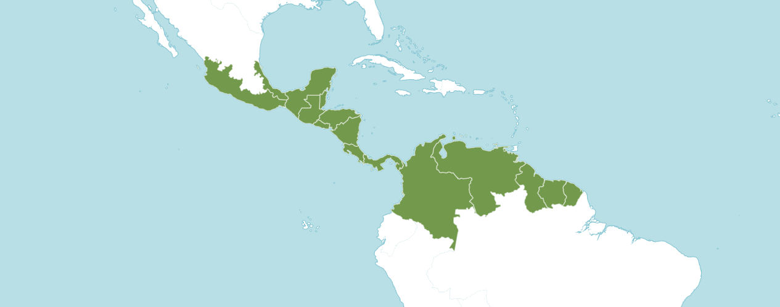
Natural Habitat by Kew

Native to: Belize, Colombia, Costa Rica, El Salvador, French Guiana, Guatemala, Guyana, Honduras, Mexico Gulf, Mexico Southeast, Mexico Southwest, Netherlands Antilles, Nicaragua, Panamá, Suriname, Venezuela, Venezuelan Antilles.

Homotypic Synonyms

Cymbidium cordigerum Kunth in F. W .H. von Humboldt, A. J. A. Bonpland & C. S. Kunth, Nov. Gen. Sp. 1: 341 (1816)

Epidendrum cordigerum (Kunth) Foldats in Bol. Soc. Venez. Ci. Nat. 28: 234 (1969)

Heterotypic Synonyms

Encyclia atropurpurea var. leucantha Schltr. in Repert. Spec. Nov. Regni Veg. Beih. 17: 45 (1922)

Encyclia atropurpurea var. rhodoglossa Schltr. in Repert. Spec. Nov. Regni Veg. Beih. 17: 45 (1922)

Encyclia atropurpurea var. rosea (Bateman) Summerh. in Bot. Mag. 171: t. 290 (1957)

Encyclia cordigera f. leucantha (Schltr.) Withner in Cattleyas & Relatives 5: 104 (1998)

Encyclia cordigera var. rosea (Bateman) H. G. Jones in Darwiniana 15: 23 (1969)

Encyclia doeringii Hoehne in Arq. Bot. Estado São Paulo, n.s., f.m., 2: 24 (1946)

Encyclia macrochila (Hook.) Neumann in Rev. Hort. (Paris), sér. 2, 4: 137 (1846)

Epidendrum atropurpureum var. laciniatum Ames, F. T. Hubb. & C. Schweinf. in Bot. Mus. Leafl. 3: 63 (1935)

Epidendrum atropurpureum var. roseum (Bateman) Rchb.f. in Bonplandia (Hannover) 2: 19 (1854)

Epidendrum doeringii (Hoehne) A.D. Hawkes in Orquídea (Rio de Janeiro) 18: 170 (1957)

Epidendrum longipetalum God.-Leb. in Orchidophile (Argenteuil) 12: 257 (1892), nom. illeg.

Epidendrum macrochilum Hook. in Bot. Mag. 63: t. 3534 (1836)

Epidendrum macrochilum var. albopurpurea C. Morren in Ann. Soc. Roy. Agric. Gand 2: 365, t. 86 (1846)

Epidendrum macrochilum var. roseum Bateman in Orchid. Mexico Guatemala: t. 17 (1840)

Limodorum purpureum Lour. ex Steud. in Nomencl. Bot., ed. 2, 2: 46 (1841)

Epidendrum longipetalum Lindl. & Paxton in Paxton's Fl. Gard. 1: 149 (1850), nom. illeg.

The American Orchid Society provides the following information: Spring ushers in the beginning of Encyclia season and there are many excellent species in the genus whose peak flowering begins around Mother’s Day. One of the favorites is Encyclia cordigera (Kunth) Dressler. Long known as Epidendrum atropurpureum, this beautiful orchid ranges from Mexico, though Central America and Northern South America, and reportedly into Brazil. Like many wide-ranging orchids, Encyclia cordigera is adaptable to varying cultural conditions and makes a good subject for hobbyist orchid collections. This species is found in three color forms making it even more desirable.

Encyclia cordigera has travelled a rocky road of nomenclature. Having been originally described as Cymbidium cordigerum by Humboldt, Bonpland and Kunth in 1815, Reichenbach erroneously misapplied Epidendrum atropurpureum va. roseum to the pink-lipped form, an error that stood well past Dressler's 1964 correction to the current name. To confuse matters even more, Linden published a plate of Epidendrum atropurpureum var. randii picturing a white-lipped Encyclia in Lindenia in 1886. Although Linden acknowledged the obvious differences from Epidendrum atropurpureum, he went on to say "we have not considered there to be any reason for creating a new species". The plant actually pictured in Lindenia is a distinct Brazilian species, Encyclia randii, and the epithet "randii" should never be applied to Encyclia cordigera. Yet even today, semi-alba plants of our subject can still be found in the trade labeled as Encyclya cordigera var. randii. The third color form lacks any anthocyanin pigment and is less commonly seen. Withner describes plants with green petals and sepals and clear white lip as Encyclia cordigera forma leucantha, although in the trade they are usually labelled as var. alba. Major databases only accept Encyclia cordigera (Kunth) Dressler and relegate the color forms as synonyms.

Many consider the large showy flowers of Encyclia cordigera to be the finest in the genus. They have an intoxicating fragrance that varies slightly from plant to plant, but some say the pink-lipped flowers smell like roses. Flowers can last for well over a month. The species has received over 40 AOS awards, both for quality and for culture. The best flowers have a broad, flat, skirt-shaped lip with saturated color for the pink-lipped form, and a well-defined magenta central splotch for the semi-albas. Encyclia cordigera has been used as a parent both within the genus and with other members of the Cattleya alliance to create intergeneric hybrids such as the legendary Epicattleya (syn. Catyclia) Florida, registered by Lewis Vaughn in 1965 (Cattleya dowiana x Enc. cordigera).

Encyclia cordigera is easy to grow under a wide range of conditions. Its natural habitats are low-elevation oak forests that are fairly dry and bright. It can be grown in the intermediate temperature range but will do equally well in warmer conditions. The best flowering will occur if plants are grown bright but they will grow and flower under as little as 2000-foot candles. Plants can be potted in a coarse open media but if you have a tendency to overwater, a mount or basket is a preferable option and will maintain healthy roots better. This species does not tolerate stale, dank potting media. The tightly clustered pseudobulbs can be as big as an onion on healthy plants but a mature plant does not take up much space and can be accommodated even in small collections. Like all encyclias, be alert for scale between those tightly packed pseudobulbs. It can get well established before you notice, and then it is more difficult to eradicate. Keeping dry sheaths peeled away makes inspection easier. - AOS Publications Committee

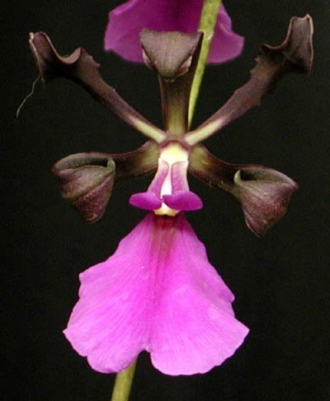

Encyclia cordigera ‘Cariads Nubien’
Photograph by Stewart Orchids
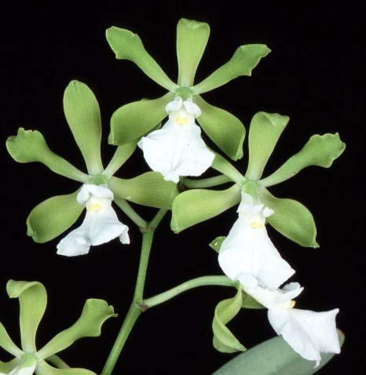

Encyclia cordigera h.f. alba ‘Henrique’ HCC/AOS, 78 points, 1990
Photograph by Fred Clarke

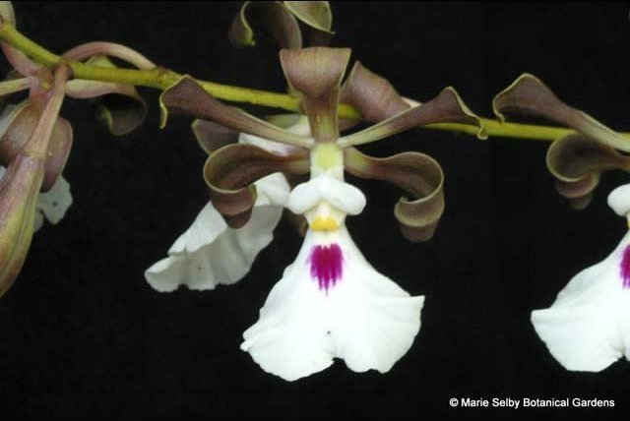

Encyclia cordigera
Photography by Phil Nelson
AOS Awards:

Encyclia cordigera
 | FCC | AM | HCC | AQ | JC | CCM | CCE | CHM | CBM | CBR | TOTAL
AOS | 4 | 24 | 9 | 0 | 4 | 8 | 2 | 2 | 0 | 0 | 53
Years Awarded | 2013  -  2022 | 1977  -  2022 | 1981 - 2008 | - | 1971 - 2006 | 1987  -  2022 | 2001  &  2004 | 1988  &  2000 | - | -

Fifty-three awards averaging 15.8 flowers and buds per inflorescences; 5.7 cm. natural spread.

Hybrids
Of the two hundred seventeen F1 generation offspring found, sixty or 27.6% have been awarded. Encyclia cordigera has three hundred seventy-three progeny. Of the two hundred seventeen F1 generation hybrids registered, Encyclia cordigera was used forty-two times as the seed parent and one hundred seventy-five times as the pollen parent. The first Encyclia cordigera hybrid was an intergeneric cross registered in 1904, Cty. Distincta (Encyclia cordigera x Cattleya harpophylla). The first registration of Encyclia cordigera hybrids were registered between 1904 to 1909. Hybrids of Encyclia cordigera were not registered again until the late 1940’s and continue until the last recorded hybrid registered in 2022.

The Encyclia cordigera hybrid that appears to have the most significance is Encyclia Rioclarense (Encyclia randii x Encyclia cordigera). Encyclia Rioclarense originated by E. Wenzel and registered in 1994 by M. Werther. Encyclia Rioclarense has received fourteen AOS awards: (AM – 7; HCC – 6; and CCM – 1). Encyclia Rioclarense has twelve F1 generation offspring and thirteen progeny.

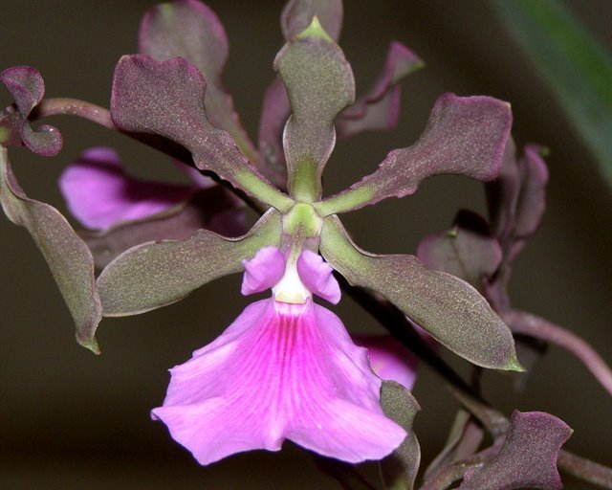

Encyclia Rioclarense ‘Silver Creek’ AM/AOS, 80 points, 2014
Photograph by Lois Cinert
Chicago Center Monthly Judging
From reviewing data and photographs from OrchidWiz, flowers of Encyclia cordigera hybrids tend to be stellate with fenestration. Depending on the secondary parent of Encyclia cordigera hybrids the lip shape of Encyclia cordigera and the dark fuchsia / pink lip coloration and midline lip coloring tend to be dominant. Encyclia cordigera installs in its progeny floriferousness.

References

American Orchid Society. (n.d.). Encyclia cordigera. https://www.aos.org/orchids/collectors-items/encyclia-cordigera.aspx.
Bastos, C., Meneguzzo, T., and van den Berg, C. (2018). A taxonomic revision of the Brazilian species of Encyclia (Orchidaceae: Epidendroideae: Epidendreae). Phytotaxa 342: 1-84.
Bechtel, H., Cribb, P., and Launert, E. (1992). The Manual of cultivated orchids. The MIT Press, Cambridge, Massachusetts.
Curtin, M. (2020). Encyclia species and hybrids with Mike Curtin. American Orchid Society. https://www.aos.org/all-about-orchids/webinars/member-only/encyclia,-a-look-at-the-species-and-hybrids.aspx.
Dressler, R. (1993). Field guide to the orchids of Costa Rica and Panama. Comstock Publishing Associates, Ithaca, New York
Dressler, R., and Pollard, G. (1976). The genus Encyclia in Mexico. Asociation Mexicana de Orquideologia, A. C., Mexico City, Mexico.
Govaerts, R. (2003). World checklist of monocotyledons Database in ACCESS: 1-71827. The Board of Trustees of the Royal Botanic Gardens, Kew.
Hammel, B. et al. (2003). Manual de plantas de Costa Rica 3: 1-884. Missouri Botanical Garden Press, St. Louis.
OrchidPro. (n.d.).
OrchidWiz X9.0. (n.d.).
Pridgeon, A., Cribb, P., Chase, M., and Rasmussen, F. (2006). Epidendroideae (Part One). Genera Orchidacearum 4: 1-672. Oxford University Press, New York, Oxford.
Pupulin, F. and Bogarín, D. (2012). A taxonomic revision of Encyclia (Orchidaceae: Laeliinae) in Costa Rica. Botanical Journal of the Linnean Society 168: 395-448.
Royal Botanical Gardens Kew, Plants of the World On-line. (n.d.). Encyclia cordigera. https://powo.science.kew.org/taxon/urn:lsid:ipni.org:names:90737-2.
Withner, C. (2000). The Cattleyas and their relatives. Volume VI. The South American Encyclia Species. Timber press, Portland, Oregon.

