Encyclia tampensis (Lindl.) Small, 1913

Common Name: Florida Butterfly Orchid or Tampa, Encyclia.

Meaning: from Tampa, Florida

From Charles Baker Culture Sheet: Oigin/Habitat: The Bahama Islands and Florida. This orchid was first collected near Tampa, Florida in 1846 and is the most common epiphytic orchid in Florida. Plants grow at low elevations in conditions that vary from dark, humid, swampy forests to high (relatively), dry, barren trees in full sun, and Luer (1972) reported that plants survive a hard freeze. Plants have been found growing on palm trees and on fence posts. In the Bahamas, plants grow in coppices on Grand Bahama Island and on Andros Island.

PSEUDOBULB/STEM: 0.4-2.8 in. (1-7 cm) long by 0.4-1.0 in. (1.0-2.5 cm) wide. The elliptic to egg-shaped pseudobulbs are erect to ascending and are enclosed at the base by thin, dry sheaths.

LEAVES: Up to 16 in. (40 cm) long by 0.8 in. (2 cm) wide. One to three dark green, linear-lanceolate leaves are carried at the apex of the pseudobulb. They are leathery to rigid, keeled on the lower side, and held in somewhat spreading positions.

INFLORESCENCE: Up to 31 in. (80 cm) long. The erect peduncle emerges from between the leaves at the apex of the pseudobulb on a developing new growth. Flowers are carried in a simple raceme or a branched panicle on the upper part of the spike, with each blossom on a pedicellate ovary that is up to 1.4 in. (3.5 cm) long.

FLOWERS: Up to 45 per inflorescence. The fragrant. long-lasting blossoms have long, slender, sepals and petals with rather narrow bases and rounded to bluntly pointed tips. The sepals and petals are found in various shades of green, yellow, or brown. They are often suffused with purple. The 3-lobed lip is white with a central purple spot on the midlobe and radiating purple lines on the lateral lobes. The column is white, and the anther is yellow. The lateral lobes are oblong to tongue-shaped, have bluntly pointed tips, and if spread point obliquely forward to the central axis of the lip. In their natural position, however, they curl upward to clasp the column. The lateral lobes are separated from the base of the midlobe by a short and fairly narrow isthmus. The midlobe then spreads rather abruptly into an ax-shaped blade with a rounded apical margin and lateral margins that are somewhat undulate and may be spreading or curl downward somewhat. The disc is a pair of parallel blades on the isthmus. Overall, the lip is 0.5-0.7 in. (1.2-1.8 cm) long by 0.5-0.7 in. (1.2-1.8 cm) wide across the lateral lobes and 0.2-0.4 in. (0.6-1.0 cm) wide across the midlobe if the lip is spread out. The column is 0.4 in. (1 cm) long and is winged at the apex.
Natural Habitat by Kew

Native to: Bahamas, Florida.

Homotypic Synonyms

Epidendrum tampense Lindl. in Edwards's Bot. Reg. 33: t. 35 (1847)

Heterotypic Synonyms

Encyclia tampensis f. albolabia P.M.Br. in N. Amer. Native Orchid J. 1: 132 (1995)

Epidendrum tampense var. albolabium A.D.Hawkes in Lloydia 13: 164 (1950)

The American Conservation Center shares: Encyclia tampensis, the Florida Butterfly Orchid, is distributed in the Bahamas, Cuba, and Florida where it is one of the most abundant epiphytic orchids in the central and southern counties, especially along waterways. Pseudobulbs are dark green and typically an inch or less in diameter with one or two narrow grass-like leaves. Inflorescences emerge from the leaf axil and can have up to 45 fragrant flowers with sepals and petals in various shades of yellow, copper, green, or bronze and the lip is white veined with purple spots or striping in the center. The flowering period is May-August with a peak in June. This orchid grows on a wide variety of trees including live oak, red maple, gum, bald cypress, buttonwood, pop ash, and pond apple.

Encyclia tampensis is apparently secure across its range and although it is one of the most common epiphytes, this orchid has been commercially exploited.

Habitat: epiphyte
Leaf Arrangement: alternate
Number of leaves on stem: one, two, three
Form of the Labellum: the labellum is not pouch-like
Labellum Outline: the labellum is lobed
Main Color of the Labellum: blue to purple, white
Nectar Spur: absent
Inflorescence Type: the inflorescence is a panicle, the inflorescence is a raceme
Labellum Characteristics: the labellum is lobed
Labellum Length: 12–18 mm
Sepal Length: 12–22 mm

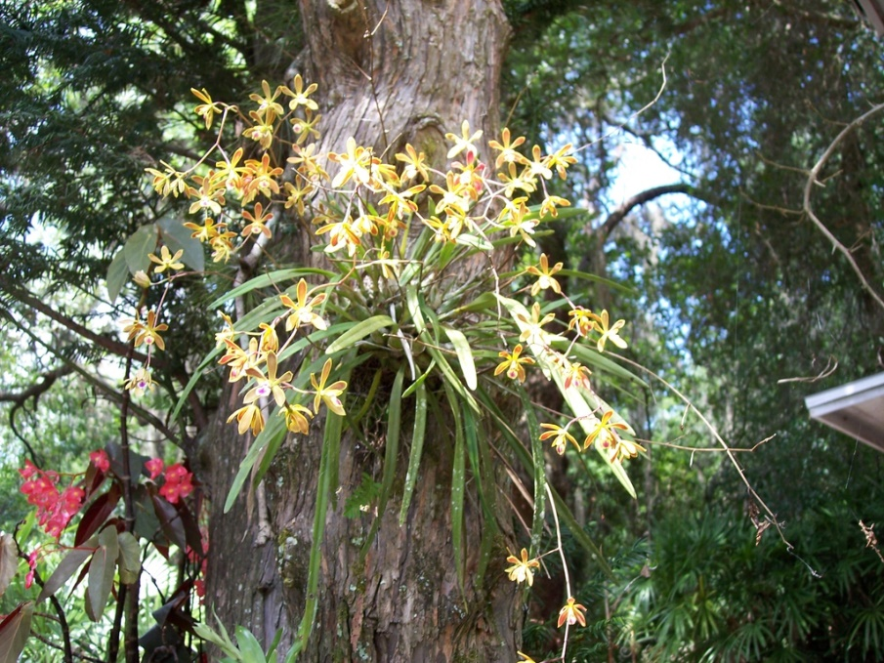
Encyclia tampensis
Photograph by unknown

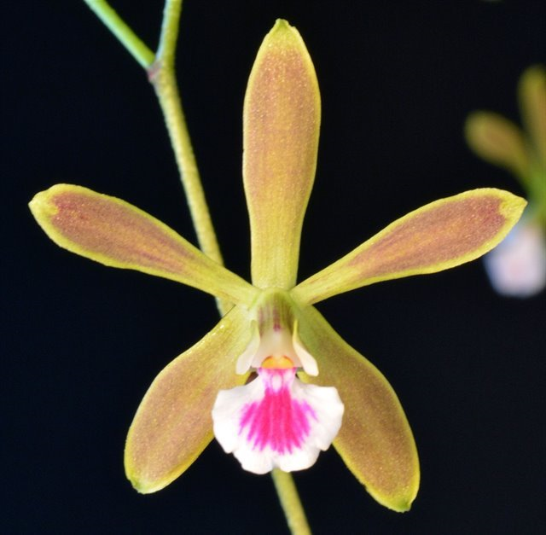

Encyclia tampensis ‘Peggy’s Delight’ AM/AOS, 82 points, 2017
Photograph by Jean Wilson
Mid-America Judging Center Monthly Judging

AOS Awards:

Encyclia tampensis
 | FCC | AM | HCC | AQ | JC | CCM | CCE | CHM | CBM | CBR | TOTAL
AOS | 0 | 14 | 8 | 0 | 2 | 14 | 1 | 0 | 1 | 0 | 40
Years Awarded | - | 1974 - 2021 | 1986 - 2021 | - | 1966 &  2004 | 1962 - 2010 | 2006 | - | 1964 | 0

Forty awards averaging 11.8 flowers and buds per inflorescences; 3.4 cm. natural spread.

Hybrids
Of the one hundred sixty-seven F1 generation offspring found, forty-one or 24.6% have been awarded. Encyclia tampensis has two hundred forty-seven progeny. Of the one hundred sixty-seven F1 generation hybrids registered, Encyclia tampensis was used thirty-three times as the seed parent and one hundred thirty-four times as the pollen parent. The first Encyclia tampensis hybrid registered in 1955, Encyclia Lee Ward (Encyclia tampensis x Encyclia aldenocaula). Encyclia Lee Ward was originated and registered in 1955 by W. W. G. Moir. The first registration of Encyclia tampensis hybrid was registered in 1955 with noted steady registration of E. tampensis crosses from 1955 to 2022.

Two Encyclia tampensis hybrids appear to have significance. Encyclia Atropine (Encyclia cordigera x Encyclia tampensis) for having the largest number of offspring, eleven. Encyclia Atropine originated and registered in 1962 by Dr. Henry Walburn. Encyclia Atropine has received seven AOS awards: (AM – 2; HCC – 2; CCE – 1; and CCM – 2).

Encyclia Atropine has eleven F1 generation offspring and twelve progeny.

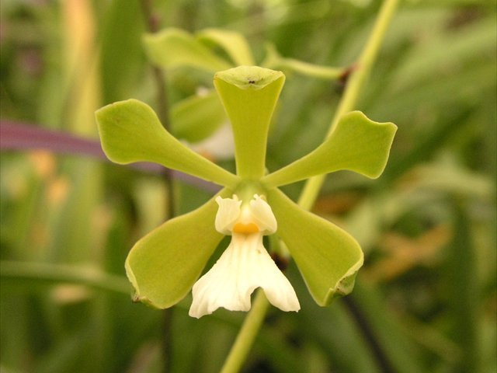

Encyclia Atropine ‘Orchidglade’ AM/AOS, 81 points, 2000
Photograph by Jean Wilson
Florida-Caribbean Center Monthly Judging
Encyclia Cindy (Encyclia alata x Encyclia tampensis) for having the largest number of awarded grex, eleven. Encyclia Cindy originated and registered in 1968 by Das Orchids. Encyclia Cindy has received eleven AOS awards: (AM – 11; HCC – 3; and CCM – 5).

Encyclia Cindy has nine F1 generation offspring and ten progeny.

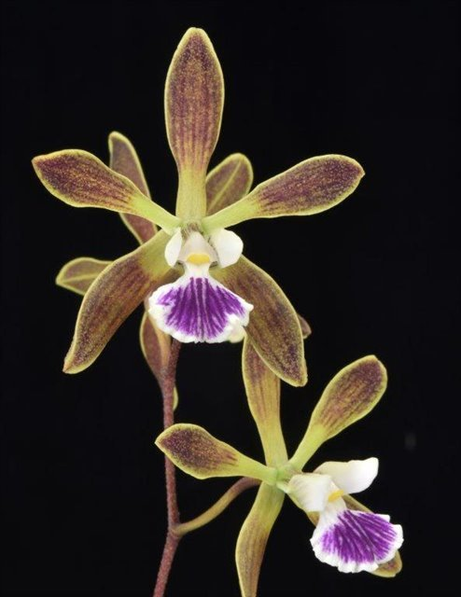
Encyclia Cindy ‘Sweet Spot’ HCC/AOS, 78 points, 2021
Photograph by Glen Barfield
Florida-Caribbean Center Monthly Judging

The positive characteristics Encyclia tampensis passes to its offspring are floriferousness, fragrance, long lasting flowers, and easy to grow. Encyclia tampensis often passes to its offspring a long inflorescence. The negative characteristics Encyclia tampensis passes to its offspring are small flowers, blooms in the summer, and may have inherited a stubbornness to hybridize. Depending on the coloring of the secondary parent used in Encyclia tampensis hybridizing, from viewing pictures of Encyclia tampensis offspring in OrchidWiz, frequently the secondary parent’s coloring is the dominate color expressed in offspring.

References

Acevedo-Rodríguez, P., and Strong, M. (2012). Catalogue of seed plants of the West Indies. Smithsonian Contributions to Botany 98: 1-1192.

American Orchid Society. (n.d.). Encyclia. https://www.aos.org/orchids/orchids-a-to-z/letter-e/encyclia.aspx.
Bastos, C., Meneguzzo, T., and van den Berg, C. (2018). A taxonomic revision of the Brazilian species of Encyclia (Orchidaceae: Epidendroideae: Epidendreae). Phytotaxa 342: 1-84.
Bechtel, H., Cribb, P., and Launert, E. (1992). The Manual of cultivated orchids. The MIT Press, Cambridge, Massachusetts.
Curtin, M. (2020). Encyclia species and hybrids with Mike Curtin. American Orchid Society. https://www.aos.org/all-about-orchids/webinars/member-only/encyclia,-a-look-at-the-species-and-hybrids.aspx.
Dressler, R. (1993). Field guide to the orchids of Costa Rica and Panama. Comstock Publishing Associates, Ithaca, New York
Dressler, R., and Pollard, G. (1976). The genus Encyclia in Mexico. Asociation Mexicana de Orquideologia, A. C., Mexico City, Mexico.
Govaerts, R. (2003). World checklist of monocotyledons Database in ACCESS: 1-71827. The Board of Trustees of the Royal Botanic Gardens, Kew.
Hammel, B. et al. (2003). Manual de plantas de Costa Rica 3: 1-884. Missouri Botanical Garden Press, St. Louis.
OrchidPro. (n.d.).
OrchidWiz X9.0. (n.d.).
Pridgeon, A., Cribb, P., Chase, M., and Rasmussen, F. (2006). Epidendroideae (Part One). Genera Orchidacearum 4: 1-672. Oxford University Press, New York, Oxford.
Pupulin, F. and Bogarín, D. (2012). A taxonomic revision of Encyclia (Orchidaceae: Laeliinae) in Costa Rica. Botanical Journal of the Linnean Society 168: 395-448.
Royal Botanical Gardens Kew, Plants of the World On-line. (n.d.). Encyclia tampensis. https://powo.science.kew.org/taxon/urn:lsid:ipni.org:names:631078-1..
Withner, C. (2000). The Cattleyas and their relatives. Volume VI. The South American Encyclia Species. Timber press, Portland, Oregon.

