Prosthechea citrina, (Lex.) W. E. Higgins, 1998
[sit-ree-nah]

From Charles Baker Culture Sheet: Origin/Habitat: Known only from Mexico. Plants are found mostly on the Pacific side of the mountains in the states of Durango, Guerrero, Jalisco, Michoacan, Nayarit, Oaxaca, and Sianola. However, they are also reported on slopes facing the Gulf of Mexico in the state of Veracruz. Plants are found in rather dry oak and oak-pine forests at 4250-7200 ft. (1300-2200 m). They grow in a pendent manner, hanging upside-down from the bottom of branches on the host trees.

Plant Size and Type: A small to medium sized sympodial epiphyte that grows to 10 in. (25 cm) tall.

Pseudobulbs: 2 in. (5 cm) tall. The egg-shaped pseudobulbs are greyish-green and are usually covered by persistent papery sheaths.

Leaves: 2-4 narrowly elliptic leaves to 8 in. (20 cm) long grow in a pendent manner from the top of each pseudobulb. They are greyish green, sharply pointed, rather soft-textured, and are covered with a whitish bloom that will not rub off.

Inflorescence: 2-4 in. (5-10 cm) long. The pendent inflorescence emerges from between the leaves at top of the newest growths.

Flowers: 1-2. The bell-shaped flowers do not open fully, are about 3 in. (7.5 cm) long and hang downward. They are waxy, long lasting, and have a strong lemon fragrance. The sepals and petals are usually a bright citron-yellow but may range from pale yellow to canary-yellow or almost orange. All flower segments are about the same length, but the petals are somewhat wider than the sepals. The large lip is 1.5-2.0 in (3.8-5.0 cm) wide, is deep golden-yellow in the middle and the throat but is often white along the frilled margins.

Natural Habitat by Kew

Native to: Mexico Northeast, Mexico Southwest

Homotypic Synonyms

Cattleya citrina (Lex.) Lindl. in Coll. Bot.: t. 37 (1826)

Encyclia citrina (Lex.) Dressler in Brittonia 13: 264 (1961)

Epidendrum citrinum (Lex.) Rchb.f. in W. G. Walpers, Ann. Bot. Syst. 6: 317 (1861)

Euchile citrina (Lex.) Withner in Cattleyas & Relatives 5: 138 (1998)

Sobralia citrina Lex. in P. de La Llave & J. M. de Lexarza, Nov. Veg. Descr. 2(Orchid. Opusc.): 21 (1825)

Heterotypic Synonyms

Cattleya sulfurina Lem. in Ill. Hort. 1(Misc.): 2 (1854)

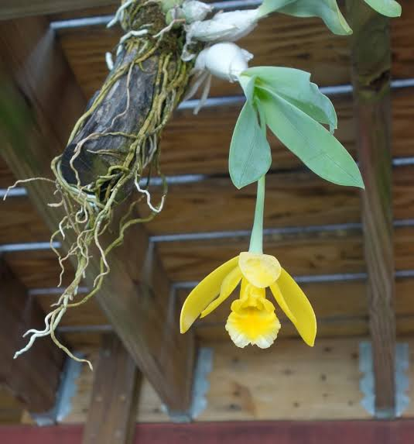

Prosthechea citrina
Photograph by unknown
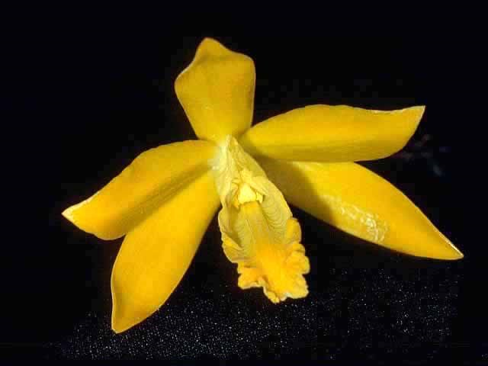

Prosthechea citrina ‘Rollie Wilson’ FCC/AOS, 91 points, 2003
Photograph by Thomas Larkin
Mid-America Center Monthly Judging

AOS Awards:

Prosthechea citrina
 | FCC | AM | HCC | AQ | JC | CCM | CCE | CHM | CBM | CBR | TOTAL
AOS | 9 | 24 | 12 | 0 | 2 | 5 | 0 | 0 | 0 | 0 | 52
Years Awarded | 1974  -  2022 | 1968 - 2012 | 1975 - 2008 | - | 1993&  1995 | 1974 - 1986 | - | - | - | 0

Fifty-two awards averaging 1.5 flowers and buds per inflorescences; 10.3 cm. natural spread.

Hybrids
Twenty-nine F1 generation offspring found, seven or 24.1% have been awarded. Prosthechea citrina has two hundred thirty-three progeny. Of the twenty-nine F1 generation hybrids registered, Prosthechea citrina was used twelve times as the seed parent and seventeen times as the pollen parent. The first Prosthechea citrina hybrid registered in 1887, Cattleychea. Lamberhurst Hybrid (Prosthechea citrina x Cattleya intermedia). Cattleychea. Lamberhurst Hybrid was originated and registered in 1887 by Dr. Harris. The first registration of a Prosthechea citrina hybrids was in 1887 with sporadic registrations until 1930, then no further registrations until 1969. Again, sporadic registration of Prosthechea citrina hybrids occurred from 1969 until 1990. A third sporadic wave of registration of Prosthechea citrina hybrids transpired from 2006 to 2019.

The Prosthechea citrina hybrid that appears to have significance is Prosthechea Marina (Prosthechea citrina x Prosthechea mariae). Prosthechea Marina has one registered offspring. Prosthechea Marina originated by Stewart Orchids and was registered in 1970 by Wium. Prosthechea Marina has received two American Orchid Society awards: (HCC – 2). The first HCC/AOS award was received in 1980 and the second HCC/AOS was received in 2017.

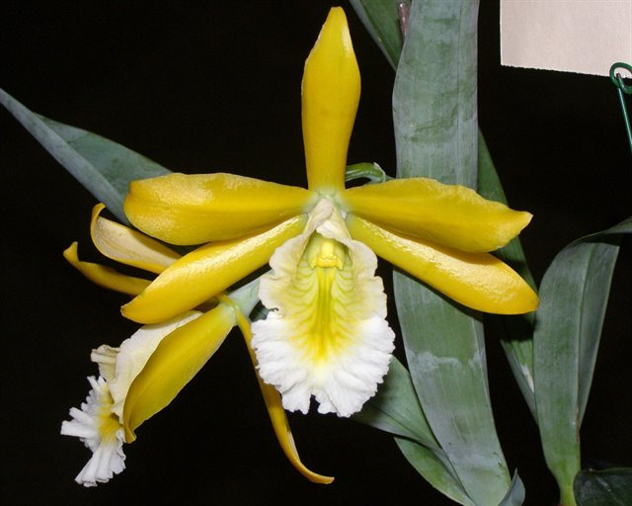

Prosthechea Marina ‘Grace’s Delight’ HCC/AOS, 78 points, 2017
Photograph by Luis Cinert
Illinois Orchid Society Show, Chicago Botanic Garden

The flowers of Prosthechea citrina are resupinate. Prosthechea citrina flowers are dependent. It is most common to see plants of Prosthechea citrina produce one flower per pseudobulb; however, it is noted at times two or more flowers can be produced on one pseudobulb. From reviewing photographs in OrchidWiz, hybrids of Prosthechea citrina petals and sepals tend to be stellate. Depending on the secondary parent of Prosthechea citrina hybrids, the offspring have elongated lips that are fringed along the edges. Although not many photographs of Prosthechea citrina hybrids are available, a number of hybrids express the rich, deep, yellow ochre color found in Prosthechea citrina. Hybrids of Prosthechea citrina tend to have a lower flower count, often only one flower is produced.

References

American Orchid Society. (n.d.). Prosthechea. https://www.aos.org/orchids/orchids-a-to-z/letter-p/prosthechea.aspx.
Bechtel, H., Cribb, P., and Launert, E. (1992). The Manual of cultivated orchids. The MIT Press, Cambridge, Massachusetts.
Dressler, R. (1993). Field guide to the orchids of Costa Rica and Panama. Comstock Publishing Associates, Ithaca, New York
Govaerts, R. (2003). World checklist of monocotyledons Database in ACCESS: 1-71827. The Board of Trustees of the Royal Botanic Gardens, Kew.
Hammel, B. et al. (2003). Manual de plantas de Costa Rica 3: 1-884. Missouri Botanical Garden Press, St. Louis.
Higgins, W. (1999). “The Genus Prosthechea: An Old Name Resurrected.” Orchids, Vol. 68, No 11, Nov 1999, pg. 1114 Dressler & Pollard, 1974, “The Genus Encyclia in Mexico.”
OrchidPro. (n.d.).
OrchidWiz X9.0. (n.d.).
Pridgeon, A., Cribb, P., Chase, M., and Rasmussen, F. (2006). Epidendroideae (Part One). Genera Orchidacearum 4: 1-672. Oxford University Press, New York, Oxford.
Pupulin, F. and Bogarín, D. (2012). A taxonomic revision of Encyclia (Orchidaceae: Laeliinae) in Costa Rica. Botanical Journal of the Linnean Society 168: 395-448.
Royal Botanical Gardens Kew, Plants of the World On-line. (n.d.). Prosthechea citrina. https://powo.science.kew.org/taxon/urn:lsid:ipni.org:names:1001246-1.
Withner, C. (2000). The Cattleyas and their relatives. Volume VI. The South American Encyclia Species. Timber press, Portland, Oregon.

