Prosthechea radiata (Lindl.) W. E. Higgins, 1998
[ra-dee-AH-ta]

From Charles Baker Culture Sheet: Origin/Habitat: Mexico, Guatemala, and Honduras. In Mexico, plants are found in the states of Chiapas, Oaxaca, Puebla, San Luis Potosí, Tabasco, and Veracruz. In Guatemala, plants are found in the northeastern Petén region, with collections made on the ruins at Tikal. Plants may be found in oak, oak-pine, or tropical evergreen forests at 500-6550 ft. (150-2000 m).

Plant Size And Type: A moderate-large epiphyte that grows 8-18 in. (21-46 cm) tall with growths spaced up to 1 in. (2.5 cm) apart.

Pseudobulb: 2.8-4.3 in. (7-11 cm) long by 0.8-2.0 in. (2-5 cm) wide. The elliptic to narrowly egg-shaped or club-shaped pseudobulbs are somewhat flattened, usually distinctly grooved, and often stalked at the base.

Leaves: 5-14 in. (12-35 cm) long by 0.6-1.2 in. (1.4-3.0 cm) wide. 2-4 linear to strap-shaped or linear-lanceolate leaves are carried at the apex of each pseudobulb. The leaves are rather leathery with a blunt tip at the apex.

Inflorescence: 3-9 in. (7-24 cm) long including the peduncle and raceme. The peduncle is stout and erect with several thin, dry bracts that are 0.1-0.4 in. (0.3-1.0 cm) long. Inflorescences emerge at the apex of the most recently matured pseudobulbs on growths that were made the previous growing season.

Flowers: 4-12. Flowers are showy, fragrant, and about 1.2 in. (3 cm) across with cream-colored sepals and petals with a purplish-streaked lip that is held uppermost. Sepals and petals are 0.6-0.8 in. (1.5-2.0 cm) long. The elliptic sepals are broadly pointed and 0.2-0.3 in. (0.5-0.7 cm) wide. The elliptic to egg-shaped petals are sharply pointed and 0.3-0.4 in. (0.8-1.1 cm) wide. The rather large, rounded lip, which is 0.4-0.5 in. (1.0-1.3 cm) long by 0.5-0.8 in. (1.3-2.0 cm) wide, is attached to the column for about 0.2 in. (0.4-0.5 cm), or half the length of the column. The blade of the lip is described variably as triangular or kidney-shaped with a base that is rather square or slightly heart-shaped, and the margin is slightly wavy and more or less notched in the center of the apex. The callus at the lip base is smooth. The stout column is 0.3-0.4 in. (0.8-1.0 cm) long with a mid-tooth that merges into a broad, fan-shaped, irregularly notched, tongue like extension. Although similar to other "cockleshell" orchids, E. radiata can be recognized by the apically fringed central tooth of its column and the notch in the center of the otherwise round apex of the lip.
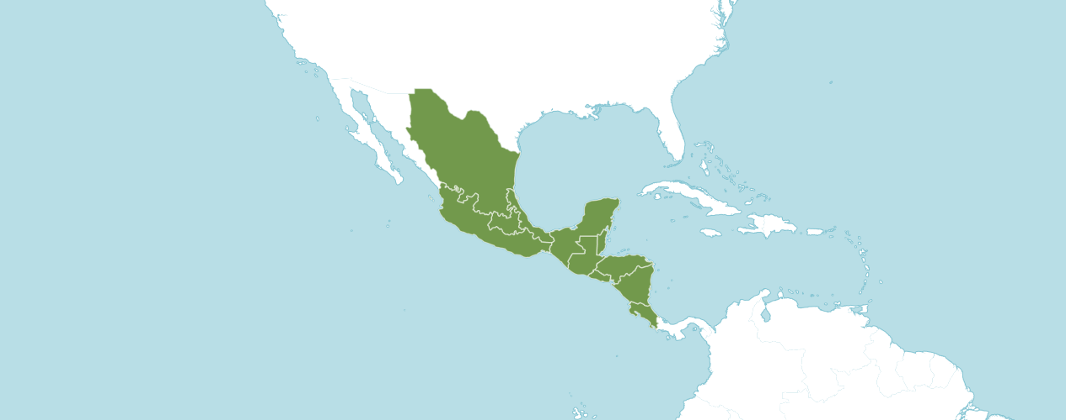
Natural Habitat by Kew

Native to: Belize, Costa Rica, El Salvador, Guatemala, Honduras, Mexico Central, Mexico Gulf, Mexico Northeast, Mexico Southeast, Mexico Southwest, Nicaragua.

Homotypic Synonyms

Anacheilium radiatum (Lindl.) Pabst, Moutinho & A. V. Pinto in Bradea 3: 184 (1981)

Encyclia radiata (Lindl.) Dressler in Brittonia 13: 265 (1961)

Epidendrum radiatum Lindl. in Edwards's Bot. Reg. 27(Misc.): 58 (1841)

Heterotypic Synonyms

Epidendrum marginatum Link in J. H. F. Link, J. F. Klotzsch & C. F. Otto, Icon. Pl. Rar. 2: 90 (1842), nom. illeg.

Epidendrum radiatum var. fuscatum Rchb.f. in Gard. Chron., ser. 3, 5: 43 (1889)

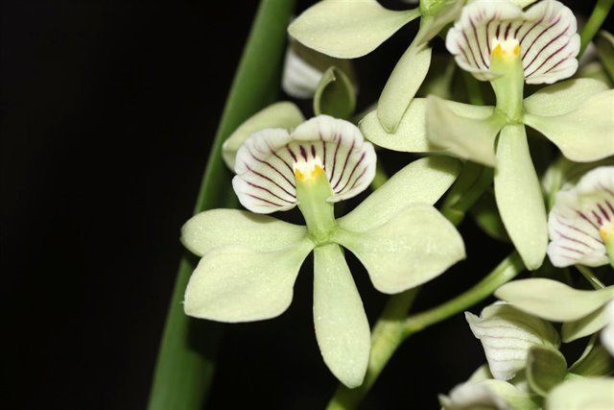

Prosthechea radiata ‘Makawao Pride’ AM/AOS, 83 points, 2019
Photograph by Michael Blietz
Hawaii Center Monthly Judging

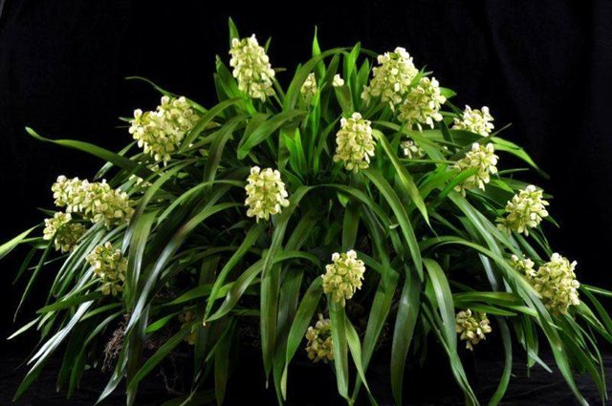
Prosthechea radiata ‘Lehua Etheral’ CCM/AOS, 84 points, 2007
Photograph by Glen Barfield
Platinum Coast Orchid Society Show

AOS Awards:

Prosthechea citrina
 | FCC | AM | HCC | AQ | JC | CCM | CCE | CHM | CBM | CBR | TOTAL
AOS | 0 | 8 | 11 | 0 | 0 | 20 | 1 | 0 | 0 | 0 | 40
Years Awarded | - | 1963 - 2019 | 1969 - 2015 | - | - | 1955 - 2010 | 2011 | - | - | 0

Forty awards averaging 10.3 flowers and buds per inflorescences; 3.9 cm. natural spread.

Hybrids
Thirty-two F1 generation offspring found, five or 15.6% have been awarded. Prosthechea radiata has two hundred forty progeny. Of the thirty-two F1 generation hybrids registered, Prosthechea radiata was used twelve times as the seed parent and twenty times as the pollen parent. The first Prosthechea raditata hybrid was registered in 1898, Guarechea (Grc.) Radiato-bowringiana, (Prosthechea radiata x Guarianthe (Gur.) bowringiana). Crc. Radiato-bowringiana was originated and registered in 1898 by Veitch. The first registration of a Prosthechea radiata hybrid was in 1898 without another registration until 1959. Sporadic registrations of Prosthechea radiata hybrids occurred from 1969 until 1990. A third sporadic wave of registration of Prosthechea citrina hybrids transpired from 1962 to 1990. Eight Prosthechea radiata hybrids were registered between 2004 to 2008. After 2008, only two Prosthechea radiata hybrids have been registered: one in 2015 and one in 2019.

The Prosthechea radiata hybrid that has received the largest number of American Orchid Society awards is Proguarleya (Pgy.) Caribbean Jewel (Prosthechea radiata x Ctt. Cynthia Martel Utuado). Pgy. Caribbean Jewel has received two HCC/AOS awards: one in 2009 and one in 2010. Pgy Caribbean Jewel has no registered offspring. Pgy Caribbean Jewel originated by and registered in 2005 by Orchids by Eli.

The Prosthechea radiata hybrids with the most offspring are Prc. Santander (Prosthechea radiata x Encyclia alata) and Prosthechea Lemon Lime (Prosthechea radiata x Prosthechea mariae); both have two offspring registered. Prc. Santander was registered in 1971 by Stewart Orchids; originator is unknown. Prc. Santander has two registered offspring and three progeny. No Prc. Santander grex has received an American Orchid Society award. No photograph for Prc. Santander was found on the Internet for reference.

Prosthechea Lemon Lime originated by and was registered in 1971 by Mr. and Mrs. W. Osment. Prosthechea Lemon Lime has two offspring and two progeny. No Prosthechea Lemon Lime grex has received an American Orchid Society award. No photograph for Prosthechea Lemon Lime was found on the Internet for reference.

The flowers of Prosthechea radiata are unusual in that though the labellum is usually below the column in orchids, in Prosthechea radiata the labellum forms a "hood" over the column. This makes the flower effectively look upside down, or non-resupinate. From reviewing photographs in OrchidWiz, hybrids of Prosthechea radiata can present as resupinate or non-resupinate, even within the same hybrid. Sepals and petals of Prosthechea radiata hybrids are stellate. Depending on the secondary parent of Prosthechea radiata hybrids, most offspring have lips that are striped at some level. If the base color of the secondary parent of a Prosthechea radiata hybrids are cream, yellow, or green, the offspring will be yellow or green with a level of striping in the lip . If the base color of the secondary parent of a Prosthechea radiata hybrid is a darker hue, the offspring have a significantly higher probability to assume the darker color. Prosthechea radiata hybrids present on an inflorescence with multiple flowers. At times the flowers express as crowded.

References

American Orchid Society. (n.d.). Prosthechea. https://www.aos.org/orchids/orchids-a-to-z/letter-p/prosthechea.aspx.
Govaerts, R. (2003). World checklist of monocotyledons Database in ACCESS: 1-71827. The Board of Trustees of the Royal Botanic Gardens, Kew.
Hammel, B. et al. (2003). Manual de plantas de Costa Rica 3: 1-884. Missouri Botanical Garden Press, St. Louis.
Higgins, W. (1999). “The Genus Prosthechea: An Old Name Resurrected.” Orchids, Vol. 68, No 11, Nov 1999, pg. 1114 Dressler & Pollard, 1974, “The Genus Encyclia in Mexico.”
OrchidPro. (n.d.).
OrchidWiz X9.0. (n.d.).
Royal Botanical Gardens Kew, Plants of the World On-line. (n.d.). Prosthechea radiata. https://powo.science.kew.org/taxon/urn:lsid:ipni.org:names:1001294-1.
Withner, C. (2000). The Cattleyas and their relatives. Volume VI. The South American Encyclia Species. Timber press, Portland, Oregon.

