Prosthechea vitellina (Lindl.) W. E. Higgins, 1998

Common Name: The yolk yellow Prosthechea; In Mexico - Manuelitos

Origin/Habitat: Mexico, Guatemala, and El Salvador. In Mexico, E. vitellina is found on mountain slopes facing the Gulf of Mexico in the states of Veracruz, Puebla, Oaxaca, and Chiapas. Plants usually grow epiphytically in moist pine-oak forest, in cloud forest, and in scrub on lava fields at 4600-8550 ft. (1400-2600 m).

Plant Size and Type: A small sympodial epiphyte that is 8-11 in. (20-28 cm) tall.

Pseudobulbs: 1.0-2.5 in. (2.5-6.4 cm) tall. The clustered elongated pseudobulbs are dark green, egg shaped to cone shaped, and somewhat compressed.

Leaves: 2-3 emerge from the top of the pseudobulb. They are linear-lanceolate, leathery, 6-9 in. (15-23 cm) long, and about 2 in. (5 cm) wide.

Inflorescence: 15-18 in. (38-46 cm) long. The spike, which emerges from between the leaves at the top of the pseudobulb, is usually erect and may sometimes branch. Flowering may be in summer on new growth or in late winter and spring on growth made the previous summer.

Flowers: 4-15 per inflorescence. The long-lasting blossoms are up to 1.5 in. (6.4 cm) across, open very flat, and are spaced along the upper half of the inflorescence. The broad, spreading sepals and petals are pointed and may be orange, cinnabar-red, deep red, or vermilion. The narrow, dagger-shaped lip is shorter than the sepals and petals, may be yellow or orange-yellow, and may be tipped with orange red.

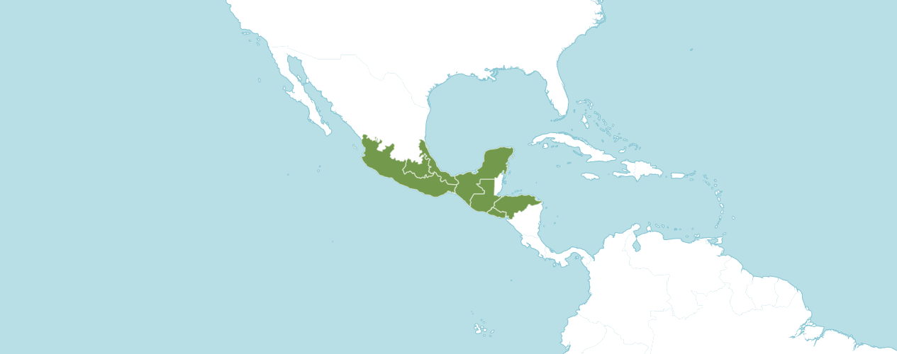
Native to: El Salvador, Guatemala, Honduras, Mexico Central, Mexico Gulf, Mexico Southeast, Mexico Southwest.

Homotypic Synonyms
Encyclia vitellina (Lindl.) Dressler in Brittonia 13: 265 (1961)
Epidendrum vitellinum Lindl. in Gen. Sp. Orchid. Pl.: 97 (1831)
Pseudencyclia vitellina (Lindl.) V. P. Castro & Chiron in Richardiana 4: 33 (2003)

Heterotypic Synonyms
Epidendrum vitellinum var. autumnale G. Wilson in Orchid World 4: 27 (1913)
Epidendrum vitellinum var. giganteum R. Warner in Select Orchid. Pl. 3: t. 27 (1878)
Epidendrum vitellinum var. majus Van Houtte in Nursery Cat. (Louis van Houtte) 177: 113 (1878-1879 publ. 1878)

AOS Awards:

Prosthechea vitellina
 | FCC | AM | HCC | AQ | JC | CCM | CCE | CHM | CBM | CBR | TOTAL
AOS | 0 | 11 | 6 | 0 | 0 | 4 | 1 | 0 | 0 | 0 | 22
Years Awarded | - | 1964 - 2012 | - | - | - | 1973 - 2011 | 2007 | - | - | -

Twenty-two awards averaging 15.9 flowers and buds per inflorescences; 4.6 cm. median natural spread.

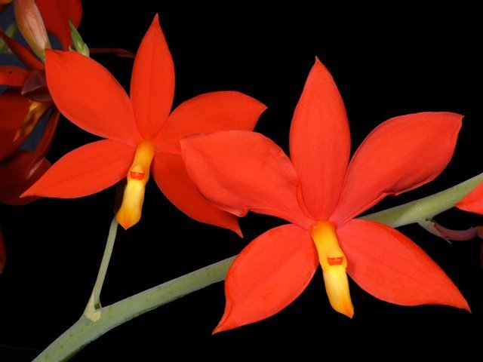
Prosthechea vitellina
Photograph by Lynn O’Shaughnessy
Hybrids
Sixty-five F1 generation offspring found, six or 9.2% have been awarded. Prosthechea vitellina has eighty-four progeny. Of the sixty-five F1 generation hybrids registered, Prosthechea vitellina was used nine times as the seed parent and fifty-two times as the pollen parent. The first Prosthechea vitellina hybrid was registered in 1897, Epithechea Radico-Vitellium, (Prosthechea vitellina x Epidendrum radicans). Epithechea Radico-Vitellium was originated and registered in 1897 by Veitch. There were registrations of Prosthechea vitellina hybrids from1897 to 1911. No Prosthechea vitellina hybrids were registered from 1911 to 1960. Registrations of Prosthechea vitellina has been steady from 1960 to 2021.

The Prosthechea vitellina hybrid tided as having the largest number registered offspring is Cattleychea Lemon Twist, (Prosthechea vitellina x Cattleya granulosa). Cattleychea Lemon Twist has had six F1 offspring and ten progeny registered. Cattleychea Lemon Twist has received three American Orchid Society awards (AM – 2; and HCC – 1). Cattleychea Lemon Twist was originated by and registered in 1963 by Rod McLellan.

The second Prosthechea vitellina hybrid tided as having received the largest number of American Orchid Society awards is Prosthechea Hilda, (Prosthechea citrina x Prosthechea vitellina). Prosthechea Hilda has received three AOS awards (AM – 1; JC – 1; and CCM – 1). Prosthechea Hilda was originated by and registered in 1978 by P. Sayer. Prosthechea Hilda has no registered offspring.

From reviewing photographs in OrchidWiz, most hybrids of Prosthechea vitellina express flower color as deep yellow, orange, or red. Depending on the secondary parent of Prosthechea vitellina hybrids, the offspring’s sepals and petals are stellate to semi-stellate or petals may have some width. Depending on the secondary parent of Prosthechea vitellina hybrids frequently have lips that are long and somewhat narrow. Prosthechea vitellina offspring tend to produce flowers averaging a width of 4.5 cm across. More so than not, Prosthechea vitellina offspring have multiple flowers on each inflorescence.

References
American Orchid Society. (n.d.). Prosthechea. https://www.aos.org/orchids/orchids-a-to-z/letter-p/prosthechea.aspx

Govaerts, R. (2003). World checklist of monocotyledons Database in ACCESS: 1-71827. The Board of Trustees of the Royal Botanic Gardens, Kew.

Hagsater, E. et al. (2005). Orchids of Mexico. Productos Farmaceuticos. p.89.

Hammel, B. et al. (2003). Manual de plantas de Costa Rica 3: 1-884. Missouri Botanical Garden Press, St. Louis.

Higgins, W. (1999). “The Genus Prosthechea: An Old Name Resurrected.” Orchids, Vol. 68, No 11, Nov 1999, pg. 1114 Dressler & Pollard, 1974, “The Genus Encyclia in Mexico.”

Luer, C. (1972). The Native Orchids of Florida. The New York Botanical Garden.

OrchidPro. (n.d.).

OrchidWiz X9.0. (n.d.).

Pridgeon A., Cribb, P., Chase M., & Rasmussen, F. (2005). Genera Orchidacearum, Volume 4, Epidendroideae (Part one). Oxford University Press.

Royal Botanical Gardens Kew, Plants of the World On-line. (n.d.). Prosthechea vitellina. https://powo.science.kew.org/taxon/urn:lsid:ipni.org:names:1001314-1.

Withner, C. (2000). The Cattleyas and their relatives. Volume VI. The South American Encyclia Species. Timber press, Portland, Oregon.

