Mini Cattleya: Five Sample Descriptions

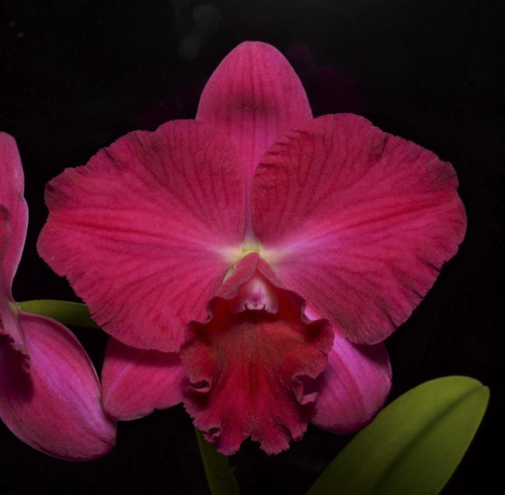
Potinara. Ramon De Los Santos '4 Red Balloons'
(Pot. Mem. Irene Fiel x Pot. Loud Nine 'Four Red Balloons')
Photograph by Fred Clarke

Two flowers on one x-cm inflorescence; sepals and petals magenta, veined darker magenta; lip ruffled dark magenta; column white suffused magenta, anther cap white suffused magenta; substance medium; texture matt.

AM/AOS – 86 points

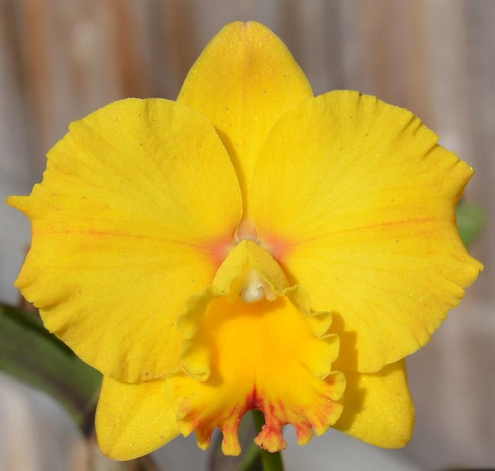
Potinara Excellent Ina 'SVO'
(Pot. Martha Clarke x Slc. Sierra Gem)
Photograph by Fred Clarke

One flower on one x-cm inflorescence; sepals yellow; petals yellow, proximal overlaid red, proximal to distal one faint splash red; lip ruffled, yellow, distal suffused red; column white suffused yellow, anther cap white; substance medium; texture crystalline.

AM/AOS – 85 points
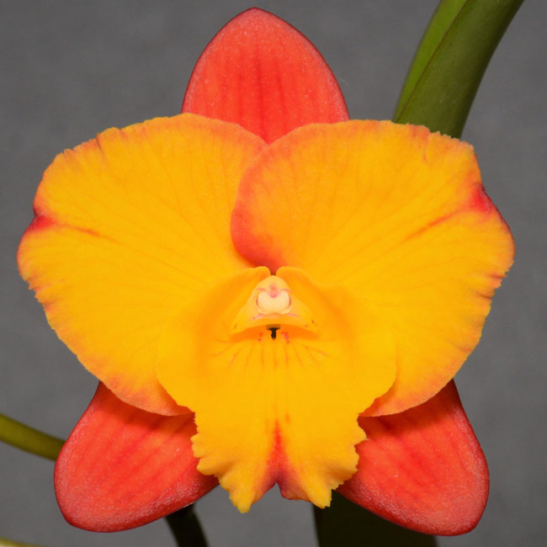
Cattleya Candy Sparks 'Gold Spark'
(Memoria Trudy Marsh x Angel’s Fantasy)
Photograph Fred Clarke

One flower on one x-cm inflorescence; sepals orange, veined faintly red; petals yellow, suffused proximal orange, distally flared red; lip ruffled, yellow, throat veined faintly red, flared red; column yellow, slightly suffused red, anther cap cream; substance medium; texture crystalline.

AM/AOS – 82 points

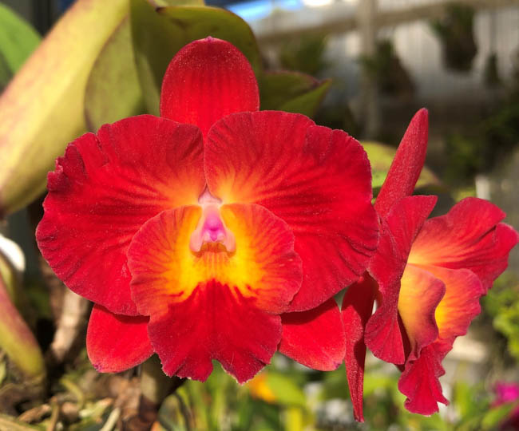
Cattleya Cosmic Circle 'Summer Candy'
(C. Cosmic Delite x C. Circle of Life 'Summer Candy')
Photograph by Fred Clarke

Two flowers on one x-cm inflorescence; sepals red; petals yellow proximal one sixth, red four-fifths, dark red venation; lip yellow overlaid red distally, sidelobes distal venation red; column white suffused fuchsia, anther cap white suffused fuchsia; substance firm; texture matte.

AM/AOS – 84 points

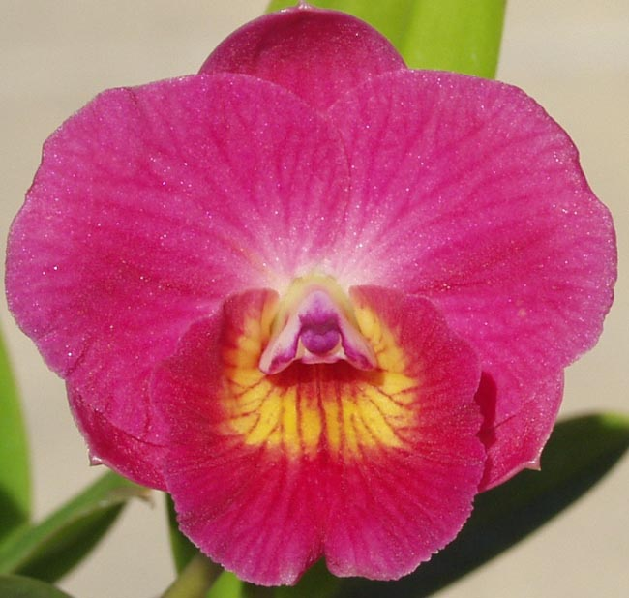
Slc. Sacramento Jewel 'SVO'
(Slc. Tangerine Jewel x Lc. Sacramento Rose)
Photograph by Fred Clarke

One flower on one inflorescence; sepals fuchsia; petals pink, veined fuchsia; lip yellow veined red, distally fuchsia; column white distally suffused magenta, anther cap white overlaid magenta; substance firm; texture crystalline.

HCC/AOS – 78 points

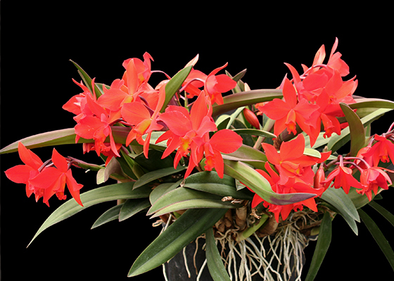
C. Psyche
Photograph by Santa Barbara Orchid Estate

Well-grown plant in 9" pot; 43 bulbs; 8 spikes (24"-28" tall) averaging 9-10 flowers.

x flowers and x buds on x inflorescences on a robust plant grown in a 20 cm black plastic; plant x cm tall and x cm wide; sepals and petals red; lip yellow overlaid red, throat veined red; substance firm; texture matt.

CCM – 83 points

