Brassavola, Broughtonia and Rhyncholaelia
Five Sample Award Descriptions

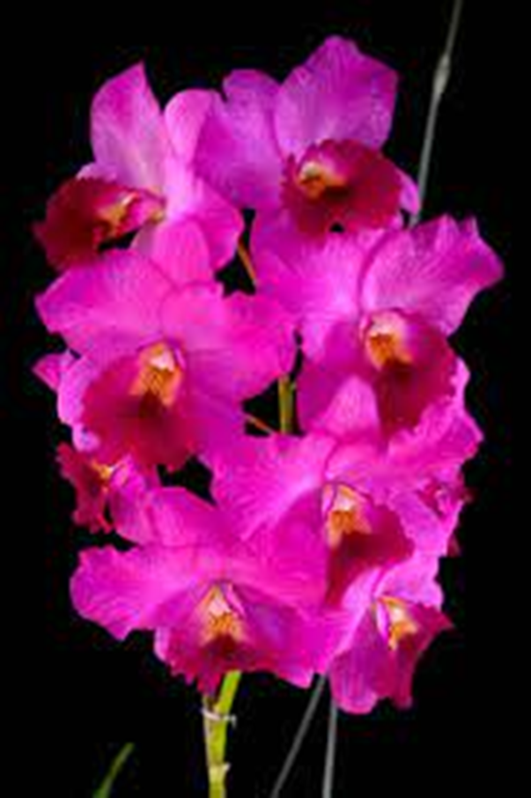
Guaritonia Rosy Jewel (Guarianthe bowringiana x Broughtonia sanguinea)
Photography by Unknown

Eight well-shaped flowers on one x cm inflorescence; sepals and petals magenta; lip crimson, throat golden yellow, basal spotting maroon; column white, anther cap white; substance firm, texture crystalline.

Award: AM/AOS, 87 points.

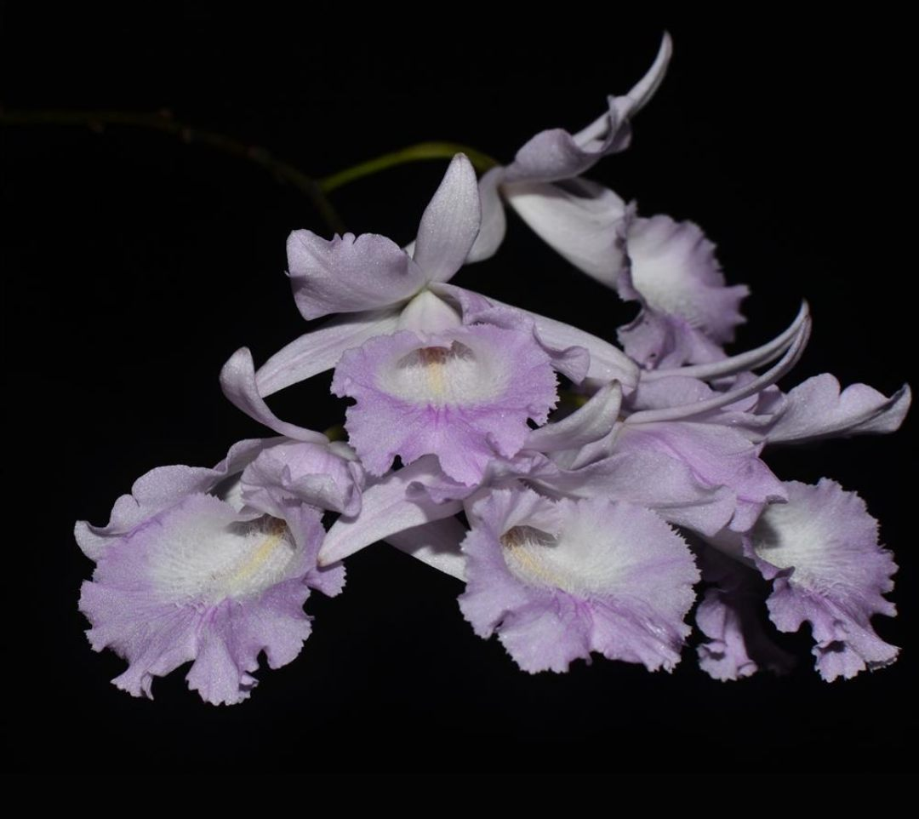
Broughtonia domingensis
Photography by Unknown

Six flowers on one x cm inflorescence; sepals white suffused pale lavender; petals pale lavender; lip undulated, white suffused lavender distally, throat white, suffused cream centrally, column white, anther cap white; substance light; texture lightly crystalline.

Award: HCC/AOS, 76 points

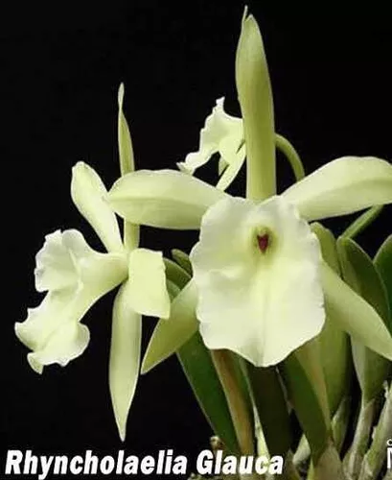
Rhyncholaelia glauca
Photography by Unknown

Three flowers on three up to x cm inflorescences; sepals and petals chartreuse; lip cream, suffused chartreuse centrally, maroon mark under column; column light chartreuse; substance heavy; texture waxy.

Award: AM/AOS, 82 points

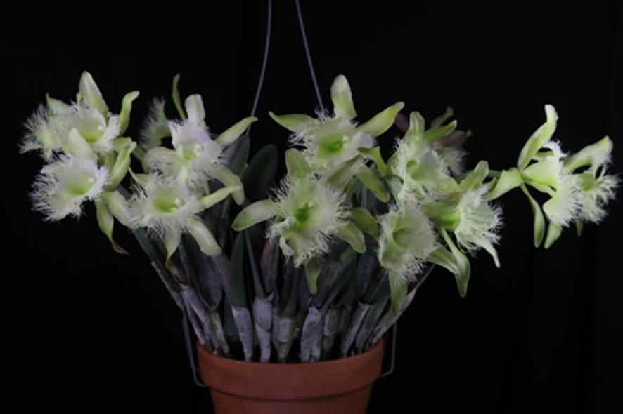
Rhyncholaelia digbyana
Photography by St. Augustine Orchid Society

Twelve flowers on six inflorescences; sepals chartreuse; petals chartreuse; lip light chartreuse heavy frilled, throat dark green; column white suffused chartreuse, anther cap cream; substance firm; texture waxy.

Award: AM/AOS, 86 points
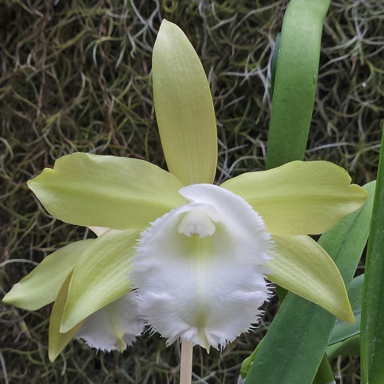
Rhynchobrassoleya Unbelievable Times
(Brassocattleya Flyboy Jimmy Lawson x Rhyncholaela digbyana)
Photography by St. Augustine Orchid Society

Two flowers on one inflorescence; sepals and petals chartreuse; lip white, fringed along margins, distally centrally slight suffusion chartreuse, throat overlaid chartreuse; column white, anther cap white; substance firm; texture matt.

Award: HCC/AOS, 76 points
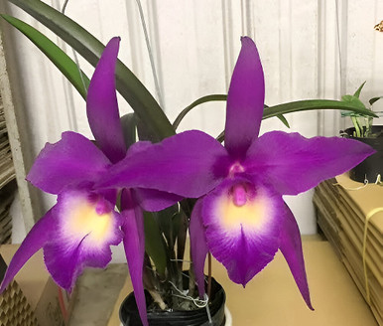
Brassocattleya. Yuan Nan Star War
(Cattleya Memoria Robert Strait x Brassocattleya Wonder Star)
Photography by Orchid Roots

Two flowers on one inflorescence; sepals and petals purple, margin slightly undulate; lip midlobe white overlaid yellow, purple distally, throat suffused purple, margin slightly undulated; column white, overlaid fuchsia, anther cap white overlaid fuchsia; substance firm; texture matt.

Award: AM/AOS, 86 points

