What is the Difference Between Brassavola appendiculata and Brassavola cucullata?

Robert Brown described Brassavola cucullata in 1813. Henri Galeotti and Achille Richard described Brassavola appendiculata in 1845. Brassavola appendiculata was considered a synonym of Brassavolia cucullata. In May of 2020, taxonomist Eliana Noguera-Savelli, Ph.D. published a paper in which she proposed separating Brassavola appendiculata and Brassavolia cucullata into two distinct valid species of Brassavola. She provided specific reasons why there should be two distinct species. Please see the table below for specific details.

Factor | Brassavola appendiculata | Brassavola cucullata
Lip length | 6 – 7.5 cm | 4.5 – 5.5 cm
Number of pollinia | 12 | 8
Flowering period | May – October | September – May
Geographic distribution | 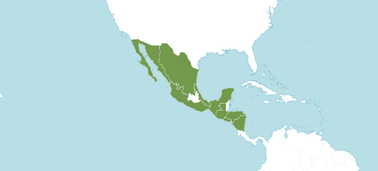  El Salvador, Guatemala, Honduras, Mexico Gulf, Mexico Northeast, Mexico Northwest, Mexico Southeast, Mexico Southwest, and Nicaragua | 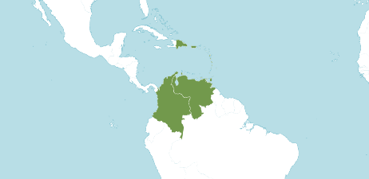  Colombia, Dominican Republic, Leeward Is., Puerto Rico, Trinidad-Tobago, Venezuela, Venezuelan Antilles, and Windward Islands.
Information From B. Martin American Orchid Society Webinar

Between 2020 and 2021, Kew agreed with Dr. Noguera-Savelli acknowledging both species as distinct valid species. The Royal Horticultural Society changed all hybrids listed as made with Brassavola cucullata to having been made with Brassavola appendiculata. In October 2021, the American Orchid Society changed references to Brassavola cucullata to Brassavola appendiculata. Claude Hamilton and Thomas Mirenda published an article in the American Orchid Society Magazine, “Will the real Brassavola cucullata please stand up.”

References
American Orchid Society. (n.d.). Brassavola. https://www.aos.org/orchids/orchids-a-to-z/letter-b/brassavola.aspx .
Hamilton, C. and Mirenda, T. (2022, January). Will the real Brassavola cucullata please stand up. Orchids, American Orchid Society.
Martin, B. (2023, November 15). A new look at an old genus. American Orchid Society. https://www.aos.org/all-about-orchids/webinars/member-only/brassavola.aspx .
Noguera-Savelli, E. & Cetzal-Ix, W. (2014). Revisión e integración del conocimiento de las Orchidaceae de Tabasco, México. Botanical Sciences 92: 519-540.
Noguera-Savelli, E. (2020). Systematics of the neotropical genus Brassavola (Orchidaceae). Caldasia 42: 188-219.
Royal Botanical Gardens Kew, Plants of the World On-line. (n.d.). Brassavola appendiculata. https://powo.science.kew.org/taxon/urn:lsid:ipni.org:names:618022-1.
Royal Botanical Gardens Kew, Plants of the World On-line. (n.d.). Brassavola cucullata. https://powo.science.kew.org/taxon/urn:lsid:ipni.org:names:618026-1.

