Brassavola appendiculata A.Rich. & Galeotti 1845
[a-pen-dik-yew-LAH-ta]

Common Name: No common name.
There was confusion between Brassavola appendiculata and Brassavola cucullata. Brassavola cucullata was described in 1815. Thirty years later Brassavola appendiculata was described. Until 2020, both species were considered synonyms. In 2020, Noguera-Savelli proposed separating B. appendiculata and B. cucullata.
Brassavola appendiculata has one to three flowers per inflorescence. The flowers measures five inches wide and five to six inches long. Flowers are fragrant at night.

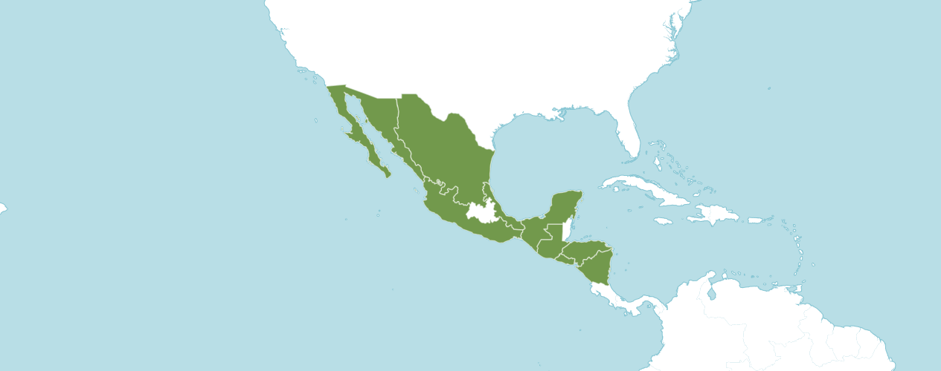
Habitat of Brassavola appendiculata
Native to:
El Salvador, Guatemala, Honduras, Mexico Gulf, Mexico Northeast, Mexico Northwest, Mexico Southeast, Mexico Southwest, Nicaragua
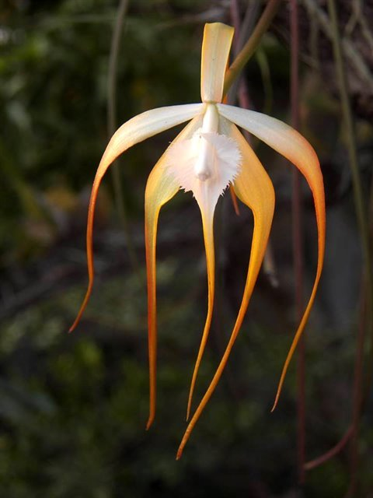
Brassavola appendiculata
Photograph by Jan Pahl

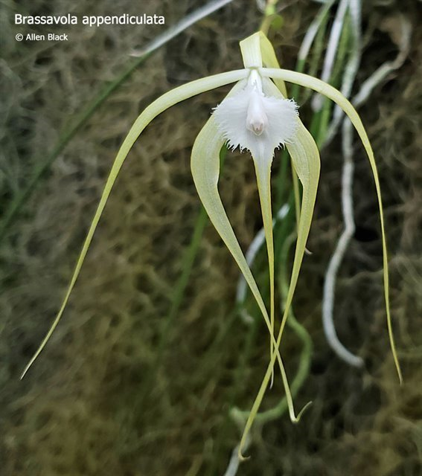

Brassavola appendiculata
Photograph by Allen Black

There are no registered American Orchid Society awards for Brassavola appendiculata in OrchidPro or OrchidWiz.

Registered Brassavola appendiculata Hybrids
 | Pre -  1930 | 1930 - 1940 | 1940 - 1950 | 1950  -  1960 | 1960  -  1970 | 1970 - 1980 | 1980 -1990 | 1990 -2000 | 2000 - 2020 | 2020 + | TOTAL
appendiculata | 1 | 1 | 1 | 1 | 4 | 2 | 9 | 6 | 52 | 11 | 88

Two Generations of Progeny
Generation | Awarded | % Awarded | Awards
1 | 88 | 17.0% | 32
2 | 30 | 10.0% | 3

Hybrids
Eighty-eight F1 generation offspring found, thirty-two or 17.0% have been awarded. Brassavola appendiculata has one hundred eighteen progeny. Of the eighty-eight F1 generation hybrids registered, Brassavola appendiculata was used fourteen times as the seed parent and seventy-four times as the pollen parent. The first Brassavola appendiculata hybrid was registered in 1914, Brassocattelya Virgo, (Brassavola appendiculata x Cattleya mossiae). Brassocattleya Virgo was originated and registered in 1914 by Charlesworth Ltd. No registrations of Brassocattleya Virgo hybrids were found. No Brassocattleya Virgo hybrids have been awarded.

The Brassavola appendiculata hybrid with the largest number of progeny is Brassavola Yaki. Brassavola Yaki has fourteen F1 generation hybrids registered as fourteen progeny. Brassavola Yaki was used twelve times as the seed parent and two times as the pollen parent. Brassavola Yaki was registered in 1946 by A. Hawkes and originated by Mr. and Mrs. W. Osment. One Brassavola Yaki has received an American Orchid Society award. Brassavola Yaki ‘Black’s Nova’ received an HCC/AOS of 77 points in 2009. Brassavola Yaki ‘Black’s Nova’ averaged 2.3 flowers and buds per inflorescence: 7.0 cm median natural spread.

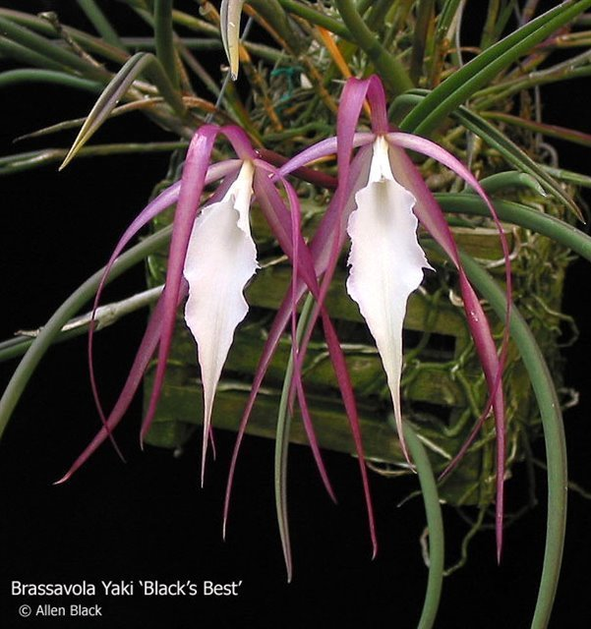

Brassavola Yaki ‘Black’s Best’ HCC/AOS, 77 points, 2009
Photograph by A. Black

The Brassavola appendiculata hybrid which received the most American Orchid Society awards is Rhynchovola [Rcv.] (syn. Brassavola or B.) David Sander, (Brassavola appendiculata x Rhyncholaelia digbyana). Rhynchovola David Sander has seven F1 offspring and seven progeny registered. Rhynchovola David Sander has received twelve American Orchid Society awards (AM – 8; HCC – 3; and CCM - 1), averaging 1.4 flowers and buds per inflorescence; 15.8 median natural spread. Rhynchovola David Sander was originated by and registered in 1938 by Sanders (St. Albans).

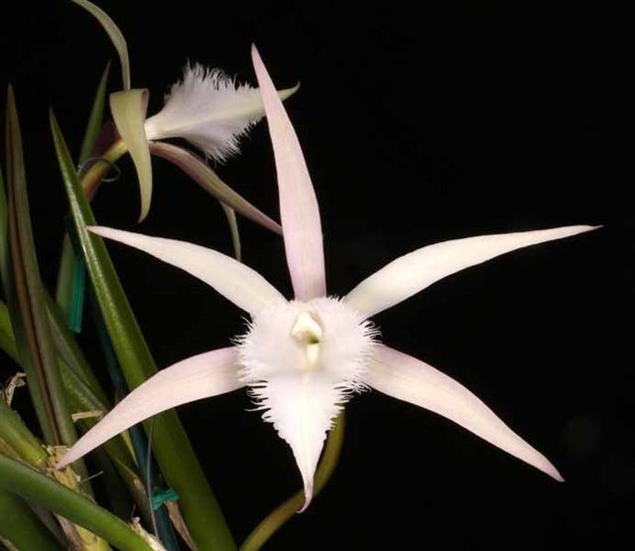

Rhynchovola David Sander ‘Quest’ AM/AOS, 82 points, 2018
Photograph by Tom Kuligowski
References

American Orchid Society. (n.d.). Brassavola. https://www.aos.org/orchids/orchids-a-to-z/letter-b/brassavola.aspx .

Govaerts, R. (2003). World Checklist of Monocotyledons Database in ACCESS: 1-71827. The Board of Trustees of the Royal Botanic Gardens, Kew.

Govaerts, R. (1996). World Checklist of Seed Plants 2(1, 2): 1-492. MIM, Deurne.
Martin, B. (2023, November 15). A new look at an old genus. American Orchid Society. https://www.aos.org/all-about-orchids/webinars/member-only/brassavola.aspx .
Noguera-Savelli, E. & Cetzal-Ix, W. (2014). Revisión e integración del conocimiento de las Orchidaceae de Tabasco, México. Botanical Sciences 92: 519-540.
Noguera-Savelli, E. (2020). Systematics of the neotropical genus Brassavola (Orchidaceae). Caldasia 42: 188-219.
OrchidPro. (n.d.).
OrchidWiz X9.0. (n.d.).
Royal Botanical Gardens Kew, Plants of the World On-line. (n.d.). Brassavola appendiculata. https://powo.science.kew.org/taxon/urn:lsid:ipni.org:names:618022-1

