Rhyncholaelia digbyana (Lindl.) Schltr.1918
[dig-BEE-ah-na]

Common Name: Digby’s Beaked Laelia

From Charles Baker Culture Sheet: Origin/Habitat: Plants are found in the southeastern Mexican states of Yucatan and Quintana Roo with distribution extending through the Caribbean-facing lowlands of Belize into Honduras. They grow on stunted trees in hot, humid lowlands near sea level. There have been reports of occurrences in Nicaragua and Guatemala, but we have been unable to locate any details relating to collections or habitat location in these areas.

Plant Size and Type: A 14 in. (35 cm) sympodial epiphyte.

Pseudobulb: 6 in. (15 cm) long. The somewhat compressed, club-shaped pseudobulbs are concealed by whitish papery sheaths.

Leaves: Up to 8 in. (20 cm) long. A single erect, rigidly fleshy, leathery leaf carried at the top of the pseudobulb is gray-green and is covered with a whitish bloom that will not rub off. Each elliptic leaf is more than 2 in. (5 cm) wide.

Inflorescence: 0.4–0.6 in. (1.0–1.5 cm) long. The short spike emerges at the top of the most recently matured pseudobulb and is concealed by a large spoon like sheath that is up to 5 in. (13 cm) long.

Flowers: A single large, showy blossom is carried on each inflorescence. The glossy, pale yellowish green flowers spread to almost 7 in. (18 cm) across. They are extremely fragrant, especially at night, are long lasting, and have a very heavy texture with a waxy sheen. The large lip, which is vaguely 3–lobed, forms a widely-flaring tube around the column with apical margins that are deeply and intricately fringed and cut. It is usually cream-white but is more or less flushed with green and often has a vivid emerald-green area in the throat.
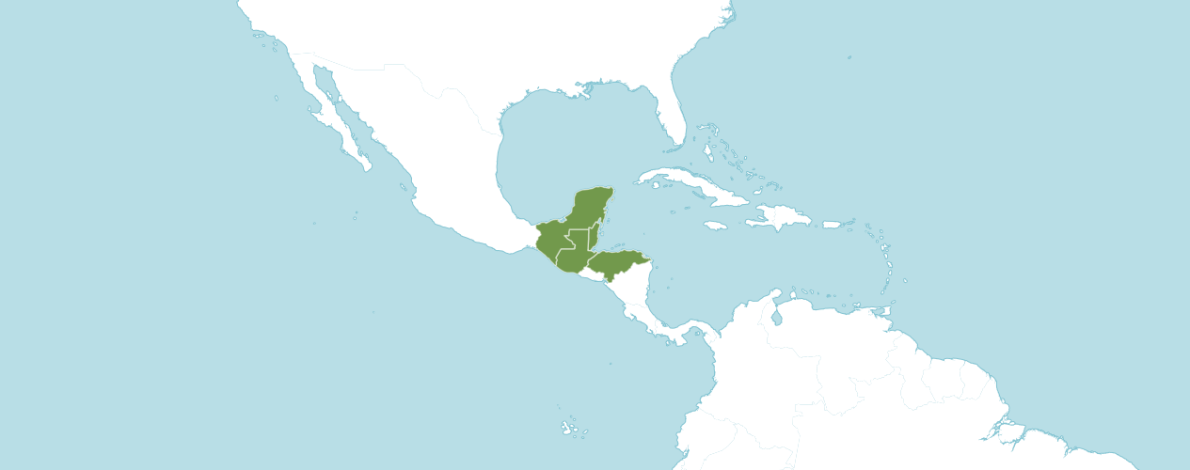
Habitat of Rhyncholaelia digbyana
Native to:
Belize, Guatemala, Honduras, Mexico Southeast

Homotypic Synonyms

Bletia digbyana (Lindl.) Rchb.f. in W. G. Walpers, Ann. Bot. Syst. 6: 422 (1862)

Brassavola digbyana Lindl. in Edwards's Bot. Reg. 32: t. 53 (1846)

Cattleya digbyana (Lindl.) Gentil in Pl. Cult. Serres Jard. Bot. Brux.: 49 (1907)

Laelia digbyana (Lindl.) Benth. ex Hemsl. in Biol. Cent.-Amer., Bot. 3: 246 (1884)

Heterotypic Synonyms

Brassavola digbyana var. fimbripetala (Ames) H. G. Jones in Orchid Rev. 70: 234 (1962)

Brassavola digbyana f. fimbripetala (Ames) O. Gruss & M. Wolff in Orchid. Atlas: 49 (2007)

Laelia digbyana var. fimbripetala Ames in Amer. Orchid Soc. Bull. 1: 59 (1932)

In the American Orchid Society web article Hereditary Influences of the Cattleya Alliance, Rhyncholaelia digbyana is reported to be the source of wonderful, fringed lips in complex hybrid cattleyas. Hybrids are very vigorous and exceptionally fragrant. The shape and fringed lip is dominant along with heavy substance. Hybrids with Rhyncholaelia digbyana as a direct parent usually have only one or two flowers per inflorescence but those flowers can be large. The species requires high light to flower well and many of its hybrids also share this requirement. Hybrids can flower at any time of the year.

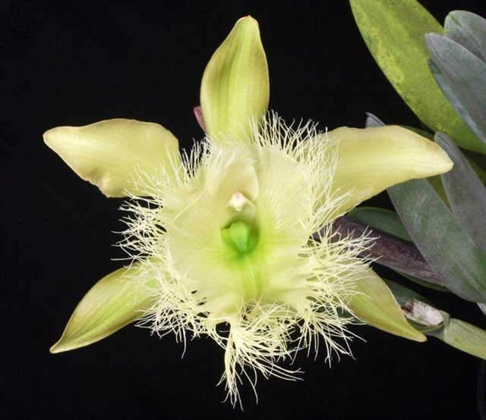
Rhyncholaelia digbyana ‘Quacker Farms’ AM/AOS, 82 points, 2021
Photograph by Glen Barfield
Hawaii AOS Judging Center – Big Island

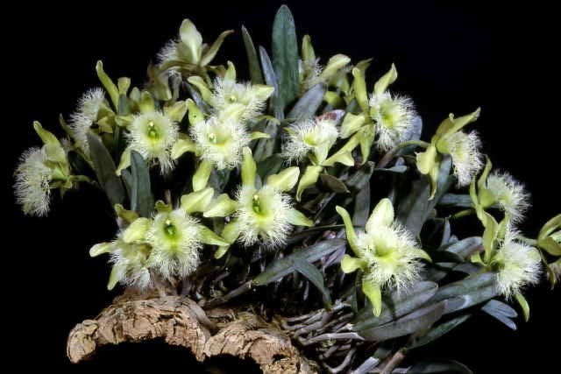
Rhyncholaelia digbyana ‘Dragonstone’ CCM/AOS, 92 points, 1992
Photograph by OWZ Lib
Pacific South Regional Monthly Judging, Los Angles, California

Hybrids

Rhyncholaelia digbyana has four hundred nineteen F1 generation offspring found, fifty-six or 13.4% have been awarded. Rhyncholaelia digbyana has nineteen thousand three hundred and forty-four progeny. Of the four hundred nineteen F1 generation hybrids registered, Rhyncholaelia digbyana was used one hundred fifty-five times as the seed parent and two hundred sixty-four times as the pollen parent.

Registered Rhyncholaelia digbyana F1 Hybrids
 | Pre -  1930 | 1930 - 1940 | 1940 - 1950 | 1950  -  1960 | 1960  -  1970 | 1970 - 1980 | 1980 -1990 | 1990 -2000 | 2000 - 2020 | 2020 + | TOTAL
Number of Hybrids | 91 | 10 | 21 | 19 | 32 | 31 | 72 | 35 | 99 | 8 | 419

Rhyncholaelia digbyana Progeny
Thirteen Generations of Progeny
Generation | Grexes | Awdd. | %Awdd. | Awds.
1 | 419 | 56 | 13.4% | 169
2 | 1,041 | 77 | 7.4% | 179
3 | 1,360 | 139 | 10.2% | 389
4 | 2,509 | 249 | 9.9% | 688
5 | 3,756 | 502 | 13.4% | 1,295
6 | 4,315 | 526 | 12.2% | 1,253
7 | 3,509 | 421 | 12.0% | 1,034
8 | 1,707 | 230 | 13.5% | 503
9 | 488 | 41 | 8.4% | 101
10 | 163 | 26 | 16.0% | 106
11 | 39 | 10 | 25.6% | 28
12 | 37 | 3 | 8.1% | 4
13 | 1 | 0 | 0% | 0

The first Rhyncholaelia digbyana hybrid was registered in 1889, Rhyncholaeliocattleya Digbyano-mossiae, (Rhyncholaelia digbyana x Cattleya mossiae). Rhyncholaeliocattleya Digbyano-mossiae was originated and registered in 1889 by Veitch. Rhyncholaeliocattleya Digbyano-mossiae has not received an AOS award. Rhyncholaeliocattleya Digbyano-mossiae has seventy-six F1 offspring and four thousand two hundred and fifty-two progeny. hybrids have been awarded.

Registered Rhyncholaelia Digbyano-mossiae F1 Offspring
 | Pre -  1930 | 1930 - 1940 | 1940 - 1950 | 1950  -  1960 | 1960  -  1970 | 1970 - 1980 | 1980 -1990 | 1990 -2000 | 2000 - 2020 | 2020 + | TOTAL
Number of Hybrids | 52 | 5 | 12 | 6 | 0 | 1 | 0 | 0 | 0 | 0 | 76

Rhyncholaelia Digbyano-mossiae Progeny
Eleven Generations of Progeny
Generation | Grexes | Awdd. | %Awdd. | Awds.
1 | 76 | 4 | 5.3% | 5
2 | 172 | 12 | 7.0% | 16
3 | 259 | 20 | 7.7% | 30
4 | 310 | 28 | 9.0% | 89
5 | 694 | 112 | 16.1% | 353
6 | 1,128 | 137 | 12.1% | 314
7 | 846 | 61 | 7.2% | 102
8 | 411 | 26 | 6.3% | 53
9 | 222 | 16 | 7.2% | 40
10 | 108 | 4 | 3.7% | 9
11 | 26 | 0 | 0% | 0

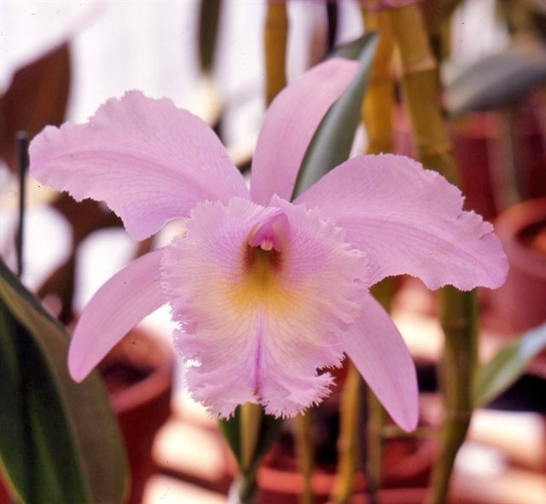
Rhyncholaelia Digbyano-mossiae
Photograph by Don Lindabury

The Brassavola appendiculata hybrid which received the most American Orchid Society awards is Rhynchovola [Rcv.] (syn. Brassavola or B.) David Sander, (Brassavola appendiculata x Rhyncholaelia digbyana). Rhynchovola David Sander has seven F1 offspring and seven progeny registered. Rhynchovola David Sander has received twelve American Orchid Society awards (AM – 8; HCC – 3; and CCM - 1), averaging 1.4 flowers and buds per inflorescence; 15.8 median natural spread. Rhynchovola David Sander was originated by and registered in 1938 by Sanders (St. Albans).

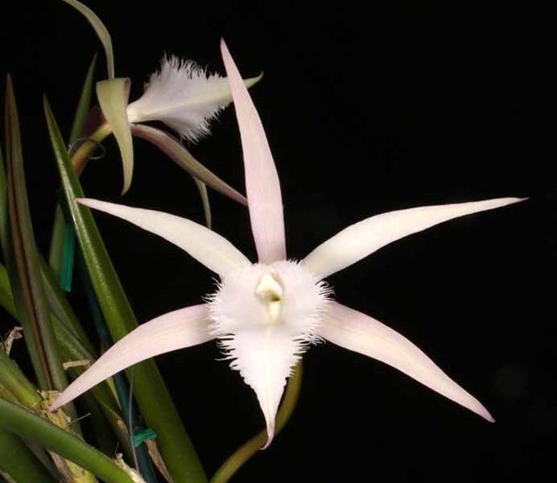

Rhynchovola David Sander ‘Quest’ AM/AOS, 82 points, 2018
Photograph by Tom Kuligowski

References

American Orchid Society. (n.d.). Brassavola. https://www.aos.org/orchids/orchids-a-to-z/letter-b/brassavola.aspx .

Ames, O., and Correll, D. (1965). Orchids of Guatemala and Belize. Dover Publications, New York.

Bechtel, H., Cribb, P. and Launert, E. (1980). Manual of cultivated orchid species. MIT Press, Cambridge, Mass.

Govaerts, R. (2003). World Checklist of Monocotyledons Database in ACCESS: 1-71827. The Board of Trustees of the Royal Botanic Gardens, Kew.

Govaerts, R. (1996). World Checklist of Seed Plants 2(1, 2): 1-492. MIM, Deurne.
Hamilton, R. (1988). When does it flower? 2nd ed. Robert M. Hamilton, 9211 Beckwith Road, Richmond, B.C., Canada V6X 1V7.
Hawkes, A. [1965] 1987. Encyclopaedia of cultivated orchids. Faber and Faber, London.
Hetherington, E. 1986. Cattleya hybrids and hybridizers: Brassavola digbyana - the unsung patriarch. American Orchid Society Bulletin, 55(2): 122-131.
Martin, B. (2023, November 15). A new look at an old genus. American Orchid Society. https://www.aos.org/all-about-orchids/webinars/member-only/brassavola.aspx .
Nelson Sutherland, C.H. (2008). Catálogo de las plantes vasculares de Honduras. Espermatofitas: 1-1576. SERNA/Guaymuras, Tegucigalpa, Honduras.
Noguera-Savelli, E. & Cetzal-Ix, W. (2014). Revisión e integración del conocimiento de las Orchidaceae de Tabasco, México. Botanical Sciences 92: 519-540.
Noguera-Savelli, E. (2020). Systematics of the neotropical genus Brassavola (Orchidaceae). Caldasia 42: 188-219.
OrchidPro. (n.d.).
OrchidWiz X9.0. (n.d.).
Royal Botanical Gardens Kew, Plants of the World On-line. (n.d.). Brassavola appendiculata. https://powo.science.kew.org/taxon/urn:lsid:ipni.org:names:618022-1
Williams, L. [1951] 1986. The Orchidaceae of México. CEIBA 2(1–4): 1–256.
Williams, L. 1956. An enumeration of the orchidaceae of Central America, Belize, and Panama. CEIBA 5(1–4).

