Broughtonia R.Br. 1813
[braw-TOE-nee-ah]

Described by Robert Brown in 1813 and named to honor Arthur Broughton, an English botanist who collected in Jamaica in the early nineteenth century, Broughtonia is closely allied to Laeliopsis and Cattleyopsis and the World Monocot Checklist currently considers both genera to be synonymous with Broughtonia. The genus is characterized by conspicuous, usually flattened and tightly clustered, typically bifoliate, pseudobulbs and moderately long cylindrical inflorescences that carry the brightly colored flowers clustered near the apex. Commonly found in collections are the assorted color forms of Broughtonia sanguinea, ranging from deep pink to white or yellow and splash petal. These species are popular in collections because of their showy, brightly colored flowers and compact growth habit.

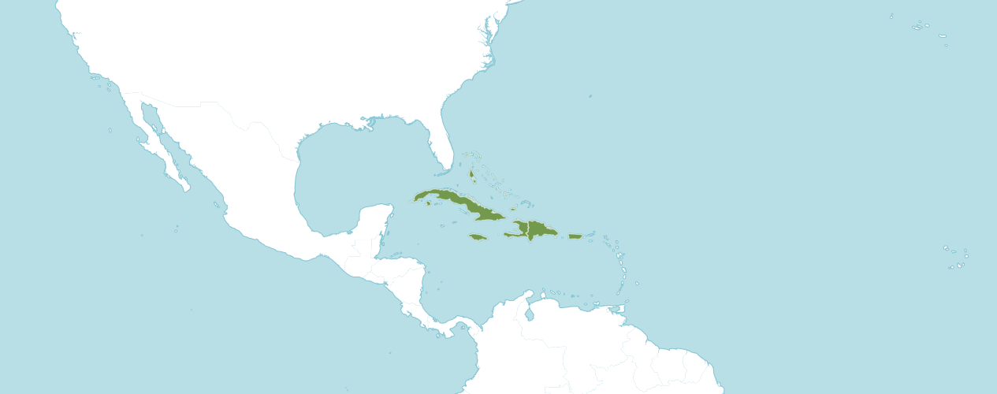
Habitat of Broughtonia

Native to:
Bahamas, Cuba, Dominican Republic, Haiti, Jamaica, Puerto Rico

Heterotypic Synonyms
Cattleyopsis Lem. in Jard. Fleur. 4(Misc.): 59 (1854)
Laeliopsis Lindl. in Paxton's Fl. Gard. 3: 155 (1853)

Accepted Species
Broughtonia cubensis (Lindl.) Cogn.
Broughtonia domingensis (Lindl.) Rolfe
Broughtonia × guanahacabibensis Múj. Benítez, E. González & J.M. Díaz
Broughtonia × jamaicensis Sauleda & R. M. Adams
Broughtonia lindenii (Lindl.) Dressler
Broughtonia negrilensis Fowlie
Broughtonia ortgiesiana (Rchb.f.) Dressler
Broughtonia sanguinea (Sw.) R. Br.

Type species Broughtonia sanguinea

Broughtonia Species Awards
 | FCC | AM | HCC | AQ | JC | CCM | CCE | CHM | CBM | CBR | TOTAL
alba | - | - | - | - | - | 1 | - | 1 | - | - | 2
amoena | - | - | - | - | - | - | - | 1 | - | - | 1
coccinea, ~sanguinea | 2 | 75 | 24 | 5 | 5 | 7 | - | - | 2 | - | 120
cubensis | - | 1 | - | - | - | 1 | - | - | 1 | - | 3
domingensis | - | - | 1 | - | - | - | - | 1 | - | 1 | 3
x jamicensis | - | - | - | - | - | - | - | - | - | 1 | 1
lindenii | - | - | - | - | - | - | - | 2 | - | - | 2
negrilensis | - | 2 | 4 | - | 1 | 3 | - | 2 | 1 | - | 13
ortgiensiana | 1 | 2 | - | - | - | 1 | - | 1 | - | - | 5
pilosa | - | - | - | - | - | - | - | - | - | - | 0
sanguinea | 2 | 75 | 24 | 5 | 5 | 7 | - | - | 2 | - | 120
violacea, ~domingensis | - | - | 1 | - | - | - | - | 1 | - | 1 | 3
x guanahacbibensis | - | - | - | - | - | - | - | - | - | - | 0

Broughtonia Species Offspring and Progeny
 | Pre - 1930 | 1930  -  1940 | 1940  -  1950 | 1950  -  1960 | 1960  -  1970 | 1970  -  1980 | 1980  -  1990 | 1990  -  2000 | 2000  -  2010 | 2010  + | Total | Progeny
alba | - | - | - | - | - | - | - | - | - | - | 0 | 0
amoena | - | - | - | - | - | - | - | - | - | - | 0 | 0
coccinea, ~sanguinea | - | - | - | 3 | 30 | 23 | 43 | 17 | 14 | 7 | 137 | 1,080
cubensis | - | - | - | - | - | 1 | - | - | - | - | 1 | 2
domingensis | - | - | - | 3 | 9 | - | 5 | 1 | - | 1 | 19 | 43
x jamicensis | - | - | - | - | - | - | - | 1 | 2 | - | 3 | 4
lindenii | - | - | - | - | 1 | - | 2 | 2 | 2 | 1 | 8 | 15
negrilensis | - | - | - | - | - | - | 1 | 10 | 5 | 3 | 19 | 36
ortgiensiana | - | - | - | - | 4 | 1 | - | - | 5 | -3 | 13 | 22
pilosa | - | - | - | - | - | - | - | - | - | - | 0 | 0
sanguinea |  |  |  | 3 | 30 | 23 | 43 | 17 | 14 | 7 | 137 | 1,080
violacea, ~domingensis | - | - | - | 3 | 9 | - | 5 | 1 | - | 1 | 19 | 43
x guanahacbibensis | - | - | - | - | - | - | - | - | - | - | 0 | 0

Carl Withner reports in his book, The Cattleyas and Their Relatives, volume IV: The Bahamian and Caribbean Species, Robert Brown described the genus in 1813, naming Broughtonia sanguinea as the first species. He pointed out the presence of a nectary tube attached to the ovary. In addition, Robert pointed out the footless column clasped by the lateral edges of the lip base as a distinguished characteristic of the genus, (The Cattleyas and Their Relatives, Volume IV, page 15).

Broughtonia sanguinea has had a considerable influence on orchid hybridization. Broughtonia sanguinea has multiple color forms which allow for producing offspring of assorted colors. Broughtonia sanguinea installs several positive characteristics in its offspring and several post generation progeny, such as round, flat form to the flowers, wide and overlapping petals and sepals, an intensity of rose color, flowers in a cluster at the end of a comparatively long inflorescence, a show display of flowers for the size of the plant, early seedling maturity, a tolerance of heat and sun, and ability to grown well in baskets or on slabs. Hybrids of Broughtonia sanguinea adapt well to outdoor culture, where warmth and humidity are present.

The negative influences Broughtonia sanguinea imparts to its offspring are plants are unusually susceptible to certain pesticide sprays, such as malathion. In addition, offspring, and progeny of Broughtonia sanguinea are vulnerable to rot from over watering, especially during their period of dormancy. Broughtonia instills in its offspring narrow sepals and papery substance. Broughtonia sanguinea offspring and some progeny prefer to be mounted with their roots exposed.

Intergeneric Hybrid Combinations with Broughtonia
Registered Through March 1995
With Approved Abbreviations
From The Cattleyas and Their Relatives, volume IV:
The Bahamian and Caribbean Species

Brouightonia (Bro.)

x Brassavola = Brassotonia (Bstna.)

x Brassavola x Cattleya = Stellamizutaara (Stlma.)

x Brassavola x Cattleya x Epidendrum x Lealia = Hattoriara (Hatt.)

x Brassavola x Cattleya x Lealia = Otaara (Otr.)

x Brassavola x Cattleya x Laelia x Schomburgkia = Westara (Wsta.)

x Brassavola x Cattleya x Laelia x Sophronitis = Hasegwaara (Hasgw.)

x Brassavola x Epidendrum = Wooara (Woo.)

x Brassavola x Laeliopsis = Casoara (Csr.)

x Cattleya = Cattleytonia (Ctna.)

x Cattleya x Cattleyopsis = Vejuarutara (Vja.)

x Cattleya x Diacrium = Brownara (Bwna.)

x Cattleya x Diacrium x Laelia = Cookara (Cook.)

x Cattleya x Diacrium x Laeliopsis = Kraussara (Krsa.)

x Cattleya x Epidendrum = Epicatonia (Epctn.)

x Cattleya x Epidendrum x Laelia = Jewellara (Jwa.)

x Cattleya x Epidendrum x Laelia x Sophronitis = Buiara (Bui.)

x Cattleya x Epidendrum x Schomburgkia = Wilburchangara (Wbchg.)

x Cattleya x Laelia = Laeliocantonia (Lctna.)

x Cattleya x Laelia x Laeliopsis = Filaara (Fia.)

x Cattleya x Laelia x Sophronitis = Hawkinsara (Hknsa.)

x Cattleya x Laeliopsis = Osmentara (Osmt.)

x Cattleya x Laeliopsis x Tetramicra = Fordyceara (Fdca.)

x Cattleya x Schomburgkia = Schombocatonia (Smbcna.)

x Cattleya x Sophronitis = Bishopara (Bish.)

x Cattleyopsis = Cattleyopsistonia (Ctpsta.)

x Cattleyopsis x Diacrium = Nashara (Nash.)

x Cattleyopsis x Diacrium x Epidendrum = Leslieara (Lesl.)

x Cattleyopsis x Domingoa = Dunnara (Dnna.)

x Cattleyopsis x Epidendrum = Lemaireara (Lemra.)

x Cattleyopsis x Laeliopsis = Gauntlettara (Gtra.)

x Diacrium = Diabroughtonia (Diab.)

x Diacrium x Schomburgkia = Shipmanara (Shipm.)

x Domingoa = Domintonia (Dmtna.)

x Epidendrum = Epitonia (Eptn.)

x Epidendrum x Laeliopsis = Moscosoara (Mscra.)

x Laelia = Laelonia (Lna.)

x Laelia x Laeliopsis = Jimenezara (Jnzra.)

x Laelia x Sophronitis = Hartara (Hart.)

x Laeliopsis = Lioponia (Lpna.)

x Laeliopsis x Schomburgkia = Hidaara (Hdra.)

x Laeliopsis x Tetramicra = Bloomara (Blma.)

x Schomburgkia = Schombonia (Smbna.)

x Tetramicra = Tetratonia (Tttna.)

Noted online in an American Orchid Society page is the offspring of Broughtonia are usually flattened and tightly clustered flowers, offspring plants can be bifoliate, pseudobulbs and moderately long cylindrical inflorescences that carry brightly colored flowers in clustered near the apex of the inflorescences.

References
American Orchid Society. (n.d.). Broughtonia. https://www.aos.org/orchids/orchids-a-to-z/letter-b/broughtonia.aspx .
Bechtel, H., Cribb, P., and Launert, E. (1992). The Manual of Cultivated Orchid Species, 3rd edition, MIT Press, Cambridge, MA.
Govaerts, R. (1996). World Checklist of Seed Plants 2(1, 2): 1-492. MIM, Deurne.
Govaerts, R. (2003). World Checklist of Monocotyledons Database in ACCESS: 1-71827. The Board of Trustees of the Royal Botanic Gardens, Kew.
Hawkes, A. (1965) Encyclopaedia of Cultivated Orchids, Faber & Faber, London.
Mújica, E., González, E., Bocourt, J., et.la. (2015). "A new natural hybrid of Broughtonia (Orchidaceae) from Cuba". Lankesteriana. Universidad de Costa Rica. 15 (3). doi:10.15517/lank.v15i3.21432. ISSN 2215-2067.
OrchidPro. (n.d.).
OrchidWiz X9.0. (n.d.).
Pridgeon, A., Cribb, P., Chase, M., and Rasmussen, F. (2006). Epidendroideae (Part One). Genera Orchidacearum 4: 1-672. Oxford University Press, New York.
Pridgeon, Alec, The Illustrated Encyclopedia of Orchids, Timber Press, Portland, OR, 1992.
Royal Botanical Gardens Kew, Plants of the World On-line. (n.d.). Broughtonia. https://powo.science.kew.org/taxon/urn:lsid:ipni.org:names:1008135-2 .
Withner, C. (2000). The Cattleyas and their relatives. Volume VI. The South American Encyclia Species. Timber press, Portland, Oregon.

