Encyclia and Prosthechea:
Three Sample descriptions for Awards and an Addition Two for Intergeneric Crosses

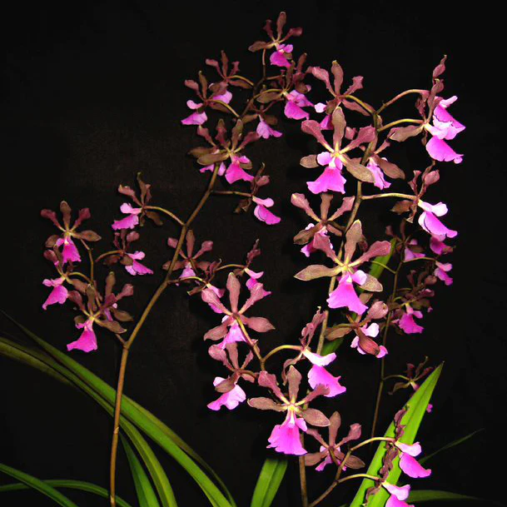

Encyclia Rioclarense
Photography by Jewell Orchids

Forty-two flowers and one bud on three up to x cm inflorescences; sepals chartreuse overlaid chestnut; petals chartreuse overlaid burgundy; lip fuchsia, side lobs fuchsia proximal, white distal; column white; substance firm, texture matt.

Award: AM/AOS, 82 points.

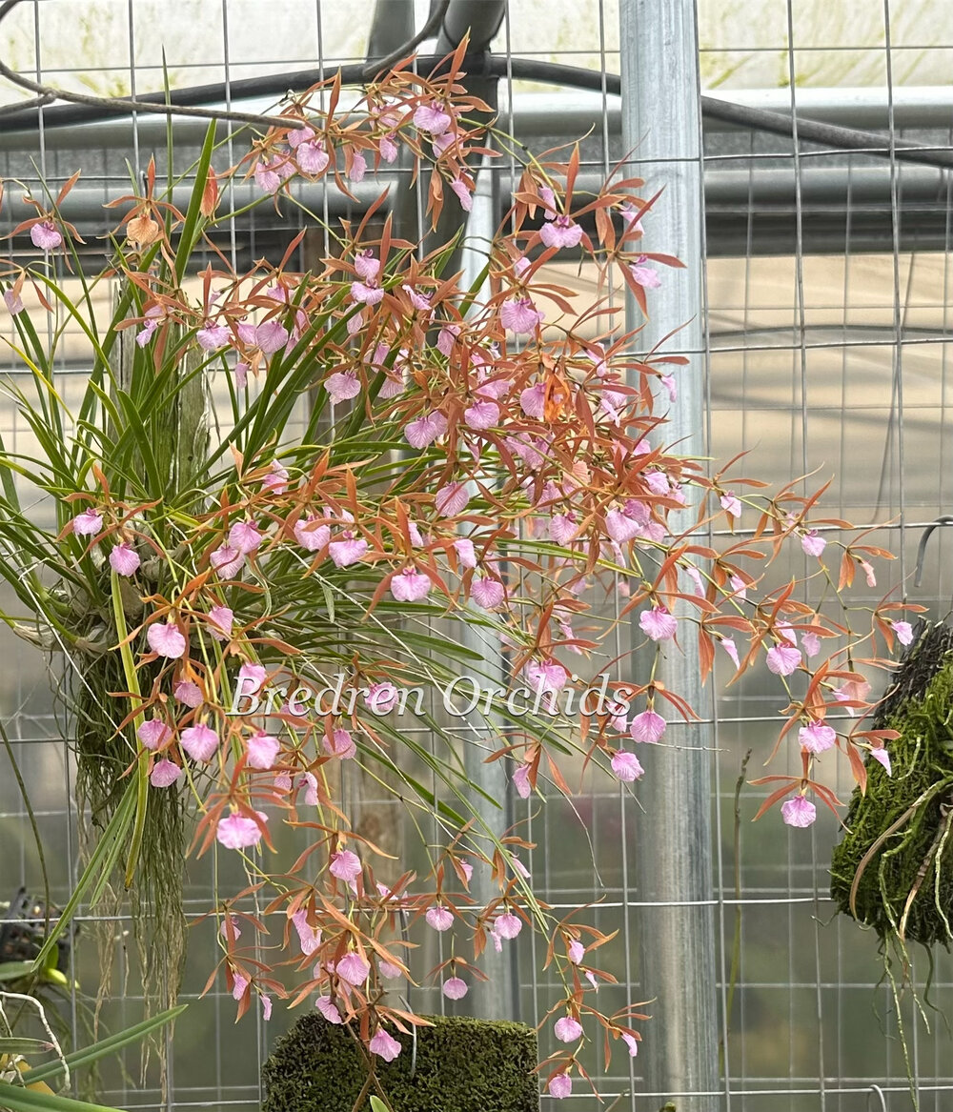

Encyclia bractescens
Photography by Bredren Orchids

One hundred ten stellate flowers and three buds on ten arched inflorescences; sepals and petals chestnut; lip pink, side lobes pink; substance good; texture matte.

Award: HCC/AOS, 79 points

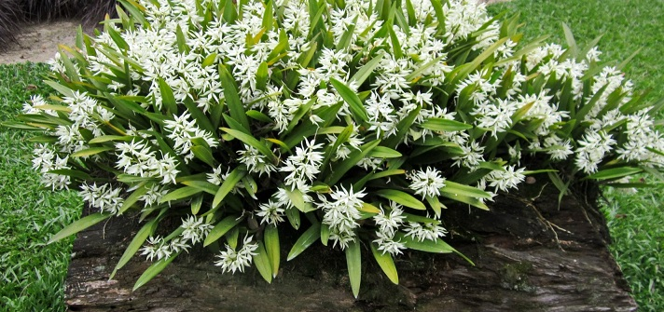

Prosthechea fragrans
Photography by unknown

Approximately 631 flowers and x buds on ninety-three inflorescences, plant grown on a x cm by x cm wooden log; sepals and petals white; lip white striped maroon; column pale green; substance firm; texture sparkling.

Award: CCM/AOS, 90 points

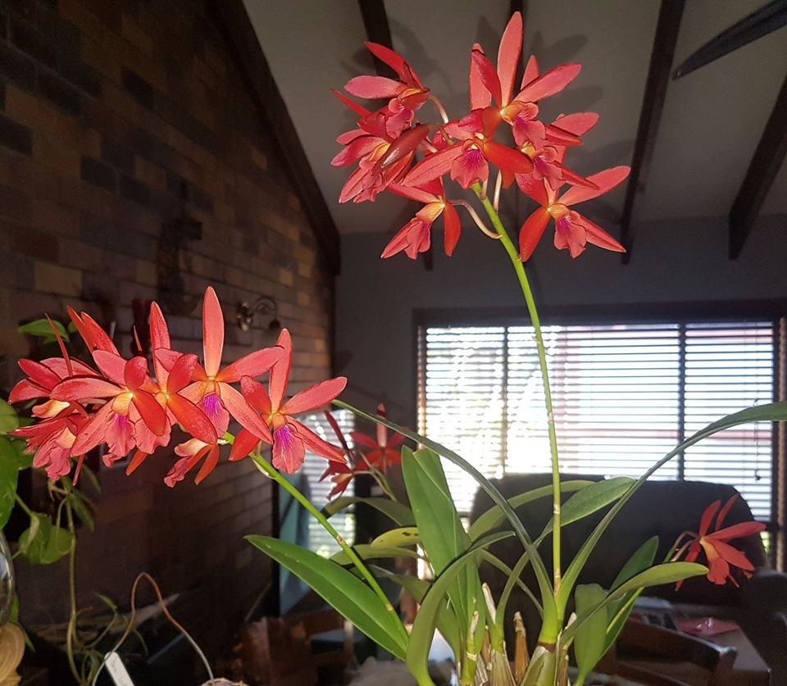

Epilaeliocattleya Charlie Brown, (Lc. Rojo x E. codigera)
Photography by unknown

Twenty-three stellate flowers and 1 bud on four inflorescences; sepals and petals, red; lip midlobe fuchsia, side lobes enclose column, tangerine, column white; substance firm; texture satiny.

Award: HCC/AOS, 77 points

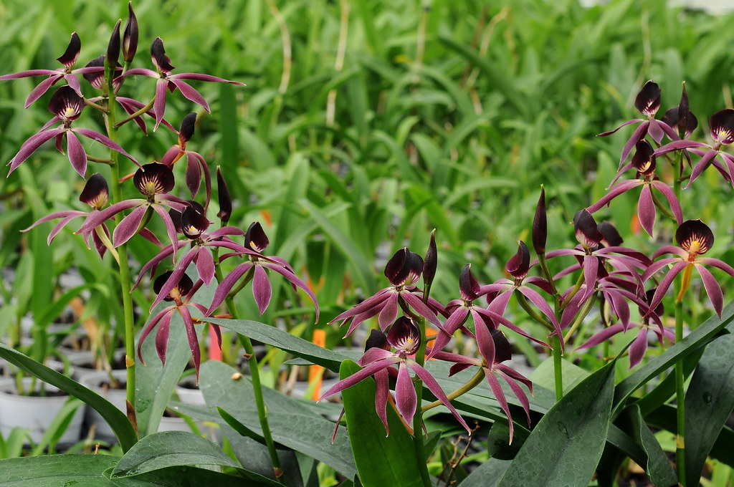

Guarechea (Grc.) Black Comet, (Guarianthe cochleata x Epicattleya Miva Etoile)
Photography by unknown

Twenty-three stellate flowers and six buds on five upright inflorescences upto x cm; sepal and petals purple, chartreuse basally; lip cupped, dark plum purple marginally, chartreuse proximally, dark purple lines radiate to column; column chartreuse, anther cap yellow; substance firm; texture matte.

Award: AM/AOS, 84 points.

