Prosthechea cochleata (Lind.) W. E. Higgins, 1998
[kok-lee-ah-ta]

OrchidWiz notes from Charles Baker: Origin/Habitat: Mexico, Central America, Colombia, Venezuela, the West Indies, and Florida. In Mexico, plants grow on mountain slopes facing the Atlantic Ocean in the states of Campeche, Chiapas, Hildalgo, Oaxaca, Puebla, Quintana Roo, San Luis Potosí, Tabasco, Tamaulipas, and Veracruz. They are found in open forests and clearings in many types of forests including tropical deciduous, tropical evergreen, and oak. Habitat range is listed as near sea level to 6550 ft. (0-2000 m). Plants usually grow in the midrange of the preceding elevations, however, and in much of Central America, plants are found at 1000-4250 ft. (300-1300 m). In Venezuela, plants were seen in open forests above Pie del Cerro near La Victoria at about 5000 ft. (1520 m) and in cloud forests along the road to Choroní at about 4500 ft. (1370 m). In Puerto Rico, this orchid is widespread and common. It grows in both shady and bright conditions in nearly dry to wet forests at 650-2950 ft. (200-900 m). In the Virgin Islands, however, plants are reported only on St. Croix.

Plant Size and Type: A relatively large, 10-23 in. (25-59 cm) epiphyte, lithophyte, or terrestrial.

Pseudobulb: 2.2-10.2 in. (5.5-26.0 cm) long by 0.8-2.0 in. (2-5 cm) wide. The ellipsoid to pear-shaped pseudobulbs are loosely clustered, somewhat flattened, and sometimes have a short stalk.

Leaves: 8-13 in. (20-33 cm) long by 1.2-2.0 in. (3-5 cm) wide. Usually 2, but sometimes 3 or 4, oblong-lanceolate to linear-lanceolate leaves are carried at the apex of each pseudobulb. They are glossy, slightly leathery, and taper to a sharp point at the tip. The leaf has a short, folded base where they are attached to the pseudobulb.

Inflorescence: 20 in. (50 cm) long, or more. The flower spike is long stalked, rarely branched, and may be erect or arching. It develops at the top of a recently matured pseudobulb. It emerges through a sheath that may be 1-5 in. (2.5-13.0 cm) long. Flowering is a prolonged process that lasts from late spring into winter. Flowers open in succession as the spike continues to lengthen and new buds form. Plants may be in almost continuous bloom. By the time flowering is completed, the stalk may have reached a length of 28 in. (70 cm).

Flowers: Many. Long lasting blossoms open in succession, and only a few are open at any one time. Flowers are up to 3.5 in. (9 cm) long, with the "cockle-shell" lip at the top. They are highly variable in size and degree of expansion. Flower color is somewhat variable, but sepals and petals are usually greenish yellow with some purple spots near the base. The apical part of the lip is most often a rich, deep purple (almost purple-black) with a yellow-green flush. The white base of the lip has conspicuous radiating purple veins and 2 yellow calli at the base of the disc. The column is green with purple spots. The narrowly lanceolate, sharply pointed sepals and petals are 1.2-3.0 in. (3.0-7.5 cm) long by 0.1-0.3 in. (0.3-0.7 cm) wide. They may be spreading or sharply down-turned with more or less twisting. The lip is 0.4-0.8 in. (1.0-2.1 cm) long by 0.5-1.0 in. (1.2-2.5 cm) wide. The lip, which is attached to the column, starts spreading at about the middle to the column. It may be broadly rounded to heart-shaped, and deeply concave, with rather wavy margins. The stout column is 0.3 in. (0.7-0.9 cm) long and broadest in the middle, with a blunt, to at the apex that is shorter than the side teeth.

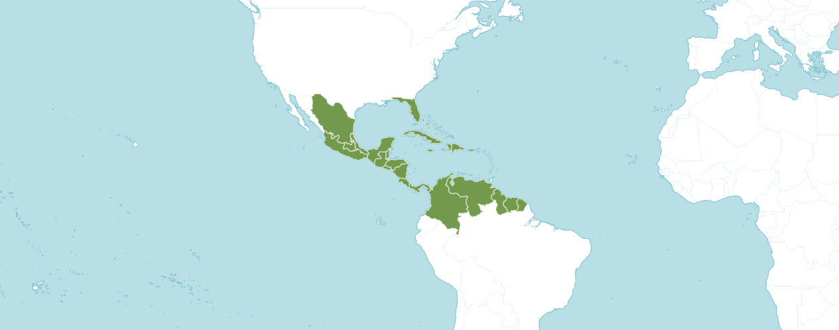

Native to:
Bahamas, Belize, Cayman Is., Colombia, Costa Rica, Cuba, Dominican Republic, El Salvador, Florida, French Guiana, Guatemala, Guyana, Haiti, Honduras, Jamaica, Leeward Is., Mexico Central, Mexico Gulf, Mexico Northeast, Mexico Southeast, Mexico Southwest, Nicaragua, Panamá, Puerto Rico, Suriname, Venezuela, Venezuelan Antilles, Windward Island.

Homotypic Synonyms
Anacheilium cochleatum (L.) Hoffmanns. in Verz. Orchid.: 21 (1842)
Encyclia cochleata (L.) Dressler in Brittonia 13: 264 (1961)
Epidendrum cochleatum L. in Sp. Pl., ed. 2.: 1351 (1763)

Prosthechea cochleata blooms on a sequential inflorescence with one bloom after the other fades so it will stay in bloom for a year to 18 months on one inflorescence and seems to always be in bloom. The blooms are very resistant to pests, particularly slugs.
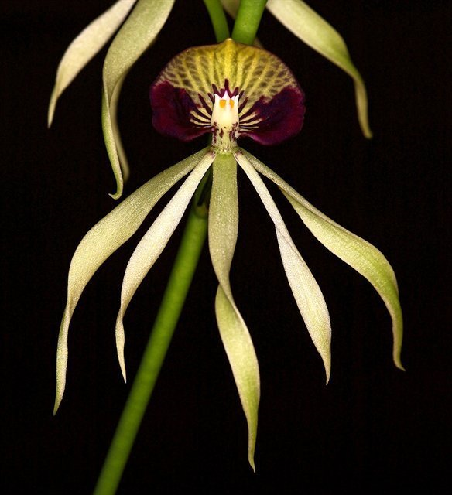
Prosthechea cochleate
Photograph by Jonathan Cara

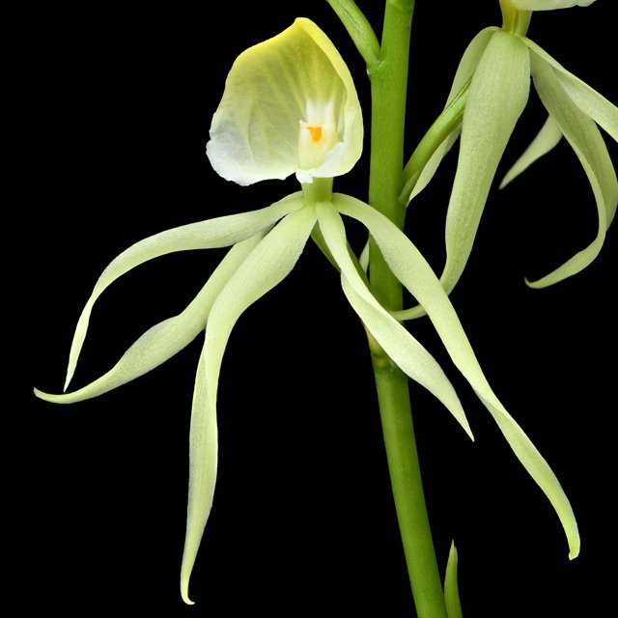
Prosthechea cochleate f. alba
Photograph by Mark Duttweiler

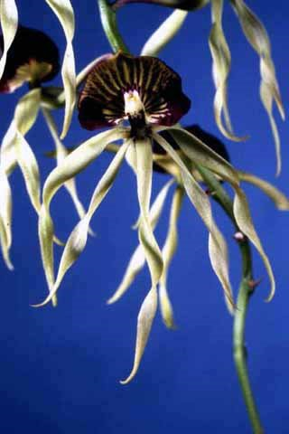

Prosthechea cochleate ‘DB’ HCC/AOS,
Photograph by Lewis Ellsworth
Florida North Central Center Monthly Judging
AOS Awards:

Prosthechea cochleate
 | FCC | AM | HCC | AQ | JC | CCM | CCE | CHM | CBM | CBR | TOTAL
AOS | 1 | 14 | 3 | 1 | 0 | 4 | 0 | 2 | 2 | 0 | 27
Years Awarded | 2015 | 1977 - 2017 | 2000  -  2016 | 2004 | - | 2003 –  2018 | - | 1981  &  1992 | 1977  &  1977 | -

Thirty-six awards averaging 9.1 flowers and buds per inflorescences; 7.4 cm. median natural spread.
Hybrids
Forty-one F1 generation offspring found, ten or 24.4% have been awarded. Prosthechea cochleate has forty-five progeny. Of the thirty-two F1 generation hybrids registered, Prosthechea radiata was used twenty-seven times as the seed parent and fourteen times as the pollen parent. The first Prosthechea cochleate hybrid was registered in 1902, Epithechea Cuco, (Prosthechea cochleate x Epidendrum biforatum). Epithechea Cuco was originated and registered in 1902 by T. L. Mead.

The first registration of a Prosthechea cochleate hybrid was in 1902 without another registration in 1907. Another registration of a Prosthechea cochleata hybrid did not occur until 1960. Steady registration of Prosthechea cochleate hybrids transpired from 1960’s into the 1980’s. Steady registration of Prosthechea cochleata hybrids occurred from 1987 to 2021.

The Prosthechea cochleata hybrid that has received the largest number of American Orchid Society awards and has the largest number of registered offspring is Prosthechea Green Hornet (Prosthechea cochleata x Prosthechea trulla). Prosthechea Green Hornet has received three awards (AM – 1; HCC – 1; and CCM – 1) Prosthechea Green Hornet has three registered offspring. Prosthechea Green Hornet originated by and registered in 1995 by H & R Orchids.

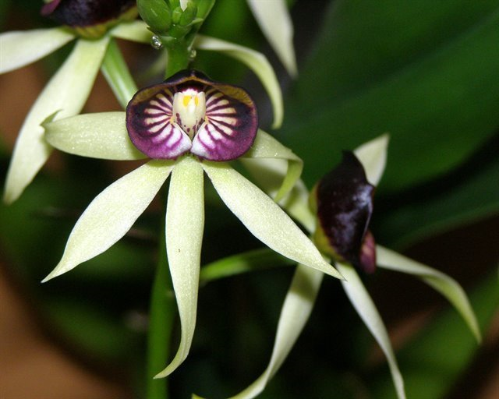

Prosthechea Green Hornet
Photograph by Lois Cinert

The flowers of Prosthechea cochleate are unusual in that though the labellum is usually below the column in orchids, with Prosthechea cochleate the labellum forms a "hood" over the column. This makes the flower effectively look upside down, or non-resupinate. From reviewing photographs in OrchidWiz, most hybrids of Prosthechea cochleate are non-resupinate, although some Prosthechea cochleate hybrids are resupinate. Sepals and petals of Prosthechea cochleate hybrids are stellate. Depending on the secondary parent of Prosthechea cochleate hybrids frequently have lips that are striped. If the secondary parent of Prosthechea cochleate hybrids are cream, yellow, or green, sepals and petals of the offspring will be green or yellow. If the secondary parent of a Prosthechea cochleate hybrid are darker hues, the offspring will frequently absorb the coloration of the secondary parent. Prosthechea cochleate offspring tend to produce multiple flowers on an inflorescence and at times are crowded in their presentation.

References
American Orchid Society. (n.d.). Prosthechea. https://www.aos.org/orchids/orchids-a-to-z/letter-p/prosthechea.aspx
Govaerts, R. (2003). World checklist of monocotyledons Database in ACCESS: 1-71827. The Board of Trustees of the Royal Botanic Gardens, Kew.
Hagsater, E. et al. (2005). Orchids of Mexico. Productos Farmaceuticos. p.89.
Hammel, B. et al. (2003). Manual de plantas de Costa Rica 3: 1-884. Missouri Botanical Garden Press, St. Louis.
Higgins, W. (1999). “The Genus Prosthechea: An Old Name Resurrected.” Orchids, Vol. 68, No 11, Nov 1999, pg. 1114 Dressler & Pollard, 1974, “The Genus Encyclia in Mexico.”
Luer, C. (1972). The Native Orchids of Florida. The New York Botanical Garden.
OrchidPro. (n.d.).
OrchidWiz X9.0. (n.d.).
Pridgeon A., Cribb, P., Chase M., & Rasmussen, F. (2005). Genera Orchidacearum, Volume 4, Epidendroideae (Part one). Oxford University Press.
Royal Botanical Gardens Kew, Plants of the World On-line. (n.d.). Prosthechea cochleata. https://powo.science.kew.org/taxon/urn:lsid:ipni.org:names:1001247-1
Withner, C. (2000). The Cattleyas and their relatives. Volume VI. The South American Encyclia Species. Timber press, Portland, Oregon.

