Prosthechea mariae (Ames) W. E. Higgins, 1998
[mar-ee-eye]

Named for Mother of Christ or name after the daughter of the collector

Common Name: Wedding Orchid of Mexico

From OrchidWiz and Charles Baker sheets: Origin/Habitat: Mexico. Found in dry oak forests of the mountains in northeastern Mexico at 3300-4000 ft. (1000-1200 m) in the states of Tamaulipas, San Luis Potosi, Vera Cruz, and Hidalgo. The habitat extends from near the Texas border to just northeast of Mexico City.

Plant Size and Type: A sympodial epiphyte to 12 in. (30 cm) tall.

Pseudobulb: 1-2 inches (2-5 cm) tall. They are tightly clustered, conic-ovoid in shape, and do not have the fibrous core common in most other epiphytes.

Leaves: 2-3 per growth. The oblong leaves are 4-7 in. (9-18 cm) long and are silvery grey-green in color.

Inflorescence: 5-10 in. (12-25 cm) long. One suberect to arching spike arises from between the leaves at the apex of each new pseudobulb.

Flowers: 2-4 per inflorescence. The blossoms are 3-4 in. (7-10 cm) across and open simultaneously. The sepals and petals are yellow to olive. The very large, white lip is ruffled along the edge with green veining in the throat.

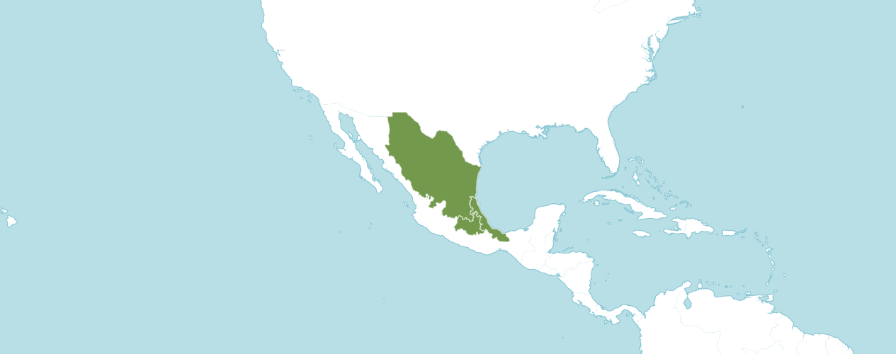

Native to:
Mexico Central, Mexico Gulf, Mexico Northeast

Homotypic Synonyms
Encyclia mariae (Ames) Hoehne in Arq. Bot. Estado São Paulo, n.s., f.m., 2: 152 (1952)
Epidendrum mariae Ames in Bot. Mus. Leafl. 5: 36 (1937)
Euchile mariae (Ames) Withner in Cattleyas & Relatives 5: 139 (1998)

AOS Awards:

Prosthechea mariae
 | FCC | AM | HCC | AQ | JC | CCM | CCE | CHM | CBM | CBR | TOTAL
AOS | 0 | 17 | 10 | 0 | 0 | 6 | 1 | 0 | 0 | 0 | 34
Years Awarded | - | 1966 - 2021 | 1967 - 2015 | - | - | 1957 - 1990 | 2006 | - | - | -

Thirty-four awards averaging 3.9 flowers and buds per inflorescences; 8.0 cm. median natural spread.

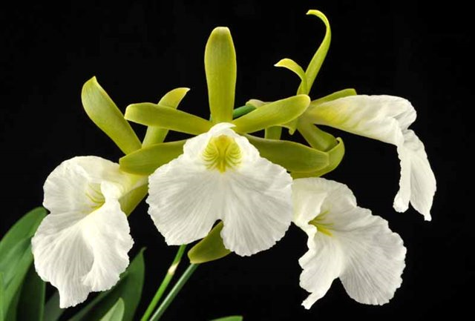
Prosthechea mariae ‘Gabriel Amaru’ AM/AOS, 80 points, 2017
Photograph by G. Barfield
Hawaii Center Monthly Judging
Hybrids
One hundred fourteen F1 generation offspring found, nineteen or 16.7% have been awarded. Prosthechea mariae has two hundred eighteen progeny. Of the thirty-two F1 generation hybrids registered, Prosthechea mariae was used fifty times as the seed parent and sixty-four times as the pollen parent. The first Prosthechea mariae hybrid was registered in 1953, Cattleychea Ave Maria, (Prosthechea mariae x Cattleya mossiae). Cattleychea Ave Maria was originated and registered in 1953 by Raasch. There have been steady registrations of Prosthechea mariae hybrids since 1953 with the last registration occurring in 2020.

The Prosthechea mariae hybrid that has received the largest number of American Orchid Society awards and has the largest number of registered offspring is Cattleychea Mae Bly, (Prosthechea mariae x Cattleya Ann Follis). Cattleychea. Mae Bly has received twenty American Orchid Society awards (AM – 9; HCC – 7; and CCM – 2). Cattleychea. Mae Bly has ten registered offspring and twelve total progeny. Cattleychea Mae Bly was originated by and registered in 1967 by Frederick Thorton.

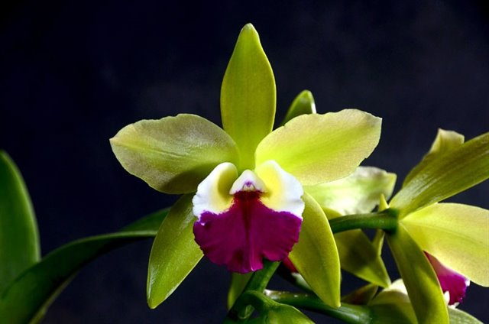

Cattleychea Mae Bly ‘Daniela’ HCC/AOS, 77 points, 2015
Photograph by Jorge Enrique Cespedes Trigueros
Ascociacion Costarricense de Orquideologia Show

From reviewing photographs of Prosthechea mariae hybrids on OrchidWiz, I noted offspring of Prosthechea mariae have a high propensity to inherit a lip that is large and open. Depending on the base color of the secondary species or hybrid used in hybridization, the offspring lip can be white. When the secondary species or hybrid is green, yellow, or white, there is a higher significance the offspring lip color will be white. Again, if the secondary species or hybrid used in the cross is green, yellow, or white, the sepals and petals have a higher chance of expressing as yellow or green. If the secondary parent has a recessive gene or color, even if the secondary parent is lavender or pink, the offspring still has a chance of expressing yellow or green sepals and petals with a white lip. Prosthechea mariae offspring often produce multiple flowers on one inflorescence, and at times can be somewhat crowded.

References
American Orchid Society. (n.d.). Prosthechea. https://www.aos.org/orchids/orchids-a-to-z/letter-p/prosthechea.aspx
Govaerts, R. (2003). World checklist of monocotyledons Database in ACCESS: 1-71827. The Board of Trustees of the Royal Botanic Gardens, Kew.
Hagsater, E., et al. (2005). Orchids of Mexico. Productos Farmaceuticos. p.89.
Hammel, B., et al. (2003). Manual de plantas de Costa Rica 3: 1-884. Missouri Botanical Garden Press, St. Louis.
Higgins, W. (1999). “The Genus Prosthechea: An Old Name Resurrected.” Orchids, Vol. 68, No 11, Nov 1999, pg. 1114 Dressler & Pollard, 1974, “The Genus Encyclia in Mexico.”
Luer, C. (1972). The Native Orchids of Florida. The New York Botanical Garden.
OrchidPro. (n.d.).
OrchidWiz X9.0. (n.d.).
Pridgeon A., Cribb, P., Chase M., & Rasmussen, F. (2005). Genera Orchidacearum, Volume 4, Epidendroideae (Part one). Oxford University Press.
Royal Botanical Gardens Kew, Plants of the World On-line. (n.d.). Prosthechea mariae. https://powo.science.kew.org/taxon/urn:lsid:ipni.org:names:1001275-1
Withner, C. (2000). The Cattleyas and their relatives. Volume VI. The South American Encyclia Species. Timber press, Portland, Oregon.

