Cattleya: Five Sample Descriptions

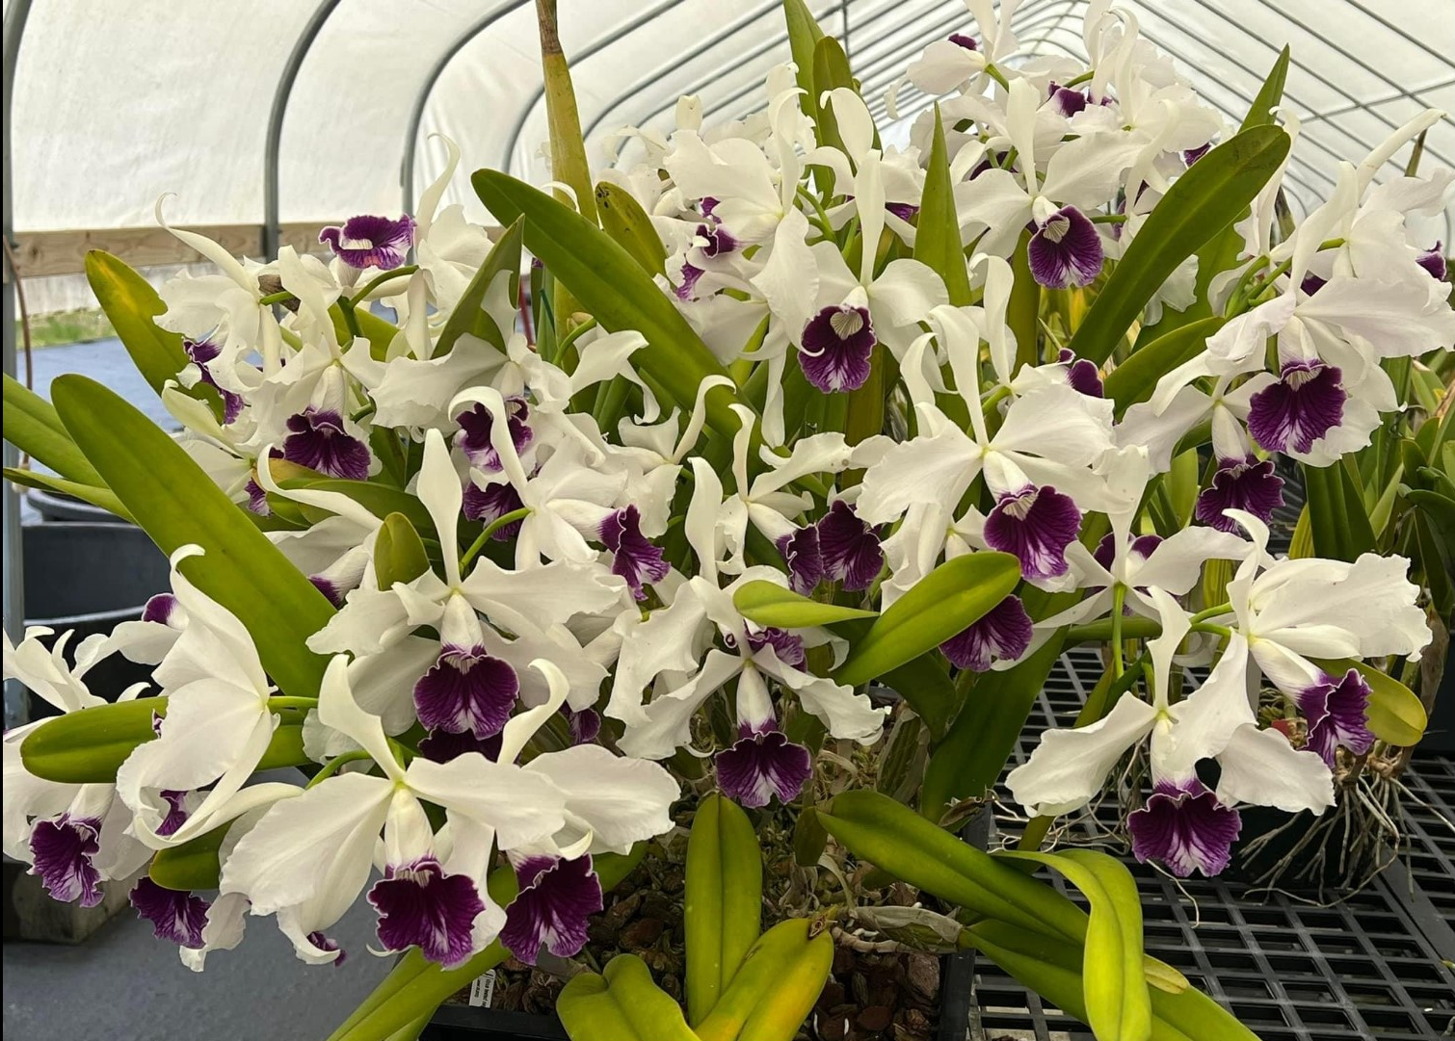
Cattleya purpurata
Photograph by Matthias Seelis

A robust grown plant grown in a x cm square black plastic pot; x flowers and x buds; sepals and petals white, sepals proximal margin recurved; lip tubular, white overlaid purple, throat veined purple, exterior distally overlaid purple; substance medium; texture matte.

CCE – 92 points

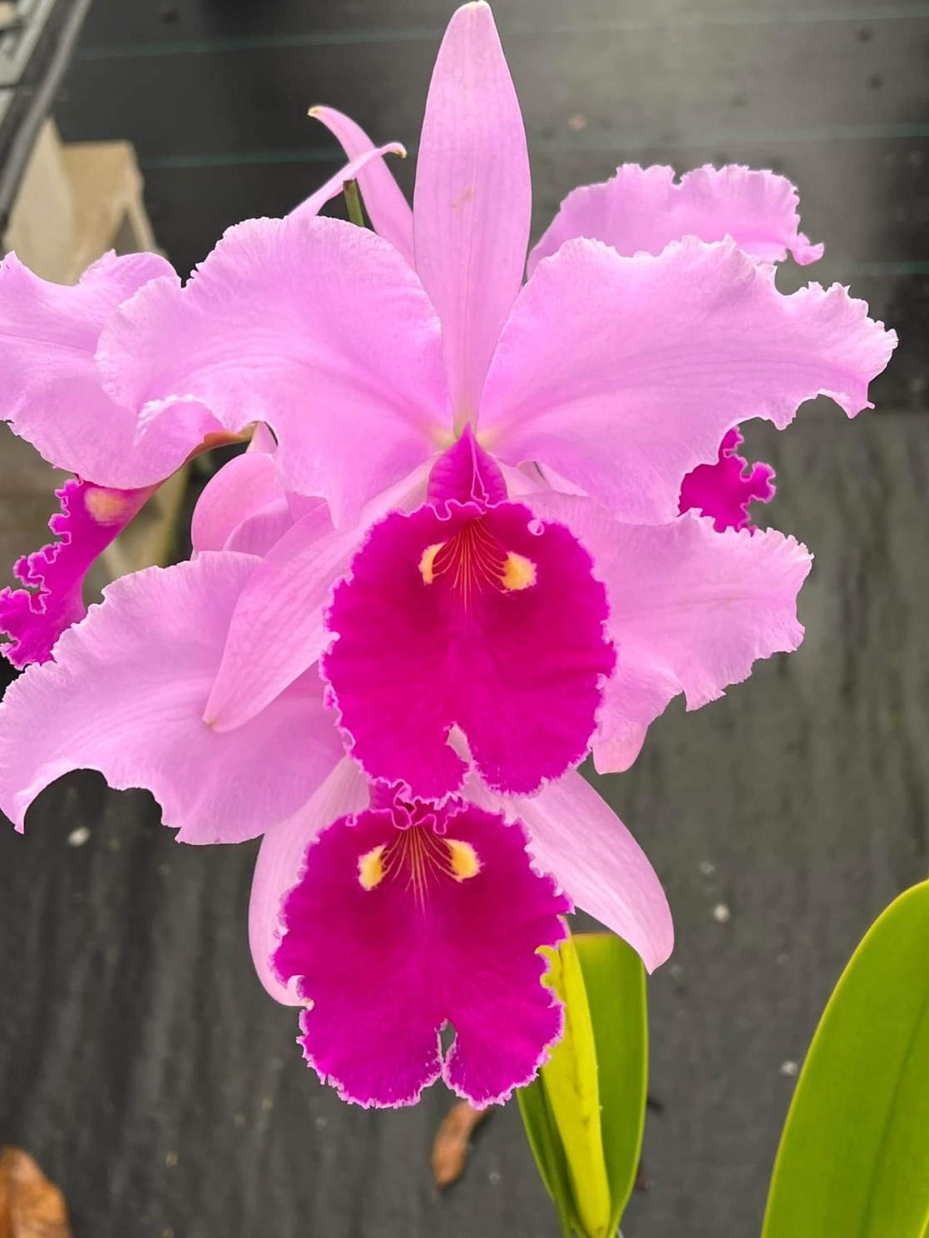

Cattleya warscewiczii
Photograph by Matthias Seelis

Four flowers on one inflorescence; sepals pink; petals undulate pink; lip edges undulate, ruffled magenta, throat gold eyes, centrally striped gold; substance fine; texture matte.

HCC/AOS - 76 points

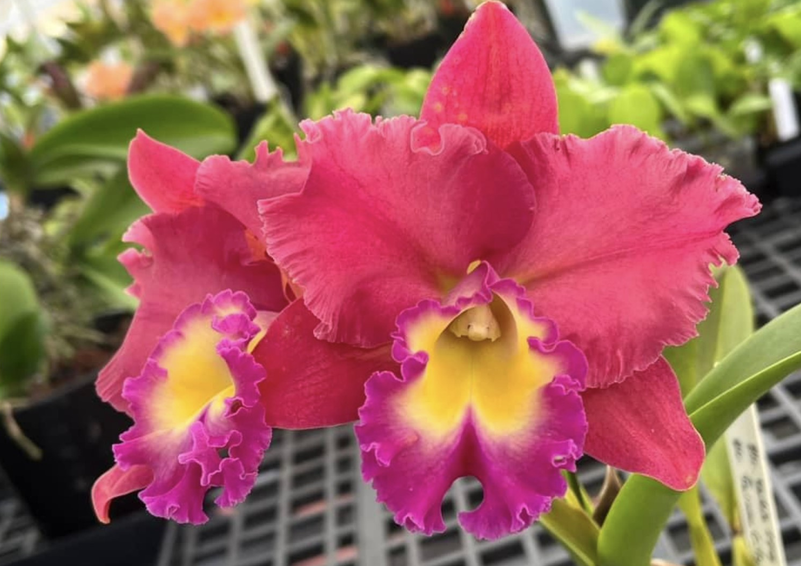

Rhyncholaeliaccattleya (Nadia Song x Tainan City)
Photograph by Matthias Seelis

Two flowers on one inflorescence; sepals red; petals distal undulate, red; lip distal undulate, golden, margins fuchsia; column cream, anther cap cream; substance medium; texture matte.

AM/AOS - 82 points

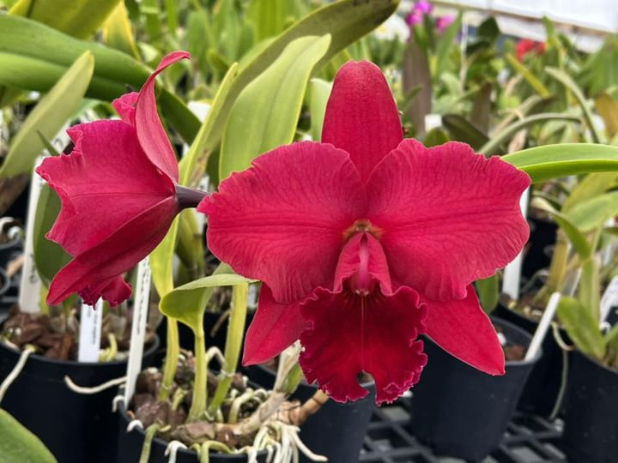

Rhyncholaeliocattelya Fire Desire ‘Shogun’s Red Rocket’
Photograph by Matthias Seelis

Two flowers on one inflorescence; sepals dark red; petals dark red, edges slightly undulated; lip burgundy, undulated; column white suffused red; anther cap white suffused red; substance medium; texture matte.

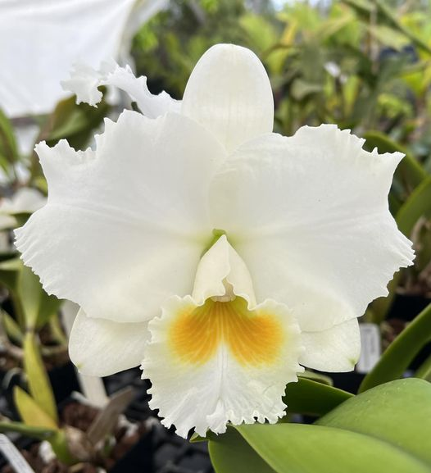

Photo: Cattleya Celine Dion
(C. ThatchMO x Mishima Pearl)

x flowers on two inflorescences; sepals white; petals ruffled, slightly overlapped white; lip edges ruffled, proximally encloses column; throat yellow striped gold; substance fine; texture matt.

AM/AOS – 86 points
Cattleya labiate
Photograph by Matthias Seelis

Two flowers on one inflorescence; sepals pink; petals slightly undulate, pink; lip tubular, edges undulated, white overlaid pink, throat yellow veined red; substance fine; texture matt.

HCC/AOS – 76 points

