Cattleya cinnabarina (Bateman ex Lindl.) Van den Berg (2008)
[Sin-a-bar-EE-na]

Named: The Cinnabar Lealia (refers to flower color (vermilion)

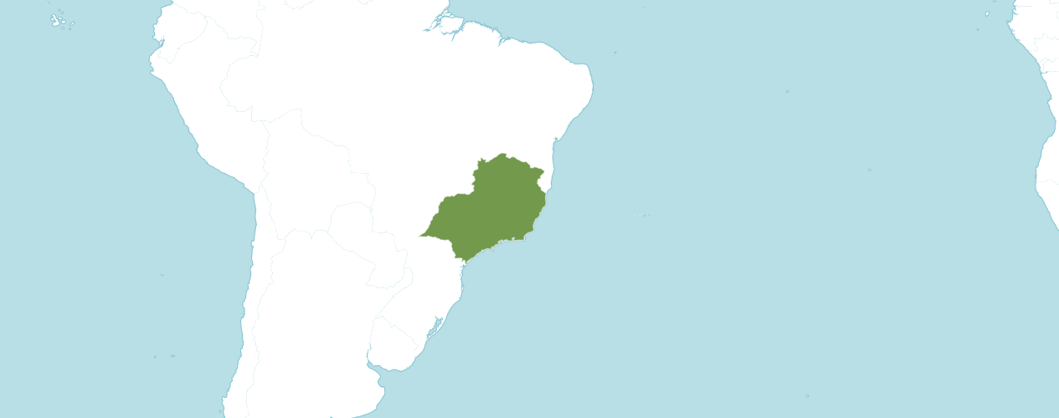

Native to:
Southeast Brazil

Homotypic Synonyms

Amalia cinnabarina (Bateman ex Lindl.) Heynh. in Alph. Aufz. Gew.: 29 (1846)

Bletia cinnabarina (Bateman ex Lindl.) Rchb.f. in W.G.Walpers, Ann. Bot. Syst. 6: 430 (1862)

Hoffmannseggella cinnabarina (Bateman ex Lindl.) H.G.Jones in Acta Bot. Acad. Sci. Hung. 14: 69 (1968)

Laelia cinnabarina Bateman ex Lindl. in Sert. Orchid.: t. 28 (1839)

Sophronitis cinnabarina (Bateman ex Lindl.) Van den Berg & M.W.Chase in Lindleyana 15: 116 (2000)

Heterotypic Synonyms

Bletia cinnabarina var. sellowii Rchb.f. in Xenia Orchid. 2: 61 (1863)

Bletia cinnamomea (Rchb.f.) Rchb.f. in W.G.Walpers, Ann. Bot. Syst. 6: 418 (1862)

Cattleya cinnabarina var. sellowii (Rchb.f.) K.A.Roberts in Orchids (West Palm Beach) 85(10, Suppl.): 39 (2016)

Laelia cinnabarina var. sellowii (Rchb.f.) Cogn. in C.F.P.von Martius & auct. suc. (eds.), Fl. Bras. 3(5): 276 (1901)

Laelia cinnamomea Rchb.f. in Hamburger Garten- Blumenzeitung 16: 180 (1860)

Information provided by OrchidWiz: Brazil. Laelia cinnabarina is a large species from southern Minas Gerais and the northern parts of the adjacent states of Rio de Janeiro and São Paulo. Plants grow on rocky slopes, often with their roots extending down into crevices in the rock. They grow amid tall grasses and shrubby vegetation at 2300–4900 ft. (700–1500 m).

PLANT SIZE AND TYPE: A large, 10–20 in. (25–50 cm) sympodial lithophyte.

PSEUDOBULB: 5–10 in. (12–25 cm) long. The tightly clustered pseudobulbs may be cylindrical or tapered. They are tightly covered with sheaths and are often tinged with purple.

LEAVES: 5–12 in. (12–30 cm) long by 1.2 in. (3 cm) wide. A single sub-erect to spreading, more or less oblong leaf is carried at the top of each growth. It is often tinged with purple.

INFLORESCENCE: 16–20 in. (40–50 cm) long. A very tall, erect flower spike emerges from the top of the most recently matured pseudobulb.

FLOWERS: 10–15, rarely as few as 5. The star-shaped blossoms are orange to cinnabar-red. They are long-lasting and open in sequence over an extended period of time. Flowers are 2.4–3.5 in. (6–9 cm) across. Narrow, wide-spreading sepals and petals are 1.4–2.0 in. (3.5–5.0 cm) long by about 0.3 in. (0.7 cm) wide. The dorsal sepal and petals are slightly longer that the lateral sepals. The 3–lobed lip is 0.8–1.4 in. (2.0–3.5 cm) long with more or less triangular sidelobes that curl upward to completely enclose the column. The sidelobes are orange yellow with red veins and are slightly recurved at the pointed tips. The strongly recurved midlobe has a narrow isthmus at its base and a rounded, very frilly apical portion that is usually dark orange red. The isthmus at the base of the lip may be white or yellow with red streaks.

The American Orchid Society discloses Cattleya (Laelia) cinnabarina contributes dominant orange color, medium-size flowers, and good flower count. The shape is nearly dominant with a small lip and flowers typically have no fragrance. Cattleya cinnabarina often transmits its very thing pseudobulbs to its progeny.

Cattleya cinnabarina needs a winter resting period with day temperatures of 66 – 68 F and night temperatures of 50 – 52 F. There should be extraordinarily little water provided unless bulbs or leaves start to shrivel. No fertilizer during this period. They require very high light, 3000-to-4000-foot candles or they won’t bloom.

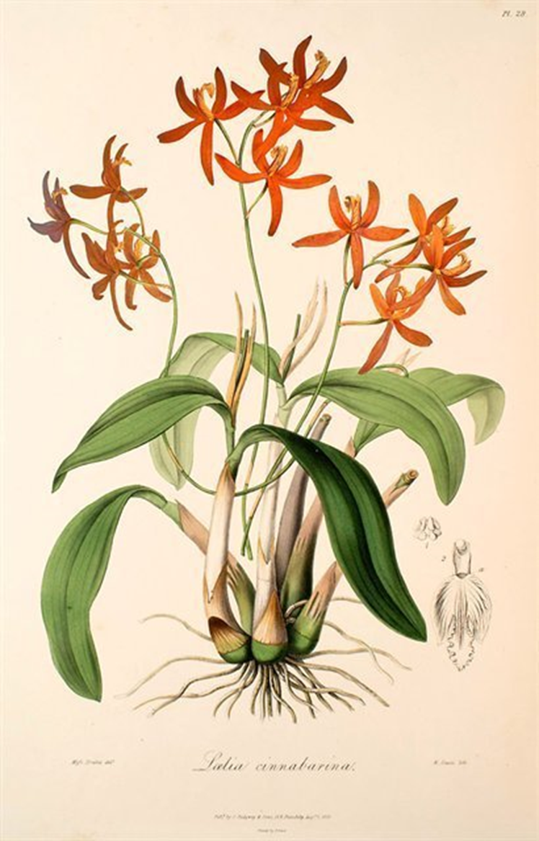
Lealia cinnabarina, illustrated by Sertum Orchidaceum, Lindley (1838)

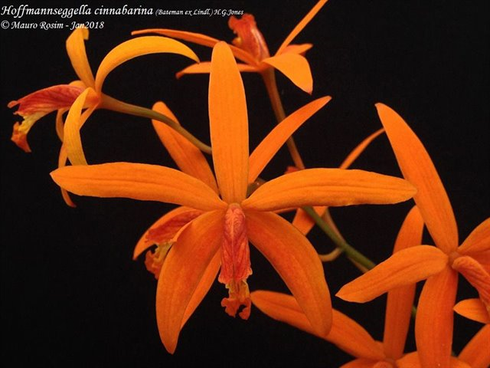
Cattleya cinnabarina
Photograph by Mauro Rosim

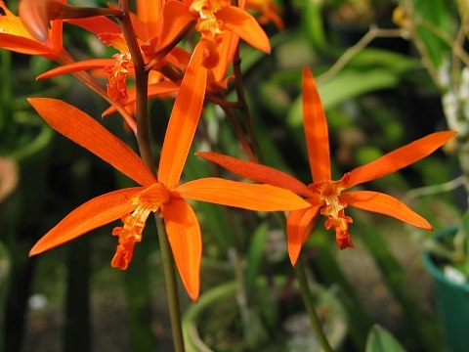
Cattleya cinnabarina
Photograph by Seattle Orchids

AOS Awards:

Laelia anceps
 | FCC | AM | HCC | AQ | JC | CCM | CCE | CHM | CBM | CBR | TOTAL
AOS | 1 | 2 | 1 |  |  | 1 |  | 1 |  |  | 62
Years Awarded | 1980 | 1977  &  2008 | 1980 |  |  | 1959 |  | 2014

Six American Orchid Society awards averaging 10.2 flowers and buds per inflorescences; 9.3 cm. median natural spread.

Hybrids

One hundred fifty-eight F1 generation offspring found, twenty-six or 16.5% have been awarded. Cattleya cinnabarina has fifteen thousand seven hundred sixty-nine registered progeny. Of the one hundred fifty-eight F1 generation hybrids registered, Cattleya cinnabarina was used one hundred forty-six times as the seed parent and one hundred twelve times as the pollen parent. The first Cattleya cinnabarina hybrid was registered in 1874, Cattleya Flammea, (Cattleya cinnabarina x Cattleya Pilcheri). Cattleya Flammea originated and registered in 1874 by Veitch. The periods between 1874 and 1910, then again between 1961 and 1980 have been the times when the most Cattleya cinnabarina hybrids have been registered.

Cattleya cinnabarina Hybrids Registered

Years | 1874 –  1910 | 1911 – 1920 | 1921 – 1940 | 1941  -  1960 | 1961  -  1980 | 1981  -  2000 | 2001 –  2020 | 2021  -  Forward | Total
Number of Hybrids Registered | 55 | 4 | 3 | 11 | 44 | 22 | 18 | 1 | 158

The Cattleya cinnabarina hybrid that has received the largest number of American Orchid Society awards is Brassocatanthe Robert Randall, (Cattleya cinnabarina x Bsn Bill Worsley). Brassocatanthe Robert Randall has received seven American Orchid Society awards (AM – 3; HCC – 3; and CCM – 1). B Brassocatanthe Robert Randall has one registered offspring (F1) and a total of one progeny. Brassocatanthe Robert Randall registered by C. Hamilton in 2006. Originator of Brassocatanthe Robert Randall is unknown.

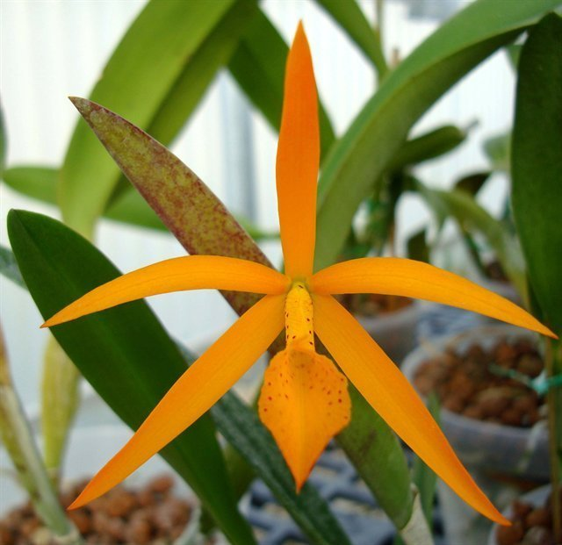
Brassocatanthe Robert Randall ‘D’
Photography by Isabelle Lindroos

The Cattleya cinnabarina hybrid that has the largest number of offspring is Cattleya Psyche, (Cattleya cinnabarina x Cattleya coccinea). Cattleya Psyche has received six American Orchid Society awards (AM – 3; HCC – 2; and CCM - 1). Cattleya Psyche has one hundred eighty-four F1 offspring registered offspring and seven thousand sixteen total progeny. Cattleya Psyche has been used forty-six times as the seed parent and one hundred twelve times as the pollen parent. Cattleya Psyche was originated by and registered in 1902 by Charlesworth Ltd.

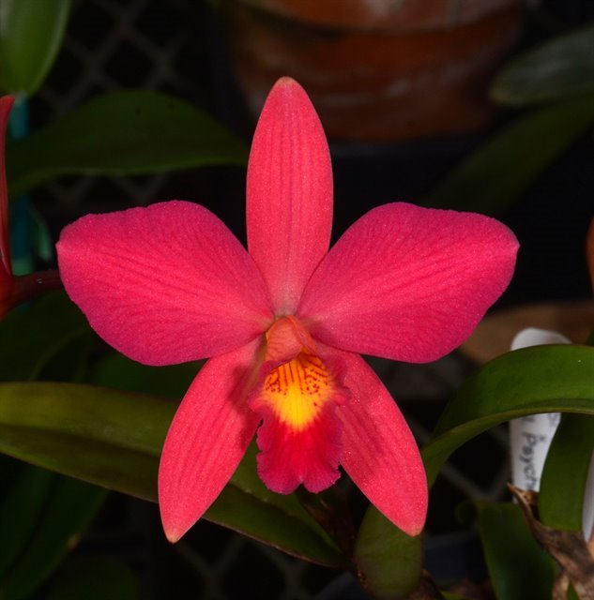
Cattleya Psyche (‘China’ AM/AOS x ‘Prolific’)
Photography by Fred Clarke

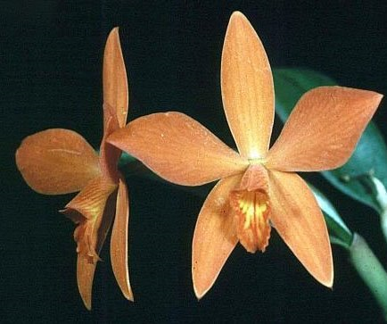
Cattleya Psyche ‘China’ AM/AOS, 84 points, 1977
Photography by OWZ Lib.
San Diego County Orchid Show
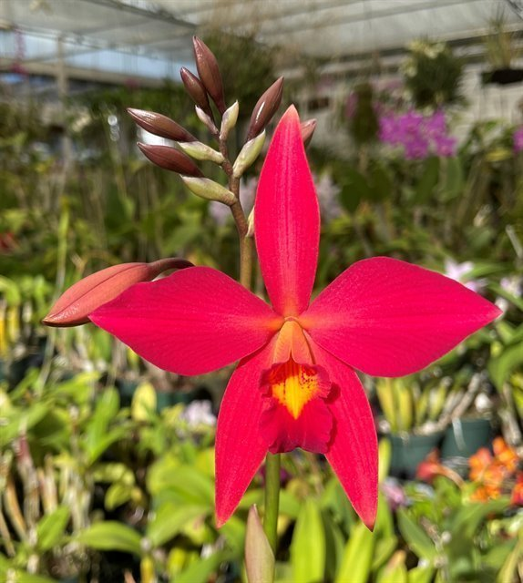
Cattleya Psyche ‘SVO 8’
Photography by Fred Clarke

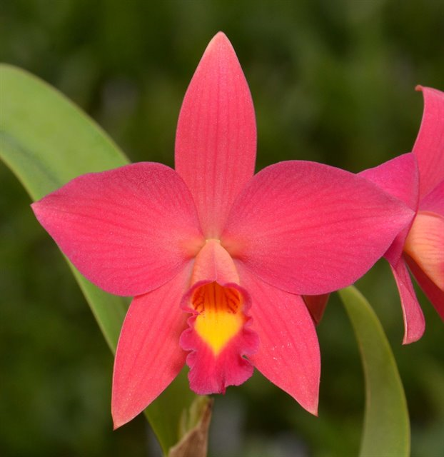
Cattleya Psyche (‘China’ AM/AOS x ‘Prolific’)
Photography by Fred Clarke
The major flaw passed to Cattleya cinnabarina offspring is the under curved lip. Fred Clarke reported the acuted lip that is often passed down for three to four generations. This was the dominant breeding of the 1980s, 1990s and 2000s, per Fred.

References

American Orchid Society. (n.d.). Hereditary influences of the Cattleya alliance. On-line: https://www.aos.org/orchids/additional-resources/hereditary-influences-of-the-cattleya-alliance.aspx .

Callahan, D. (2024, June 3). Cattleya cinnabarina. [email exchange].

Chapman, S., Johnson, T. and Rose, K. (1988). The rupicolous laelias; Section Parviflorae. A paper written for The American Orchid Society judge training program.

Clarke, F. (2024, June 6). Cattleya cinnabarina. [Personal interview].

Hamilton, R. (1988). When does it flower? 2nd ed. Robert M. Hamilton, 9211 Beckwith Road, Richmond, B.C., Canada V6X 1V7.

McQueen, J., and B. McQueen. (1993). Orchids of Brazil. Timber Press, Portland, OR.

Miranda. F. (1990). Brazilian laelias - Part III: Section Parviflorae. American Orchid Society Bulletin, 59(5): 462–472.

Nickou, J. (1990). Culture of rupicolous laelias. American Orchid Society Bulletin, 59(5): 455–459.

OrchidPro. (n.d.).

OrchidWiz X9.0. (n.d.).

Pabst, G. (1984). The section Parviflorae Lindl. of the genus Laelia. Orchid Digest, 48(1): 13–21 and 24–32. Translated and reprinted from 1978 Die Orchidee, vol. 29: 156–165, 196–200.

Royal Botanical Gardens Kew, Plants of the World On-line. (n.d.). Cattleya cinnabarina On-line: https://powo.science.kew.org/taxon/urn:lsid:ipni.org:names:60448079-2 .

Withner, C. (1990). The cattleyas and their relatives, vol. II: the laelias. Timber Press, Portland, OR.

