Guarianthe bowringiana (O'Brien) Dressler & W.E.Higgins 2003
[bow-ring-ee-AH-na]
Common Name: Bowring’s Cattleya
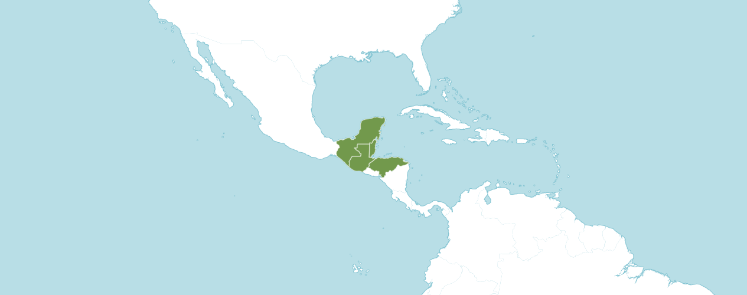

Native to:
Belize, Guatemala, Honduras, Mexico Southeast

In the Manual of Cultivated Orchid Species, Bechtel, Cribb and Launert describe Guarianthe bowringiana as a very floriferous terrestrial plant, up to 60 cm high, or rarely higher. Pseudobulbs club-shaped, 20 – 35 cm long, rarely ore, 0.7 cm in diameter, swollen at base, 2 rarely 3 leaved at apex. Leaves narrowly oblong, leathery, 15 – 20 cm long, 5 – 6 cm broad, obtuse, dark green. Inflorescences 5 – 15, rarely 47 flowered, up to 25 cm long or more, subtended by 2 compressed sheaths at base. Flowers up to 7 cm across; sepals and petals magenta with deeper colored veins; lip pale rose purple at base, deep purple around the margin with white blotches edged with pale yellow in the throat; column white, tinged pink at base. Sepals oblong or narrowly elliptic; 3.9 – 4.9 cm long, 1 – 1.2 cm broad, acute. Petals broader than the sepals, ovate-oblong, 4.1 – 4.9 cm long, 2.4 – 2.8 cm broad, obtuse, margins undulate. Lip ovate-oblong, 3.6 – 4 cm long, 2.7 – 3.4 cm broad, basal half curved up around column to form a tube, apical margin undulate. Column 1 – 1.2 cm long, narrowly winged on either side.

OrchidWiz provides the following information about Guarianthe bowringiana: ORIGIN/HABITAT: Plants grow on rocky cliffs and the sides of ravines close to streams with rapidly moving water. Most often they are found where the air is charged with moisture. Plants are commonly found on granite outcroppings and limestone rocks at 350-3300 ft. (100-1000 m), but they are sometimes found on trees in mixed pine and oak forests.

PLANT SIZE AND TYPE: A moderate to large, 8-14 in. (20-35 cm), occasionally 24-36 in. (61-91 cm), sympodial lithophyte.

PSEUDOBULB: 8-36 in. (20-91 cm) long. The strong, club-shaped pseudobulbs have a bulblike swelling at the base. They are covered by sheaths which emerge from nodes along the stem.

LEAVES: 6-8 in. (15-20 cm) long by about 2 in. (5 cm) wide. Each growth carries 2 sometimes 3 leaves at the top of the pseudobulb. Leaves are thick, leathery, and dark green.

INFLORESCENCE: Up to 10 in. (25 cm) long. The inflorescence is erect to arching and emerges from a double sheath. In late summer or autumn, the sheath develops between the leaves of the newest growths, and flowers emerge from green sheaths soon after they form.

FLOWERS: Normally 5-20, but as many as 47 are recorded. The showy blossoms are usually less than 3 in. (7 cm) across. They have wide sepals and even wider, wavy-margined petals. The entire lip is rolled up forming an open tube, but the wavy margins do not quite meet above the column. The front margin on the lip is also wavy. Sepals and petals are rose-purple, sometimes with darker veins. They often have a beautiful glittering surface, especially when viewed in good light. The outer portion of the lip is deeper purple with a dark maroon band between the outer edge of the lip and the throat. The throat is white with a pale-yellow edge.

Homotypic Synonyms
Cattleya bowringiana O'Brien in Gard. Chron., n.s., 24: 683 (1885)
Cattleya skinneri var. bowringiana (O'Brien) Rchb.f. in Xenia Orchid. 3: 82 (1892)

Heterotypic Synonyms
Cattleya autumnalis O'Brien in Orchid Album 7: t. 323 (1888), nom. illeg..

From the American Orchid Society, Guarianthe bowringiana is another species that, until recently was considered a member of the genus Cattleya. It has been used extensively in hybridizing to produce deeply colored, so-called cluster hybrids. Like Gur. aurantiaca, Gur. bowingiana has no fragrance and most of its hybrids do not either. The species is dominant in shape, very vigorous growth habit, flower count, color, excellent texture, and strong, pure color.

American Orchid Society Awards:

Guarianthe bowringiana
 | FCC | AM | HCC | AQ | JC | CCM | CCE | CHM | CBM | CBR | TOTAL
AOS | - | 7 | 6 | - | 1 | 7 | - | 3 | 1 | - | 25
Years Awarded |  | 1971  -  2010 | 1965  -  2011 |  | 2010 | 1962  -  2005 |  | 1979  -  2002 | 1974

Twenty-five awards averaging 15.5 flowers and buds per inflorescence; 7.3 cm, medium natural spread.

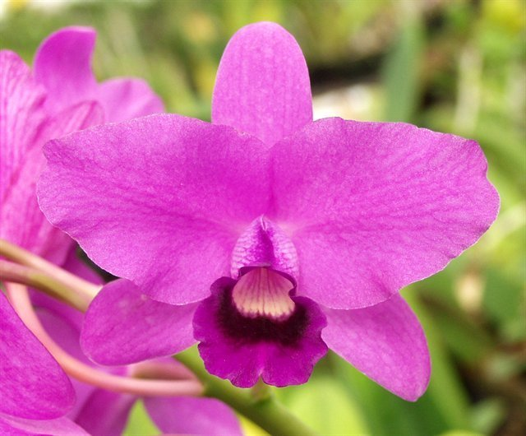
Guarianthe bowringiana ‘Augusta’ AM/AOS, 80 points, November 2023
Photography by Fred Clarke
Chicago Monthly Judging Center

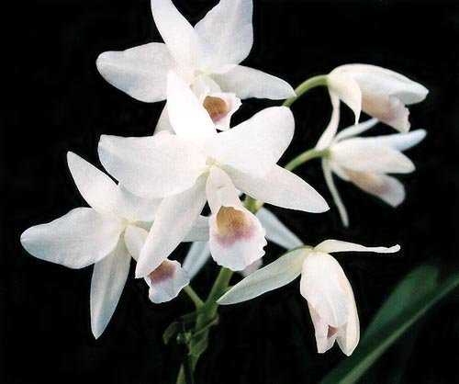
Guarianthe bowringiana hf albescens ‘Tower Grove’ AM/AOS, 83 points, 1974
Photography by Dr. F. Thomas Ott, MD
Missouri Botanical Gardens

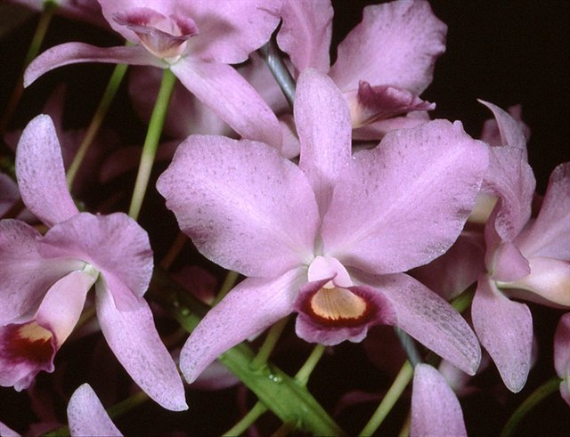
Guarianthe bowringiana hf coerulea ‘Butterfly’ HCC/AOS, 76 points, 1987
Photography by Dr. unknown
Award Location unknown
Hybrids

Guarianthe bowringiana Hybrids Registered
Years | 1893 –  1900 | 1901 – 1920 | 1921 – 1940 | 1941  -  1960 | 1961  -  1980 | 1981  -  2000 | 2001 –  2020 | 2021  -  Forward | Total
Number of Hybrids Registered | 29 | 31 | 8 | 31 | 77 | 54 | 50 | 1 | 281

Guarianthe bowringiana has two hundred eighty-one F1 generation offspring found, fifty-one or 18.1% have been awarded. Guarianthe bowringiana has two thousand two hundred eighteen-two progeny. Of the two hundred eighty-one F1 generation hybrids registered, Guarianthe bowringiana was used one hundred sixty-eight times as the seed parent and one hundred and thirteen times as the pollen parent. The first Guarianthe bowringiana hybrid was registered in 1893, Cattlianthe Chloris, (Guarianthe bowringiana x Cattleya maxima). Cattlianthe Chloris was originated and registered in 1893 by Veitch. There has been only one registration of a Guarianthe hybrid, Cattlianthe Chloringiana (Cattlianthe Chloris x Guarianthe bowringiana) originated and registered in 1916 by Colman. No other Cattlianthe Chloris hybrids have been registered. No American Orchid Society awarded have been registered for Cattlianthe Chloris.

The Guarianthe bowringiana hybrid that has received the largest number of American Orchid Society awards and the largest number of registered offspring is Cattlianthe Portia, (Guarianthe bowringiana x Cattleya labiata). Cattlianthe Portia originated and was registered in 1897 by Veitch. Cattlianthe Portia has received twenty-eight American Orchid Society awards (AM – 8; HCC – 8; CCE – 1; and CCM – 11). Cattlianthe Portia has one hundred twenty F1 registered offspring and four hundred twenty-two total progeny.

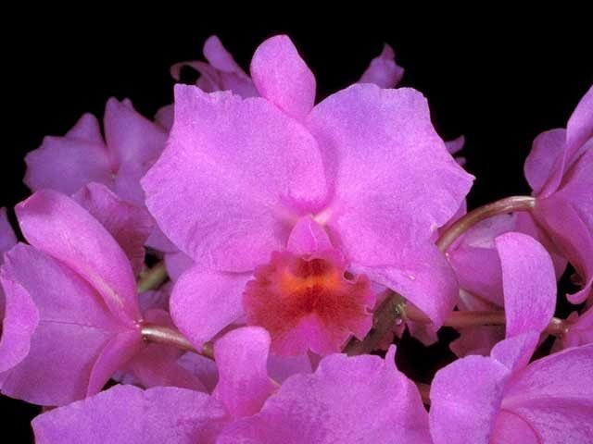
Cattlianthe Portia ‘Gloriosa’ AM/AOS, 84 points, 1989
Photography by OWZ Lib
30th Annual Mid-American Orchid Show

In the article, Hereditary Influences of the Cattleya Alliance, the American Orchid Society shares, Guarianthe bowringiana is a species that, until recently was considered a member of the genus Cattleya. It has been used extensively in hybridizing to produce deeply colored, so-called cluster hybrids. Guarianthe bowingiana has no fragrance and most of its hybrids do not either. The species is dominant for shape, very vigorous growth habit, flower count, color, excellent texture, and strong, pure color.

References

American Orchid Society. (n.d.) Hereditary influences of the Cattleya alliance. On-line: https://www.aos.org/orchids/additional-resources/hereditary-influences-of-the-cattleya-alliance.aspx .

Ames, O., and Correll, D. (1985). Orchids of Guatemala and Belize. Dover Publications, New York.

Bechtel, H., Cribb, P., and Launert, E. (1980) Manual of cultivated orchid species. MIT Press, Cambridge, Mass.

Fowlie, J. (1967) Ecology notes - Observations on Cattleya skinneri and Cattleya deckeri. American Orchid Society Bulletin, 36(9):777.

Govaerts, R. (2004). World Checklist of Monocotyledons Database in ACCESS: 1-54382. The Board of Trustees of the Royal Botanic Gardens, Kew.

Hamilton, R. (1988) When does it flower? 2nd ed. Robert M. Hamilton, 9211 Beckwith Road, Richmond, B. C., Canada V6X 1V7.

Hawkes, A. (1987) Encyclopaedia of cultivated orchids. Faber and Faber, London.

Hetherington, E. (1985) Bifoliate Cattleyas - 1 - purples, pinks, and whites. American Orchid Society Bulletin, 54(10):1210.

McLeish, I., Pearce, N. and Adams, B. (1995) Native orchids of Belize. A. A. Balkema, P. O. Box 1675, 3000 BR Rotterdam, Netherlands.

Nelson Sutherland, C. (2008). Catálogo de las plantes vasculares de Honduras. Espermatofitas: 1-1576. SERNA/Guaymuras, Tegucigalpa, Honduras.

OrchidPro. (n.d.).

OrchidWiz X9.0. (n.d.).

Royal Botanical Gardens Kew, Plants of the World On-line. (n.d.). Laelia anceps. On-line: https://powo.science.kew.org/taxon/urn:lsid:ipni.org:names:1067235-2.

Tanaka, R., and Kamemoto, H. (1984) Chromosomes in orchids: counting and numbers. Appendix in Orchid biology: reviews and perspectives, vol. III. Ed. by J. Arditti. Comstock Publishing, Cornell University Press, Ithaca, N. Y.

Withner, C. (1988) The cattleyas and their relatives, vol. 1: the cattleyas. Timber Press, Portland, OR.

