Guarianthe 2003, Dressler and W. E. Higgins
Pronounced: Gwar-e-ANTH-e
Type Species: Guarianthe skinneri
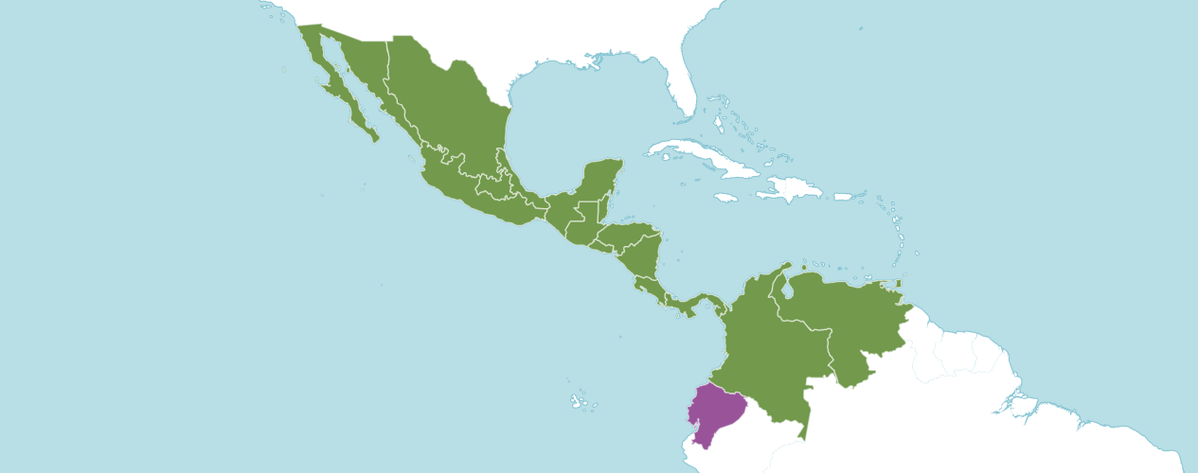

Native to:
Belize, Colombia, Costa Rica, El Salvador, Guatemala, Honduras, Mexican Pacific Is., Mexico Central, Mexico Gulf, Mexico Northeast, Mexico Northwest, Mexico Southeast, Mexico Southwest, Nicaragua, Panamá, Trinidad-Tobago, Venezuela
Introduced into:
Ecuador

The American Orchid Society notes this genus was segregated from Cattleya in 2003 by Dressler and Higgins based on several structural features of the plants and is supported by recent molecular DNA analyses. The genus comprises the following former Cattleya species: Guarianthe skinneri Guarianthe bowringiana, Guarianthe patinii, Guarianthe aurantiaca and the natural hybrid Guarianthe x guatemalensis. Guarianthe skinneri, Guarianthe aurantiaca and Guarianthe bowringiana are commonly seen in cultivation. All of the species are easy to cultivate.

Number of species:
The World Monocot Checklist currently recognizes 4 species and 1 natural hybrid.

The American Orchid Society notes in their offspring, have been used extensively in hybridizing to produce deeply colored, so-called cluster hybrids. Most Guarianthe produce offspring with limited to no fragrance. Guarianthe species tend to be dominant for shape, produce offspring with very vigorous growth habit, a higher flower count, most often strong pure color, and excellent texture.

Guarianthe Species F1 Offspring, and Progeny

Species | F1 Offspring | Progeny
* aurantiaca | 304 | 5,770
bowringiana | 281 | 2,323
deckeri,  ~ x laelioides | 24 | 29
hennisiana | 5 | 5
patinii, ~ henisiana | 5 | 5
skinneri | 104 | 213
x guatemalensis,  ~ x laelioides | 24 | 29

Guarianthe Species Awards

Species | FCC | AM | HCC | AQ | JC | CCM | CCE | CHM | CBM | CBR | TOTAL
aurantiaca | 1 | 24 | 20 | 2 | 4 | 9 | - | 1 | 1 | - | 62
bowringiana | - | 7 | 6 | - | 1 | 7 | - | 3 | 1 | - | 25
x laelioides | - | 1 | - | - | - | 1 | - | - | 1 | - | 3
guatemalensis,  ~ x laelioides | - | 1 | - | - | - | 1 | - | - | 1 | - | 3
hennisiana | - | 1 | 1 | - | - | 2 | - | 1 | - | - | 5
patinii, ~ hennisiana | - | 1 | 1 | - | - | 2 | - | 1 | - | - | 5
skinneri | 17 | 78 | 16 | 4 | 13 | 45 | 6 | - | - | - | 179

When considering which Guarianthe species is the building block for the genus, if you consider which species has the largest number of progeny, I would select Guarianthe aurantiaca as this species has 5,770 progeny. The second in line would be Guarianthe bowringiana, which has 2,323 progeny.

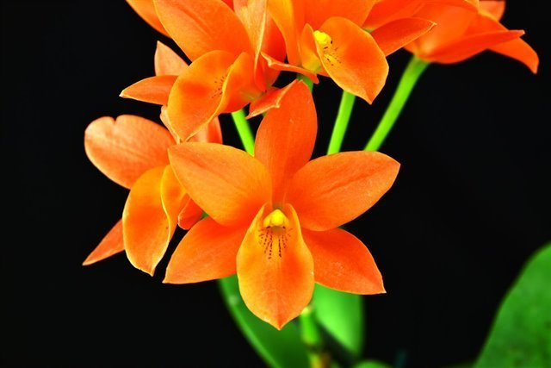
Guarianthe aurantiaca ‘Palmeiri’s Tangerine’ AM/AOS, 80 points, 2019
Photograph by Jorge Carlos
Ascociacion Guatemalteca de Orquideologia Show

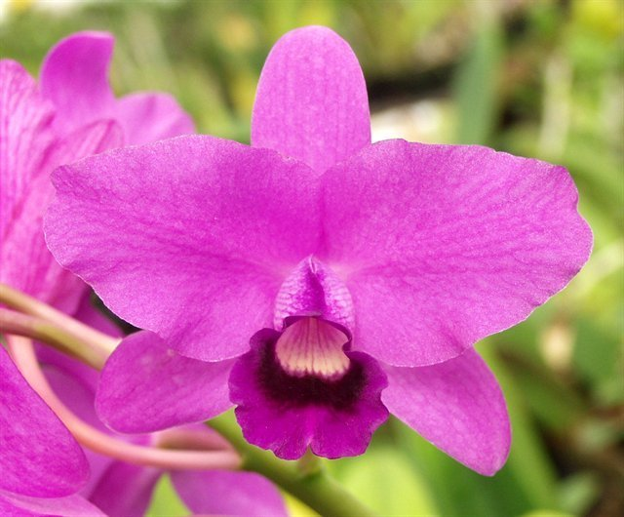
Guarianthe bowringiana ‘Augusta’ AM/AOS, 80 points, 2003
Photograph by Fred Clarke
Chicago Judging Center

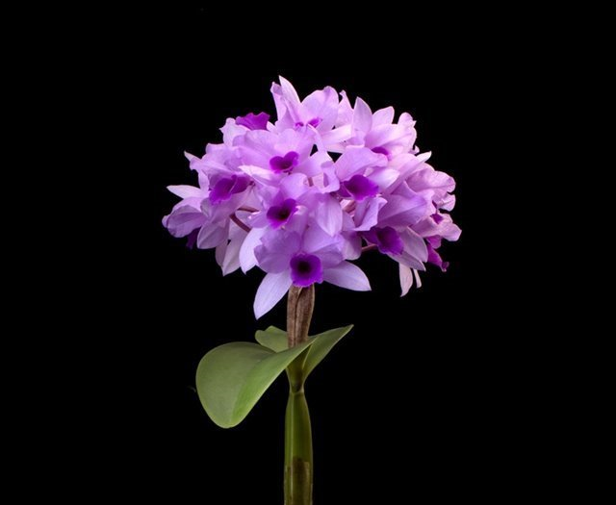
Guarianthe hennisiana ‘Munjeet’ AM/AOS, 81 points, 2016
Photograph by Judith Higham
Pacific Northwest Judging Center

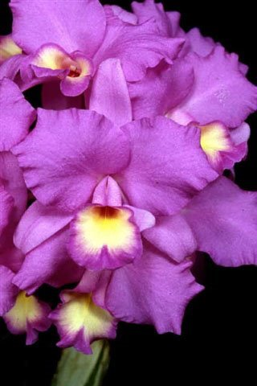
Guarianthe skinneri ‘Carpinteria’ FCC/AOS, 90 points, 1993
Photograph by OWZ Lib
Pacific South Regional Judging Center

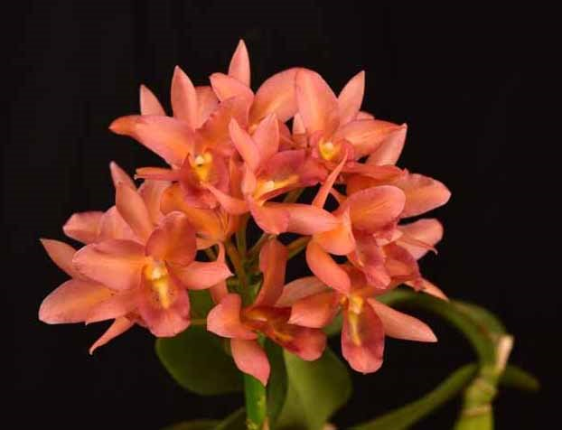

Guarianthe x guatemalensis (x laelioides) ‘Silva de Palmieri’ AM/AOS, 80 points, 2018
Photograph by Jorge Carlos
Ascociacion Guatemalteca de Orquideologia Show

References

American Orchid Society. (n.d.). Guarianthe. On-line: https://www.aos.org/orchids/orchids-a-to-z/letter-g/guarianthe.aspx .

American Orchid Society. (n.d.). Hereditary Influences of the Cattleya Alliance. On-line: https://www.aos.org/orchids/additional-resources/hereditary-influences-of-the-cattleya-alliance.aspx.

Bechtel, H., Cribb, P., and Launert, E. (1992). The Manual of Cultivated Orchid Species, 3rd edition, MIT Press.

Govaerts, R. (2003). World Checklist of Monocotyledons Database in ACCESS: 1-71827. The Board of Trustees of the Royal Botanic Gardens, Kew.

OrchidPro. (n.d.).

OrchidWiz X9.0. (n.d.).

Pridgeon, A., Cribb, P., Chase, M. & Rasmussen, F. (2006). Epidendroideae (Part One). Genera Orchidacearum 4: 1-672. Oxford University Press, New York, Oxford.

Royal Botanical Gardens Kew, Plants of the World On-line. (n.d.). Guarianthe. On-line: https://powo.science.kew.org/taxon/urn:lsid:ipni.org:names:327461-2 .

Withner, C. (2003). The Cattleyas and Their Relatives, Vol. 1, Timber Press.

