Laelia anceps Lindl., 1835
Named: two edge, two headed
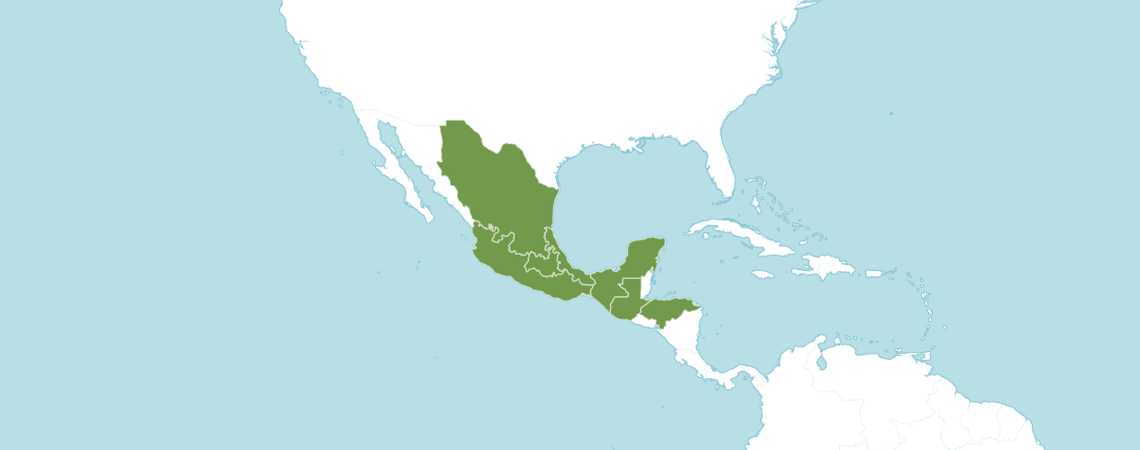

Native to:
Guatemala, Honduras, Mexico Central, Mexico Gulf, Mexico Northeast, Mexico Southeast, Mexico Southwest

Information provided by OrchidWiz: Origin/Habitat: Mexico, Guatemala, and Honduras. In Mexico, plants are found in the mountains on the Gulf of Mexico side of the country in the states of Nuevo León, Tamaulipas, San Luis Potosí, Hidalgo, Querétaro, Puebla, Veracruz, Oaxaca, and Chiapas. They normally grow in warm oak forests with tropical deciduous trees at 3950–5250 ft. (1200–1600 m). The habitat is varied, however, and plants may grow somewhat higher or lower in cooler or hotter climates in both shady and sunny locations. The varied habitat indicates an adaptability that explains why plants are usually considered easy to cultivate. On the Pacific side of the mountains, plants are found in the state of Oaxaca and possibly in Guerrero and Jalisco as well. They are most often found in oak trees in humid forests at 5250–5900 ft. (1600–1800 m), but they occasionally grow on rocks. This species is also reported in Guatemala and Honduras, but we found no information about habitat location and elevation in these countries.

Plant Size and Type: A 12–14 in. (30–35 cm) sympodial epiphyte or lithophyte.

Information obtained from OrchidWiz: Pseudobulb: To 4 in. (10 cm) long by about 1.2 in. (3 cm) wide. The glossy pseudobulbs often have a purple flush. They are usually flattened and vary in size and shape. Pseudobulbs have two sharp edges with broad ribs on each of the flattened sides. New growths appear at the end of an elongated rhizome, and growths may be separated by as much as 1.6 in. (4 cm).

Leaves: 8–10 in. (20–25 cm) long. Usually a single rigid, leathery, elliptical leaf is carried at the apex of the pseudobulb, but some growths produce 2 leaves. Vegetation sometimes has a purple flush on the bottom side, particularly when grown in high light.

Inflorescence: Usually 16–24 in. (40–60 cm) long, rarely to 48 in. (122 cm). The inflorescence emerges at the top of the recently matured pseudobulb. It is slender, jointed, erect to gracefully arching and covered with 2–edged sheathing bracts. Blossoms are clustered near the apex of each inflorescence.

Flowers: 2–5. The large, showy flowers are 2.5–4.0 in. (6.4–10.0 cm) across and last for several weeks, particularly if kept cool and dry. They are usually fragrant on sunny days. Blossom color is highly variable, but in the typical form, sepals are pale rose-purple with somewhat darker petals. The 3–lobed lip has sidelobes that fold over the column. The midlobe is whitish or pale rose, usually with a wide, dark purple border on the outside edges. The yellow keel has 3 ridges and is located in the center beneath the column. The throat is marked with relatively wide, branching rays of red purple. Subspecies dawsonii has larger than normal flowers with white sepals and petals, often with a pink flush. Some forms have a white lip with red-purple veins in the throat, but others have a purple midlobe with white margins or a white patch at the base of the midlobe. Many cultivars have been named. Variations include numerous shades of red and purple, an alba form that is all white with yellow on the lip, and numerous clones with combinations of purple and white segments.

The American Orchid Society notes that Laelia anceps features prominently in the development of cold tolerance in cattleyas. The species is dominant for its long inflorescence and characteristic four-angled pseudobulbs. The species imparts good shape, size, substance, and flower flatness to its hybrids. The color is recessive allowing hybridizers to develop a wide range of colors with the exception of yellow.

Homotypic Synonyms
Amalia anceps (Lindl.) Heynh. in Alph. Aufz. Gew.: 29 (1846)
Amalias anceps (Lindl.) Hoffmanns. in Verz. Orchid.: 20 (1842)
Bletia anceps (Lindl.) Rchb.f. in W. G. Walpers, Ann. Bot. Syst. 6: 418 (1862)
Cattleya anceps (Lindl.) Beer in Prakt. Stud. Orchid.: 208 (1854)
Schomburgkia anceps (Lindl.) Peraza & Carnevali in Taxon 65: 1258 (2016)

Laelia anceps is the Laelia building block based on three hundred thirty-nine offspring, eight hundred fifty-six progeny and having received one hundred thirty-eight American Orchid Society awards.

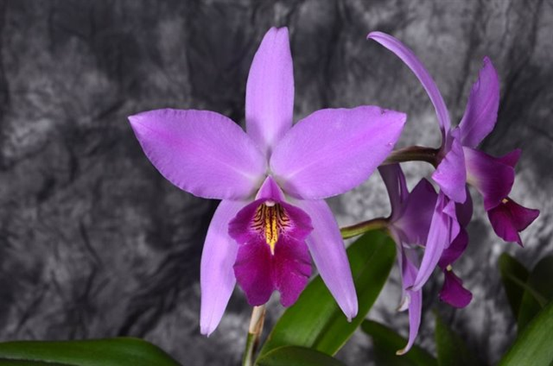
Laelia anceps ‘Carlos Solis’ AM/AOS, 80 points, 2016
Photograph by Jorge Cespedes
Ascociacion Acostena de Orquideologia Show

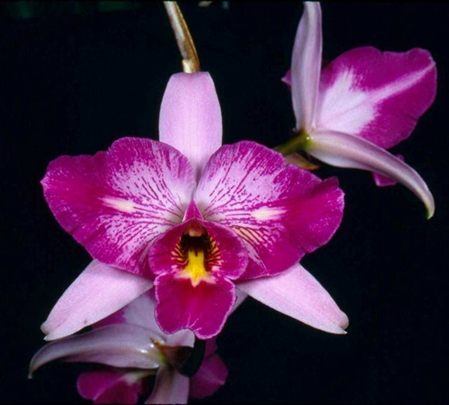
Laelia anceps ‘SanBbar Super Splash’ AM/AOS, 83 points, 1996
Merritt Collection, Specific Photographer not disclosed
Pacific South Regional Judging

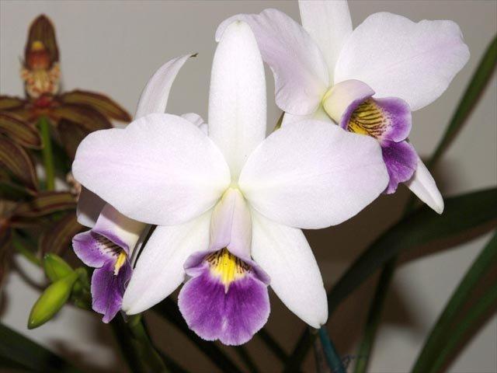
Laelia anceps hf veitchiana ‘Tamara’ AM/AOS, 85 points, 2007
Photography by Lauren Batchman
California Sierra Nevada Center Monthly Judging

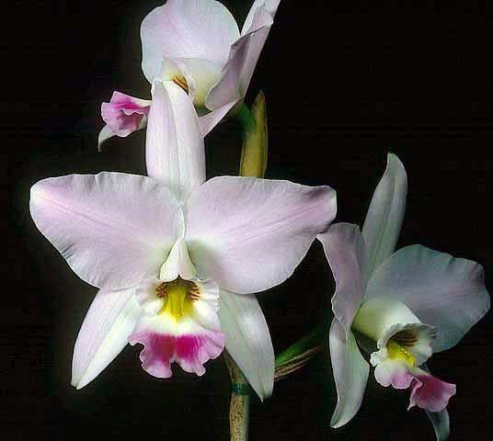

Laelia anceps ‘SanBar Pinky’ HCC/AOS, 78 points, 2004
Photography by William Merritt Collection
Pacific South Center Monthly Judging Center
AOS Awards:

Laelia anceps
 | FCC | AM | HCC | AQ | JC | CCM | CCE | CHM | CBM | CBR | TOTAL
AOS | 5 | 53 | 55 | 1 | 2 | 15 | 1 | 3 | 3 |  | 138
Years Awarded | 1984 - 2020 | 1966 - 2022 | 1984  -  2018 | 2006 | 2003  and 2008 | 1994  -  2020 | 2014 | 1978  -  1989 | 1964 –  1975

One hundred thirty-eight American Orchid Society awards averaging 3.1 flowers and buds per inflorescences; 11.0 cm. median natural spread.

Hybrids
Three hundred thirty-nine F1 generation offspring found, eighty-nine or 26.3% have been awarded. Laelia anceps has eight hundred fifty-six progeny. Of the thirty-two F1 generation hybrids registered, Laelia anceps was used one hundred thirty-five times as the seed parent and two hundred four times as the pollen parent. The first Laelia anceps hybrid was registered in 1893, Laelia Finckeniana, (Laelia anceps x Laelia albida). Laelia Finckeniana originated and registered in 1953 by hort. There have been steady registrations of Laelia anceps hybrids since 1893 with the last registration occurring in 2021.

Laelia anceps Hybrids Registered
Years | 1893 –  1900 | 1901 – 1920 | 1921 – 1940 | 1941  -  1960 | 1961  -  1980 | 1981  -  2000 | 2001 –  2020 | 2021  -  Forward | Total
Number of Hybrids Registered | 7 | 22 | 7 | 9 | 51 | 92 | 144 | 9 | 339

The Laelia anceps hybrid that has received the largest number of American Orchid Society awards is Laeliocattleya Miss Wonderful, (Laelia anceps x Cattleya Mari’s Song). Laeliocattleya Miss Wonderful has received nineteen American Orchid Society awards (AM – 12; HCC – 5; AQ – 1; and JC – 1). Laeliocattleya Miss Wonderful has seven registered offspring and seven total progeny. Laeliocattleya Miss Wonderful was originated by and registered in 2005 by Santa Barbara Orchids.

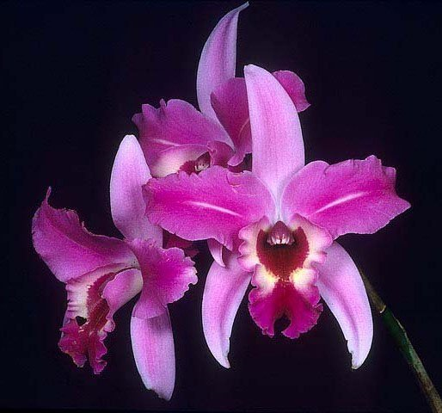
Laeliocattleya Miss Wonderful ‘Fine Line’ JC/AOS, 2004
Photography by L. Batchman
Orchid Society of Santa Barbara Show

The Laelia anceps hybrid that has the largest number of offspring is Laeliocattleya Puppy Love, (Laelia anceps x Cattleya Dubiosa). Laeliocattleya Puppy Love has received eight American Orchid Society awards (AM – 2; and HCC – 6). Laeliocattleya Puppy Love has sixty-eight registered offspring and two hundred fourteen total progeny. Laelia Puppy Love was used sixty-three times as the seed parent and five times as the pollen parent. Laeliocattleya Puppy Love was originated by and registered in 1970 by Stewart Orchids, Inc.

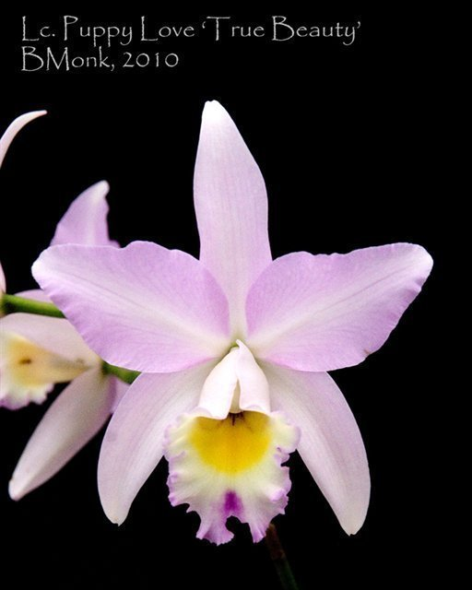
Laeliocattleya Puppy Love ‘True Beauty’ HCC/AOS,76 points, 1976
Photography by Brian Monk
Los Angeles Regional Monthly Judging

References

American Orchid Society. (n.d.) Hereditary influences of the Cattleya alliance. On-line: https://www.aos.org/orchids/additional-resources/hereditary-influences-of-the-cattleya-alliance.aspx .

Bechtel, P. (1990) The laelias of México. American Orchid Society Bulletin, 59(12): 1229–1234.

Bechtel, H., Cribb, P., and Launert, E. (1980) Manual of cultivated orchid species. MIT Press, Cambridge, Mass.

Govaerts, R. (2003). World Checklist of Monocotyledons Database in ACCESS: 1-71827. The Board of Trustees of the Royal Botanic Gardens, Kew.

Halbinger, F. (1993). Laelias de México. Asociación Mexicana de Orquideología, A. C. México D. F. México.

Halbinger, F. and M. Soto. (1997) Laelias of México. Orquidea (Mex) 15(1).

Hamilton, R. (1988) When does it flower? 2nd ed. Robert M. Hamilton, 9211 Beckwith Road, Richmond, B.C., Canada V6X 1V7.

Hawkes, A. (1965) Encyclopaedia of cultivated orchids. Faber and Faber, London.

Löb, U. (1990) The genus Laelia in México. Schlechteriana 1(1): 8–15.

OrchidPro. (n.d.).

OrchidWiz X9.0. (n.d.).

Nelson Sutherland, C.H. (2008). Catálogo de las plantes vasculares de Honduras. Espermatofitas: 1-1576. SERNA/Guaymuras, Tegucigalpa, Honduras.

Pridgeon, A., Cribb, P., Chase, M., and Rasmussen, F. (2006). Epidendroideae (Part One). Genera Orchidacearum 4: 1-672. Oxford University Press, New York, Oxford.

Royal Botanical Gardens Kew, Plants of the World On-line. (n.d.). Laelia anceps. On-line: https://powo.science.kew.org/taxon/urn:lsid:ipni.org:names:325605-2 .

Wiard, L. (1987) An introduction to the orchids of México. Comstock Publishing Assoc. Ithaca and London.

Withner, C. (1990) The Cattleyas and their relatives: Volume II. The Laelias. Timber Press. Portland, Oregon.

