Five Award Description Examples: Laelia and Guarianthe

Laelia undulata var. alba
Photography by Palmer Orchids

One hundred twenty-one flowers and four buds on ten upright inflorescences up to x cm; sepals and petals undulate, lemon yellow; lip white; column white, anther cap cream; substance firm; texture glossy.

Award: AM/AOS, 83 points.

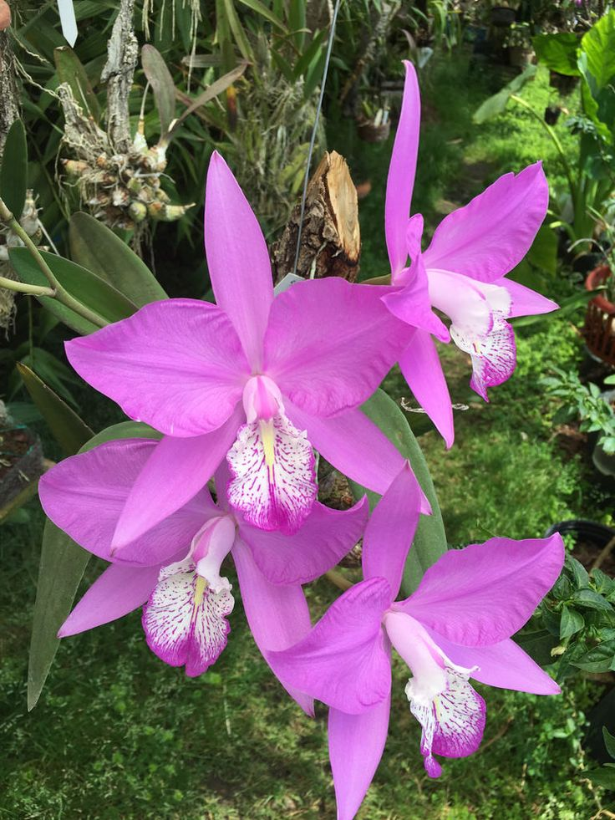
Laelia speciosa
Photography by farm5.staticflickr.com

Four flowers on one inflorescence; sepals and petals pink-rose; labellum white, magenta spots arranged in lines radiating from throat, edged in magenta; column white suffused magenta; anther cap white suffused dark magenta; substance good; texture matte.

Award: AM/AOS, 86 points

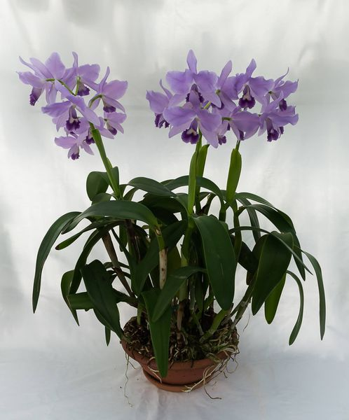
Cattlianthe Portia
(Gaurianthe bowringiana var. coerulea x Cattleya labiata var. coerulea)
Photography by Sabine Furtwängler

Nineteen flowers on three inflorescences, sepals, and petals lavender; petals margins slightly undulate; lip throat yellow, margins deep violet; column white; substance firm, texture crystalline.

Award: AM/AOS, 83 points

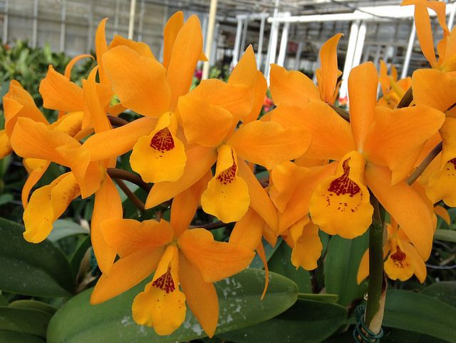

Cattlianthe Gold Digger
Photography by unknown

Twenty-one flowers on three inflorescences; sepals and petals, orange; lip yellow-orange, throat spotted arranged in lines, faint random mid lip, carnelian; substance firm; texture waxy.

Award: HCC/AOS, 78 points

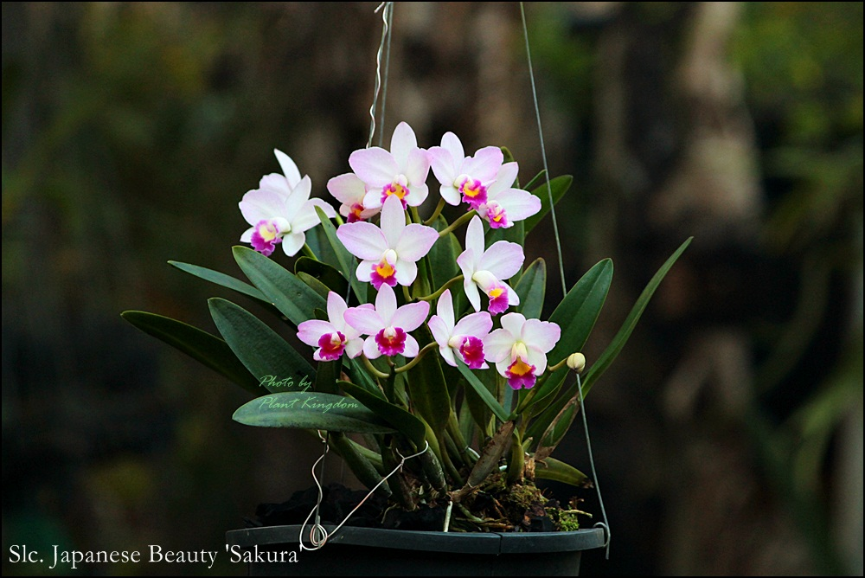

Cattlianthe Japanese Beauty
Photography by Plant Kingdom

Twelve flowers and one buds on five inflorescences; sepal white; petals white, marginally suffused pink; lip white, magenta marginally, throat yellow; anther cap white; substance firm; texture crystalline.

Award: AM/AOS, 86 points.

Twelve flowers and one buds on five inflorescences borne on a strong plant, measuring x cm wide and x cm tall; eighteen pseudobulbs containing unblemished leaves grown in a plastic hanging eight in pot; sepal white; petals white, marginally suffused pink; lip white, magenta marginally, throat yellow; anther cap white; substance firm; texture crystalline.

Award: CCM/AOS, 84 points

