Laelia Lindl., 1831
Pronounced: lay-LEE-uh
Type Species: Laelia grandiflora
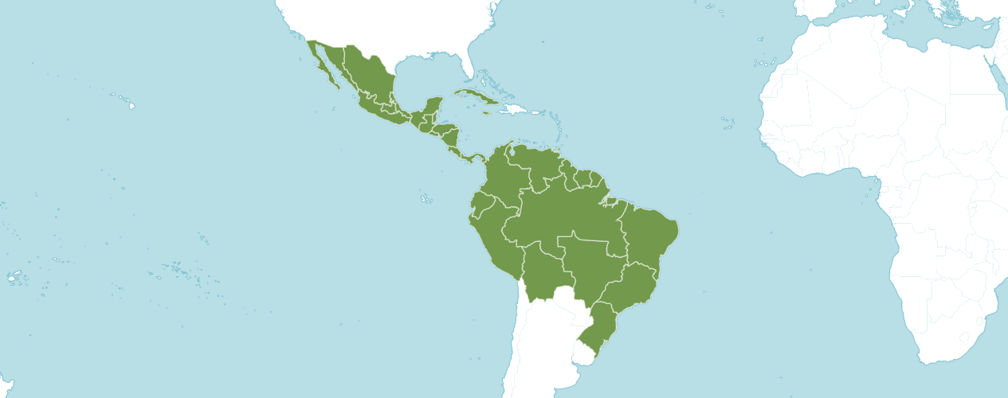

Native to:
Belize, Bolivia, Brazil North, Brazil Northeast, Brazil South, Brazil Southeast, Brazil West-Central, Colombia, Costa Rica, Cuba, Ecuador, El Salvador, French Guiana, Guatemala, Guyana, Honduras, Jamaica, Mexico Central, Mexico Gulf, Mexico Northeast, Mexico Northwest, Mexico Southeast, Mexico Southwest, Nicaragua, Panamá, Peru, Suriname, Trinidad-Tobago, Venezuela
The American Orchid Society relays Laelia was formerly a large genus that included species in Mexico and Brazil. With the publication of Genera Orchidacearum Vol. 5 in 2009 the Brazilian laelias were moved into an expanded concept of Cattleya based upon DNA evidence.

Laelia species currently number 24 and include some formerly included in Schomburgkia.

It is not certain what "Laelia" means, but it seems that Lindley gave the genus the name of one of the Vestal Virgins from Greek Mythology, referring to their beauty. Three of the former sections occur in Mexico (and share many structural features) while the majority of species, occur in Brazil. Many of the Mexican species (Laelia anceps, for example), grow in dry areas where the plants are subject to extremely low temperatures and even frost, and so they should be grown cooler for their best development. The Brazilian species can be found from sea level up into the mountains, so their growing conditions vary from very warm to cool depending on the particular species. The type species is Laelia speciosa, a Mexican species with compact plants and very showy large flowers. Laelia purpurata, now Cattleya purpurata, the Brazilian national flower.

The former section Parviflorae, the so-called "Rupiculous laelias" from Brazil, includes more than half the species (35+). This section is in the genus Cattleya as recognized by the World Checklist of Selected Plant Families but some taxonomists classify them as Hoffmannseggella.

Number of species:
Twenty-three in the strictest definition of the genus and around seventy in the broadest sense. Color forms number the hundreds. It should be noted that there is currently great debate regarding which species should actually be included in this genus. The World Monocot Checklist currently recognizes only twenty-three species; the "rupiculous laelias" and those of section Cattleyodes having been moved to Sophronitis (see above). In addition, many former Schomburgkia species have been moved to Myrmecophila and the remaining species transferred to Laelia.

Kew notes: Accepted Species
Includes 25 Accepted Species

Laelia albida Bateman ex Lindl.
Laelia anceps Lindl.
Laelia aurea A.V.Navarro
Laelia autumnalis (Lex.) Lindl.
Laelia colombiana J. M. H. Shaw
Laelia × crawshayana Rchb.f.
Laelia elata (Schltr.) J. M. H. Shaw
Laelia eyermaniana Rchb.f.
Laelia furfuracea Lindl.
Laelia gloriosa (Rchb.f.) L. O. Williams
Laelia × gouldiana Rchb.f.
Laelia halbingeriana Salazar & Soto Arenas
Laelia heidii (Carnevali) Van den Berg & M. W. Chase
Laelia lueddemannii (Prill.) L. O. Williams
Laelia lyonsii (Lindl.) L. O. Williams
Laelia marginata (Lindl.) L. O. Williams
Laelia × meavei Cetzal & Pérez-García
Laelia moyobambae (Schltr.) C. Schweinf.
Laelia × oaxacana Salazar & R. Jiménez
Laelia perezgarciae (Archila & Szlach.) Cetzal & Carnevali
Laelia rosea (Linden ex Lindl.) C. Schweinf.
Laelia rubescens Lindl.
Laelia schultzei (Schltr.) J. M. H. Shaw
Laelia speciosa (Kunth) Schltr.
Laelia splendida (Schltr.) L. O. Williams
Laelia superbiens Lindl.
Laelia × tlaxiacoensis Solano & Cruz-García
Laelia undulata (Lindl.) L. O. Williams
Laelia vandenbergiana (E. M. Pessoa, V. Brito & Ralf-Neto) Van den Berg
Laelia weberbaueriana (Kraenzl.) C. Schweinf.

Bechtel, Cribb and Launert disclose in The Manual of Cultivated Orchid Species Laela is closely related to Cattleya and Epidendrum but may be identified by its eight rather than four pollinia.

Laelia Species Awards

Species | FCC | AM | HCC | AQ | JC | CCM | CCE | CHM | CBM | CBR | TOTAL
albida | - | 1 | 2 | - | - | 1 | 1 | - | - | - | 3
amesiana | - | - | - | - | - | - | - | - | - | - | 0
anceps | 5 | 53 | 55 | 1 | 2 | 15 | 1 | 3 | 3 |  | 138
aurea | - | 1 | 2 | - | 1 | 1 | - | - | - | - | 5
autumalis | - | - | 2 | - | - | 1 | - | 1 | - | - | 4
callistoglossa | - | - | - | - | - | - | - | - | - | - | 0
cattleyoides | - | - | - | - | - | - | - | - | - | - | 0
colombiana | - | 6 | - | - | - | 2 | - | 3 | - | 1 | 12
elata | - | 1 | 2 | - | - | - | - | - | - | - | 3
euspatha | - | - | - | - | - | - | - | - | - | - | 0
eyermaniana | - | - | - | - | - | - | - | - | - | - | 0
furfuracea | - | - | 1 | - | 1 | - | - | - | - | - | 2
gloriosa | - | 1 | 2 | - | - | - | - | 1 | - | - | 4
gouldiana | - | - | 1 | - | - | 5 | - | - | - | - | 6
halbingeriana | - | 1 | - | - | - | - | - | 1 | - | - | 2
heidii | - | - | - | - | - | - | - | - | - | - | 0
hookeri | - | - | - | - | - | - | - | - | - | - | 0
longipes | - | 3 | 2 | - | - | - | - | 1 | - | - | 6
lueddemannii | - | 3 | 1 | - | - | - | - | - | - | - | 4
lyonsii | - | 4 | 1 | - | - | 1 | - | - | - | - | 6
marginata | - | 1 | - | - | - | - | 1 | 1 | - | - | 3
moyobambae | - | 1 | 4 | - | - | - | 1 | - | - | - | 6
primulina | - | - | - | - | - | - | - | - | - | - | 0
rosea | - | 1 | - | - | - | 2 | - | 1 | - | - | 4
rubescens | - | 3 | 4 | - | 1 | 7 | 1 | - | - | - | 16
schultzei | 1 | - | 2 | - | - | - | - | - | - | 1 | 4
speciosa | - | 1 | 2 | - | 1 | - | - | - | - | - | 4
splendida | - | 16 | 4 | - | - | 1 | - | - | 1 | - | 22
superbiens | - | 9 | 7 | - | 1 | - | - | - | - | 1 | 18
undulata | - | 11 | 3 | - | - | 6 | 1 | 2 | - | - | 23
weberbaueriana | - | - | - | - | - | 1 | - | 1 | - | - | 2
xanthotropis | - | - | - | - | - | - | - | - | - | 1 | 1
x crawshayana | - | - | 2 | - | - | - | - | - | - | 1 | 3
x christinae | - | - | - | - | - | - | - | - | - | - | 0

Laelia Species Awards

Species | FCC | AM | HCC | AQ | JC | CCM | CCE | CHM | CBM | CBR | TOTAL
x dellensis | - | - | - | - | - | - | - | - | - | - | 0
x euterpe | - | - | - | - | - | - | - | - | - | - | 0
x finckeniana | - | - | - | - | - | - | - | - | - | - | 0
x gouldiana | - | - | - | - | - | - | - | - | - | - | 0
x juvenilis | - | - | - | - | - | - | - | - | - | - | 0
x meavei | - | - | - | - | - | - | - | - | - | - | 0
x oaxacana | - | - | - | - | - | - | - | - | - | - | 0
x oweniae | - | - | - | - | - | - | - | - | - | - | 0
x oweniana | - | - | - | - | - | - | - | - | - | - | 0
x veitchiana | - | - | - | - | - | - | - | - | - | - | 0
x veitchii | - | - | - | - | - | - | - | - | - | - | 0

Laelia Species Offspring and Progeny

Species | F1 | Progeny
albida | 24 | 188
amesiana | 0 | 0
* anceps | 339 | 856
aurea | 17 | 20
autumalis | 39 | 62
callistoglossa | 0 | 0
cattleyoides | 0 | 0
colombiana | 17 | 17
elata | 1 | 1
euspatha | 0 | 0
eyermaniana | 2 | 2
furfuracea | 7 | 7
gloriosa | 22 | 34
gouldiana | 22 | 36
halbingeriana | 0 | 0
heidii | 3 | 6
hookeri | 0 | 0
longipes | 43 | 96
lueddemannii | 19 | 43
lyonsii | 37 | 59
marginata | 4 | 4
myobarnbae | 10 | 10
primulina | 0 | 0
rosea | 8 | 10
rubescens | 77 | 125
schultzei | 10 | 11
speciosa | 31 | 40
splendida | 55 | 68
superbiens | 65 | 99
Undulata | 98 | 173

Laelia Species Offspring and Progeny

Species | F1 | Progeny
weberbaueriana | 1 | 1
xanthotropis | 0 | 0
x crawshayana | 2 | 2
x christinae | 0 | 0
x dellensis | 0 | 0
x euterpe | 0 | 0
x eyermaniana | 2 | 2
x finckeniana | 1 | 1
x gouldiana | 0 | 0
x juvenilis | 0 | 0
x meavei | 0 | 0
x oaxacana | 0 | 0
x oweniae | 0 | 0
x oweniana | 0 | 0
x veitchiana | 0 | 0
x veitchii | 0 | 0

Laelia building block include:
1. Laelia anceps is the Laelia building block based on three hundred thirty-nine offspring, eight hundred fifty-six progeny and having received one hundred thirty-eight American Orchid Society awards.

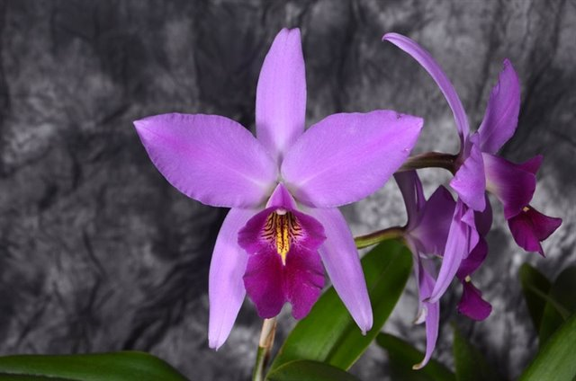

Laelia anceps ‘Carlos Solis’ AM/AOS, 80 points, 2016
Photograph by Jorge Cespedes
Ascociacion Acostena de Orquideologia Show

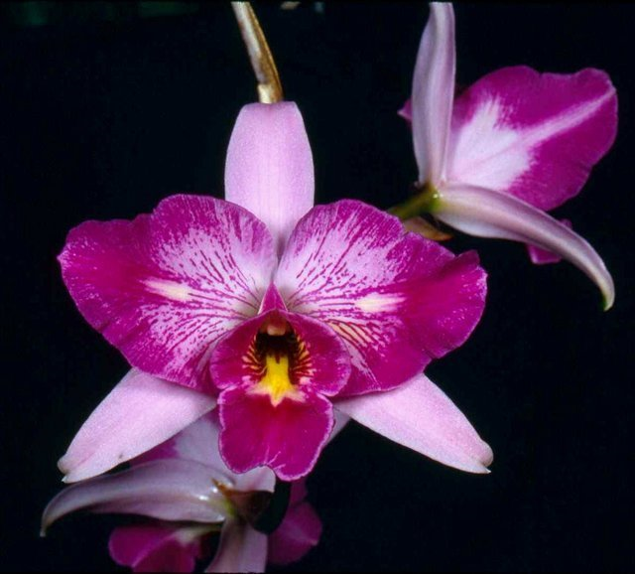

Laelia anceps ‘SanBbar Super Splash’ AM/AOS, 83 points, 1996
Merritt Collection, Specific Photographer not disclosed
Pacific South Regional Judging

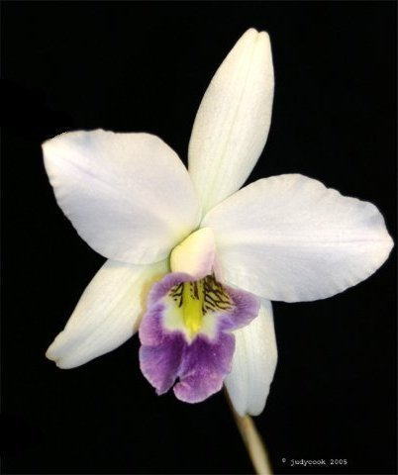

Laelia anceps hf veitchiana ‘Elizabeth’s Eyes’ AM/AOS, 83 points, 2004
Photography by Judy Cook
Atlanta Judging Center

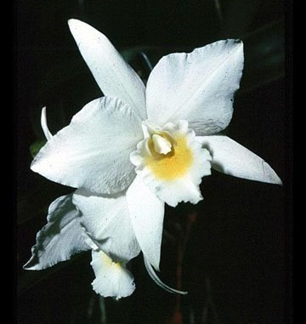

Laelia anceps var. vestalis ‘Twin Oaks’ AM/AOS, 83 points, 2004
Photography by OWZ Lib
No Venue Information Provided

The American Orchid Society notes that Laelia anceps features prominently in the development of cold tolerance in cattleyas. The species is dominant for its long inflorescence and characteristic four-angled pseudobulbs. The species imparts attractive shape, size, substance, and flower flatness to its hybrids. The color is recessive allowing hybridizers to develop a wide range of colors with the exception of yellow.

References

American Orchid Society. (n.d.) Laelia. Online: https://www.aos.org/orchids/orchids-a-to-z/letter-l/laelia.aspx

American Orchid Society. (n.d.) Hereditary influences of the Cattleya alliance. On-line: https://www.aos.org/orchids/additional-resources/hereditary-influences-of-the-cattleya-alliance.aspx .

Bechtel, P. (1990) The laelias of México. American Orchid Society Bulletin, 59(12): 1229–1234.

Bechtel, H., Cribb, P., and Launert, E. (1980) Manual of cultivated orchid species. MIT Press, Cambridge, Mass.

Govaerts, R. (2003). World Checklist of Monocotyledons Database in ACCESS: 1-71827. The Board of Trustees of the Royal Botanic Gardens, Kew.

Halbinger, F. (1993). Laelias de México. Asociación Mexicana de Orquideología, A. C. México D. F. México.

Halbinger, F. and M. Soto. (1997) Laelias of México. Orquidea (Mex) 15(1).

Hamilton, R. (1988) When does it flower? 2nd ed. Robert M. Hamilton, 9211 Beckwith Road, Richmond, B.C., Canada V6X 1V7.

Hawkes, A. (1965) Encyclopaedia of cultivated orchids. Faber and Faber, London.

Löb, U. (1990) The genus Laelia in México. Schlechteriana 1(1): 8–15.

OrchidPro. (n.d.).

OrchidWiz X9.0. (n.d.).

Pridgeon, A., Cribb, P., Chase, M., and Rasmussen, F. (2006). Epidendroideae (Part One). Genera Orchidacearum 4: 1-672. Oxford University Press, New York, Oxford.

Royal Botanical Gardens Kew, Plants of the World On-line. (n.d.). Laelia. On-line: https://powo.science.kew.org/taxon/urn:lsid:ipni.org:names:325605-2 .

Wiard, L. (1987) An introduction to the orchids of México. Comstock Publishing Assoc. Ithaca and London.

Withner, C. (1990) The Cattleyas and their relatives: Volume II. The Laelias. Timber Press. Portland, Oregon.

