SPECIES DATA REPORT
Bulbophyllum amplebracteanum Teijsm. & Binn. 1862
Section: Lepidorhiza (Schlechter 1911)
Synonym: N/A
Found only in the Molouccas island of Indonesia with 0.5 to 1.2" [1.25 to 3 cm] between each large, ovoid pseudobulb carrying a single, apical, thick, oblong, obtuse, gradually narrowing below into the 1.2 to 3.4" [3 to 8.5 cm long] petiolate base leaf and blooms in the fall and winter on a basal, arching, to 19.2" [48 cm] long, successively single, 9-12 flowered per inflorescence which can last over a 2 to 3 month period with each foul scented flower lasting 1 to 2 weeks. The flowers are golden yellow, clear to lightly striped with a dark undulate (move with a wavelike motion), verrucose (warty), rugose (wrinkled), lingulate (tongue-shaped) lips from purple to almost black with a horned lateral lobes. Lateral sepals are falcate (sickle-shaped) and forward pointing. Dorsal sepal and petals are ovate with sharply pointed tips. Column is erect with a pair of forward pointing arms
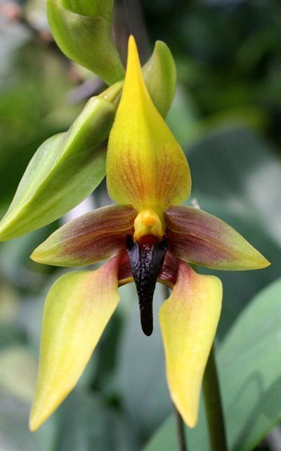
Bulb. amplebracteanum sub. carunculatum ‘Bronze Age’ – Photographed by Bill Thoms
Varieties: Bulb. carunculatum (from Sulawesi) and Bulb. orthoglossum ( from the Sulawesi and the Phillippines) are now considered to be subspecies of this species

Awards: 5 AMs, 6 HCCs, 4 CCMs, 6 Others
Vanda scale should be utilized to judge this species due to the significant in overall impact of the sepals and, to a lesser extent, petals and lips toward the appearance of the flower.
Hybrids

Hybrids: Total of 32 registered, to the 2nd generation
Before 2000 | 2000-2009 | 2010-Present
1 | 13 | 18
1st generation offspring: 28, total progeny: 32
There are 2 major primary hybrids of this species.
Bulb. Wilbur Chang (echinolabium x amplebracteanum sub. carunculatum) (2006) was made to increase the size of the species while maintaining wider segments. It has won 7 AMs, 4 HCCs, and 1 CCM in the last 10 years. Pictured below is Bulb. Wilbur Chang ‘Elermore’ HCC/OSNSW in 2006
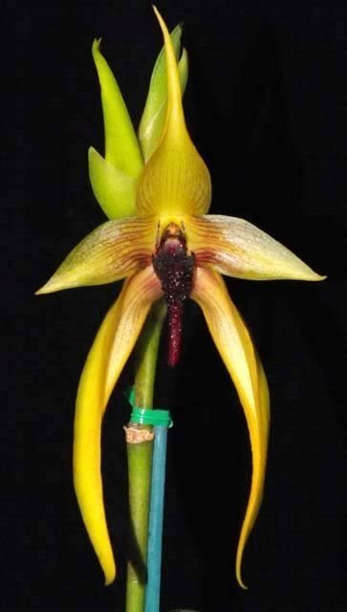
Bulb. Frank Smith (lobbii x amplebracteanum sub. carunculatum) (1999) improves over this species because of the addition of wider natural spread and floriferousness of Bulb. lobbii. It has won 5 AMs, 5 HCCs, and 2 CCE awards since 2000. Pictured below is Bulb. Frank Smith ‘The King’ CCE/AOS with 96 points awarded in 2009
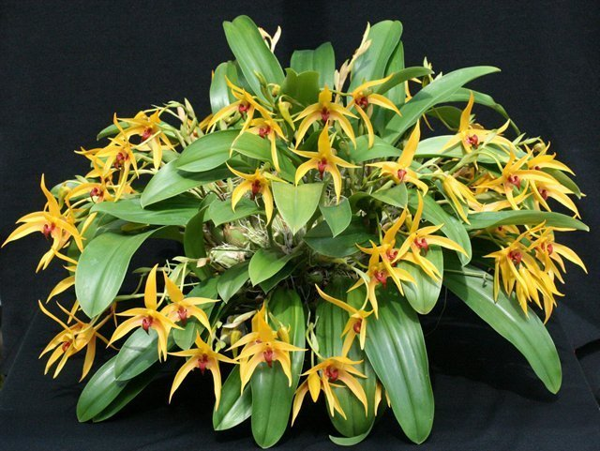

Reference:
OrchidWiz Encyclopedia version 3.3
Orchid Plus Online
Jay Pfahl’s Internet Orchid Species Photo Encyclopedia:
http://www.orchidspecies.com/bulbamplibracteatum.htm - accessed 9/5/2017

