SPECIES DATA REPORT
Bulbophyllum appendiculatum [Rolfe] J.J.Sm. 1915
Section: Cirrhopetaloides (Garay, Hamer, & Siegerist 1994)
Synonym: *Cirrhopetalum appendiculatum Rolfe 1890; Mastigion appendiculatum (Rolfe) Garay, Hamer & Siegerist 1994
Found in northeastern India and Sikkim in hilly country as a miniature sized, hot to warm growing epiphyte with quadrangular, ovate, sulcate pseudobulbs carrying a single, thick, leathery, fleshy, elliptic to oblong to ovate, obtuse, minutely bilobed, shiny above, sessile base leaf that blooms in the fall on a basal, erect, horizontal to descending, 3.2 to 6" [8 to 15 cm] long, 1 to 4 flowered inflorescence with unpleasantly, musky scented flowers.
This orchid is a hot to warm growing epiphyte that requires light shade, good drainage, air circulation and high humidity.
This species is similar to Bulbophyllum putidum which has irregular lamellate palae, petals that are linear-oblong and an acute to subacuminate (somewhat tapering) labellum, but Bulb. appendiculatum differs in being a less wide overall flower, the clavate (club shaped) cilia, narrowly triangular-lanceolate petals, and a roundish, obtuse (blunt) labellum.
Varieties: N/A
Awards: Bulb. appendiculatum ‘AGE’ CHM/AOS 83 points in 2006 pictured below
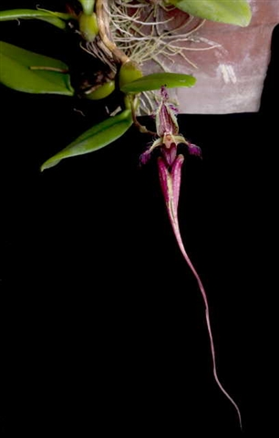
Pleurothallid scale should be utilized to judge this species due to the significant in overall impact of the lateral sepals and, to a lesser extent, dorsal sepal toward the appearance of the flower.
Hybrids

Hybrids: Total of 14 registered, one generation
Before 2000 | 2000-2009 | 2010-Present
0 | 10 | 4

Bulb. appendiculatum hybrids are registered 2005 or after, none has stood out or gathered awards. This is a much underappreciated species in this genus.

Reference:
OrchidWiz Encyclopedia version 3.3
Orchid Plus Online
Jay Pfahl’s Internet Orchid Species Photo Encyclopedia:
http://www.orchidspecies.com/mastappendiculatum.htm - accessed 9/5/2017

