SPECIES DATA REPORT
Bulbophyllum careyanum (Hook.) Spreng. 1826
Section Racemosae Benth & Hkr.f 1883
Synonym: Anisopetalum careyanum Hook. 1825; Bulbophyllum careyanum var ochraceum Hkr. 1890; Bulbophyllum cupreum auct. no Lindl 1862; Bulbophyllum cupreum Hook. non Lindl. 1862; Phyllorchis purpurea (Hook.) Kuntze 1891; Pleurothallis purpurea D. Don 1825; Tribrachia purpurea [D.Don] Lindl. 1826
Found in the eastern Himalayas, Assam, Nepal, Bhutan, Sikkim, Myanmar, Thailand, and Vietnam in evergreen lowland forests as a small sized, warm to cool growing epiphyte at elevations of 200 to 2100 meters with remote, spherical to oblong, lightly grooved pseudobulbs with a single apical, oblong to linear oblong, tapering at each end, sub-sessile below , sub-acute and notched apically leaf that blooms in the winter and spring on a basal, stout, brown, to 9 1/4" [23 cm] long, lateral to hanging, many flowers infloresence with many lanceolate, brown bracts and carrying foul smelling flowers with lanceolate floral bracts that are longer than the ovary and all held in a dense cylindric raceme.
Best grown on tree fern or cork, kept wet although allowed to dry out and hot to cool conditions with slight shade.
Varieties: N/A
Awards: 1 CBM, 2 CCM. Most recent award is Bulb. careyanum ‘Caridad Lopez Montalvo’ CCM/AOS of 83 points pictured below. Notice most awards are from small flower Bulbophyllum are cultural awards.
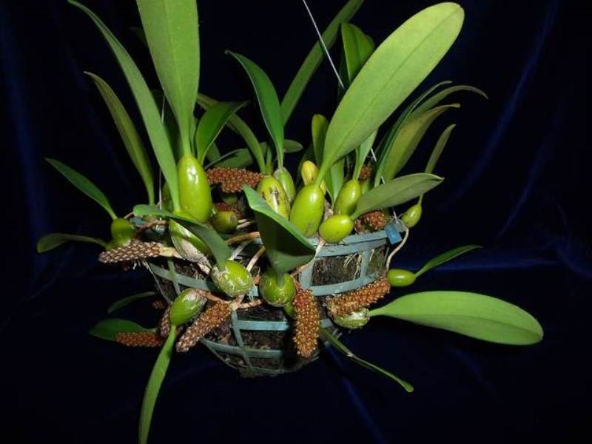
Close up of the flowers of this diminutive species: pictured below, photographed by Phil Nelson, MD
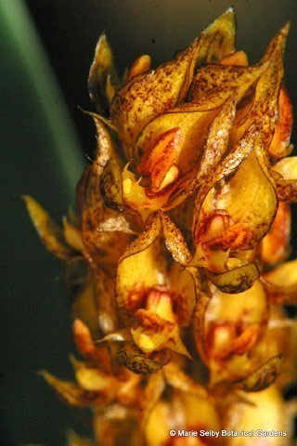
Vanda scale should be utilized to judge this species due to the significant in overall impact of the sepals and, to a lesser extent, petals and lips toward the appearance of the flower. However, overall flower presentation and vigor are more important to judge these small-flowered Bulbophyllum.
Hybrids: no hybrid registered, this species is underutilized in hybridizing

Reference:
OrchidWiz Encyclopedia version 3.3
Orchid Plus Online
Jay Pfahl’s Internet Orchid Species Photo Encyclopedia:
http://www.orchidspecies.com/bulbamplibracteatum.htm - accessed 9/5/2017

