SPECIES DATA REPORT
Bulbophyllum grandiflorum Blume 1847
Section: Hyalosema (Schlechter 1911)
Synonym: Bulbophyllum burfordiense Rolfe 1901; Bulbophyllum micholitzii Rolfe 1901; *Ephippium grandiflorum Bl. 1849; Hyalosema grandiflorum [Bl.]Rolfe 1919; Hyalosema micholitzii (Rolfe) Rolfe 1919; Phyllorchis grandiflora (Bl) Kuntze 1891; Sarcopodium grandiflorum (Bl) Lindl. 1853
A hot growing epiphyte found in Sumatra, Sulawesi, the Moluccas, and New Guinea at elevations of 100 to 800 meters in primary rainforests on the lower trunks of large trees that blooms on a basal, erect to arching, to 10" [to 25 cm] long, single flowered, green inflorescence with foul smelling flowers that is longer than the leaves and occurs in the fall.
Very similar to Bulbophyllum burfordiense but it differs in a ciliate labellum, triangular petals, free, acute to obtuse lateral sepals, and a smaller dorsal sepal, while the other has a glaborous labellum, ovate petals that are apically acute, tapering lateral sepals with the apex acuminate, and a larger dorsal sepal of at least 14 cm long x 4 cm wide. Below are frontal view of the flower showing lips and petals structure (from The Orchid Column)
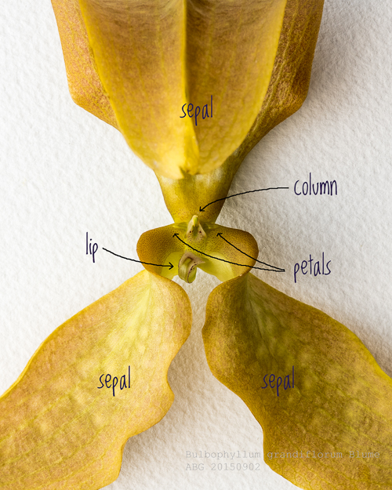
The huge sepals are what give this flower its hooded cobra-like appearance. The petals are tiny by comparison. The lip, which has a lovely fringe of purple hairs, is hinged -it is connected to the base of the column by a narrow flexible ligament that allow the lip to tip like a seesaw under the weight of an insect. As the insect redistributes its weight, the lip tips up, slamming the insect against the column and releasing the pollinarium onto the insect's body.
Varieties: N/A
Awards: 1 FCC, 6 AMs, 2 HCCs, 5 CCMs, 2 CCEs, 1 CBM. The best example of this species is Bulbophyllum grandiflorum ‘E-Lin’ FCC/AOS 92 points in 2014 pictured below. “Great size, superior conformation” and “attractive tessellated patterns” dictate the high quality that this species can achieve. In addition, this species has achieve a high percentage of cultural awards demonstrating the floriferousness of the species.
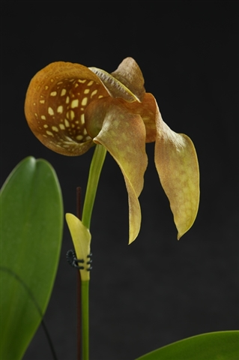
General scale should be utilized to judge this species due to the significant in overall impact of the sepals toward the appearance of the flower. The petals and lips are miniscule and non-significant. It is more important to judge the flower’s symmetry since the flower segments are not traditionally flat.

Hybrids
There are 4 hybrid registered since 2000 registered on Orchidwiz, however, there are only 2 hybrids registered with B. grandiflorum as a parent since Orchidwiz considered B. burfordiense a synonym of B. grandiflorum. Bulbophyllum Hsinying Grand-arfa ‘CS’ (grandiflorum x arfakianum) registered in 2008 received CCE of 90 points for a near perfectly grown specimen in March 2017 (Pictured below).
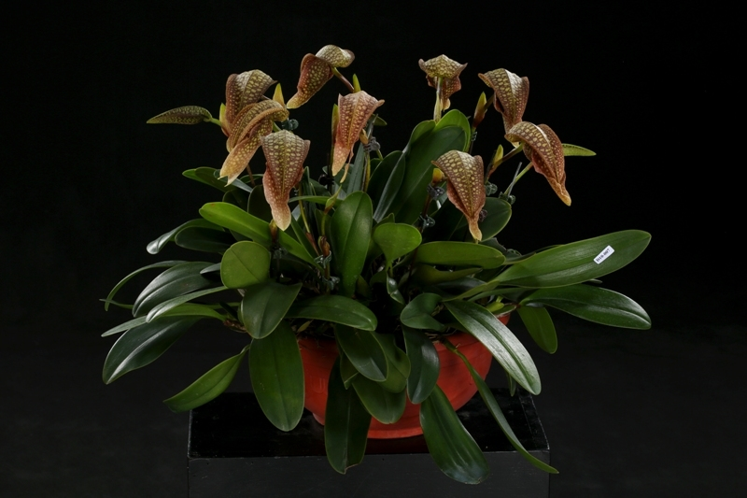

Reference:
OrchidWiz Encyclopedia version 3.3
Orchid Plus Online
Jay Pfahl’s Internet Orchid Species Photo Encyclopedia:
http://www.orchidspecies.com/bulbograndiflorum.htm - accessed 9/5/2017
The Orchid Column – The Cobra
http://www.theorchidcolumn.com/2015/07/the-cobra.html -accessed 9/5/2017

