SPECIES DATA REPORT
Bulbophyllum macranthum Lindley 1844
Synonyms: Bulbophyllum cochinchinense Gagn. 1950; Bulbophyllum patens Auct. no King ex Hkr. Gagn. 1951; Bulbophyllum purpureum Náves in F.M.Blanco 1880; Carparomorchis macrantha (Lindl.) M.A.Clem. & D.L.Jones 2002; Phyllorchis macrantha (Lindl.) Kuntze; *Sarcopodium macranthum Lindley 1850-1; Sarcopodium purpureum Rchb.f 1859;
Blooms in the spring and fall with a solitary, non-resupinate, wide opened and spreading flower that has a 2" [5 cm] long, basal, lateral, single flowered inflorescence that holds the fragrant [cloves] flower amid the leaves, occuring from Assam, Myanamar, Thailand, Malaysia, Vietnam, Borneo, Java, Moluccas, The Philippines, Sulawesi, Sumatra, Papua New Guinea and the Solomon Islands at altitudes of sea-level 700 up to 1500 meters and has a stout, hairy rhizome with well-spaced, ovate-elliptic psuedobulbs carrying a single, oblong, fleshy, petiolate leaf. The petals and dorsal sepal are white/creamy yellow with numerous small/medium sized dark red/dark purple spots. Lateral sepals varies depending on the cultivar. Best grown on a slab of tree fern or cork, given hot temperatures and good shade.
Below is Bulbophyllum macranthum ‘Shiraz’ AM/AOS (85 points) awarded in 2001
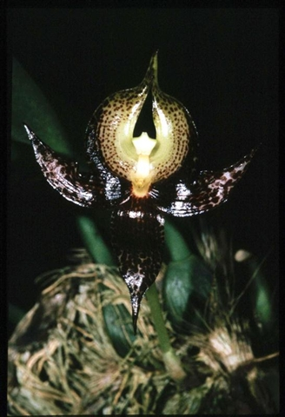
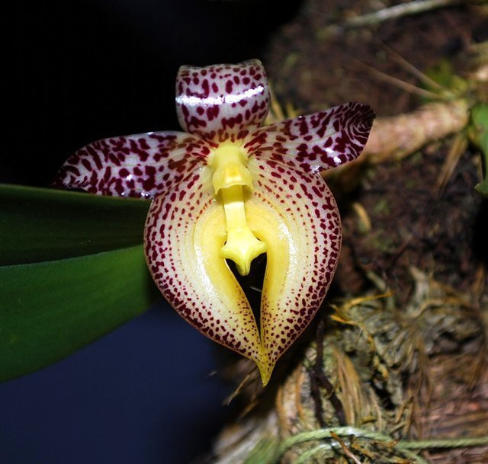
Another clone of this beautiful species

Varieties: f. alba
Awards: 2 AM, 1 HCC, 2 CCM, 2 CHM, 1 CBM ranging from 1965 to recently 2012
Hybrids: 6 known hybrids of first generation, and they are seldom awarded
Reference:
OrchidWiz Encyclopedia version 3.3
Orchid Plus Online
Jay Pfahl’s Internet Orchid Species Photo Encyclopedia:
http://www.orchidspecies.com/bulbophylummacranthum.htm - accessed 10/11/17

