SPECIES DATA REPORT
Bulbophyllum macrobulbum J.J. Sm. 1910
Synonym: Bulbophyllum balfourianum
Found as an epiphyte in New Guinea on moss covered trees or rocks at elevations of 300 to 400 meters as a hot growing epiphyte with huge, dull olive-green, ovoid, clustered pseudobulbs carrying a single, apical, oblong, coriaceous (having texture of leather), long, tinged with purple leaf that blooms in the later spring on a short, basal, raceme with 3 to 5 large, carnose (flesh-like) foul smelling flowers. This species is seldom seen in cultivation
These plants have tremendously long leaves and they must hang free without laying on benches which promotes rot so use hanging pots or baskets, hot tempratures, high humidity and partial shade aid in keeping this species well grown.
The flowers do not open widely, are 6-10 cm long, yellow to yellow green base color marked with red/red purple/dark brown spots. Petals are dark red at the base with undulating (having a smooth, wavy outline) yellow/gold margin
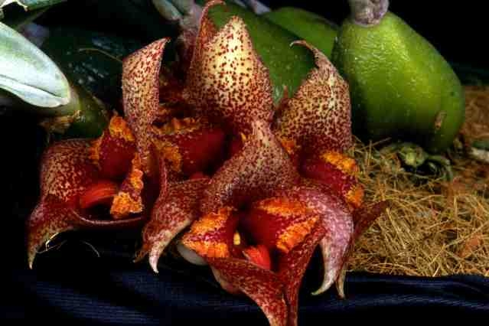
Varieties: N/A
Awards: 1 AM, 1 CHM, 1 CCM, 1 CCE, all coming from the single most popular clone ‘Magnifico’ pictured above. Most recently award is in 2005 and is a CCE of 92 points.
Hybrids: 3 known hybrids, most well-known is Bulb. Laura Newton (macrobulbum x agastor) registered in 2012 that has received 8 AOS awards (5 AM, 2 HCC, 1 CCM) in the year 2014 and 2015, 4 of them was exhibited by Laura Newton herself. These are some variation of the hybrid but all are with wonderful speckles and yellow/gold colored ruffled petals’ margins from microbulbum.
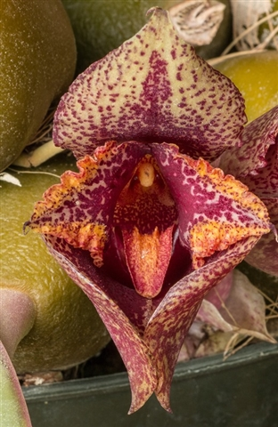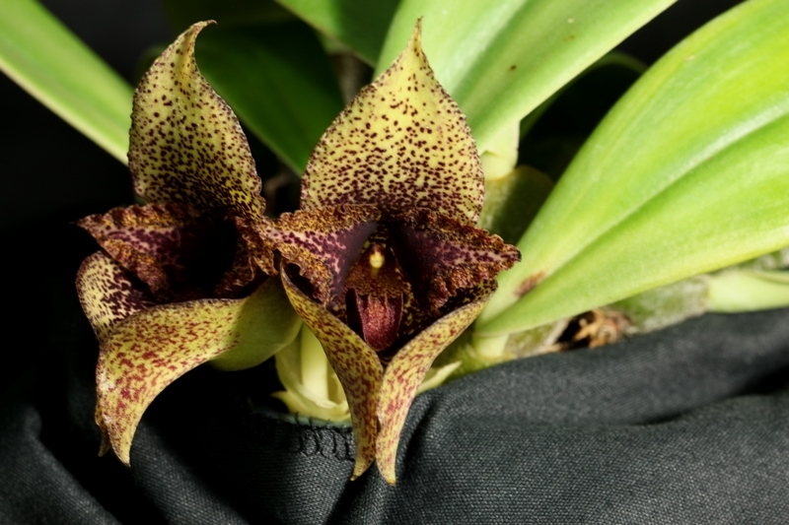
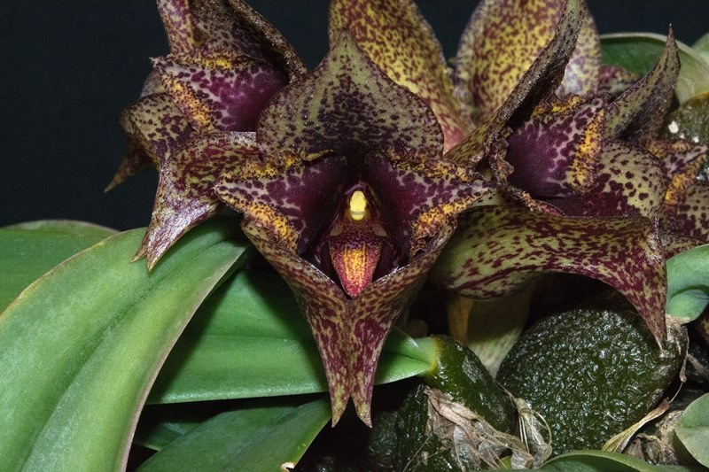
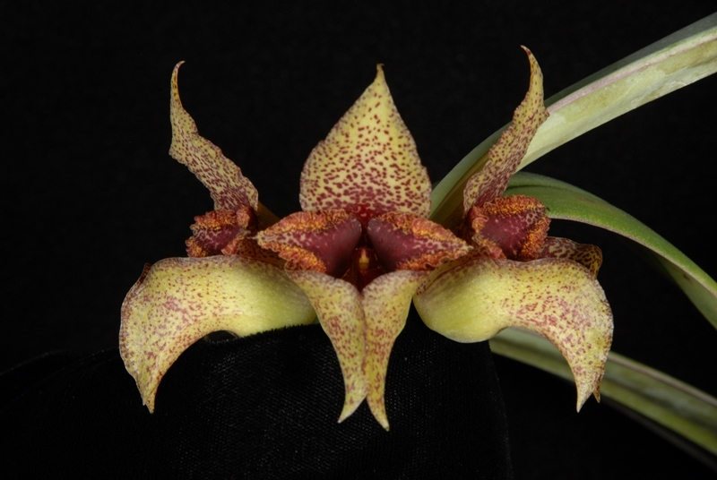

Reference:
OrchidWiz Encyclopedia version 3.3
Orchid Plus Online
Jay Pfahl’s Internet Orchid Species Photo Encyclopedia:
http://www.orchidspecies.com/bulbmacrobulbon.htm - accessed 10/11/17

