SPECIES DATA REPORT
Bulbophyllum sunguineopunctatum Seidenf. & A.D.Kerr 1973
Synonym: N/A
Found in Laos and Thailand along streams in dense jungle at elevations around 500 meters as a miniature sized, hot to warm growing epiphyte with a sheath covered rhizome with .6" [1.5 cm] between each ovoid, lightly ridged in youth, quadrangular and deeply ridged in maturity pseudobulb carrying a single, apical, erect, lanceolate, basally twisted 90 degrees, widest in the middle, many bright green veined, petiolate base leaf that blooms in the late summer and early fall on an erect, basal, 6.8" [17 cm] long, green, heavily blotched with maroon, 3 to 8 flowered inflorescence with 3 sterile bracts and carrying the flowers in an apical umbel.
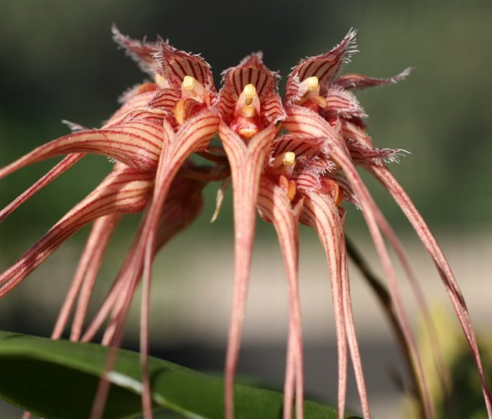
Varieties: f. alba

Awards: B. sanguineopunctatum ‘A-doribil’ CHM/AOS (81 points) in 2011
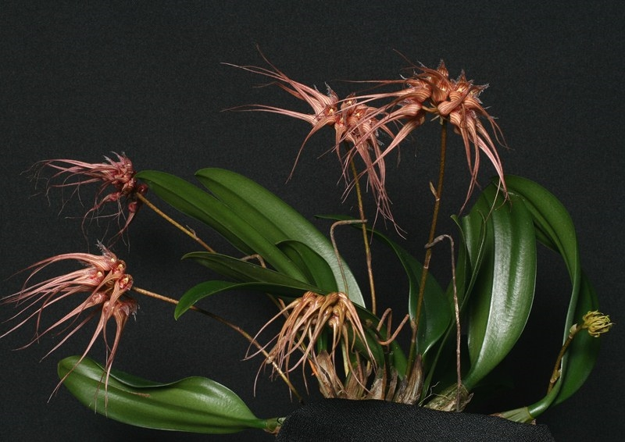
Hybrids: 10 hybrids was registered between 2005 to the most recent 2013. Only 1 award was given to B. Jiraporn Punpreuk (x annandalei) ‘A-doribil’ HCC/AOS (78 points) in 2010.
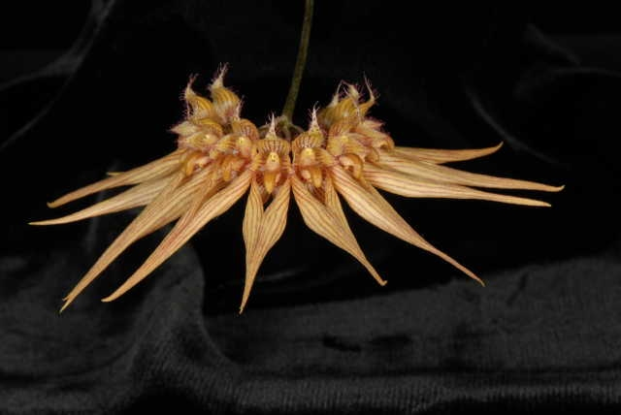

Reference:
OrchidWiz Encyclopedia version 3.3
Orchid Plus Online
Jay Pfahl’s Internet Orchid Species Photo Encyclopedia:
http://www.orchidspecies.com/bulbsanguineopuntatum.htm - accessed 10/11/2017

