The Genus Brassavola
R. Brown 1813
Type species: Brassavola cucullata
The genus Brassavola was named in honor of the Italian botanist, Antonio Musa Brassavola. Species found in hobbyist collections include B. cordata, B. cucullata, B. cebolleta and B. acaulis with B. nodosa being the most well-known and easily cultivated. In 1698 Brassavola nodosa was the first tropical orchid to be brought from the Caribbean island Curaçao to Holland. Thus began the propagation of this orchid and the fascination for orchids in general.
The 20, epiphytic and sometimes lithophytic species of Brassavola are spread throughout the tropical America from Mexico through Central America and the West Indies to Brazil and Argentina. Most Brassavola orchids are very fragrant, attracting pollinators with their citrusy smell. But they are only fragrant at night, in order to attract Sphingid moth. Longevity of flowers depends on the species and is between five and thirty days.
They have a single, apical, subterete leaf on a pencil-like pseudobulb and bloom with a single or a raceme of a few large flowers with elongate narrow sepals and petals and the base of the lip embracing at least a portion of the column which carries 12, sometimes eight unequal pollina occuring as a rule in spring, summer and fall. Named by Robert Brown in the early 1800’s, Brassavola is a very popular, showy genus that has been used hundreds of times by hybridizers. Beloved by all from the beginner to the advanced hobbyist to the sophisticated hybridizer, Brassavola, especially B. nodosa, is a must for any collection due to its easy growth habit, flower longevity and wonderful evening fragrance. Commonly known as ‘the lady of the night’ the sweet fragrance of B. nodosa can easily fill a large greenhouse. Although now considered a separate genus, (Rhyncholaelia) B. digbyana was once the backbone of ‘fluffy’ Cattleya breeding, the brassocattleyas (BC.) and brassolaeliacattleyas (BLC.). Nowadays breeding with B. nodosa has become very popular as evidenced by the numerous awards granted to such hybrids as Bl. Yellow Bird, Blc. Apache Sunrise, BC. Binosa, BC. Maikai, BC. Carnival Kids, Bl. Richard Mueller, BL. Morning Glory and a long etc.
The orchid yields a single white or greenish white flower, or a raceme of a few flowers. The three sepals and two lateral petals are greenish, narrow and long. The base of the broad, sometimes fringed lip partially enfolds the column. This column has a pair of falciform (sickle-shaped) ears on each side of the front and contains twelve (sometimes eight) pollinia.
The species of Brassavola have been divided into four sections:
- Section Brassavola: This monotypic section, erected by H. G. Jones in 1969, contains the type of the genus:
Brassavola cucullata - Hooded brassavola, daddy longlegs orchid (Mexico to N. South America)
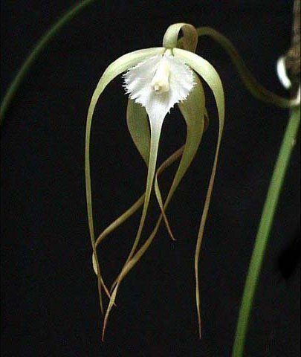
- Section Sessilabia: This section, erected by Rolfe in 1902, is characterized by narrow labella with fimbriate margins to wider labella with entire margins.
B. fasciculata (Brazil)
B. filifolia (Colombia)
B. flagellaris (Brazil)
B. gardneri (French Guiana, Brazil)
B. martiana (S. Trop. America)
B. perrinii (Brazil to Bolivia and Paraguay)
B. reginae (Argentina, Brazil, Peru)
B. retusa (Venezuela, N. Brazil to Peru)
B. revoluta (Brazil)
B. rhomboglossa (WC. & S. Brazil)
B. tuberculata (Brazil to Peru, NE. Argentina and Paraguay)
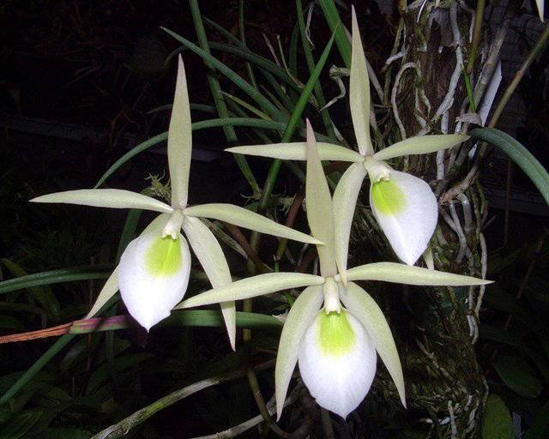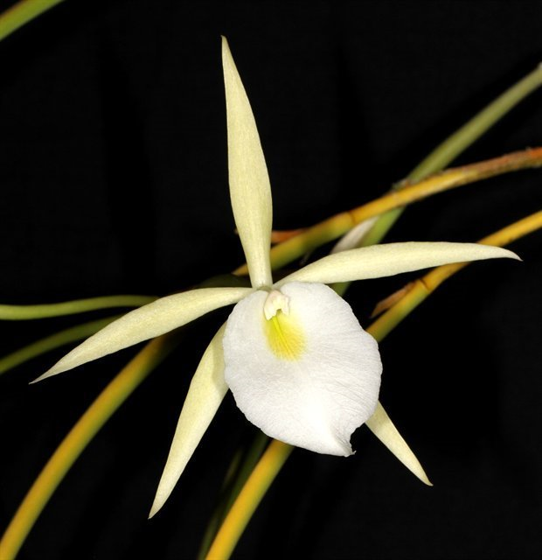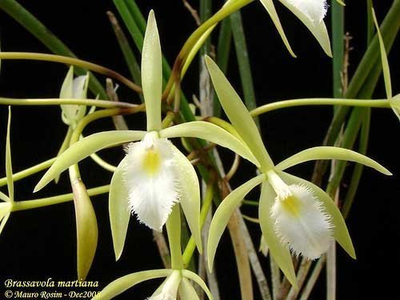
- Section Cuneilabia: This section, erected by Rolfe in 1902, is characterized by narrowly constricted labellum bases. The sectional type is B. nodosa
B. gillettei (Trinidad)
B. grandiflora (C. America to Colombia)
B. harrisii (Jamaica)
B. nodosa - Lady-of-the-night orchid (Mexico to Trop. America: Belize)
B. subulifolia (Jamaica)
B. venosa (SE. Mexico to C. America)
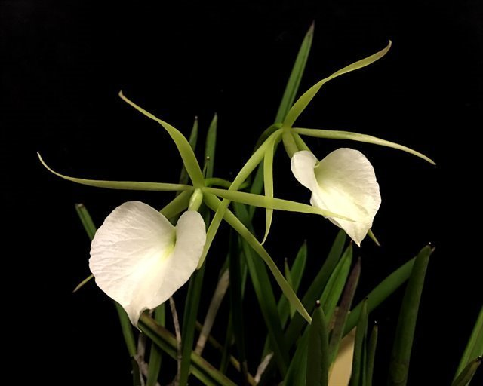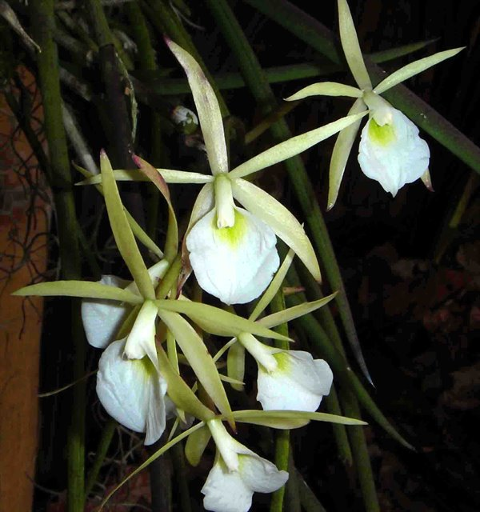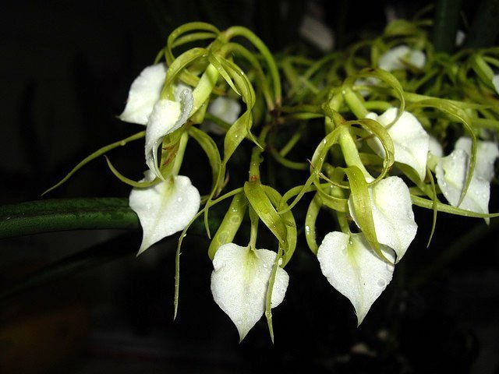
- Section Lateraliflorae: This section, erected by H.G.Jones in 1975, is characterized by laterally-borne inflorescences. The sectional type is B. acaulis
B. acaulis (C. America: Belize)
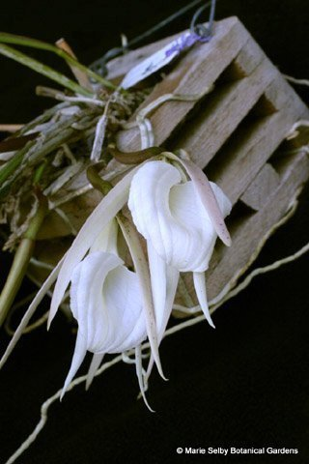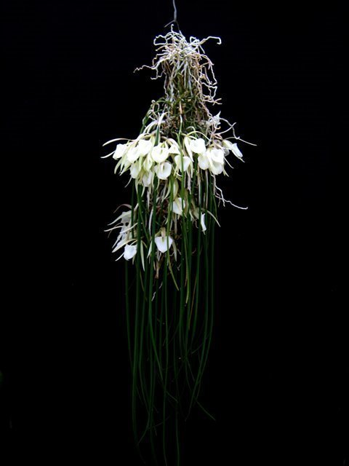
- Other species accepted as of May 2014[1] but of unknown section:
B. angustata (Trinidad-Tobago, Guyana, Venezuela, Suriname, Roraima)
B. ceboletta (Brazil, Bolivia, Argentina, Peru, Paraguay)

Significant species | Offspring/Progeny | Awards | Bloom season
B. nodosa* | 430/1068 | 3 FCCs, 18 AMs, 6 HCCs, 1 CCE, 25 CCMs, 1 CBR, 1 CBM | Mainly Sp and Su
B. perrinii* | 86/102 | 1 CCE, 7 CCMs | Sp, Su
B. cucullata* | 65/89 | 5 AMs, 4 CCMs, 2 JCs | Su to F
B. subulifolia (cordata)* | 45/93 | 3 AMs, 1 CCE, 8 CCMs | Late Su to F
B. flagellaris | 16/24 | 2 AMs, 1 HCC, 3 CCMs, 1 CBR | Early Su
B. tuberculata | 15/23 | 1 AM, 2 CCMs | Late Sp, early Su

Hybrid: Brassavola is in the same alliance as the genera Cattleya and Laelia. They have been used extensively in hybridization and represent the B at the beginning of the names of such crosses. For example, Blc. is Brassolaeliacattleya.
Judging: most awards given to Brassavola orchids are cultural awards due to its floriferousness. Brassavola nodosa and B. cucullata are the exception with more flower quality awards vs. cultural awards. Cattleya judging scale should be sufficient to use for Brassavola judging

SPECIES DATA REPORT
Brassavola nodosa Lindley 1831
Synonym: Bletia nodosa Rchb.f 1861; Bletia rhopalorrhachis (Rchb.f.) Rchb.f. 1862; Brassavola grandiflora Lindley 1839; Cymbidium nodosum Sw. 1799; *Epidendrum nodosum L. 1753
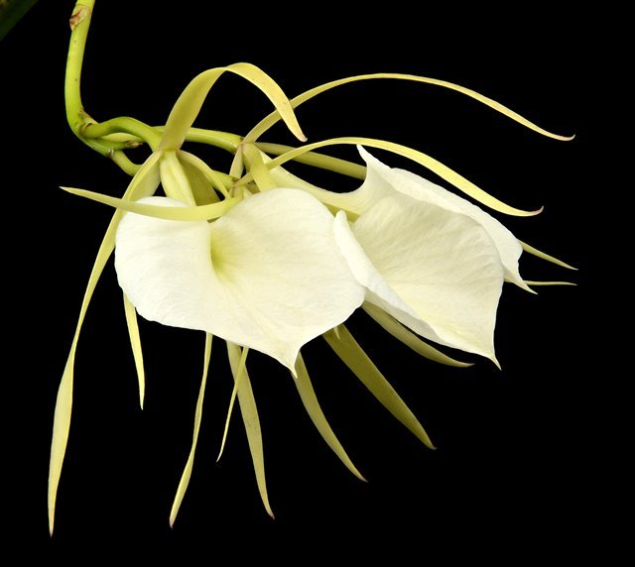
This hardy, medium sized, hot growing epiphyte or lithophyte has cylindrical, short stems enveloped by scarious(thin, dry, membranous) sheaths with a single, sub-terete (almost cylindrical), sulcate (having a narrow deep groove), acute-apiculate (pointy at the end) leaf. It has a nice, citrus fragrance at night and the flowers are close to 4" across and occur in the spring and summer but are possible at any time of the year on a 8" [20 cm] long, bracteates (bearing bracts) inflorescence that arises on a newly maturing pseudobulb that carries a single, long, sub-terete leaf that carries up to 6 flowers. The colour ranges from ivory to pale green (Murren & Ellison 1996). In many of the hybrids the flowers have distinct coloured spots on the lip (American Orchid Society, 2012). The flowers themselves consist of 5 thin tepals with a wide lip which can measure up to 7cm wide. They are found from Mexico, Guatemala, Belize, El Salvador, Honduras, Nicaragua, Costa Rica, Panama, Caymans, Aruba, Curacao, Bonaire, Puerto Rico?, French Guiana, Surinam, Guyana, Venzuela, Colombia and Brazil from sea level to about 500 meters as epiphytes or lithophytes and can be quite salt tolerant.
In some regions B. nodosa has been found to naturally hosted on different trees within its region of distribution. The species is found on mangroves including the buttonwood mangrove, Conocarpus erectus L. in Belize, to the red mangrove, Rhizophora mangle (Murren & Ellison 1996), which seems to be a favourite host tree for B. nodosa, thriving on tree branches and the lower trunks. Brassavola nodosa can also be found growing on the exposed rocks and cliffs of the Costa Rica coast (Murren & Ellison 1996).
Though this is not an edible plant, it is highly regarded in the ornamental sector and is thought to be a relatively easy orchid to grow. The reward for growing and caring for Brassavola nodosa is the beautiful scent which fills the air once the evening starts. For the optimum results it is best to grow this orchid mounted on tree bark or in a basket, this will allow the aerial roots to grow freely (The Atlanta Orchid Society Bulletin, 2010). In its natural habitat B. nodosa will experience a wet rainy season followed by a dry one in good light conditions. It is best to follow this pattern for optimal results while watering frequently is needed. It is key to ensure free drainage, and maximum humidity is also advisable as B. nodosa can withstand up to 80% humidity in its natural habitat. In case baskets or bark is not an option, one can pot up this orchid in a light bark mix making sure some of the aerial roots are on the surface and free drainage is provided (The Atlanta Orchid Society Bulletin, 2010). With regards to temperature, it is best to maintain a temperature above 12°C to ensure the orchid will produce flowers. In order to really maximise the flower production a temperature range of 18-27°C is advised.
Varieties: var. grandiflora, var. major, var. venosa, var. rhopalorrhachis
Awards: 3 FCCs, 18 AMs, 6 HCCs, 1 CCE, 25 CCMs, 1 CBR (var. venosa), 1 CBM (var. rhopalorrhachis)
Hybrids: 430 first generation hybrids and 1068 total progeny. Brassavola nodosa is dominant in nearly all aspect in hybridizing, also tend to block out red pigment productions. Pseudobulbs are thin, often nearly cylindrical with narrow leaves. Flowers may often be cupped and spots are commonly produced.
Within the genus, Brassavola Little Stars is most recognizable combining the large flower size Spring/Summer of B. nodosa and the floriferousness Fall blooming habit of B. subulifolia. This hybrid has received 2 AMs, 2 HCCs, 1 CCE, 11 CCM
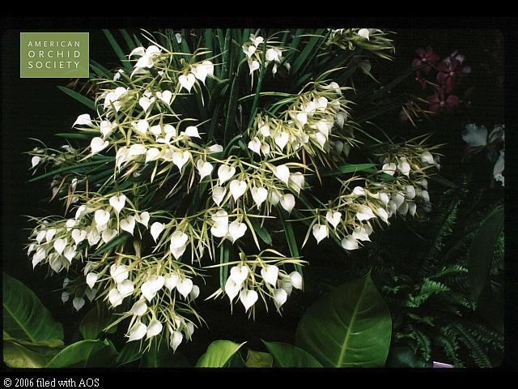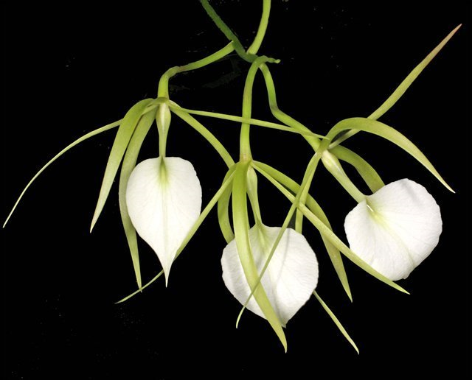
Amongs them, the most highly awarded are the primary hybrid of B. nodosa and Gur. bowringiana: Brassanthe. Maikai (left)(2 AMs, 3 HCCs, 15 cultural awards) due to its floriferous nature. It is also the parent of Bc. Little Mermaid (right) which is another popular hybrid. Bsn. Maikai has 69 offsprings and 96 progeny under its belt.
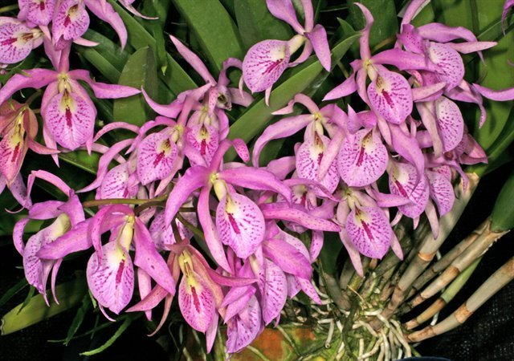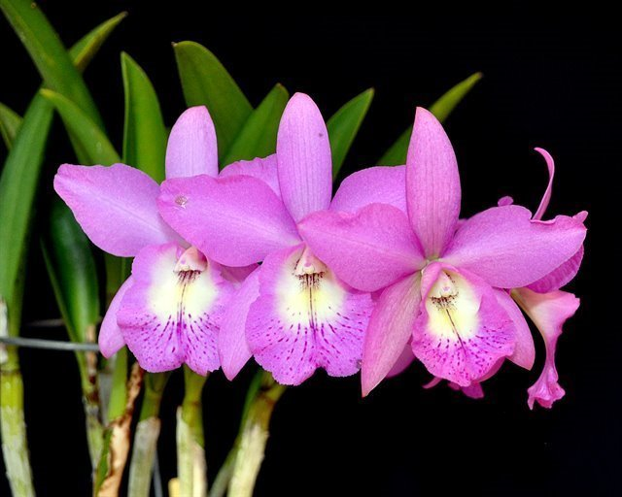
Brassocattleya Keowee (C. Lorraine Shirai x B. nodosa) with the most flower quality awards including 9 AMs, 6 HCCs, 2 CCMs, 1 AQ. The impressive lip veining and size is inherited from C. dowiana.
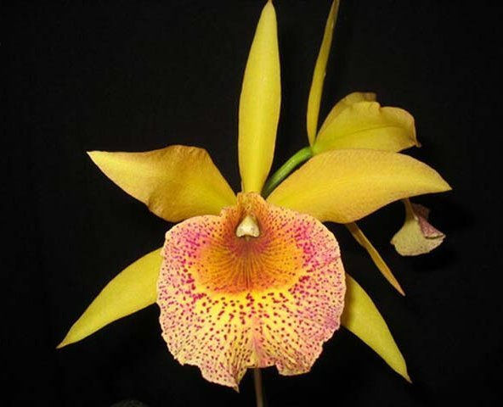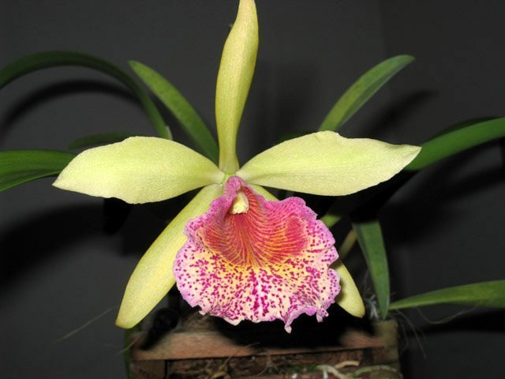
Brassocattleya Richard Mueller (x C. milleri) pictured left is a very popular breeding for yellow/sunset star shaped flowers with its characteristic of color change when the flowers age. This hybrid has 75 offsprings and 173 total progeny. Most well-known of its children is Rhynchobrassaoleya Golden Tang (Rc. Waikiki Gold x Bc. Richard Mueller) with 7 AMs, 8 HCCs pictured right
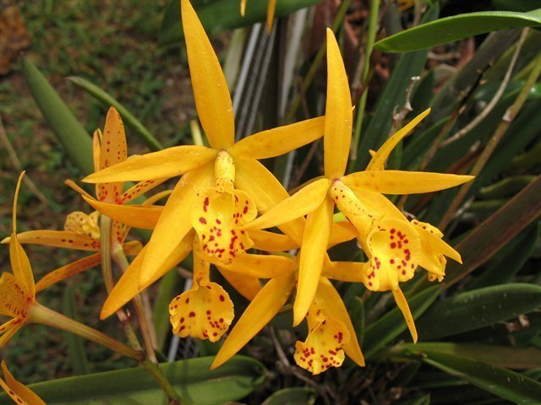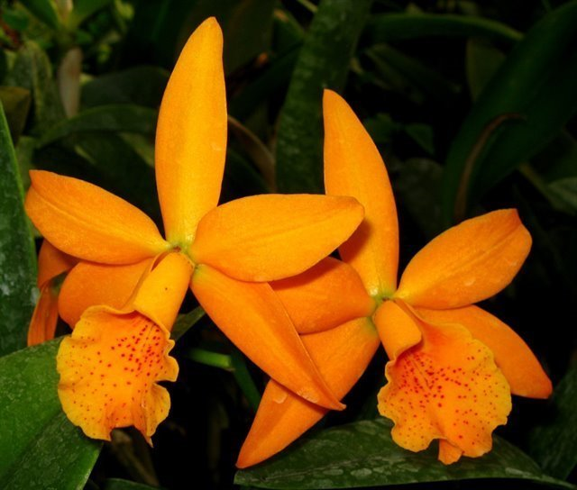
Brassocattleya Binosa (x C. bicolor) has received 8 AMs, 5 HCCs, 3 CCMs is also popular with star-shaped breeding with 73 offsprings and 106 total progeny. Most well-known of its children is Bc. Memoria Vida Lee (Bc. Binosa x C. Brazillian Treasure) pictured right
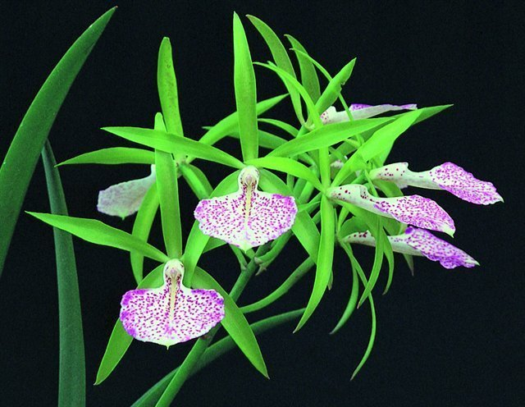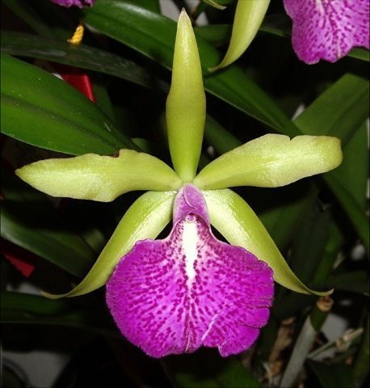

Reference:
OrchidWiz Encyclopedia version 4.1
Orchid Plus Online
American Orchid Society - Brassavola
http://www.aos.org/orchids/orchids-a-to-z/letter-b/brassavola.aspx
Wikipedia Encyclopedia
https://en.wikipedia.org/wiki/Brassavola
Jay Pfahl’s Internet Orchid Species Photo Encyclopedia:
http://www.orchidspecies.com/brassavolanodosa.htm
Tropical Biodiversity – Brasavola nodosa
http://blogs.reading.ac.uk/tropical-biodiversity/2012/12/brassavola-nodosa/

