The Genus Rhyncholaelia
Schlechter 1918
Type species: Rhyncholaelia glauca
In 1918, Rudolph Schlechter recognized that two species of spectacular flowering plants were sufficiently different taxonomically from Cattleya, Laelia and Brassavola to be placed in a separate genus. He coined the generic name Rhyncholaelia from the Greek word rhynchos (snout) and the genus name Laelia, undoubtedly a reference to the seed capsule, which Schlechter considered a main point in his generic separation. Although still debated by taxonomists, Rhyncholaelia is considered by most as the proper generic name. From a horticulturist’s standpoint, however, Brassavola probably will continue to be used as the generic name to be consistent with the thousands of hybrids already recorded, which is until those names are changed.
This genus was created by the removal of two species from Brassavola because they differed in their Cattleya-like psuedobulbs and leaf and in differences in the flower structure.
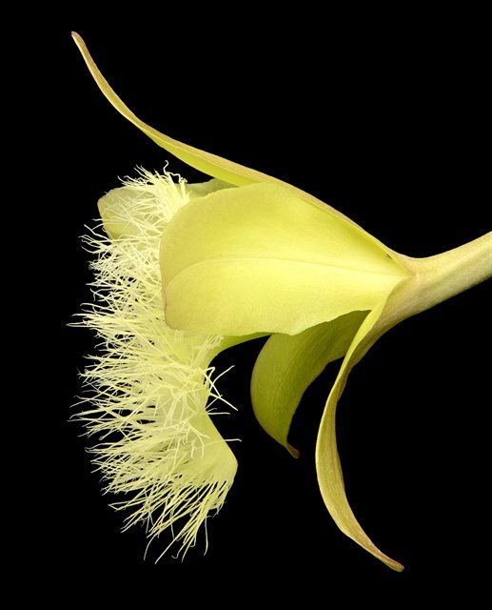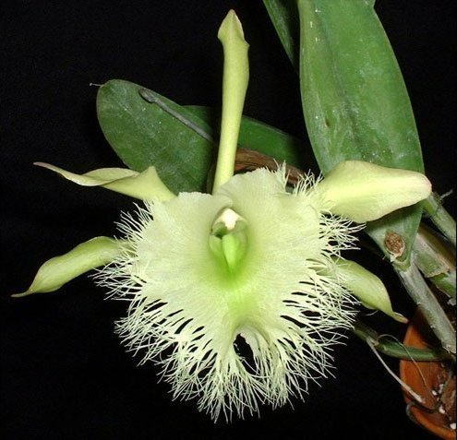
Vegetatively, these sympodial epiphytes are very easy to distinguish from their close relatives. They have club-shaped to spindle-shaped pseudobulbs that often are hidden by very glaucous (covered with powdery bloom), almost white sheaths. Each pseudobulb is topped by a single stiff, leathery, gray-green, glaucous leaf that is usually elliptic and up to 8 inches (20 cm) long. Each growth bears a single flower subtended by a very large, leafy sheath.

The basic flower colors are light green to creamy white, with an occasional flower displaying a pale lavender-pink tint. The throats of the flowers range from emerald green in color to having a large rose-colored spot. The flowers which can be up to 7 inches (17.5 cm) in diameter are very similar as far as their sepals and petals are concerned, usually being alike in size, shape and color, with the segments of Rhyncholaelia glauca a little more reflexed. The lips, however, are so distinctly different that these two species can be separated easily without question. Rhyncholaelia digbyana has an extremely large, slightly three-lobed lip, which has a very deeply fringed margin, whereas R. glauca has a broad, blunt, fringeless lip.
In cultivation they prefer humid conditions with healthy air circulation. Do not water excessively. Mount on cork slabs or tree branch mounts or grow in small pots. Water with care as they resent excessive water around the roots. Grow in bright light (like Cattleyas or brighter) and provide a lot of fertilizer during the growing season.
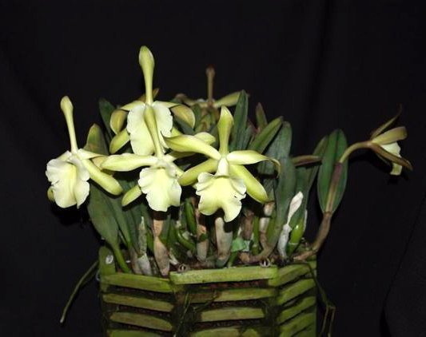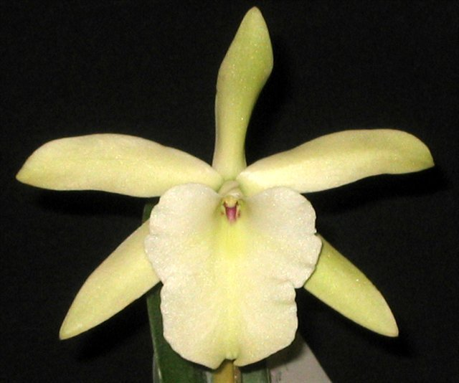
Significant species | Offspring/Progeny | Awards | Bloom season
Rl. digbyana* | 391/17106 | 1 FCC, 14 AMs, 10 HCCs, 1 CCEs, 7 CCMs, 1 JC | Summer
Rl. glauca* | 113/1038 | 14 AMs, 10 HCCs, 1 CCE, 6 CCMs | Spring

SPECIES DATA REPORT
Rhyncholaelia digbyana [Lindley] Schlechter 1918
Bletia digbiyana [Lindley]Rchb.f 1861; *Brassavola digbyana Lindley 1846; Brassavola digbyana f. fimbripetala (Ames) O.Gruss & M.Wolff 2007; Brassavola digbyana var fimbripetala [Ames] H.G. Jones 1962; Cattleya digbyana (Lindl.) Gentil 1907; Laelia digbyana [Lindley]Benth. 1880; Laelia digbyana var fimbripetala Ames 1932; Rhyncholaelia digbyanan f. fimbripetala [Ames] Hawkes 1964
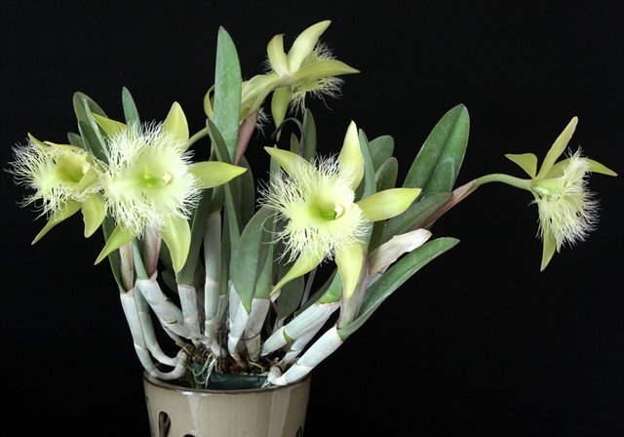
Varieties: var. fimbripetala
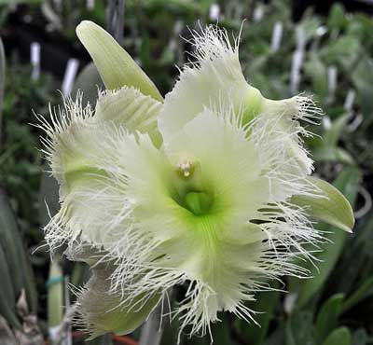
A hot to warm growing, medium to large sized, epiphytic plant from Yucatan, Campeche and Quintana Roo states of Mexico, Belize, Guatemala, Honduras and Costa Rica at elevations of 10 to 1000 meters with 6" [15 cm], elongate, compressed, closely spaced pseudobulbs with a single axillary , elliptic, erect, stiff, fleshy, 8" [20 cm] leaf. The entire plant is glaucous, and the terminal, erect, 3" [7.5 cm] long, inflorescence subtended by a large sheath, bears a single large, lemon scented, flower that appears in the summer. This species does best mounted on wood or tree fern, given plenty of bright light and ample water while growing and a lessening after the bulbs have matured. This is the national flower of Honduras
Rhyncholaelia digbyana needs bright light, intermediate growing temperatures and good air circulation. Although it may be grown successfully in well drained pots, the plants grow best when mounted on cork or grown in slatted wood or plastic baskets. Rhyncholaelia digbyana is slow to recover from repotting or other traumatic disturbances and may take a year or more to begin new growth. Let the plant dry out between watering to prevent rotting.
Awards: 1 FCC, 14 AMs, 10 HCCs, 1 CCEs, 7 CCMs, 1 JC
Hybrids:
This species is the source of those wonderful fringed lips in complex hybrid cattleyas. The species requires high light to flower well and many of its hybrids also share this requirement. Hybrids can flower at any time of the year. Hybrids are very vigorous and exceptionally fragrant. The shape and fringed lip is dominant along with heavy substance. Hybrids with Rhyncholaelia digbyana as a direct parent usually have only one or two flowers per inflorescence but those flowers can be very large.
Notable hybrids with 50% + Rl. digbyana:
Rlc. Ports of Paradise (Rlc. Fortune x Rl. digbyana) (1970): 2 FCCs, 3 AMs, 8 HCCs, 1 CCM. 85 offsprings/151 progeny. Pioneer of green/yellow big-flowered Cattleya breeding.
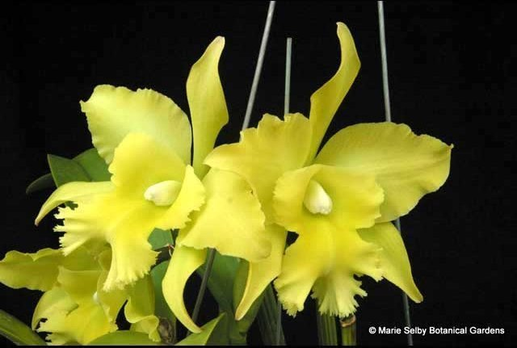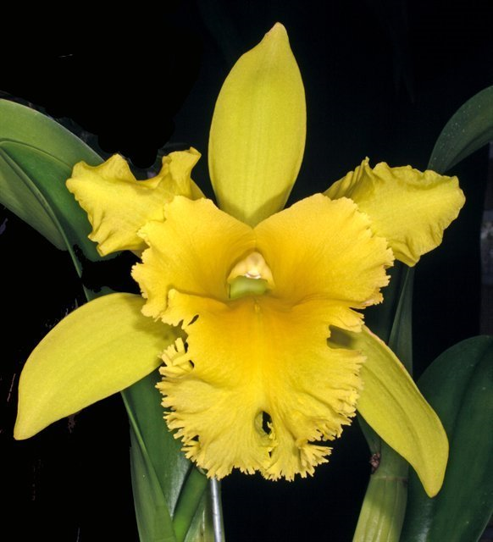

Rl. Aristocrat (glauca x digbyana) (1973): 3 AMs, 10 HCCs. 9 offsprings/9 progeny. Most popular primary hybrid of Rl. digbyana.
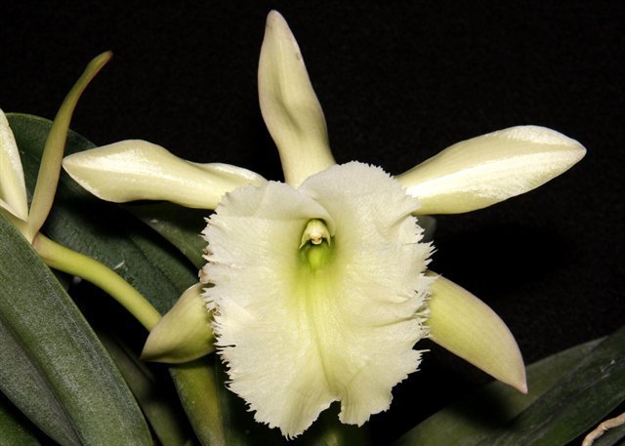
Rcv. David Sander (B. cucullata x Rl. digbyana) (1938): 6 AMs, 3 HCC, 1 CCM. 6 offsprings/6 progeny.
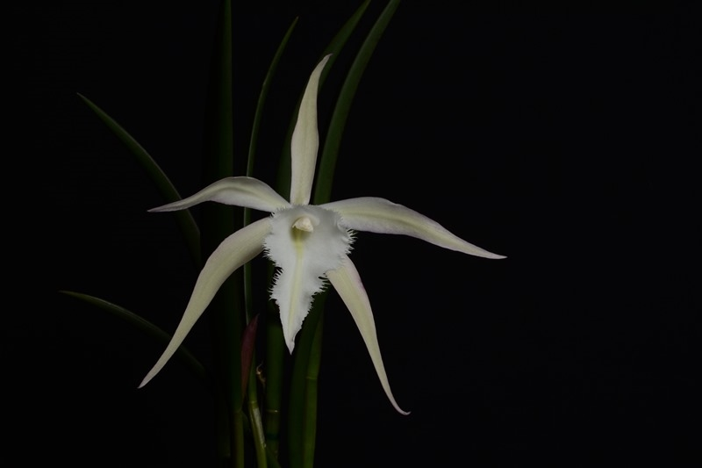
Rlc. Greenwich (C. Ann Folis x Rlc. Lester MacDonald) (1968) is another popular hybrid that has 25% Rl. digbyana. 7 AMs, 5 HCCs. 42 offspring/ 131 progeny.
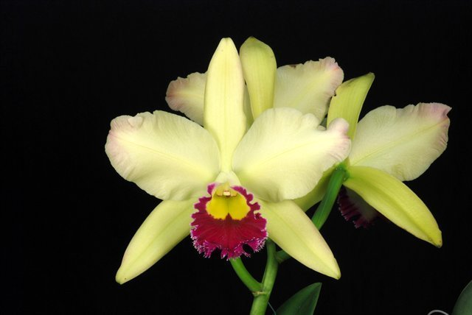
Most popular modern hybrid contain less than 20% of Rl. digbyana. However we can’t deny the influence of the heavily fringed lip to its progeny

Reference:
OrchidWiz Encyclopedia version 4.2
Orchid Plus Online
American Orchid Society - Rhyncholaelia
http://www.aos.org/orchids/orchids-a-to-z/letter-r/rhyncholaelia.aspx
The National Orchid of Honduras: Orchid Brassavola digbyana
http://nationalflowers.info/2013/05/20/national-flower-of-honduras-orchid-brassavola-digbyana/
Jay Pfahl’s Internet Orchid Species Photo Encyclopedia:
http://www.orchidspecies.com/brassavoladigbiyana.htm
Pinterest
https://www.pinterest.co.uk/pin/41799102769341880/
Cattleya Orchid Source: Rhyncholaelia
http://cattleyaorchidsource.blogspot.com/2009/12/rhyncholaelia.html

