**The Genus Encyclia**

Hooker 1828

Type species: *Encyclia viridiflora*

Encyclia comes from Greek enkykleomai ("to encircle"), referring to the lateral lobes of the lip which encircle the column. The abbreviation in the horticultural trade is E. The Encyclia genus is found throughout Central and South America including the West Indian islands and has approximately 250 species. In general they are all epiphytic in nature (growing on trees) so they need high humidity, good air circulation and frequent watering without allowing their roots to become waterlogged. They have been extensively interbred with Cattleya Alliance plants.

Encyclia is a genus of epiphytic orchids, segregated from Epidendrum, described by Hooker in 1828 establishing Encyclia *viridiflora* as the type species. Since that time, the number of species in this genus, Epidendrum and a number of other genera segregated from Epidendrum at various times, has varied dramatically. In 1997, Higgins established the genus Prosthechea, moving many former Encyclia species in a further attempt to classify this group. Over time, there will likely be other changes as well.

Encyclias are extremely variable and range in size from 2 inch plants up to pseudobulbs the size of softballs with leaves 2 feet or more in length. In spite of this variability, they all share the common feature of a lip that, while not fused to the column, more or less enfolds it. Commonly grown species are Encyclia *cordigera* (often seen horticulturally as Encylia *atropurpurea*, a completely misapplied name); Encyclia *cochleata* (now Prosthechea *cochleata*), Encyclia *tampense* and Encyclia *alata*.

The World Monocot Checklist currently recognizes 147 species and numerous natural hybrids. (8/2007)

The epiphytic genus Encyclia occurs in Florida, the Caribbean, Mexico, and other regions of the tropical Americas. It grows in lowland forests at altitudes up to 1000 meters. The distribution of the species is more or less evenly spread throughout this area. Most of these species are found in seasonally dry forests where the humidity tends to remain high throughout the year, though precipitation is infrequent, sometimes lacking for months. They are most common in dry oak forests.

Most species have stiff, drought-resistant leaves and large onion-shaped pseudobulbs.[2] The flowers arise from an apical inflorescence. This genus is pollinated by bees and birds. There are normally eight pollinia, but in some subgroups this is reduced to four. One species, Encyclia *cyperifolia*, produces cylindrical, terete leaves

Many species in this genus are cultivated as ornamental plants. The flowers may last over a month. They are easily overwatered and require only a periodic misting during the winter. Some species are fragrant; Encyclia *fragrans* produces vanilla-scented flowers.

The plants have continuously growing rhizomes that eventually create a large mass. In the wild the plants shed the older pseudobulbs. In cultivation they may fail to split, so growers will divide them by hand to prevent the plants from forming unwieldy mounds. An exception is Encyclia *tampensis*, which does well in a mounded form and does not need to be divided.

|  |  |  |  |
| --- | --- | --- | --- |
| Significant species | Offspring /progeny | Awards | Bloom season |
| E. cordigera* | 197/318 | 2 FCCs, 22 AMs, 10, HCCs, 13 CCMs, 2 CHMs, 2 CBMs, 5 JCs | Spring, around Mother’s Day |
| E. tampensis* | 156/224 | 13 AMs, 7 HCCs, 1 CCE, 13 CCMs, 2 JCs, 1 CBM | June-August and again in September |
| E. alata* | 92/196 | 14 AMs, 20 HCCs, 2 CCEs, 8 CCMs, 6 JCs, 2 CHMs | Spring to Fall, peak in June |
| E. bractescens | 13/15 | 3 AMs, 3 CCEs, 7 CCMs, 1 CBM | Late Winter to Spring |
| E. phoenicea* | 90/216 | 4 AMs, 6 HCCs, 1 CCM, 1 JC, 1 CHM | Spring to Fall |
| E. correllii | 47/63 | 0 | Late Spring to mid Fall |
| E. adenocaula | 43/85 | 3 AMs, 6 HCCs, 2 CCMs, 1 JC | Late Spring to Summer |
| E. plicata | 42/64 | 2 AMs, 3 HCCs, 1 CCM, 1 CHM, 1 CBM | Late Spring to Summer |

**SPECIES DATA REPORT**

**Encyclia correllii**Sauleda 2012

Synonym: N/A

Found in the Bahamas and Turks and Caicos Islands on low coppices as a large to giant sized, hot growing epiphyte on the base of trees or lithophyte on limestone with erect, clustered, elongate, ovate to sublate pseduobulbs carrying a single, coriaceous, stiff, erect, linear to linear-lanceolate, acute, basally clasping leaf that blooms in the late spring through mid-fall on a terminal, erect, racemose, slender, up to 52" [130 cm] long, to 45 flowered inflorescence with ovate-triangular, acute, concave floral bracts

**E. correllii and its variations **

Encyclia *correllii* has a distinctive character that is rare in the orchid family. The bases of the leaves lack an abscission layer. Consequently the leaves never abscise. All of the natural hybrids and introgression hybrids of E. *correllii* also lack the abscission layer making them easy to identify using live material or herbarium specimens. The greatest amount of hybridization (four natural hybrids) and introgression in the Bahama archipelago occurs with this species. However, although the hybrids are easy to identify, the other species involved in introgression in the hybrids are not easily identified. In the Bahama archipelago this species shows the greatest amount of phenotypic variation but no phenotype is clearly dominant.

**Varieties*:*** *N/A*

**Awards**: N/A

**Hybrids:** Encyclia x gracillis (pictured right). Found in the Bahamas and the Turks and Caicos at low elevations as a medium sized, hot to warm growing lithophyte or terrestrial with a short, stout, creeping rhizome giving rise to crowded, ovate-elongate pseudobulbs carrying 1 to 3, apical, erect, coriaceous, linear-lanceolate, acute leaves that blooms in the summer on an erect, 3' and more [1 meter] long, paniculate, laxly many flowered inflorescence with triangular, acuminate floral bracts and carrying sweetly fragrant flowers. This species has now been confirmed as a natural hybrid between E. *correllii* and E. *fehlingii* (pictured left).

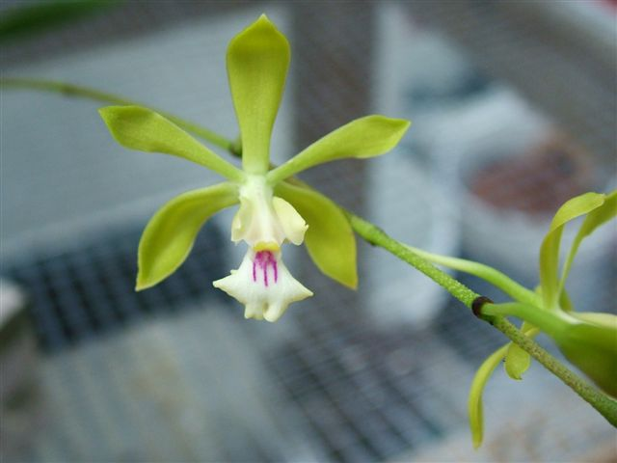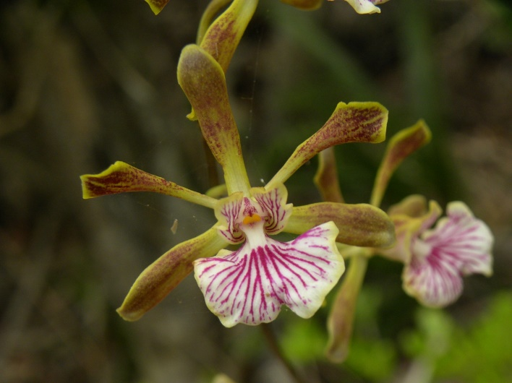

One of the most common and widespread species of Encyclia in the Bahama archipelago was named Epidendrum *gracile* Lindl. and later transferred by Schlechter to Encyclia (Encyclia *gracilis* (Lindl.) Schltr.). Sauleda (2012) determined that this common species did not match the plate or the type specimen of E. *gracile*. The plate and type represent a natural hybrid of the common species crossed with E. *fehlingii*, previously named Encyclia xlucayana Sauleda and Adams. Therefore, the common species did not have a name; Encyclia *correllii* was published by Sauleda (2012) as the name for the population.

Greuter et al. (2016) listed E. *gracilis* as occurring in three locations in Cuba (Provincia Ciego de Avila, Provincia Camaguey, and Provincia Las Tunas). What Greuter et al. (2016) are referring to, as E. *gracilis* is not clear. Sauleda (2012) made the determination that E. *gracilis* was a natural hybrid and published E. *correllii* as the proper name for the common species. The use of the epithet E. *gracilis* by Greuter et al. (2016) shows either a lack of knowledge of the literature or understanding of either taxa

**SPECIES DATA REPORT**

**Encyclia bractescens** (Lindl.) Hoehne 1952

Synonym: Encyclia acicularis (Bateman ex Lindl.) Schlechter 1914; Epidendrum aciculare Bateman ex Lindley 1841; Epidendrum bractescens Lindley 1840; Epidendrum esculentum Lindl. 1853; Epidendrum linearifolium Hkr. 1851

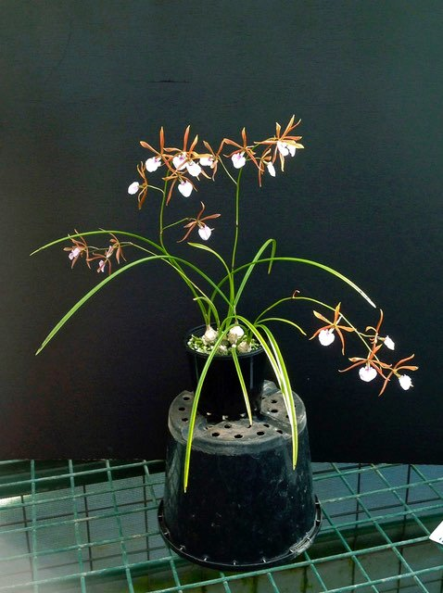 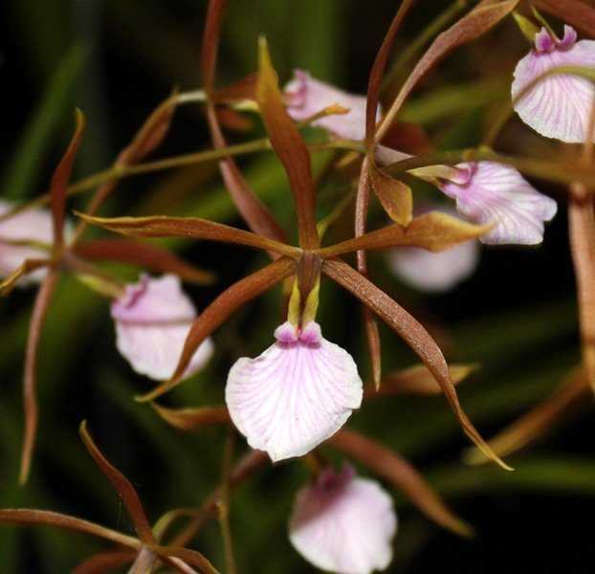

Native of Mexico and Central America in humid forests at elevations up to 1200 meters. It is one of the smallest of the Encyclias and is very attractive even when not in bloom as the foliage is rather grass like in appearance with two to three leaves on each pseudobulb. The small bulbs are about the size of pigeon’s eggs from which the leaves and inflorescence emerge. This is an easy-to-grow orchid which will form a nice size plant in three or four years. They remain compact rarely reaching more than 8 inches, or 20 centimeters, high. The flowers are held above the leaves to make a very nice display.

Most people grow this plant mounted, but it will do well in small pots, especially when grown in lava rock so that the roots will dry out quickly. It does not require very high light to flower well, although it will flower more prolifically with higher light and air circulation.

This orchid normally flowers in late winter to spring, but some plants when mature will bloom twice a year in the spring and fall. The spikes emerge with new growth in the fall and mature during the winter to bloom on inflorescences up to 12 inches, or 30 centimeters long. There can be up to 14 flowers on a single inflorescence and the flowers are up to 2 inches, or 5 centimeters, and are an attractive gold or brownish color with a white and pink lip. The flowers are long lasting and slightly fragrant, depending upon the cultivar.

They need warm to intermediate orchid conditions year round and will do well grown with Cattleyas but with slightly less light. They should be grown in moderate light of 3,000-4,500 foot candles with night time temperatures in the range of 60 degrees F or 15 degrees C. They can tolerate high temperatures during the day with adequate water and air circulation. If grown mounted daily watering is necessary especially during the hotter months of the year. They have very fine roots so will respond negatively to under watering. Watch the pseudobulbs for any withering which will indicate that they are not receiving enough water. They do not need any kind of a rest since they are truly tropical plants.

**Varieties*:*** *N/A*

**Awards**: 3 AMs, 3 CCEs, 7 CCMs, 1 CBM

**Hybrids:** 2 important primary hybrids: E. Borincana (x E. *alata*) pictured left with 9 AMs, 1 HCC, 1 CCM, and E. Hereford Jewel (x E. *cordigera*) pictured right with 5 AMs, 2 HCCs, 1 CCM, 1 AQ

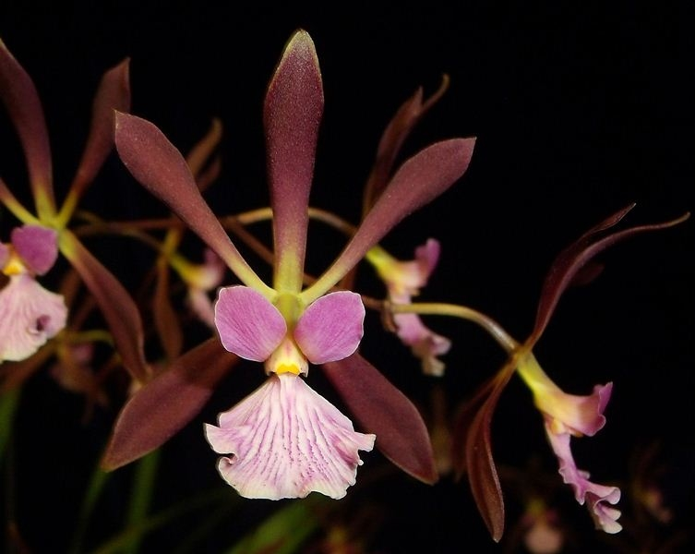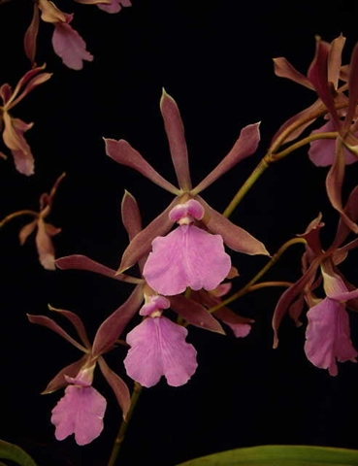

**Reference:**

OrchidWiz Encyclopedia version 4.1

Orchid Plus Online

American Orchid Society - Encyclia

<http://www.aos.org/orchids/orchids-a-to-z/letter-e/encyclia.aspx>

Wikipedia Encyclopedia

<https://en.wikipedia.org/wiki/Encyclia>

Jay Pfahl’s Internet Orchid Species Photo Encyclopedia:

<http://www.orchidspecies.com/enccorrellii.htm>

<http://www.orchidspecies.com/epibractescens.htm>

Encyclia bractescens – Miniature Orchids Series – Orchids - BellaOnline

<http://www.bellaonline.com/articles/art63040.asp>

The Genus Encyclia Hook. in the Bahama Archipelago – Species, Hybrids and

Introgression Hybrids.

<http://rsauleda.tripod.com/encycliabahamas.pdf>

A New Name for an Old Species

<http://www.academia.edu/5086028/A_New_Name_For_An_Old_Species_Orchidaceae_>