The Genus Prosthechea
Knowles & Westc. 1838
Type species: Prosthechea glauca
The World Monocot Checklist recognizes over 100 species (7/2009). This is the newly resurrected genus name for the group of orchids that have been classified in the past with Epidendrums, Encyclias, Anacheiliums and many others. This group has always been problematic in that the physical characteristics seem not to fit into nice discrete groups allowing easy classification. In 1997, Higgins placed many plants into this genus. This group of plants has a rhizome with pseudobulbs that are at least somewhat flattened. The inflorescence has a spathe at the base. The lip is attached or adnate to the column only part way and the column has three teeth at the apex. The seed capsule is three-angled or three-winged. Generally speaking, this group consists of two sub groups of plants. The first group is the cockleshell group, known for the non-resupinate (flowers upside down, lip uppermost.) such as Prosthechea (synonym Encyclia) cochleata. The second group includes the Mexican and Central American types such as Prosthechea (synonym Encyclia) prismatocarpa with the same plant type but resupinate flowers and bright colors.

These plants are generally very fragrant and the flowers last a long time, sometimes months. They bloom usually once a year but as the flowers last so long they seem in bloom a lot. Prosthechea cochleata blooms on a sequential inflorescence with one bloom after the other fades so it will stay in bloom for a year to 18 months on one inflorescence and seems to always be in bloom. The blooms are very resistant to pests, particularly slugs.

Significant species | Offspring/Progeny | Awards | Bloom season
Psh. citrina | 27/31 | 8 FCCs, 24 AMs, 12 HCCs, 5 CCMs, 2 JCs | Spring to early Summer
Psh. mariae* | 111/199 | 14 AMs, 10 HCCs, 1 CCE, 6 CCMs | Spring to Summer
Psh. cochleata | 32/35 | 1 FCC, 17 AMs, 9 HCCs, 4 CCM, 3 CBM, 1 CHM, 1 AQ, 1 JC | Year round
Psh. radiata | 31/39 | 7 AMs, 11 HCCs, 1 CCE, 19 CCMs, 1 CHM | Fall, Winter, Spring
Psh. vitellina* | 59/78 | 11 AMs, 6 HCCs, 1 CCE, 4 CCMs | Spring through Fall
Psh. prismatocarpa | 24/26 | 2 FCCs, 4 AMs, 3 HCCs, 7 CCMs, 1 JC | Spring through Fall

SPECIES DATA REPORT
Prosthechea vitellina Higgins 1997
Synonym: Encyclia vitellina (Lindl.) Dressler. 1961; *Epidendrum vitellinum Lindl. 1831; Epidendrum vitellinum var autumnale Wilson 1913; Epidendrum vitellinum var giganteum Warner 1887-8; Epidendrum vitellinum var majus Veitch 1866; Hormidium vitellina [Lindl] Brieger 1977; Pseudencyclia vitellina (Lindl.) V.P.Castro & Chiron 2003
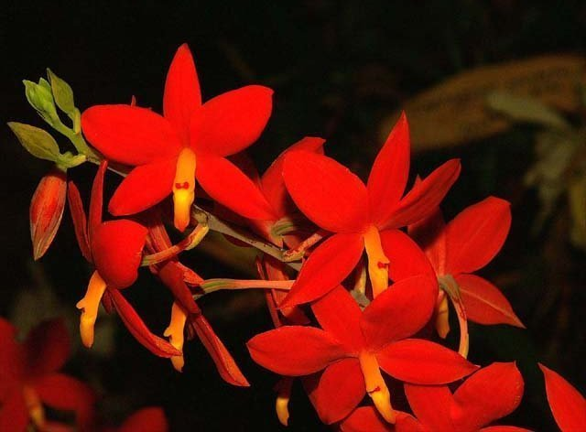

Found in cloud forests in Mexico, Nicaragua and Honduras, there it lives epiphytically on the branches with mosses and lichens of some oaks and pines, especially, but also on other trees, at altitudes between 1,300 and 1,600 meters, often accompanied by various species of Tillandsias. In the areas where it is most abundant, it is common to find plants that grow on the litter of the ground after having fallen from the branches on which they settled as terrestrial. They are medium sized, cool to cold growing epiphytes that bloom in the spring through fall on an apical, 12" to 18" long, simple to few branched inflorescence that have a basal sheath and arises on a mature, conical-ovoid, slightly compressed pseudobulb with two, apical, subcoriaceous, narrowly elliptic, obtuse leaves carrying 4 to 12, long-lived, orange to deep scarlet, showy, resupinate, wide open flowers and requires a dry winter rest ending with the onset of new growth in the early spring. Despite of having a relatively wide distribution in the east-northeast of Mexico, Prosthechea vitellina is rather strict in its climatic requirements, probably does not withstand temperatures near or lower than the freezing point, which combined with the rains are common in the winter of the Sierra Madre Oriental. Neither, it seems to be a very tolerant plant to high temperatures of the zones lowest in its distribution area. The atmospheric humidity in many places seems to fluctuate widely during the day and in some of them it is close to saturation most of the nights of the year
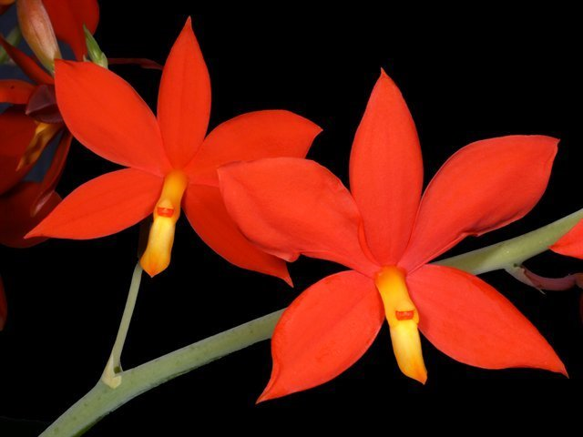
Prosthechea vitellina is clearly distinguishable from its congeners in Mexico, it is the only species with sepals and red-orange petals and yellow lip and column. This is one of the showiest orchids of Mexico, with great demand in culture and this is the cause of the massive extraction of wild specimens in many of their localities. In Mexico it is a very frequent orchid, it is known by the popular name of "Manuelitos" and although it is protected by the Official Standard 059 (Special Protection) it is not difficult to find for sale in some market stalls, from collections illegal in the forests. Some types of agriculture and certain crops, the opening of roads, as well as logging and mass collection, are the main risks for their survival in the natural environment. Fortunately, in some forests it becomes so abundant that it becomes the dominant epiphytic species. Its international commercialization is governed by Appendix II of CITES. It is possible to find it for sale in any country from authorized cultivation in greenhouses.
During the nineteenth century there were large quantities of plants that were sent to Europe to be cultivated, hence the horticultural interest for this species was born. Currently Prosthechea vitellina is one of the most frequent plants in the illicit trade of Mexican orchids and is sold as temporary ornaments or to satisfy your horticultural demand. This activity is common above all in the center of Veracruz and Mexico City. In a study on illegal trade in epiphytes, reports that between 2001 and 2003 this species was sold frequently at an average price of 13 pesos per plant (Flores-Palacios and Valencia-Díaz, 2007). Unfortunately, as the species grows in high and very humid sites, it is certain that these specimens die when cultivated in areas with inappropriate weather. The brightness and elegance of the flowers of Prosthechea vitellina have made this a very interesting orchid in horticulture since the nineteenth century, when it came to be grown in Europe. Nowadays, this interest still persists, both in Mexico and abroad, but its cultivation requires environmental conditions that are typical of a cold greenhouse and a high relative humidity.
Varieties: Although specimens with more or less clear tones are cited, some authors distinguish two varieties depending only on the size of the flowers var. majus, var. giganteum
Awards: 11 AMs, 6 HCCs, 1 CCE, 4 CCM
Hybrids: most notable primary hybrid is Psh. Hilda (x citrina) crossing the two major brightly colored Prosthechea is inevitable. This hybrid has received 1 AM, 1 CCM, 1 JC for the same specimen ‘Lucy’ in 1980
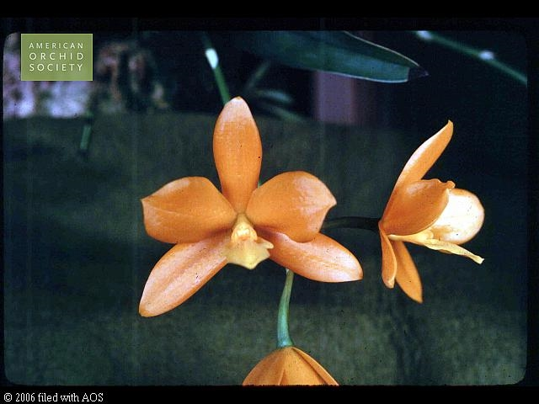
Most well known Intergeneric hybrid is Cattleychea Lemon Twist (x C. granulosa) that won 2 AMs, 1 HCC, and also gave rise to Proguarleya Lemon Trick ‘Dogashima’ (Ctyh. Lemon Twist x Ctt. Trick or Treat) with 1 HCC in 2005 pictured below.

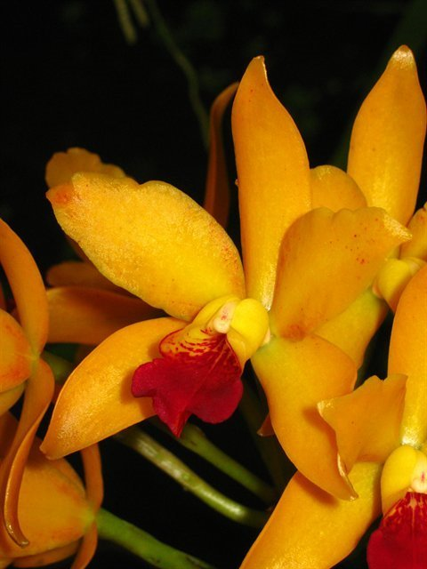

Reference:
OrchidWiz Encyclopedia version 4.1
Orchid Plus Online
American Orchid Society - Prosthechea
http://www.aos.org/orchids/orchids-a-to-z/letter-p/prosthechea.aspx
Wikipedia Encyclopedia
https://en.wikipedia.org/wiki/Prosthechea
Jay Pfahl’s Internet Orchid Species Photo Encyclopedia:
http://www.orchidspecies.com/prosvitellina.htm
Manuelitos (Prosthechea vitellina) – EncicloVida
http://www.enciclovida.mx/especies/6024511.pdf

