- 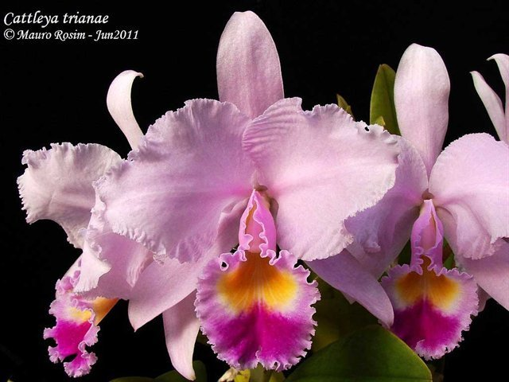 Five flat, well present flowers on two sturdy inflorescences; sepals and petals even lavender pink; dorsal sepals upright; petals overlapping, lightly undulated; lip trumpet shape with pleasantly undulated margin; throat egg yolk with white striations; midlobe white with prominent dark pink blotch; column and anther cap white; flowers are pleasantly fragrant; substance medium, texture crystalline.
- 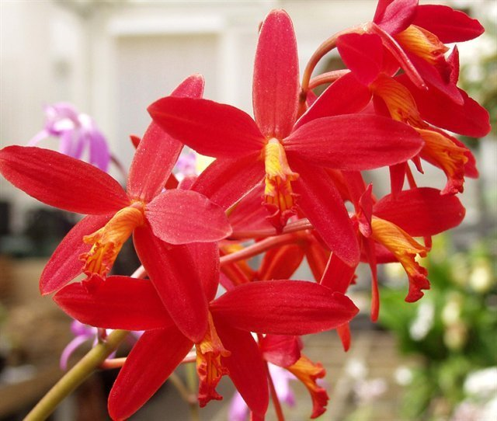 Fifty striking stellate flowers and 10 buds on four sturdy inflorescence held well foliage canopy; sepals and petals flat, saturated crimson with darker red longitudinal striation; lip tubular, bright orange with contrasting red stripes; substance firm, texture satiny.
- 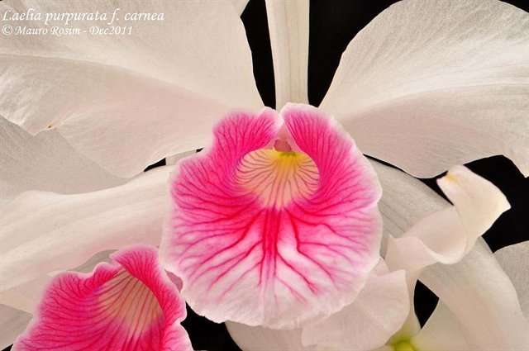 Thirty flowers and five buds on five inflorescences; sepals and petals white; lip tubular, throat cream suffusing bright yellow medially with thin brick red striations, distal two third hot pink suffusing white distally with thicker dark pink striation; column and anther cap white; substance firm, texture crystalline.
- 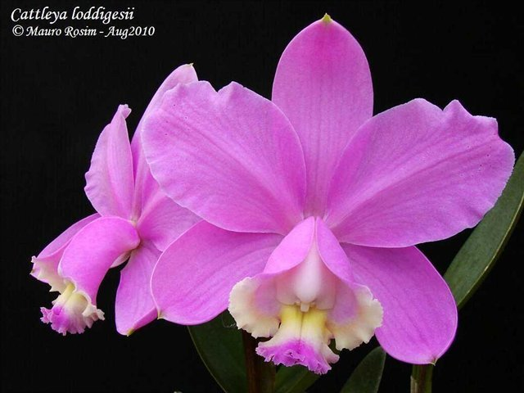 Two very flat, full flowers on one inflorescence; sepals and petals medium lavender pink ; lip lavender pink; side lobes white distally partially cover column; midlobe white with darker lavender distally and butter yellow medially with crenulated margin; column prominent, light lavender; anther cap white; substance hard, texture satiny.
- 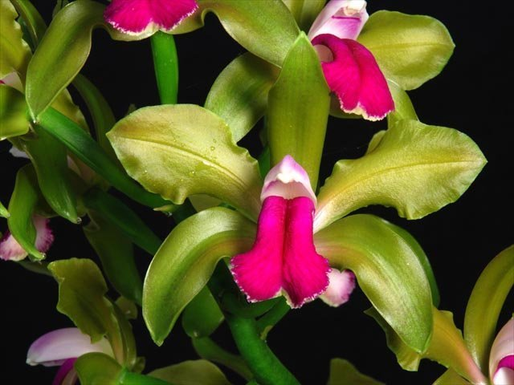 Ten flowers on one erect inflorescence; sepals and petals light olive green with faint magenta stippling medially; lip lingulate, bilobed, contrasting fuchsia with white picottee marginally; prominent column white with suffusing fuchsia; anther cap white; substance cardboard; texture satiny, lip matte.

